This request is to transform the four ASCII-art placeholders from the chat conversation into high-quality, professional-grade technical diagrams, while preserving the exact technical labels, flow logic, and sector boundaries defined in the architecture.
The core subject of all images is the UIAO (Universal Interoperability Adapter Object) architecture, which focuses on normalizing truth and claims across a fragmented digital ecosystem without sit ting in the data path. These diagrams are critical for FedRAMP and architectural documentation.
General Style and Cohesion: All diagrams must share a consistent, high-fidelity technical illustration style. Use a restricted, professional color palette (e.g., shades of charcoal, steel, and light blues for infrastructure; a single contrasting accent color like safety orange or a distinctive green for 'Truth' and compliance checkmarks). Backgrounds should be clean white or light gray. All text labels must be crisp, legible, and match the ASCII verbatim.

Image 1: Truth Flow Diagram (README.md and /truth/federated-truth.md)
This diagram must visualize the flow where local data is transformed into a canonical claim. It must prioritize the [ Agency / Vendor Boundary ] as the definitive compliance boundary (e.g., FedRAMP).
Detailed Scene Description: A professional infographic. On the far left, a distinct vertical barrier marks the boundary with labels [ Agency / Vendor Boundary ]. Inside this boundary, place a stylized representation of a data environment (e.g., AWS icons, stylized Microsoft Entra 'A').
Inside this boundary, follow the flow:
- [ Telemetry/Data Source ]: A blue cylinder icon for 'Raw, heterogenous logs, metrics, state'.
- (Flow arrow to) [ UIAO Adapter (Local) ]: A stylized, secure processing cog. List its five core functions next to it in crisp text: * Extracts raw telemetry, * Normalizes to UIAO schema, * Adds Provenance (KSI/Cert), * Computes Drift.
- (Flow arrow to) [ Canonical UIAO Claim ]: A small, glowing, encrypted digital token icon, labeled 'Small, signed, policy-governed summary'.
- (Flow arrow OUT of the boundary through a distinct, labeled channel) (Out-of-Band Channel), with a specific accent color and a large red checkmark labeled FedRAMP/Compliance boundary.
- (Flow arrow to) [ UIAO FABRIC ]: A large, clean, blue central hexagon structure labeled [ UIAO FABRIC ] (Normalization & Federation) with a note <-- Interprets Claims, doesn't store data.

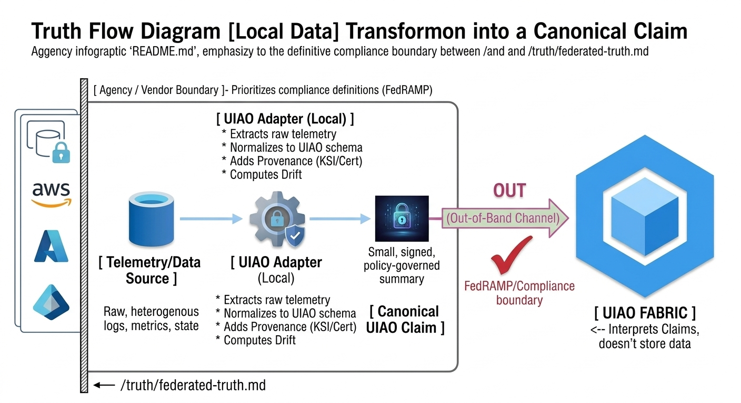

Image 2: Conflict Resolution Flow (/truth/federated-truth.md)
This diagram must visualize the logic for reconciling conflicting claims using provenance, confidence, and policy.
Detailed Scene Description: A complex logic flowchart infographic. At the top, a clean hopper labeled [ Fabric Ingests Claims ]. From the hopper, a horizontal timeline or stack of three distinct claim tokens flows:
- [ Claim #1 ] (Entra ID: Active)
- [ Claim #2 ] (Cisco ISE: Quarantined)
- [ Claim #3 ] (AWS GuardDuty: Low Risk)
These three claims converge and flow into a central processing block, a stylized 'Decision Engine'. The processing block must be broken into a vertical stack of logic checks:
- [ Provenance Check (Auth) ] <-- (KSI Root, Certificate Check) with green validation checkmarks.
- [ Confidence Scoring ] <-- (Vendor Authority x Telemetry Method)
- [ Policy Engine ] <-- (e.g., NIST 800-207 ZTA Rules)
A single output arrow flows from the bottom of this engine, leading to the final result, a large green shield icon labeled [ Reconciled UIAO Truth ] with the text (e.g., Subject Status: "Quarantined").

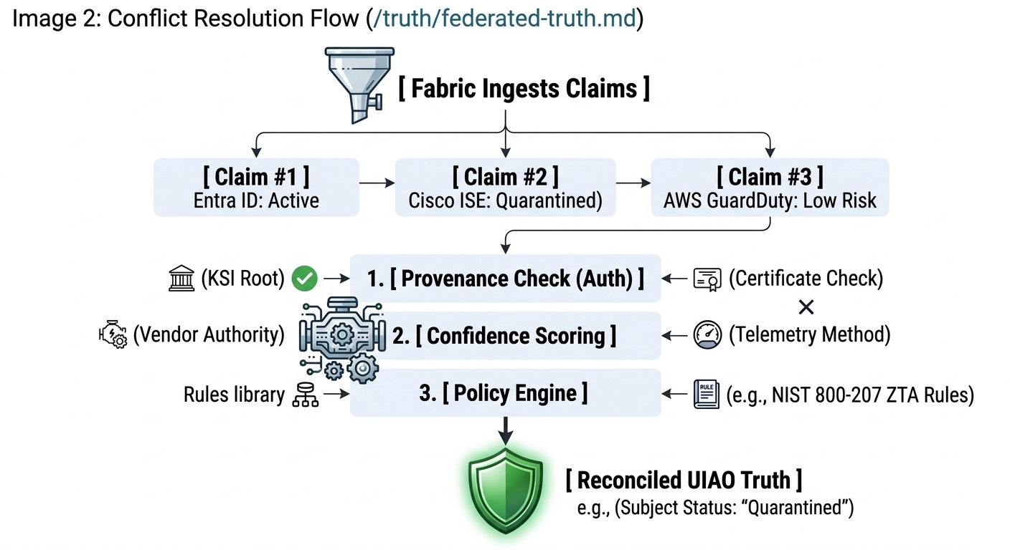

Image 3: Cross-Sector Governance Map (/governance/federated-governance.md)
This diagram must show how authority is delegated and interlocks across different sectors without a single central authority.
Detailed Scene Description: A high-level, multi-tiered hierarchy infographic. Start at the top center with [ NATIONAL Interoperability Forum ] (UIAO 'Constitution') as the ultimate governing standard body.
Flow lines delegate down to three distinct vertical columns, which must feel like separate 'sovereign domains':
- [ FEDERAL SECTOR ] (CISA/OMB/NIST)
- [ STATE SECTOR ] (e.g., Maryland)
- [ PRIVATE SECTOR ] (Healthcare/Banking)
Within each column, flow further down to specific sub-entities, showing sector-specific compliance rules:
- (Federal): [AGENCY A] (NIST 800-53), [AGENCY B] (HVA/TIC)
- (State): [STATE agency] (CJIS rules), [Local govt] (NENA/GIS)
- (Private): [Hospital A] (HIPAA/PHI), [Bank B] (FFIEC)
All these entities terminate at [ UIAO Adapters ] (Compliance, Claims) icons. All adapter icons then connect via distinct, separate data paths down to a unified, glowing, central hexagon at the bottom of the map labeled [ UIAO FEDERATED FABRIC ] with a note (Unified Cross-Sector Truth View).

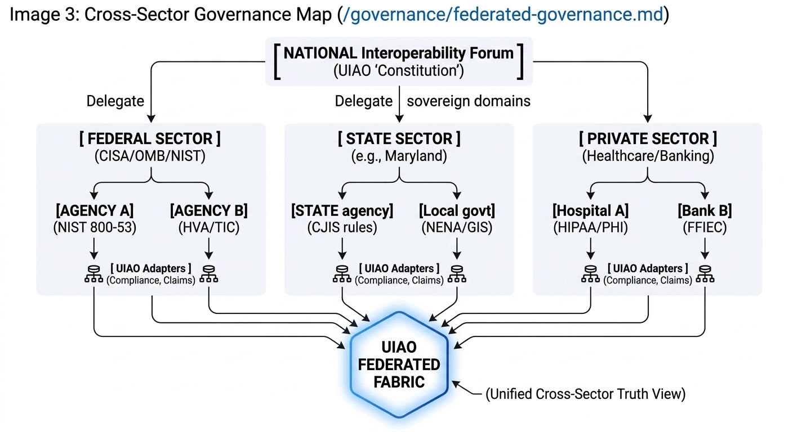

Image 4: Adapter Life Cycle / Certification Path (/contracts/adapter-contract.md)
This diagram must visualize the specific certification workflow for an adapter.
Detailed Scene Description: A professional, step-by-step process diagram/timeline, using clean, sequential boxes and validation checks. The progression flows from left to right.
- [ Adapter Creation ] (A stylized 'Development' station. List sources: Anyone builds: AI-generated, integrator, etc.. Label the model: (Contract-first model).)
- (Flow arrow to) [ UIAO-Core Validation ] (A validation shield icon. List process: (Automated check: Contract compliance, Schema binding), (Repo CI/CD Pipeline). Show an automated test report being generated.)
- (Flow arrow to) [ Provenance Rooting ] (A secure vault icon. List process: (Adapter obtains signing cert / KSI integration). Show a root certificate being linked.)
- (Flow arrow to) [ Runtime Certification ] (A live system monitor icon. List process: (Validates "observed_at" / Drift logic). Show time-series data and a green 'pass' result.)
- (Flow arrow to) [ Certified UIAO Adapter ] (A large, professional shield icon with a prominent green seal of authenticity, labeled Certified UIAO Adapter. Add note: (Ready for deployment inside sector boundary).)

