AAN Track A — Assessment Rubrics
Per-slot scoring sheets for the compliance-track capstone (the seven-slot walk)
Federal AAN Training Program — companion material for the federal AAN book series; not part of UIAO.
Part of the AAN Training Program — companion material for the federal AAN book series, not part of UIAO.
These rubrics score the Track A capstone: one document covering all seven evidence slots, backed by a real uiao oscal ksi-ar run. Self-assess or peer-assess; the rubric language is deliberately the language an assessor would use.

The scale (applies to every slot)
Level | Name | Meaning
0 | Missing | Slot not addressed, or addressed without reference to the books or the mapping YAML
1 | Named | Feeding books and KSI category named correctly, but controls or evidence flow are wrong/absent
2 | Traced | Book → NIST anchor → KSI category → evidence source chain is complete and correct against the slot mapping
3 | Assessor-ready | Level 2 plus a real verdict from uiao oscal ksi-ar, an honest gap statement for anything not-evaluated, and the deadline that gap answers to

Pass bar for Track A: every slot at level 2 or higher, and at least three slots at level 3. (All seven at level 3 is the "distinguished" outcome — it is, in substance, a ConMon narrative.)
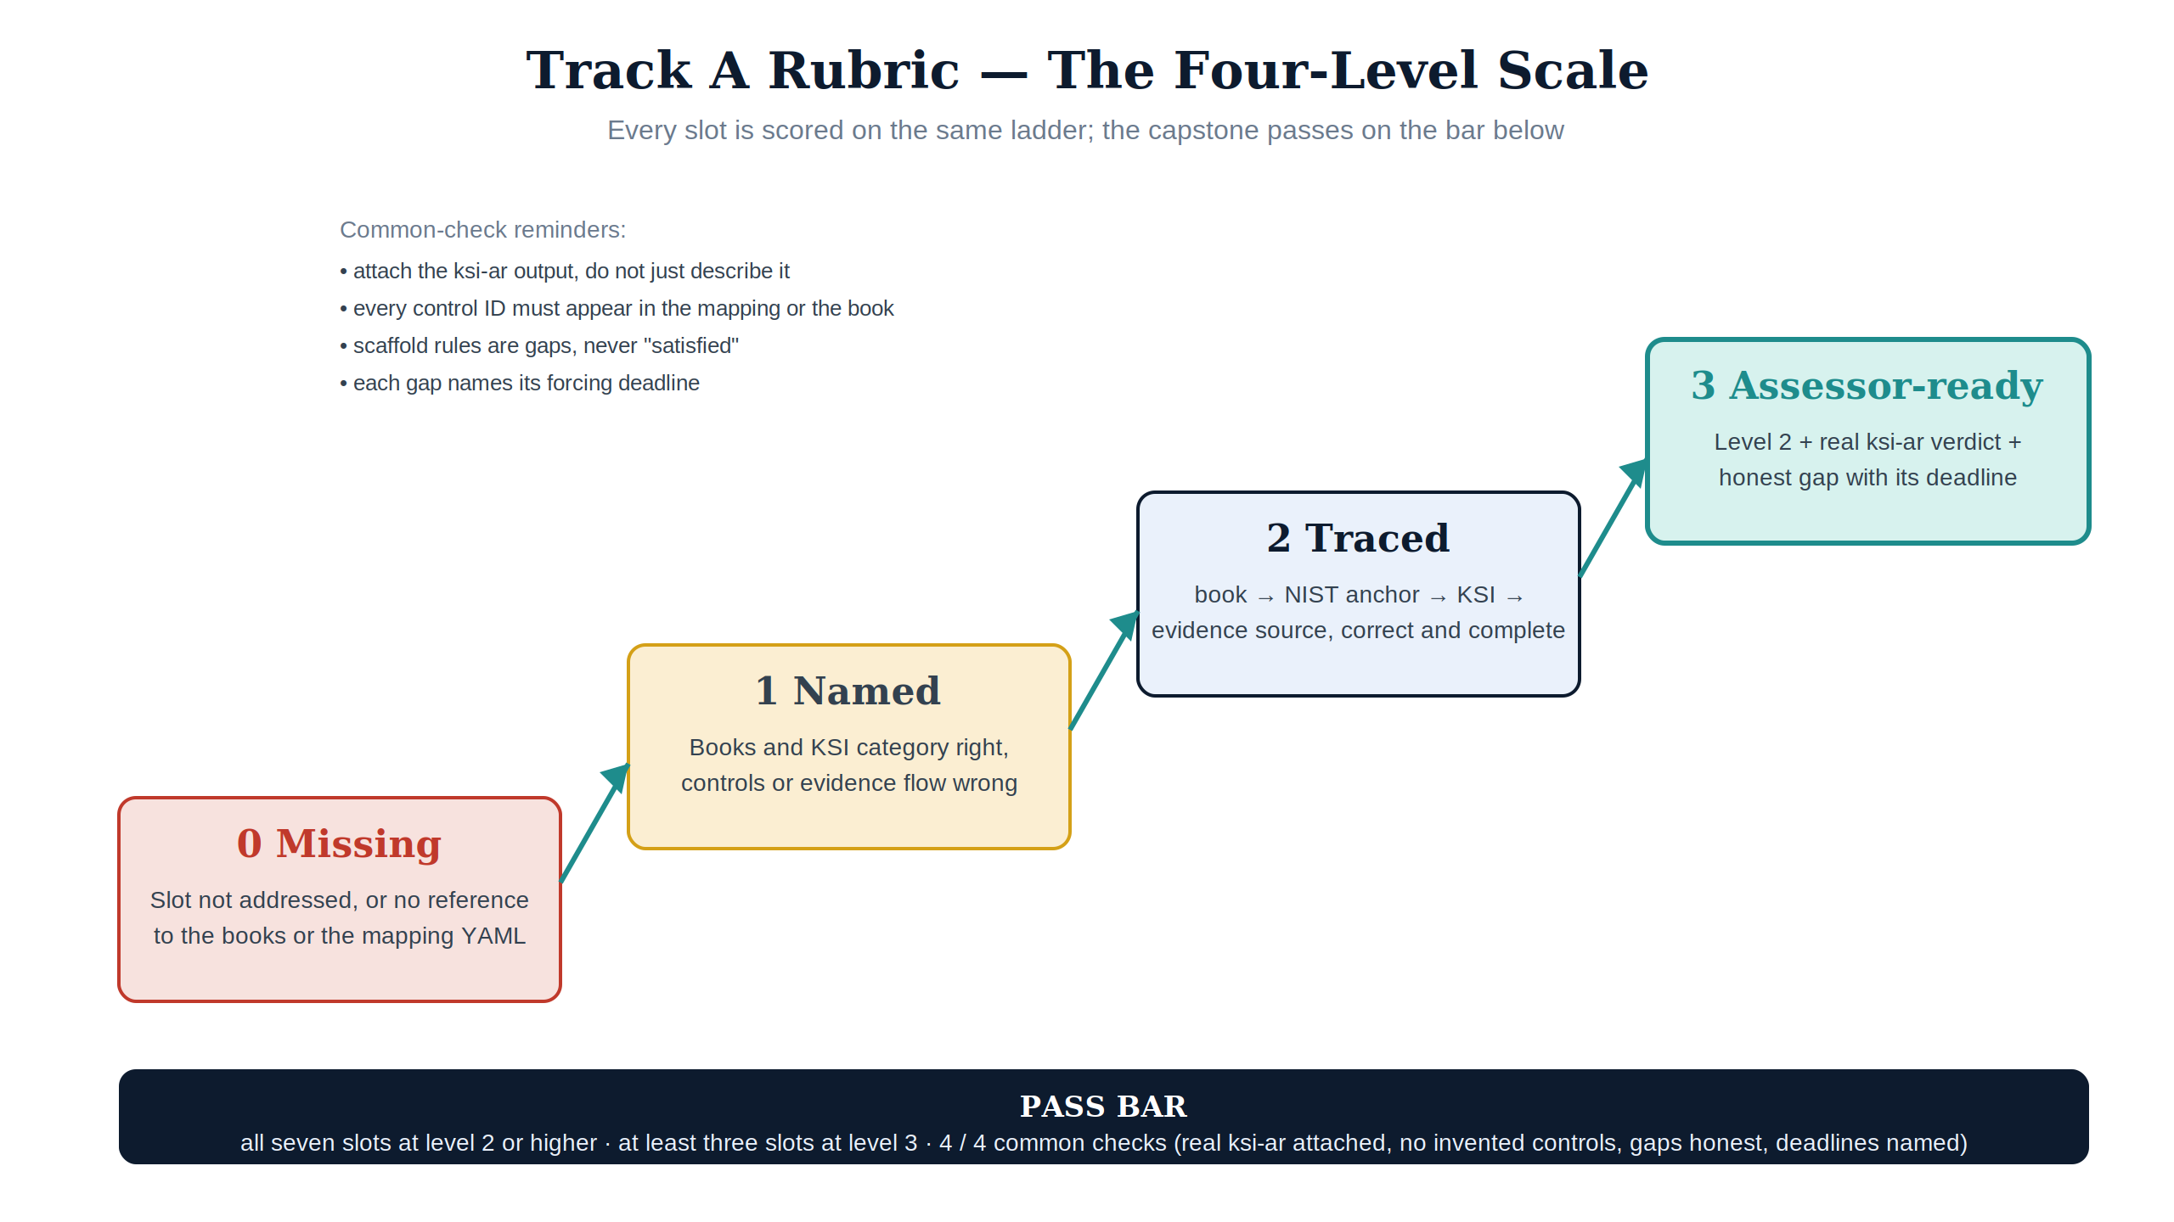
Figure 1 — The rubric ladder: Missing → Named → Traced → Assessor-ready, with the pass bar and the four common checks.

Common checks (scored once, apply to the whole capstone)
Check | Yes/No
The ksi-ar output file is attached/linked, not just described
Every control ID cited appears in the slot mapping or the book itself (no invented controls)
Scaffold/not-evaluated rules are stated as gaps, not glossed as satisfied
Each gap names its forcing deadline (e.g., BOD 26-04 Dec 7 2026; 20x mandatory Jan 1 2027)

Slot 1 — identity (KSI-IAM)
Criterion | Level 2 evidence | Level 3 adds
Books | 03, 04, 07 named (05 as procedural companion) | —
Controls | IA-2(+1/2/11), IA-5, IA-11, AC-2(+1), AC-3, AC-5/6 family, AC-17, CA-7 mapped to the right book | Before/after table for at least one AC-6 enhancement (Book 07 style)
Evidence flow | Sign-in/risk logs named as the source | A privileged-role trace: PIM design → control → KSI rule → audit log entry (e.g., the PIM lab export)

Slot 2 — addressing (KSI-PIY)
Criterion | Level 2 evidence | Level 3 adds
Books | 01 | —
Controls | CM-8 / AC-4 anchors; the 16-control closure claim attributed to the roadmap, not asserted as fact | —
Evidence flow | IPAM inventory named as the attestation | An actual inventory artifact (vendor export or the DDI lab fixture) referenced from the slot-02 mapping

Slot 3 — network (KSI-CNA)
Criterion | Level 2 evidence | Level 3 adds
Books | 02, 06 | —
Controls | SC-8 / CA-7 anchors; Book 06's SC/SI depth distinguished from Book 02's argument | —
Evidence flow | One application-aware path policy mapped to SC-8 | The CA-7 continuous signal that proves the policy stays enforced, named concretely (probe, log, or export)

Slot 4 — telemetry (KSI-MLA)
Criterion | Level 2 evidence | Level 3 adds
Books | 08, 09, 10 | —
Controls | CA-7 / SI-4 anchors; RA-5 family, SI-2, AU-6/7/8/11, IR-4/6/8 assigned to the right book | —
Evidence flow | KEV-scenario trace: Defender VM finding → Sentinel incident → SI-4/RA-5 closure | A fired-rule artifact (e.g., the Sentinel lab chain) plus the AU-11 retention argument

Slot 5 — endpoint (KSI-PIY)
Criterion | Level 2 evidence | Level 3 adds
Books | 07 (PAW), 08 (assessment surface), 14 (PII endpoints) | —
Controls | CM-8 / IA-3 anchors; PT entry points from Book 14 | —
Evidence flow | Endpoint-inventory statement covering device identity and completeness | The PII-handling endpoint subset called out with its Book 14 transparency treatment

Slot 6 — security configuration & change (KSI-CMT)
Criterion | Level 2 evidence | Level 3 adds
Books | 08, 10, 12, 13 | —
Controls | CM-2 / AC-4 anchors; SR family from Book 12; PM family from Book 13 | —
Evidence flow | The BOD 26-04 submission story: SBOM artifacts → KSI-011–014 activation | An actual SBOM/VDR artifact, and the scaffold rules honestly listed with the Dec 7 2026 gate

Slot 7 — continuity (KSI-RPL)
Criterion | Level 2 evidence | Level 3 adds
Books | 11 | —
Controls | CP-2 through CP-10 with enhancement counts right | —
Evidence flow | One contingency-test exercise mapped to CP-4 via the slot-07 binding | A tabletop AAR (even a lab one) with findings and owners — a zero-finding AAR scores 0 here, per Book 11

Scoring sheet
Slot | Level (0–3) | Notes
1 — identity
2 — addressing
3 — network
4 — telemetry
5 — endpoint
6 — security
7 — continuity
Common checks passed | /4
Result | Pass / Not yet | Pass = all ≥2, ≥3 at level 3, 4/4 common checks

