AAN Lab Environments
Scripted tenant and fixture setups for the Track B hands-on labs
Federal AAN Training Program — companion material for the federal AAN book series; not part of UIAO.
Part of the AAN Training Program — companion material for the federal AAN book series, not part of UIAO.
Each Track B module ends with labs; the pages below stand up the environments those labs need. Scripts are embedded in the pages (this repo's docs/ tree is documentation-source only — copy the blocks into your own shell/tenant).

Lab tiers
Tier | What it needs | Use when
Tier F — fixture | Nothing but this repo and Python | You want the evidence-binding mechanics (slot YAML → uiao oscal ksi-ar) without any cloud footprint
Tier T — trial tenant | A Microsoft 365 developer/trial tenant + Azure trial subscription | The PIM / Sentinel / Purview labs — full behavior, disposable blast radius
Tier P — product eval | A vendor eval (Infoblox/BlueCat) or containerized DNS/DHCP | The DDI lab's split-horizon and provisioning exercises

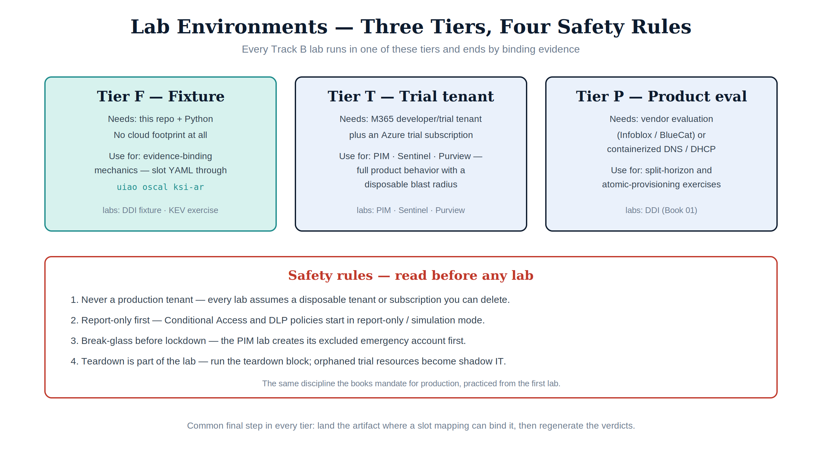
Figure 1 — The three lab tiers and the four safety rules every lab starts from.

Safety rules (read before any lab)
- Never a production tenant. Every lab assumes a disposable tenant or subscription you can delete. PIM changes, CA policies, and DLP enforcement are exactly the things that lock organizations out.
- Report-only first. Where a lab creates a Conditional Access or DLP policy, it is created in report-only/simulation mode — the same discipline Books 07 and 09 mandate for production.
- Break-glass before lockdown. The PIM lab creates its excluded emergency account first, mirroring Book 07's ordering.
- Teardown is part of the lab. Each page ends with a teardown block; run it. Orphaned trial resources are how "labs" become shadow IT.

Cost notes
- M365 E5 developer/trial tenants cover Entra ID P2 (PIM), Purview, and Defender features for the trial window.
- Sentinel bills per GB ingested — the lab keeps ingestion in the free-tier range by using a single VM/forwarder and seeded events.
- Infoblox/BlueCat evals are vendor-arranged; the Tier-F fixture path needs no license.

Lab environment pages
Page | Module | Stack | Tier
DDI lab (Book 01) | B1 | Infoblox eval or BIND/Kea containers + IPAM fixture | P / F
PIM & privileged access lab (Book 07) | B4 | Entra ID P2, Intune, Graph PowerShell | T
Sentinel detection lab (Books 08/10) | B5 | Log Analytics + Sentinel, one forwarder VM | T
Purview data-protection lab (Book 09) | B5 | Purview labels/DLP, Key Vault Premium | T

Modules B2 (SD-WAN/SASE) and B6 (continuity/SBOM/governance) intentionally have no tenant page yet: B2 needs vendor SD-WAN gear or eval licenses (track via the vendor catalog), and B6's labs are document- and CI-shaped (SBOM workflow on any repo, tabletop exercise) — they run anywhere.

The common final step — bind the evidence
Every lab ends the same way, regardless of tier: place the produced artifact where a slot mapping can reference it, then regenerate verdicts:
uiao oscal ksi-ar --output exports/oscal/ksi-ar.json
The Track A rubrics score what you produce.

