AAN Track A — Compliance
The 15-book Federal AAN series as a FedRAMP 20x / NIST SP 800-53 Rev 5 compliance curriculum
Federal AAN Training Program — companion material for the federal AAN book series; not part of UIAO.
Part of the AAN Training Program — companion material for the federal AAN book series, not part of UIAO. UIAO tooling appears here only because its conformance adapter consumes the books' evidence.
Audience: ISSOs / ISSMs, 3PAO assessors, ConMon operators, compliance leads. Prerequisite: none beyond orientation; product-level skills are optional here (they are Track B's job). Backbone: the seven evidence-slot mappings in fedramp_aan_catalog/mappings/ <https://github.com/WhalerMike/uiao/tree/main/src/uiao/adapters/fedramp_aan_catalog/mappings> — each module below is one slot, taught from the same YAML the conformance pipeline evaluates.

How to read this track
Each module gives you four things:
- Read — the AAN book(s) bound to the slot.
- Controls — the NIST SP 800-53 Rev 5 anchor controls the slot closes.
- Evaluate — the FedRAMP 20x KSI category that scores the closure.
- Checkpoint — a concrete artifact or CLI run proving you can trace book → control → KSI → evidence.
Run the pipeline pieces as you go:
# Plane 2: evaluate an IR file against the KSI rules
uiao ksi evaluate --ir ./output/ir/tenant.ir.json --out ./output/ksi/tenant.ksi.json

# Assessment Results from the AAN slot evidence bindings
# (per-KSI satisfied / not-satisfied / not-evaluated verdicts)
uiao oscal ksi-ar --output exports/oscal/ksi-ar.json

# POA&M + SSP from an evidence bundle
uiao oscal generate --help
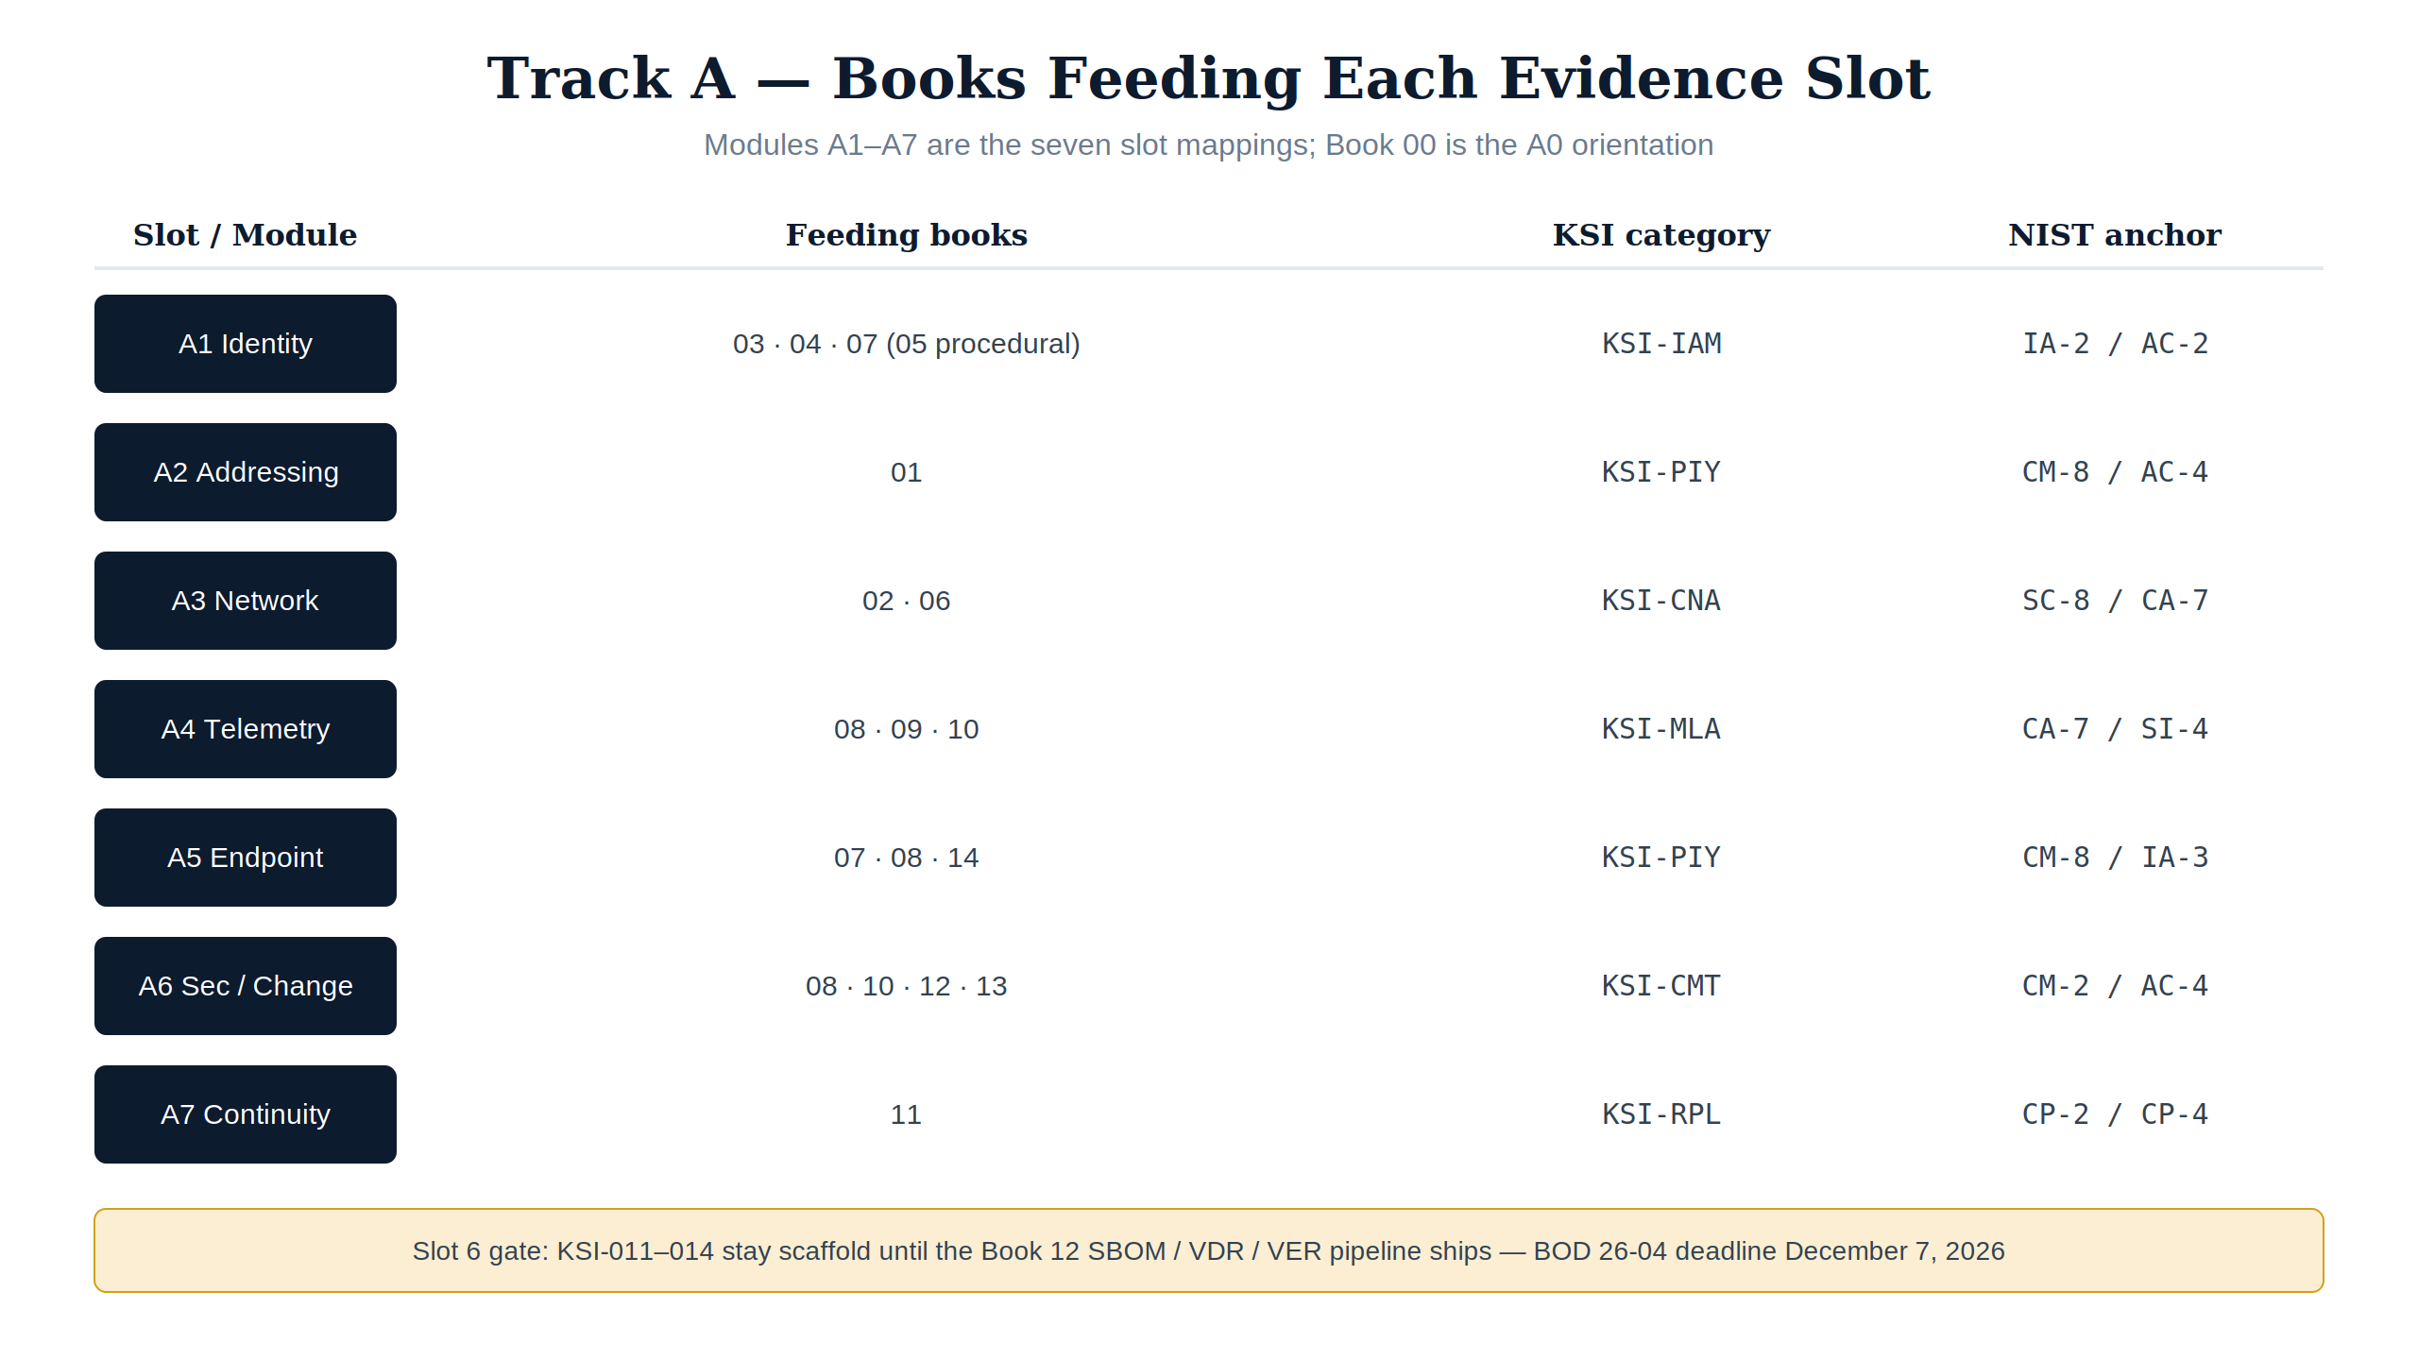
Figure 1 — Track A at a glance: the books feeding each of the seven evidence slots, with KSI category and NIST anchor. The amber strip is the slot-6 BOD 26-04 gate.

Module A0 — Orientation: the compliance shape of the corpus
- Read: Book 00 (Executive Summary) and the Federal AAN / ConMon Compliance Gap Roadmap <https://github.com/WhalerMike/uiao/blob/main/inbox/Application%20Aware%20Networking/federal-aan-conmon-gap-roadmap.md>.
- Learn: the FedRAMP 20x timeline (Class A window opened August 2026; 20x mandatory for new authorizations January 2027), the BOD 26-04 VDR/VER deadline (December 7, 2026), and the split between the evidence generation layer (the books) and the evidence governance layer (the conformance adapter / OSCAL emitter).
- Checkpoint: write a one-page brief stating which control families the corpus closes today, which were structurally absent until Books 12–14 (SR, PM, PT), and which KSI rules remain scaffold.

Module A1 — Identity control plane (slot 1)
- Read: Book 03 (Entra ID, ZTNA, Active Governance), Book 04 (SQL Server Authentication Modernization), Book 07 (Privileged Access Management). Book 05 is the procedural companion to Book 04.
- Controls: IA-2 (+enhancements 1, 2, 11), IA-5, IA-11, AC-2 (+1), AC-3, AC-5, AC-6 family, AC-17, CA-7.
- Evaluate: KSI-IAM — anchor IA-2 / AC-2; evidence source: identity-provider sign-in and risk logs.
- Checkpoint: for one privileged role, trace the full chain: Book 07's PIM design → AC-6 enhancement it closes → KSI-IAM rule that scores it → the sign-in/audit log evidence the collector ingests.

Module A2 — Addressing control plane (slot 2)
- Read: Book 01 (SSA Landing Zone, IPAM & FedRAMP) — Infoblox DDI: IPAM, DNS, DHCP, PKI.
- Controls: CM-8, AC-4 anchors; Book 01 closes 16 controls per the gap roadmap.
- Evaluate: KSI-PIY (addressing inventory evidence).
- Checkpoint: produce the address-inventory evidence statement: what the DDI platform attests (authoritative IPAM inventory), which CM-8 requirements that satisfies, and where the evidence lands in the slot-02 mapping.

Module A3 — Network control plane (slot 3)
- Read: Book 02 (Network Modernization — SD-WAN, SASE, UC) and Book 06 (Database Consolidation & Network Physics).
- Controls: SC-8, CA-7 anchors; SC/SI depth from Book 06.
- Evaluate: KSI-CNA (network architecture evidence).
- Checkpoint: map one application-aware path policy (SD-WAN/SASE) to SC-8 transmission protection and show which continuous-monitoring signal (CA-7) proves it stays enforced.

Module A4 — Telemetry control plane (slot 4)
- Read: Book 08 (Vulnerability Management — Defender VM + KEV), Book 09 (Data Protection — Purview + Key Vault CMK), Book 10 (SIEM / XDR Detection — Sentinel).
- Controls: CA-7, SI-4 anchors; RA-5 family, SI-2, AU-6/7/8/11, IR-4/6/8.
- Evaluate: KSI-MLA (monitoring / logging / audit evidence).
- Checkpoint: pick one KEV-listed CVE scenario and trace: Defender VM finding (Book 08) → Sentinel analytic + incident (Book 10) → the SI-4 / RA-5 closure statement, with the audit-retention argument from AU-11.

Module A5 — Endpoint control plane (slot 5)
- Read: Book 07 (PAW sections), Book 08 (endpoint assessment surface), Book 14 (PII Processing & Transparency).
- Controls: CM-8, IA-3 anchors; PT family entry points from Book 14.
- Evaluate: KSI-PIY (endpoint inventory evidence).
- Checkpoint: write the endpoint-inventory evidence statement covering device identity (IA-3), inventory completeness (CM-8), and where PII-handling endpoints get the Book 14 transparency treatment.

Module A6 — Security configuration & change control plane (slot 6)
- Read: Book 08 (secure configuration surface), Book 10 (detection as change evidence), Book 12 (Supply Chain Risk Management), Book 13 (Program Management & Governance).
- Controls: CM-2, AC-4 anchors; SR-1/2/3/5/6/8/10/11 from Book 12; PM family from Book 13.
- Evaluate: KSI-CMT (configuration / change-management evidence); KSI-011–014 become evaluable only once the SBOM + VDR/VER pipeline ships (BOD 26-04 gate).
- Checkpoint: state the BOD 26-04 submission story: which SBOM artifacts Book 12 requires, which KSI rules they activate, and what remains scaffold until the telemetry wiring lands.

Module A7 — Continuity control plane (slot 7)
- Read: Book 11 (Business Continuity).
- Controls: CP-2 (+3 enhancements), CP-3, CP-4 (+2), CP-6, CP-7 (+3), CP-8 (+2).
- Evaluate: KSI-RPL (recovery / resilience evidence).
- Checkpoint: map one contingency-test exercise to CP-4 and show the slot-07 continuity binding that carries it into the KSI evaluation.

Capstone — the seven-slot walk
Produce a single document (or an annotated uiao oscal ksi-ar export) that, for all seven slots:
- names the feeding books,
- lists the anchor controls and the closure status,
- shows the per-KSI verdict (satisfied / not-satisfied / not-evaluated) from a real uiao oscal ksi-ar run, and
- states the gap and its deadline where a rule is still scaffold (not-evaluated).
That document is the Track A completion artifact — it is, deliberately, the skeleton of a ConMon narrative an assessor could read. Score it against the assessment rubrics: pass = every slot at level 2+, at least three slots assessor-ready (level 3).

Where to go deeper
- Product-level skills for the evidence sources (Entra, Sentinel, Purview, Defender, Infoblox): Vendor training catalog — see the Federal & compliance section for CISA Learning, FedRAMP PMO resources, and NIST NICE.
- The engineering counterpart of every module here: Track B — Implementation.

