AAN Track B — Implementation
Building the architectures the 15 AAN books describe, and producing the evidence Track A consumes
Federal AAN Training Program — companion material for the federal AAN book series; not part of UIAO.
Part of the AAN Training Program — companion material for the federal AAN book series, not part of UIAO. UIAO tooling appears here only because its conformance adapter consumes the books' evidence.
Audience: network, platform, database, identity, and security engineers. Prerequisite: Module A0 (orientation) from the compliance track — you need the FedRAMP 20x timeline and the evidence-slot model in your head before you build, because every build here ends by landing evidence, not just by working. Companion: each module lists the matching external courses from the vendor training catalog, and the lab environments hub provides scripted setups (fixture, trial-tenant, and product-eval tiers) for the labs below.

The rule of this track
A module is done when the thing works and the conformance adapter can see it. Every lab ends with an evidence artifact in a place the fedramp_aan_catalog <https://github.com/WhalerMike/uiao/tree/main/src/uiao/adapters/fedramp_aan_catalog> slot mappings can bind.
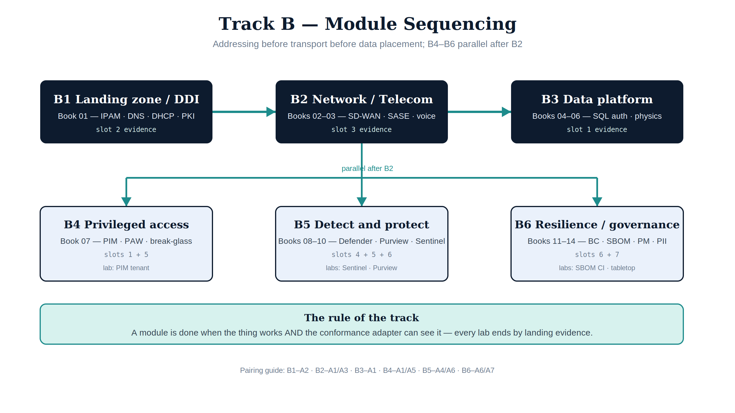
Figure 1 — Track B sequencing: B1 → B2 → B3 is a real dependency chain; B4–B6 run in parallel after B2. Every module ends by landing evidence.

Module B1 — Landing zone, IPAM & DDI (Book 01)
- Read: Book 01 (SSA Landing Zone, IPAM & FedRAMP).
- Build: the DDI core — authoritative IPAM, DNS, DHCP, and PKI issuance for the landing zone. The reference stack is Infoblox; the UIAO modernization adapters for BlueCat <https://github.com/WhalerMike/uiao/tree/main/src/uiao/adapters> and Infoblox cover directory migration into it.
- Lab: stand up (or simulate with fixtures) an IPAM inventory export and bind it as slot-02 addressing evidence — setup: DDI lab environment.
- Vendor training: Infoblox education, BlueCat learning, Microsoft AZ-700 (Azure networking for the landing-zone side) — see catalog §Networking & DDI.

Module B2 — Network & telecommunications modernization (Books 02–03)
- Read: Book 02 (SD-WAN, SASE, unified communications — Teams Phone, Amazon Connect) and Book 03 (Entra ID, ZTNA, active governance).
- Build: application-aware transport — SD-WAN path policy keyed to application identity, SASE enforcement, ZTNA in front of legacy telecom patterns.
- Lab: author one application-aware path policy and one ZTNA access policy; export the policy state and bind it as slot-03 network evidence.
- Vendor training: Cisco U / Networking Academy (SD-WAN), Microsoft SC-300 (Entra), AWS Skill Builder (Amazon Connect), Fortinet / Palo Alto (SASE) — see catalog §Networking & DDI and §Identity & zero trust.

Module B3 — Data platform modernization (Books 04–06)
- Read: Book 04 (SQL Server Authentication Modernization), Book 05 (SQL Server Implementation Guide — the runbook), Book 06 (Database Consolidation & Network Physics).
- Build: Entra-integrated SQL Server authentication (no SQL logins), then the consolidation architecture Book 06 derives from network physics (latency budgets, placement, failure domains).
- Lab: execute the Book 05 runbook against a lab instance; capture the authentication-mode evidence and bind it as slot-01 identity evidence.
- Vendor training: Microsoft DP-300, SQL Server security learning paths — see catalog §Data platform.

Module B4 — Privileged access (Book 07)
- Read: Book 07 (Privileged Access Management — Entra PIM + PAW).
- Build: role-activation workflows in PIM (eligibility, activation, approval, review) and the privileged-access-workstation tier model.
- Lab: configure one eligible role with activation approval + access review; export the PIM audit trail and bind it as slot-01/slot-05 evidence — setup: PIM lab environment.
- Vendor training: Microsoft SC-300, AZ-500; SANS privileged-access coursework — see catalog §Identity & zero trust.

Module B5 — Detect & protect (Books 08–10)
- Read: Book 08 (Vulnerability Management — Defender VM + KEV), Book 09 (Data Protection — Purview + Key Vault CMK), Book 10 (SIEM / XDR Detection — Sentinel).
- Build: the telemetry spine — Defender VM assessment with KEV prioritization; Purview sensitivity labeling + customer-managed keys; Sentinel analytics rules, incidents, and automation.
- Lab: one end-to-end detection: seed a vulnerable/exposed condition, watch it surface in Defender VM, alert in Sentinel, and close with an evidence export bound to slot-04 telemetry (and slot-06 for the configuration-drift angle) — setups: Sentinel lab and Purview lab.
- Vendor training: Microsoft SC-200 (Sentinel/Defender), SC-401 (Purview/information security), Splunk & Elastic for portable SIEM fundamentals — see catalog §Security operations.

Module B6 — Resilience & governance (Books 11–14)
- Read: Book 11 (Business Continuity), Book 12 (Supply Chain Risk Management), Book 13 (Program Management & Governance), Book 14 (PII Processing & Transparency).
- Build: the contingency architecture (alternate processing/storage, CP-4 test harness); the SBOM pipeline (Syft/Trivy-class generation, CycloneDX/SPDX VDR, VER submission flow for BOD 26-04); the PM governance charter artifacts; PII processing-transparency records.
- Lab: generate an SBOM for a real service, produce the VDR document, and bind it as slot-06 evidence; run one tabletop contingency test and bind the results as slot-07 continuity evidence.
- Vendor training: CISA Learning (incident/continuity), FedRAMP PMO materials (20x submission), OWASP/Linux Foundation SBOM resources — see catalog §Federal & compliance.

Capstone — one module, evidence-complete
Pick one module (B1–B6). Implement or lab-simulate it end-to-end, land the evidence where the slot mapping binds it, then regenerate the verdicts:
uiao ksi evaluate --ir ./output/ir/tenant.ir.json --out ./output/ksi/tenant.ksi.json
uiao oscal ksi-ar --output exports/oscal/ksi-ar.json
Completion means the Assessment Results show your module's slot verdict fed by your artifact — the same bar as UIAO_125's Operator track ("clean walker/drift run"), applied to the AAN vertical.

Sequencing note
B1 → B2 → B3 is a real dependency chain (addressing before transport before data placement). B4–B6 can run in parallel after B2. Track A modules can be interleaved freely; many teams pair each B-module with its A-module (B1↔A2, B2↔A1/A3, B3↔A1, B4↔A1/A5, B5↔A4/A6, B6↔A6/A7).

