AAN Training Program
Two-track curriculum over the 15-book Federal Application-Aware Networking series — compliance and implementation
Federal AAN Training Program — companion material for the federal AAN book series; not part of UIAO.
[IMPORTANT]

Not part of UIAO
The AAN book series and this training program are companion material for the federal vertical — they are not part of UIAO. The UIAO core is vertical-agnostic (ADR-085 <https://github.com/WhalerMike/uiao/blob/main/src/uiao/canon/adr/adr-085-universal-enterprise-positioning.md>); the AAN corpus is external federal-modernization content that UIAO's conformance tooling happens to consume as evidence. Nothing on these pages is UIAO canon, defines UIAO doctrine, or is scoped for a UIAO_NNN allocation. These pages are hosted here for convenience alongside the adapter that binds the books' evidence.
[NOTE]

Living program — expansion expected
This program is a research-driven living curriculum. It launches with the program charter, the two track outlines, and a first-pass vendor training catalog. As research continues, modules gain per-book lesson pages, labs, assessment rubrics, and additional vendor offerings. See Expansion roadmap.

What this program is
The Federal Application-Aware Networking (AAN) series is a 15-book corpus (Book 00 through Book 14) that documents a complete federal network modernization: landing zone and IPAM, network and telecommunications modernization, data-platform authentication, privileged access, vulnerability management, data protection, detection engineering, business continuity, supply-chain risk, program governance, and PII transparency. The books live in draft staging at inbox/Application Aware Networking/ <https://github.com/WhalerMike/uiao/tree/main/inbox/Application%20Aware%20Networking> and are bound to FedRAMP 20x evidence slots by the fedramp_aan_catalog adapter <https://github.com/WhalerMike/uiao/tree/main/src/uiao/adapters/fedramp_aan_catalog>.
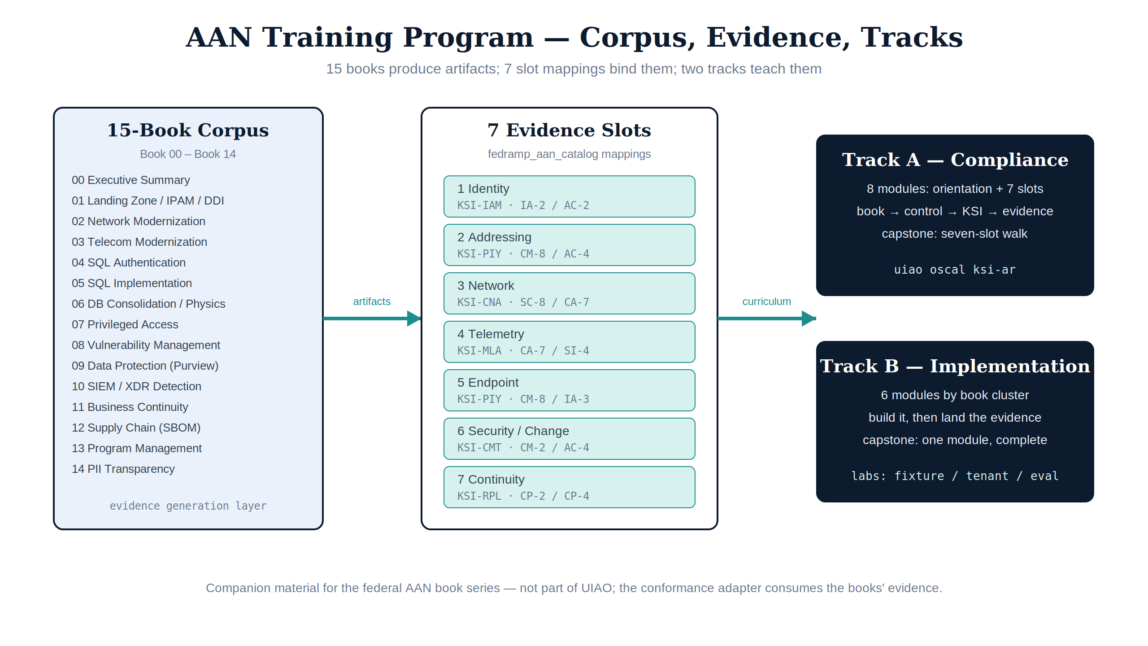
Figure 1 — The program at a glance: 15 books produce artifacts, seven slot mappings bind them as evidence, and two tracks teach the corpus.
The AAN Training Program teaches that corpus in two tracks:
Track | Page | Audience | Outcome
Track A — Compliance | Compliance track | ISSOs / ISSMs, assessors, ConMon operators, compliance leads | Can state, for each of the 15 books, which NIST SP 800-53 Rev 5 controls it closes, which FedRAMP 20x KSI category evaluates that closure, and how the evidence flows through the UIAO conformance pipeline
Track B — Implementation | Implementation track | Network, platform, database, identity, and security engineers | Can implement the architecture each book describes and produce the machine-readable evidence Track A consumes

A third page, the Vendor training catalog, maps each book to existing external training from the vendors whose products the books deploy (Microsoft, Infoblox, Cisco, AWS, and others), plus federal/compliance training sources (CISA, FedRAMP, NIST).

Relationship to UIAO
- This program is separate from UIAO_125 Training Program <https://github.com/WhalerMike/uiao/blob/main/src/uiao/canon/specs/program-training.md> (Contributor + Operator tracks). UIAO_125 teaches the UIAO substrate; this program teaches the federal AAN book series, which is not UIAO material. The only connection is mechanical: the fedramp_aan_catalog conformance adapter reads the books' artifacts as evidence, the same way UIAO adapters read any external vendor's output.
- Per ADR-085 <https://github.com/WhalerMike/uiao/blob/main/src/uiao/canon/adr/adr-085-universal-enterprise-positioning.md>, the UIAO core is vertical-agnostic. Describing this curriculum as part of UIAO would itself be a positioning bug under that ADR.
- The compliance backbone follows the Federal AAN / ConMon Compliance Gap Roadmap <https://github.com/WhalerMike/uiao/blob/main/inbox/Application%20Aware%20Networking/federal-aan-conmon-gap-roadmap.md> and the slot bindings in fedramp_aan_catalog/mappings/ <https://github.com/WhalerMike/uiao/tree/main/src/uiao/adapters/fedramp_aan_catalog/mappings>.
[WARNING]

Provenance status
The AAN books currently live under inbox/ — the repo's draft staging surface. They are external companion material, not UIAO canon, and are not on a canonization path. If the books move to their own home, the links below follow them. Treat control-closure counts as working figures from the gap roadmap, not attested facts.

The 15-book corpus
Each book now has a module page — objectives, key concepts, implementation sequence, compliance hooks, labs, pitfalls, and vendor training pointers, all derived from the book's actual content. The module page links to the canonical manuscript source.
Book | Module page | Domain | Evidence slot(s) | KSI category
00 | Executive Summary | Orientation | — | —
01 | SSA Landing Zone, IPAM & FedRAMP | DDI / IPAM landing zone | 2 — addressing | KSI-PIY
02 | Network Modernization | SD-WAN, SASE, UC | 3 — network | KSI-CNA
03 | Federal Telecommunications Modernization | Entra ID, ZTNA, cloud voice | 1 — identity | KSI-IAM
04 | SQL Server Authentication Modernization | Data-platform identity | 1 — identity | KSI-IAM
05 | SQL Server Implementation Guide | Data-platform runbook | (procedural evidence for Book 04) | —
06 | Database Consolidation & Network Physics | Database architecture | 3 — network | KSI-CNA
07 | Privileged Access Management | Entra PIM + PAW | 1 — identity; 5 — endpoint | KSI-IAM, KSI-PIY
08 | Vulnerability Management | Defender VM + KEV | 4 — telemetry; 5 — endpoint; 6 — security | KSI-MLA, KSI-PIY, KSI-CMT
09 | Data Protection (Purview) | Purview + Key Vault CMK | 4 — telemetry | KSI-MLA
10 | SIEM / XDR Detection | Sentinel detection engineering | 4 — telemetry; 6 — security | KSI-MLA, KSI-CMT
11 | Business Continuity | Contingency planning | 7 — continuity | KSI-RPL
12 | Supply Chain Risk Management | SBOM, VDR/VER, BOD 26-04 | 6 — security | KSI-CMT
13 | Program Management & Governance | PM charter | 6 — security | KSI-CMT
14 | PII Processing & Transparency | PT control family | 5 — endpoint | KSI-PIY

Slot definitions, KSI categories, and NIST anchors come from the adapter's mapping files <https://github.com/WhalerMike/uiao/tree/main/src/uiao/adapters/fedramp_aan_catalog/mappings> — the same data the conformance pipeline evaluates, so the curriculum cannot silently drift from the evidence model.

Program structure
- Orientation (both tracks) — read Book 00 and the gap roadmap <https://github.com/WhalerMike/uiao/blob/main/inbox/Application%20Aware%20Networking/federal-aan-conmon-gap-roadmap.md>; understand the FedRAMP 20x timeline (Class A opened August 2026; 20x mandatory January 2027; BOD 26-04 VDR/VER due December 7, 2026).
- Pick a track — Track A Compliance or Track B Implementation. The tracks share the corpus but read it differently: Track A reads books as control-closure evidence; Track B reads them as build instructions.
- Supplement with vendor training — each module points into the vendor training catalog for the underlying product skills (Entra, Sentinel, Purview, Infoblox DDI, SD-WAN, …).
- Capstone (both tracks) — produce or evaluate a KSI evidence bundle with the uiao CLI (uiao ksi evaluate, uiao oscal ksi-ar, uiao oscal generate) against the seven AAN evidence slots.
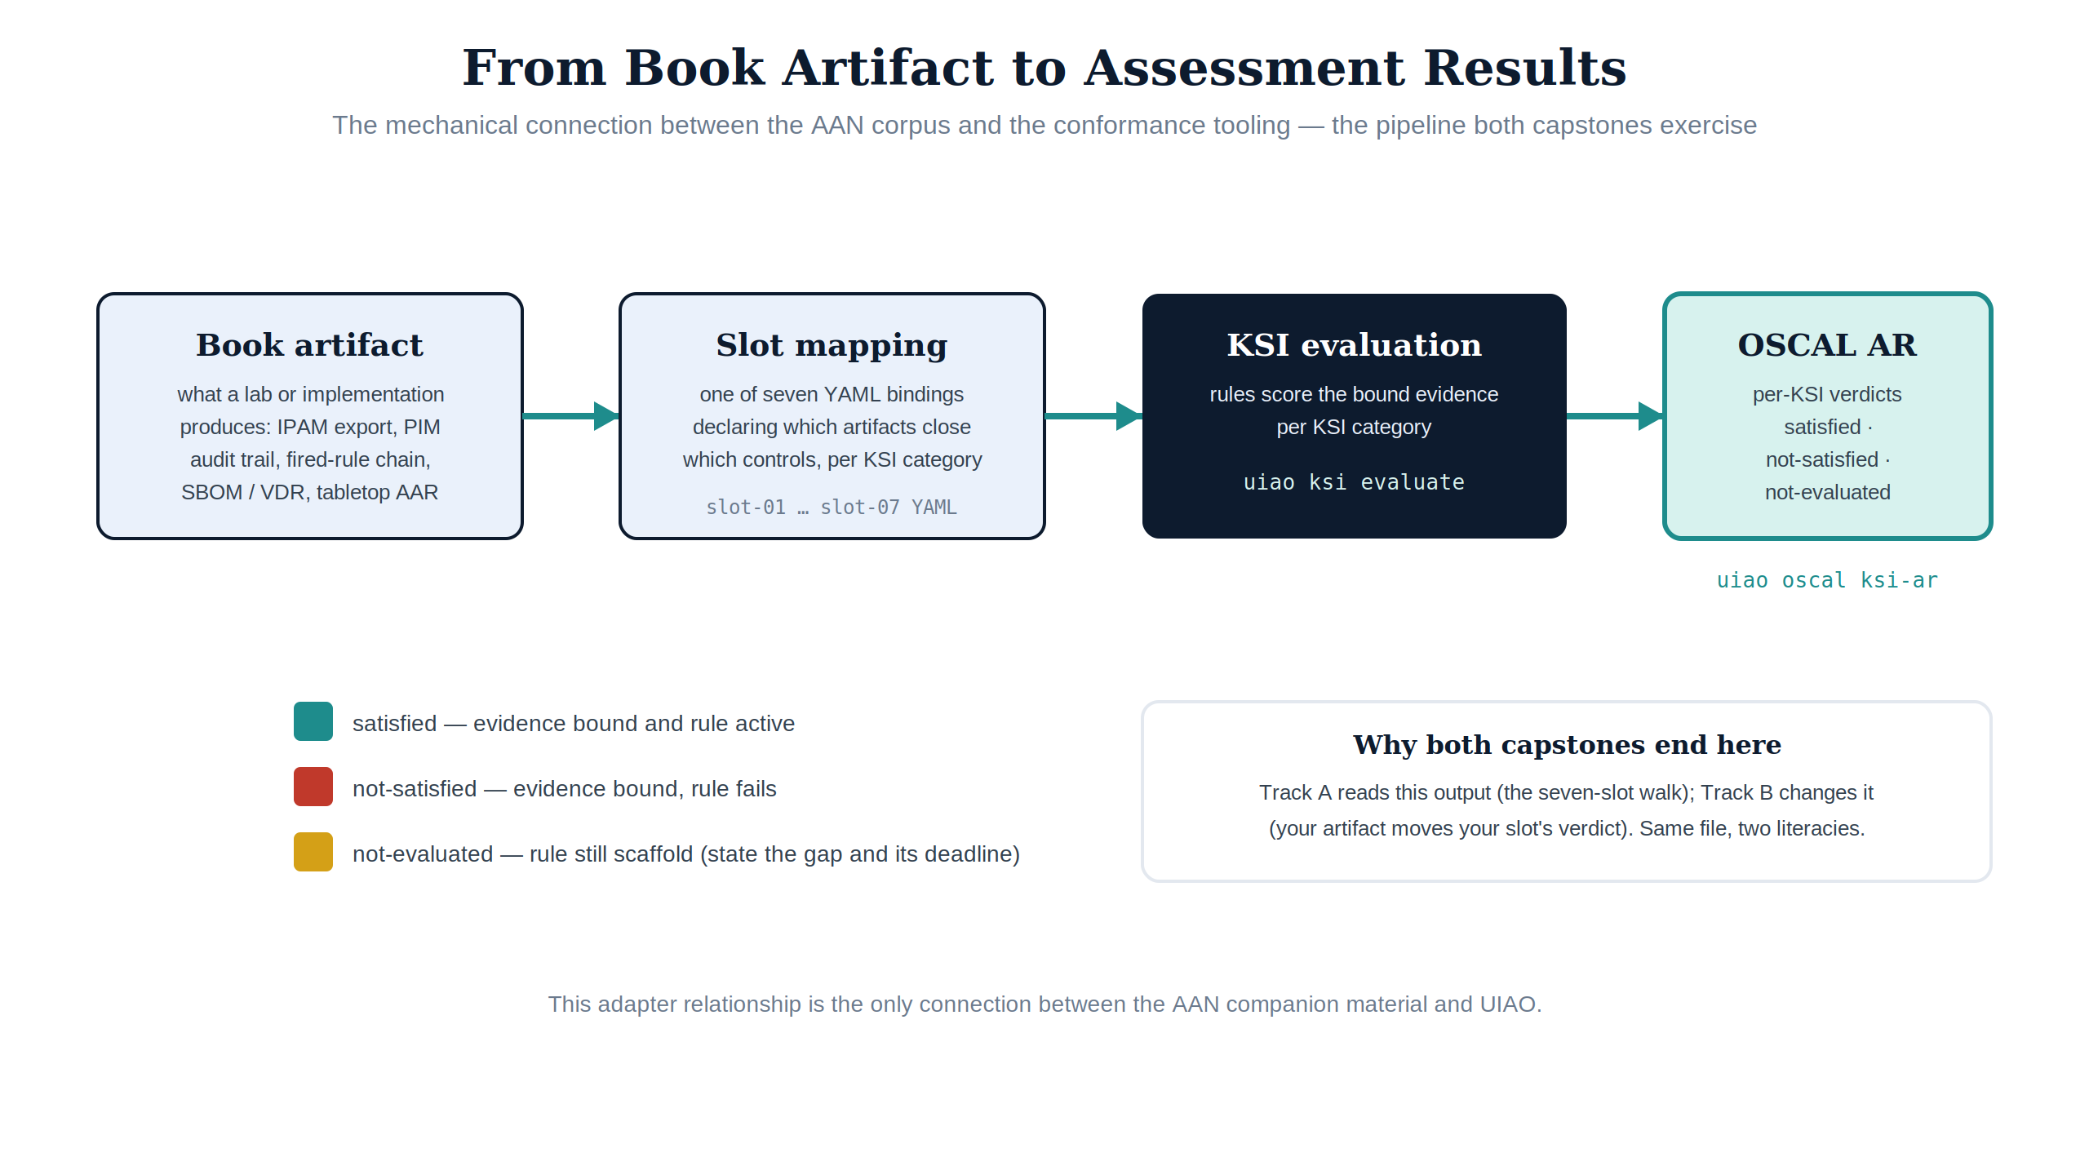
Figure 2 — The evidence flow both capstones exercise: a book artifact is bound by a slot mapping, evaluated against KSI rules, and lands as per-KSI verdicts in the OSCAL Assessment Results.

Completion criteria
Borrowing the pattern of UIAO_125 §4 (no parallel certification system), without being part of that program:
- Track A — a clean walk of all seven slot mappings: for each slot, name the books that feed it, the KSI category that evaluates it, and produce a uiao oscal ksi-ar run showing each KSI verdict (satisfied / not-satisfied / not-evaluated), with a short written gap statement for anything not yet evaluable.
- Track B — implement (or lab-simulate) one module end-to-end and land its evidence artifact where the slot mappings can bind it, verified by regenerating the KSI Assessment Results (uiao oscal ksi-ar) and seeing the slot's verdict reflect the new evidence.

Expansion roadmap
Planned growth as research continues (tracked in ordinary PRs against this directory):
- ✅ Per-book module pages — shipped: all 15 books have module pages (see the table above) with objectives, key concepts, implementation sequence, labs, and pitfalls derived from the manuscripts. Next iteration: reading checkpoints and quiz items.
- ✅ Vendor catalog verification — first research pass complete: the original research-queue vendors (Zscaler, Netskope, ServiceNow, Linux Foundation/OpenSSF, ISACA, IAPP, Tenable, Qualys) are now catalog rows with verified training-portal URLs.
- ✅ Lab environments — shipped: the lab hub with scripted setups for DDI (B1), PIM (B4), Sentinel (B5), and Purview (B5), tiered fixture / trial-tenant / product-eval. Next iteration: B2 SD-WAN eval-gear labs.
- ✅ Assessment rubrics — shipped: per-slot scoring sheets for the Track A capstone with a four-level scale and explicit pass bar.
- A permanent home — this material is not UIAO and will not be canonized as a UIAO_NNN spec; if the AAN corpus moves to its own repo/product, the program moves with it.

Next
- Compliance staff → Track A — Compliance track, scored by the assessment rubrics
- Engineers → Track B — Implementation track, with lab environments
- Everyone → Vendor training catalog

