FedRAMP 20x — Assessment & Implications for the GCC-Moderate Memo Series
Forward-looking note — companion to the GCC-Moderate Telemetry & Boundary Assessment
Document type | Assessment & forward-looking note
Scope | FedRAMP 20x Phase 2 Pilot — current as of FedRAMP docs
Relationship to prior memos | Companion update; prior findings remain valid
Authoritative source | https://www.fedramp.gov/docs/20x/

Headline. FedRAMP 20x is the modernization track that replaces the assessment method, not the assessment scope. Phase 2 Pilot is active — the requirements published at fedramp.gov/docs/20x/ are authoritative and labeled "Required (Phase 2 Pilot)." 20x does not by itself close the GCC-Moderate telemetry gaps documented in the prior memos — those remain Microsoft engineering decisions about commercial-cloud features — but it materially changes the federal framing in which agencies and CSPs operate, and gives the deterministic-telemetry subset of the gap matrix a cleaner home as machine-readable evidence.

1. What 20x is, in two pieces

1.1 Minimum Assessment Scope (the “what's in” rule)
Replaces the prior FedRAMP authorization-boundary construct with a two-pronged inclusion test. From the live documentation: providers must identify information resources that are “likely to handle federal customer data or likely to impact the confidentiality, integrity, or availability of federal customer data” (MAS-CSO-IIR). Resources that fail both prongs are out of scope. Metadata follows the same rule (MAS-CSO-MDI): metadata is in scope only when the underlying resource is in scope.
Why this matters for GCC-Moderate. Telemetry that is measurement-only and does not itself handle federal customer data — synthetic network path metrics, anonymized endpoint performance counters, fleet-wide patch posture rollups — has a credible path to descoping under MAS-CSO-MDI. Telemetry that handles federal customer data routinely (sign-in events, mailbox-access events, sensitivity-label content) does not.

1.2 Key Security Indicators (the “how it's measured” rule)
Eleven KSI families published at fedramp.gov/docs/20x/key-security-indicators/, each mapping to a control domain:
- Authorization by FedRAMP, Change Management, Cloud-Native Architecture, Cybersecurity Education, Identity and Access Management, Incident Response, Monitoring/Logging/Auditing, Policy and Inventory, Recovery Planning, Service Configuration, Supply Chain Risk.
KSIs sit above NIST 800-53 — they map to control families, but the artifact a CSP produces is a machine-readable, continuously-validated evidence payload rather than an SSP narrative. Compliance shifts from periodic-document-attesting toward continuous-evidence-emitting.

1.3 Where 20x lives today
Three deployment surfaces relevant to the GCC-Moderate conversation:
- Phase 2 Pilot — Required. Authoritative requirements at fedramp.gov/docs/20x/ for participants in the Moderate pilot.
- Rev5 Balance Improvement Releases — Optional. Minimum Assessment Scope, Significant Change Notifications, Authorization Data Sharing, Vulnerability Detection and Response, and Collaborative Continuous Monitoring are all available as opt-in updates to existing Rev5-authorized packages without going through full 20x. This is the most likely near-term path for currently-authorized CSPs to adopt the new scope rule.
- Phase 1 Pilot — archived. Documents under fedramp.gov/docs/20x/phase1/ are reference-only. Note that Phase 1's “Minimum Assessment Standard” is the predecessor to the current “Minimum Assessment Scope” — same two-prong concept, different name and refined language.
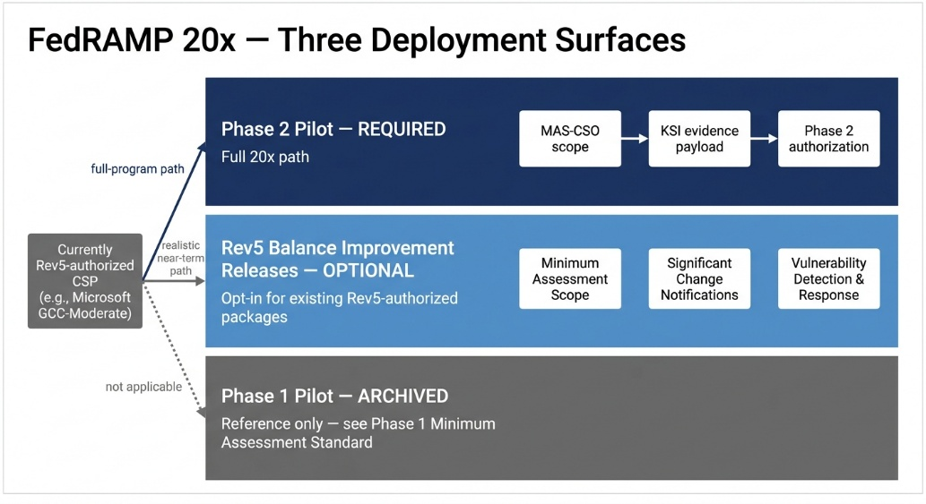
Figure 1

2. Effect on the GCC-Moderate telemetry gap inventory
Mapping the live Minimum Assessment Scope rule against the documented gap matrix, by signal class:
Signal class | Net effect | Reasoning
Network path metrics (latency / jitter / packet-loss; INR-style) | Favorable | Measurement-only, machine-generated, no federal customer data. Strong case as descoped metadata under MAS-CSO-MDI.
Endpoint performance counters (boot time, AppCrashCount, AvgProcessorUsage) | Favorable, with caveats | Anonymized perf data fits the deterministic-telemetry framing. Per-user-identified perf data approaches the “likely impact” line and may not.
Adoption Score behavioral baselines (chat/email ratios, mobility, content collaboration) | Mixed to unfavorable | User-behavior signals tied to identifiable communication. “Likely impact CIA of federal customer data” reads in.
Entra Identity Protection ML (impossible travel, atypical IP, leaked credentials) | Unfavorable | Sign-in events handle federal customer data by routine — fail prong (1) directly.
DLP behavioral analytics, sensitivity-label analytics, Copilot prompt richness | Unfavorable | Content-adjacent and policy-event-bearing — fail prong (1).
CAE real-time revocation paths | Neutral | Not a scope problem; a cross-boundary signaling architecture problem. 20x does not address.
Net. MAS-CSO-IIR plus MAS-CSO-MDI plausibly opens a path for roughly 30–40% of the prior gap matrix — the deterministic, measurement-only end. It does not close the identity / data / behavioral end where prong (1) reads in obviously. The boundary problem is necessary-but-not-sufficiently addressed.
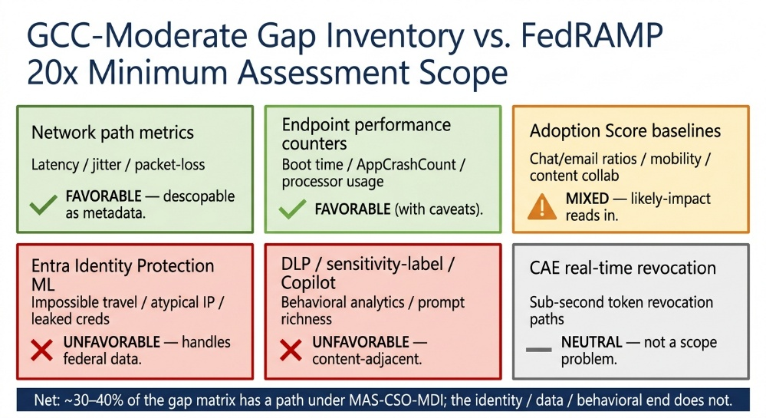
Figure 2

3. Three caveats before treating this as a remedy
- The standard does not use the word “telemetry.” MAS-CSO uses “information resources” and “metadata.” Whether a given telemetry stream qualifies as descoped metadata is a 3PAO interpretation, not a documented carve-out. Commenters raised this during the public comment period; the standard was finalized without explicit telemetry language.
- The “likely” test is intentionally broad. FedRAMP's published definition of “likely” is open to assessor judgment. The same signal could be in-scope for one CSP and out-of-scope for another. Interpretation drift across 3PAOs is a primary risk.
- The CSP side has to act. MAS-CSO does not by itself cause Microsoft to ship Adoption Score, INR, or Endpoint Analytics Advanced into GCC-Moderate. It removes one of the formal obstacles to doing so under the Rev5 optional path; it does not motivate the engineering work.

4. Forward-looking note for the GCC-Moderate memo series
The two prior memos (the combined GCC-Moderate Telemetry & Boundary Assessment, and the ThousandEyes Workaround Analysis) do not need to be rewritten. They benefit from one paragraph of context.
Suggested addition. FedRAMP 20x Phase 2 Pilot (active) and the Rev5 Balance Improvement Release for Minimum Assessment Scope (optional, available to existing Rev5-authorized packages) together provide a federal mechanism for descoping deterministic, measurement-only telemetry — including the network-path-metric class addressed by ThousandEyes — from the FedRAMP authorization boundary. This is favorable for the Networks pillar and the deterministic-telemetry subset of the Devices pillar. It does not, on its own authority, close the Identity, Data, or behavioral-analytics gaps; those remain CSP-roadmap items dependent on Microsoft engineering decisions.

5. Bottom line
20x is the federal ratification of continuous, evidence-based authorization. The boundary fight that defined the prior assessments is being replaced — not by removing the boundary, but by narrowing what counts as inside it (Minimum Assessment Scope) and changing the artifact a CSP produces to demonstrate compliance (Key Security Indicators). The strategic argument the prior memos made — that controls protecting federal information were creating an observability shadow zone — now has top cover from the FedRAMP framework itself.
What this changes operationally for an agency in GCC-Moderate today: very little until Microsoft files a 20x-aligned package or opts into the Rev5 Balance Improvement Releases for the GCC-Moderate offering. What it changes strategically: the negotiation surface. Agency requests for descoped telemetry now have a named, documented mechanism to point at.
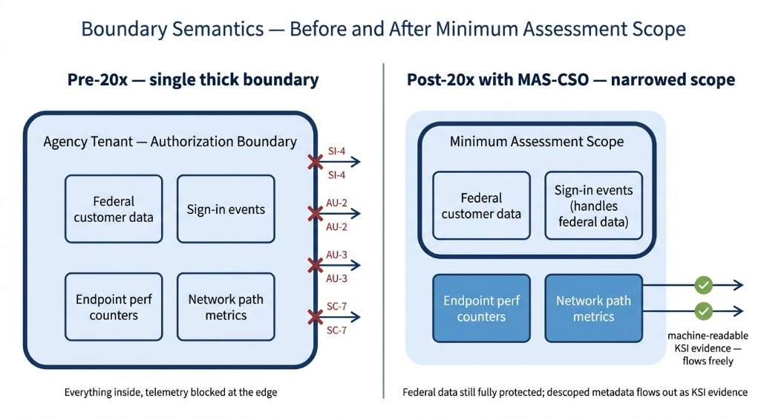
Figure 3

6. Authoritative references
- FedRAMP 20x — index of Phase 2 Pilot requirements: https://www.fedramp.gov/docs/20x/
- Minimum Assessment Scope — MAS-CSO-IIR, MAS-CSO-FLO, MAS-CSO-TPR, MAS-CSO-MDI, MAS-CSO-SUP: https://www.fedramp.gov/docs/20x/minimum-assessment-scope/
- Key Security Indicators — eleven families and their mappings: https://www.fedramp.gov/docs/20x/key-security-indicators/
- Rev5 Balance Improvement Releases — Optional opt-in path for existing Rev5 packages: https://www.fedramp.gov/docs/rev5/balance/
- M-24-15 — OMB memorandum providing the policy basis for the modernization: https://www.fedramp.gov/docs/authority/m-24-15/
- FedRAMP Authorization Act — statutory basis: https://www.fedramp.gov/docs/authority/law/

