GCC-Moderate Boundary Assessment & ThousandEyes Workaround Analysis
External assessment memo — no build steps proposed
Document type: Assessment memo
Scope: FedRAMP Moderate (M365 GCC-Moderate, Intune, Azure)
Date: April 26, 2026

This memo answers three questions about the feasibility of a live boundary assessment of GCC-Moderate environments and the suitability of Cisco ThousandEyes as a workaround for known telemetry gaps in those environments. The analysis distinguishes between what can be directly observed in a tenant under FedRAMP Moderate authorization and what must be reasoned from architecture and Microsoft documentation. No build steps are proposed.

1. Can a live GCC-Moderate boundary assessment cover M365, Intune, and Azure?
Yes — but with three different boundary postures that must not be conflated. A live assessment lets you convert architectural inference into directly observed evidence for availability questions, even though it cannot fully measure the fidelity loss in services that are present but operate with reduced telemetry.
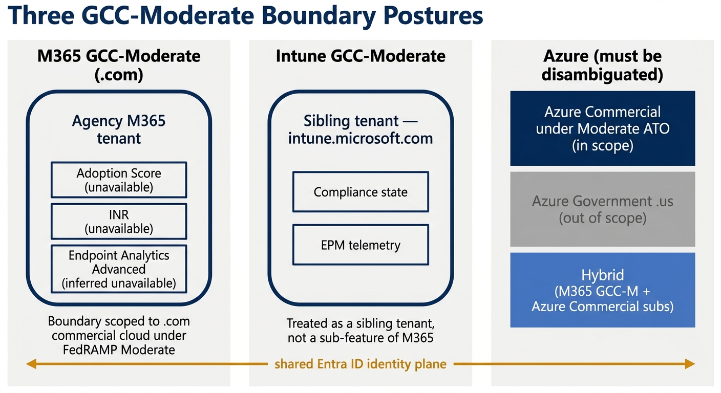
Figure 1. Three GCC-Moderate boundary postures — M365 GCC-Moderate (.com) on the left, Intune GCC-Moderate as a sibling tenant in the middle, and the three Azure variants (Azure Commercial under a Moderate ATO, Azure Government .us out of scope, hybrid bridging both) on the right. Trust edges and shared-identity-plane crossings are highlighted.

1.1 M365 GCC-Moderate (.com)
This is the boundary the assessment is scoped to. A live walkthrough can directly verify each architectural finding through the following checks:
- Microsoft 365 Admin Center → Adoption Score: expect the explicit “not available” banner, which confirms that Adoption Score is unavailable.
- Attempting Informed Network Routing (INR) enablement in Teams or the M365 Admin Center: expect the feature surface to be absent, which confirms INR is unavailable.
- Intune → Reports → Endpoint Analytics → Advanced Analytics: expect a 403 or “not available in your region” response, which would convert Endpoint Analytics Advanced from inferred to confirmed unavailability.
- Sentinel KQL queries to validate diagnostic-setting completeness against a dashboard-completeness scorecard.
- Reading the xms_cc claim presence in issued tokens to confirm whether Continuous Access Evaluation (CAE) is at least negotiated.
Required access (read-only): Global Reader, Security Reader, Reports Reader, Compliance Administrator, and Log Analytics Reader. No write access is needed for assessment.

1.2 Intune (GCC-Moderate)
Intune should be assessed as a sibling tenant, not as a sub-feature of M365. Live tests:
- Verify the intune.microsoft.com tenant URL surface — confirms tenant class.
- Run Get-MgDeviceManagement Graph queries to enumerate which advanced-analytics endpoints actually return data versus 404.
- Inspect Data Collection Rules (DCRs) for any Win32 detection-event filtering that would suppress endpoint signals before they reach Sentinel.

1.3 Azure
This is the area requiring the most up-front scoping clarity. Before assessment, “Azure” must be disambiguated:
- Azure Commercial under a FedRAMP Moderate ATO — the most common pairing with GCC-Moderate M365. Assess via Defender for Cloud → Regulatory Compliance → FedRAMP Moderate built-in initiative, plus subscription-scope Policy assignments enforcing US-only regions, private endpoints, and in-boundary diagnostic-export destinations.
- Azure Government (.us) — out of scope for a FedRAMP Moderate-only purity rule; findings here cannot be imported into a Moderate-only authorization boundary.
- Hybrid (M365 GCC-Moderate plus Azure Commercial workload subscriptions) — boundary diagrams must show the trust edge between the two, particularly for Entra ID (the same identity plane) and for log shipping into Sentinel workspaces (workspace residency matters).

1.4 Assessment limit
Live access converts inference to evidence for availability questions. It does not by itself measure the fidelity loss across the telemetry-gap matrix; that requires either a side-by-side commercial-tenant comparison (which most agencies cannot legally stand up) or modeled estimates that are explicitly labeled as such.

2. Does ThousandEyes provide a real way around the missing telemetry?
Partially, and only for one pillar. The matrix below pairs ThousandEyes capability against the telemetry-gap areas identified in the assessment.
Telemetry gap area | Can ThousandEyes substitute?
INR real-time path metrics (latency / jitter / packet loss to M365 front doors) | Yes — closest thing to a real substitute. Synthetic, not per-user-session, but genuine network measurement from Cloud + Enterprise + Endpoint Agents.
MITM / BGP hijack / DNS manipulation | Yes — strong fit. BGP route monitoring, DNS tests, and certificate-validation tests are flagship ThousandEyes use cases.
Teams CQD network-quality dimension | Partial. The Microsoft Teams test type gives synthetic call-quality baselines. Does not recover the EUII (BSSID, public IP, subnet) that makes up the forensic-attribution gap.
M365 service availability / performance | Yes. Endpoint and HTTP server tests cover this well.
Adoption Score (communication, collaboration, mobility patterns) | No. User-behavior signals; not a network problem.
Endpoint Analytics Advanced (boot time, app crashes, AppCrashCount, AvgProcessorUsage, performance outliers) | No. The Endpoint Agent collects local network telemetry, not Windows kernel or performance counters.
Entra Identity Protection ML signals (impossible travel, atypical IP, leaked credentials) | No. Identity-data problem.
Continuous Access Evaluation sub-second revocation | No. Token-state problem.
Intune EPM, app-protection, Windows Update for Business trend telemetry | No. Endpoint policy and state events.
DLP behavioral / sensitivity-label / Copilot telemetry | No. Content and policy-event problem.
MailItemsAccessed, SearchQueryInitiated, unified audit gaps | No. SaaS audit events.

2.1 Net assessment
ThousandEyes meaningfully addresses the Networks pillar and the BGP / DNS / MITM attack-detection chain. It contributes nothing to the Identity, Devices, Data, or Applications & Workloads pillars, which together account for the majority of the gap findings. Characterizing ThousandEyes as a general workaround for the missing telemetry overstates by roughly an order of magnitude — it closes approximately one of the seven Zero Trust Maturity Model pillars.
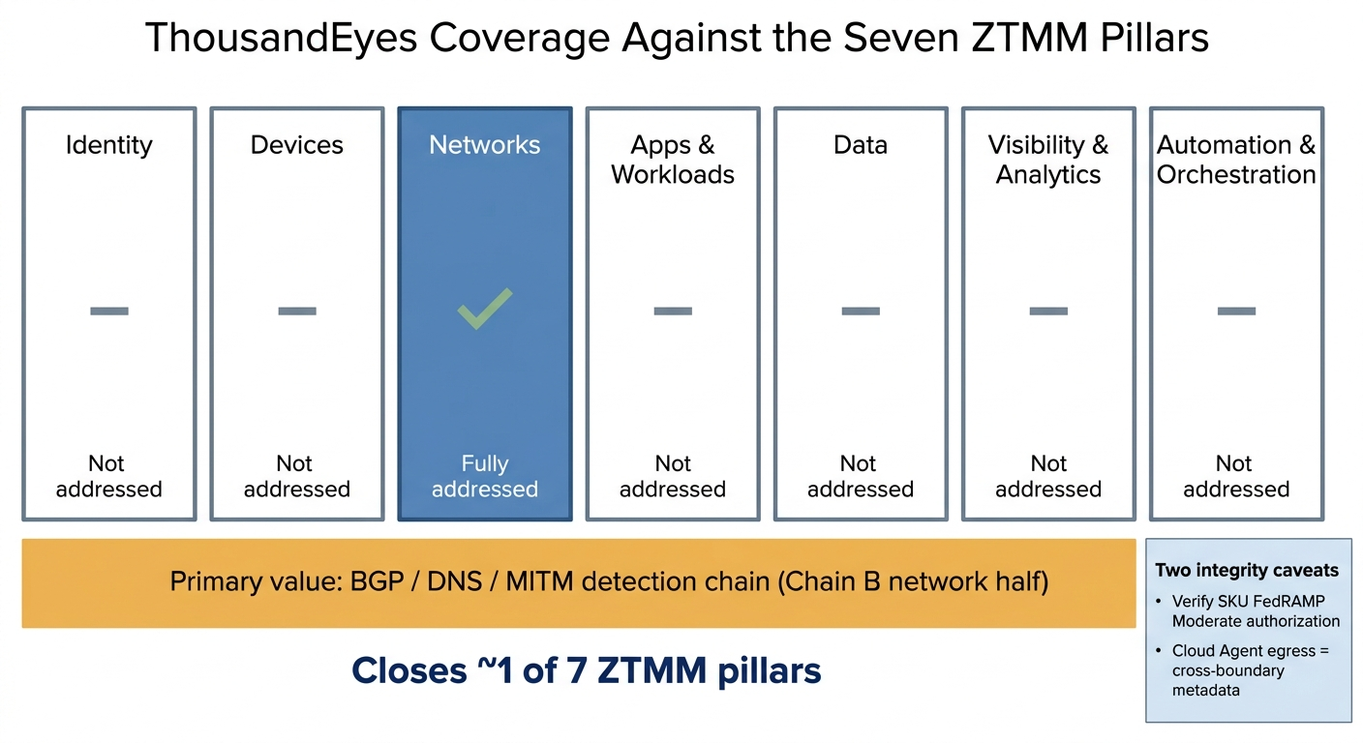
Figure 2. ThousandEyes pillar coverage against the seven CISA ZTMM pillars — Networks shaded as fully addressed, the BGP / DNS / MITM detection chain noted as the primary value, and Identity, Devices, Data, Applications & Workloads, Visibility & Analytics, and Automation & Orchestration left visibly unaddressed. The visual makes the “one of seven” framing immediately legible.

2.2 Two integrity caveats before any procurement conversation
- FedRAMP authorization. ThousandEyes' FedRAMP authorization status must be verified on the FedRAMP Marketplace at the Moderate baseline for the specific SKU being purchased. This memo does not cite a current Marketplace status; doing so without verification would be unsound. If the SKU is not Moderate-authorized, ingesting its data into the agency's boundary creates an SC-7 and supply-chain inheritance question that defeats the purpose.
- Cloud Agent egress. Cloud Agent measurements traverse the public Internet from non-agency endpoints. Synthetic-probe metadata (source IPs, paths, timing) should be treated as cross-boundary egress for assessment purposes, not as a free signal.

3. At what cost?
Five cost dimensions, presented in descending order of practical impact on agency programs.

3.1 Opportunity cost (highest)
Spending the next budget cycle deploying ThousandEyes can create the appearance of closing the telemetry gap while the Identity, Devices, and Data pillars — where the most consequential compound-attack risks actually live — go unaddressed. The cross-cutting MITRE ATT&CK chains identified in the assessment require both network observability and identity, endpoint, and data analytics; ThousandEyes addresses the network portion of one chain and none of the identity-driven chain.

3.2 ATO scope and authorization
Verifying SKU FedRAMP status, inserting the service into the System Security Plan, updating boundary diagrams, and 3PAO impact analysis typically take three to six months of governance work before ingest can begin. This is non-trivial even when the underlying technology is straightforward.

3.3 Licensing
Cisco does not publish list pricing for ThousandEyes. Agencies should expect quote-based pricing with units for Cloud Agents, Enterprise Agents (per agent or appliance), Endpoint Agents (per seat), and BGP Monitors. This memo deliberately does not cite a number; any figure produced from training data would be stale and unverifiable. The order of magnitude should be treated as a meaningful annual line item rather than a rounding error, and a fresh GSA or SEWP quote should be required.

3.4 Deployment and integration
Enterprise Agent placement at each agency site (VM or appliance), Endpoint Agent push via Intune, and OpenTelemetry or API integration into Sentinel for correlation with existing detection content together represent roughly four to eight weeks of engineering for a multi-site agency, plus ongoing baseline tuning.

3.5 SOC operating load
Synthetic monitoring generates its own alert volume. Without analyst time to triage, baseline, and suppress, it adds noise without adding detection. Budget 0.25–0.5 FTE on an ongoing basis for a meaningful deployment.

4. Bottom line
A live GCC-Moderate boundary assessment can be performed across M365, Intune, and Azure — and would let most architecturally-inferred findings be flipped to directly observed evidence — provided “Azure” is first disambiguated (Commercial-under-Moderate-ATO versus Government versus hybrid).
ThousandEyes is a legitimate but narrow answer. It materially closes the Networks pillar and the BGP, DNS, and MITM detection gap, and it addresses none of the Identity, Devices, Data, Applications & Workloads, or audit-retention gaps that drive the assessment's headline findings. Buying ThousandEyes as a general telemetry workaround would mis-spend against the actual risk surface; buying it explicitly as a Networks-pillar component of a broader compensating-architecture stack is defensible — provided FedRAMP Moderate authorization of the specific SKU is verified before ingest.

