UIAO

Unified Identity-Addressing-Overlay

What if your agency never had to manually prove compliance again?

Executive Brief • April 2026

The Problem
Every federal agency running Microsoft 365 in GCC-Moderate faces the same grind. A new CISA directive lands. A FedRAMP control needs evidence. An auditor asks for proof that a policy is actually enforced—not just documented. And what happens? Someone opens a spreadsheet. Someone else writes a memo. A third person screenshots a config panel and pastes it into a Word doc. Weeks later, an artifact package gets stapled together and sent up the chain.

Meanwhile, the environment has already drifted. The policy that was compliant last Tuesday got changed on Thursday. Nobody noticed until the next quarterly review—if they noticed at all.
This is not a technology problem. Agencies have the tools. The problem is that compliance is treated as a paperwork exercise instead of an engineering discipline. The result: months of labor, millions of dollars, and a compliance posture that is stale before the ink dries.
The average federal agency spends 12–18 months producing a FedRAMP authorization package. Most of that time is not spent securing systems. It is spent proving they are secure.

What UIAO Does About It
UIAO is a software platform—not a document, not a consulting engagement, not a dashboard that shows you what went wrong last quarter. It is a working engine that continuously monitors your Microsoft 365 environment, evaluates every configuration against the controls that actually apply to you, and produces machine-readable compliance evidence in real time.
In plain terms: UIAO watches your environment 24/7, checks it against 247 FedRAMP Moderate Rev 5 controls, and when something drifts out of compliance, it knows within two minutes. Not two weeks. Not next quarter. Two minutes.
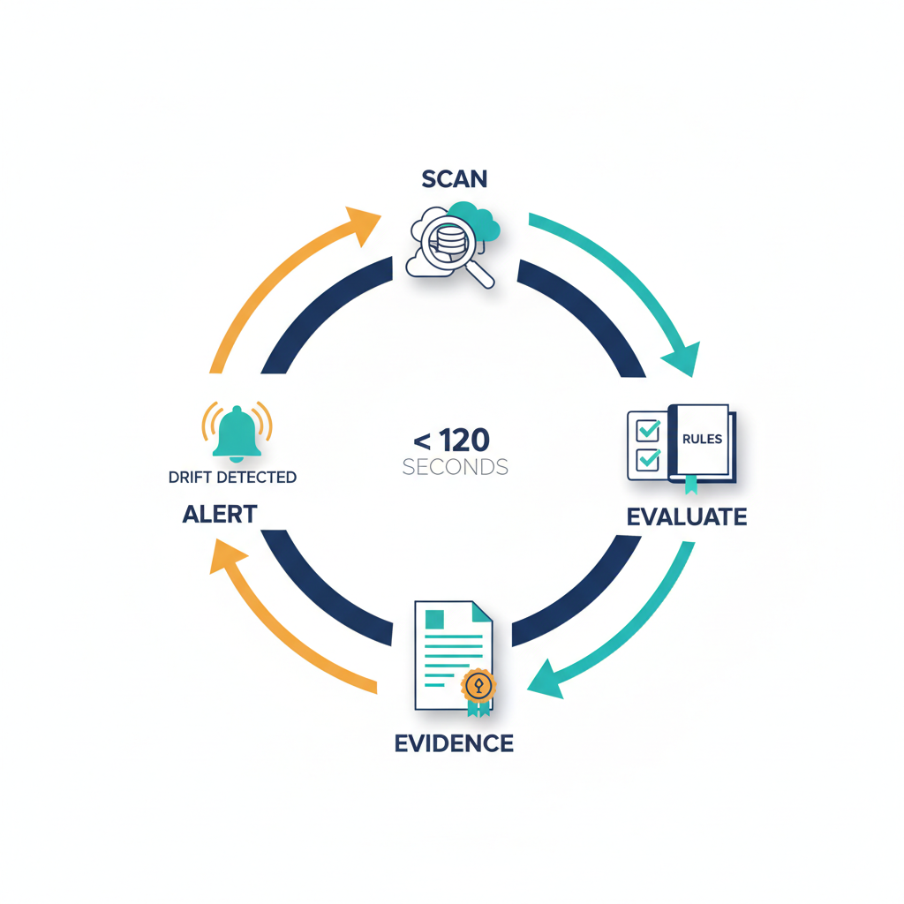
It does not stop at detection. UIAO generates the actual artifacts auditors need—System Security Plans, Plans of Action & Milestones, OSCAL profiles, CycloneDX software bills of materials—all produced automatically from the live state of your environment, signed with cryptographic evidence that proves they have not been tampered with.
Think of it this way: UIAO replaces the binder with a living system. Your compliance posture is not a document you update once a year. It is a measurement you can read at any moment.

The Effort, Time, and Money Conversation
Here is what agencies spend today, and what changes with UIAO:
 | Without UIAO | With UIAO
FedRAMP package timeline | 12–18 months | Continuous (always current)
Drift detection | Quarterly review (if lucky) | < 120 seconds
Evidence collection | Manual screenshots & spreadsheets | Automated, cryptographically signed
Audit prep labor | Hundreds of staff-hours per cycle | Near-zero: artifacts are always ready
Cost of a missed finding | Remediation + re-audit + delay | Caught and flagged in real time

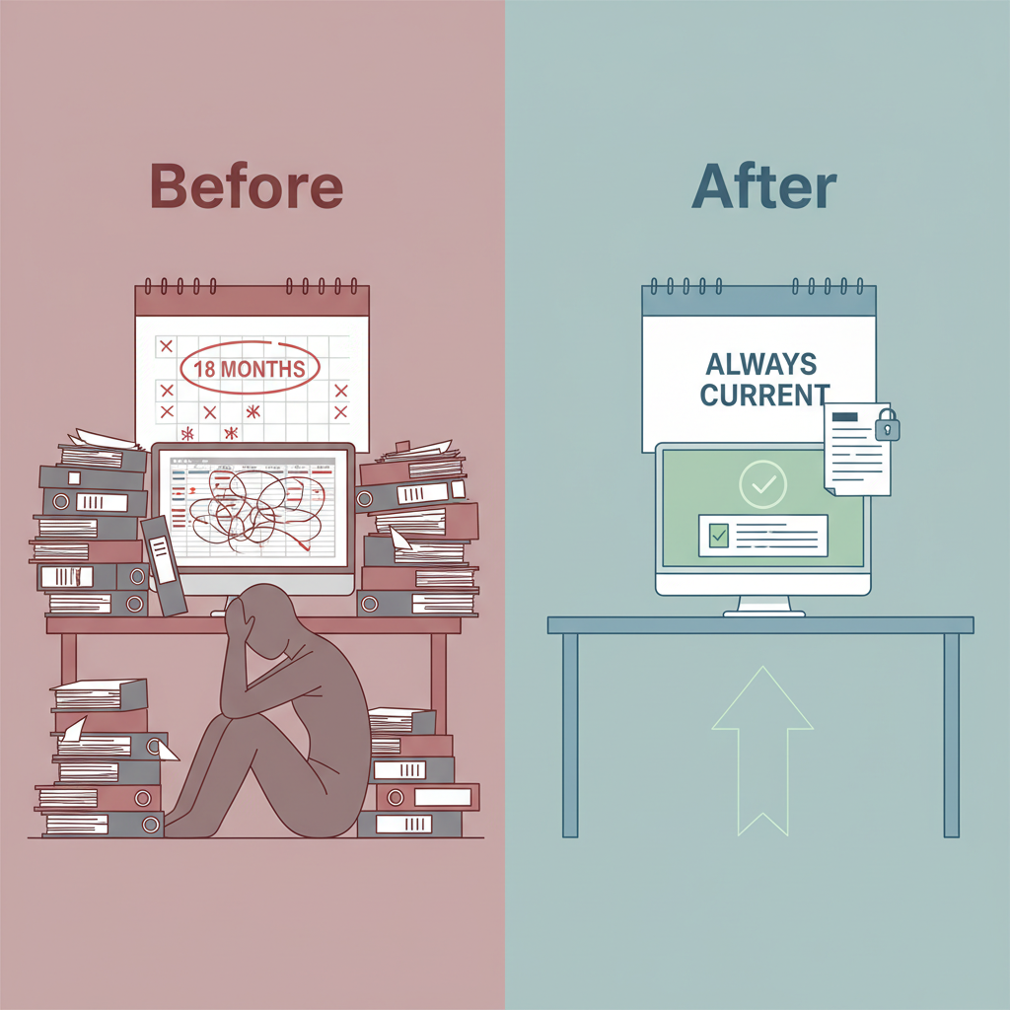
The single largest cost in federal compliance is not technology—it is labor. Staff spend months collecting evidence, cross-referencing controls, writing narratives, and assembling packages that are outdated before they are submitted. UIAO eliminates that entire category of work. The evidence is always there. The artifacts are always current. The auditor can look at the system and see the truth, not a summary someone wrote three months ago.

How It Works (Without the Jargon)
UIAO connects to your Microsoft 365 GCC-Moderate tenant and reads the configuration state of your environment—Exchange Online, SharePoint, Teams, Entra ID, Defender, Intune, and the rest of the M365 suite. It does this continuously, not on a schedule.
It then evaluates what it sees against three layers of rules:
First, the FedRAMP Moderate Rev 5 baseline—all 247 controls (163 base controls plus 84 enhancements). Second, the CISA SCuBA benchmarks and BOD 25-01 directives that apply to your tenant. Third, your own organizational policies—the things that are specific to your agency and your mission.
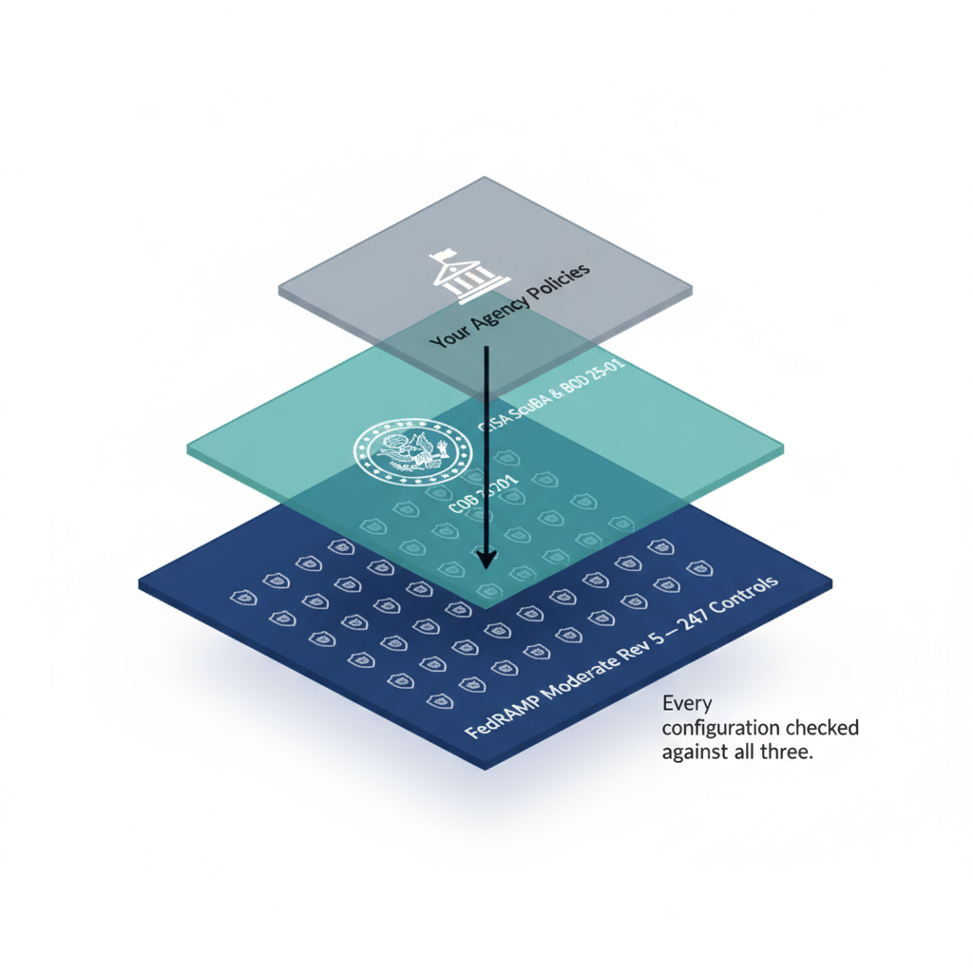
When a configuration matches what it should be, UIAO records that as evidence and moves on. When something does not match, UIAO flags it, categorizes the severity, identifies which controls are affected, and makes that information available immediately—to your security team, to your compliance officers, and to your leadership dashboard.
All of this evidence—every check, every result, every timestamp—is stored in an immutable chain with cryptographic signatures. It cannot be altered after the fact. When an auditor asks "how do you know this was true on March 15th?"—you hand them a signed record, not a screenshot.
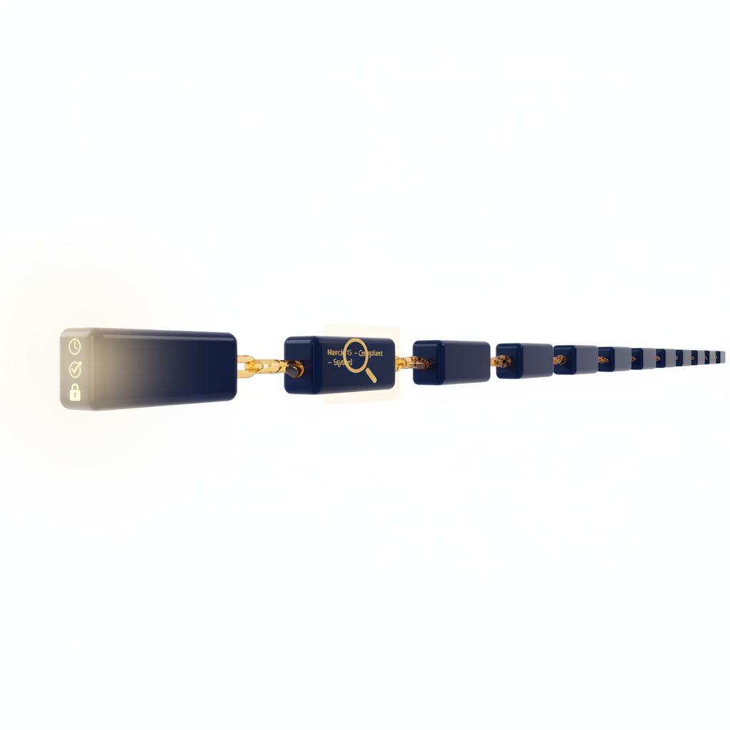

What Makes This Different
There are plenty of compliance dashboards on the market. Most of them show you the current state of something and call it a day. UIAO is different in three specific ways:
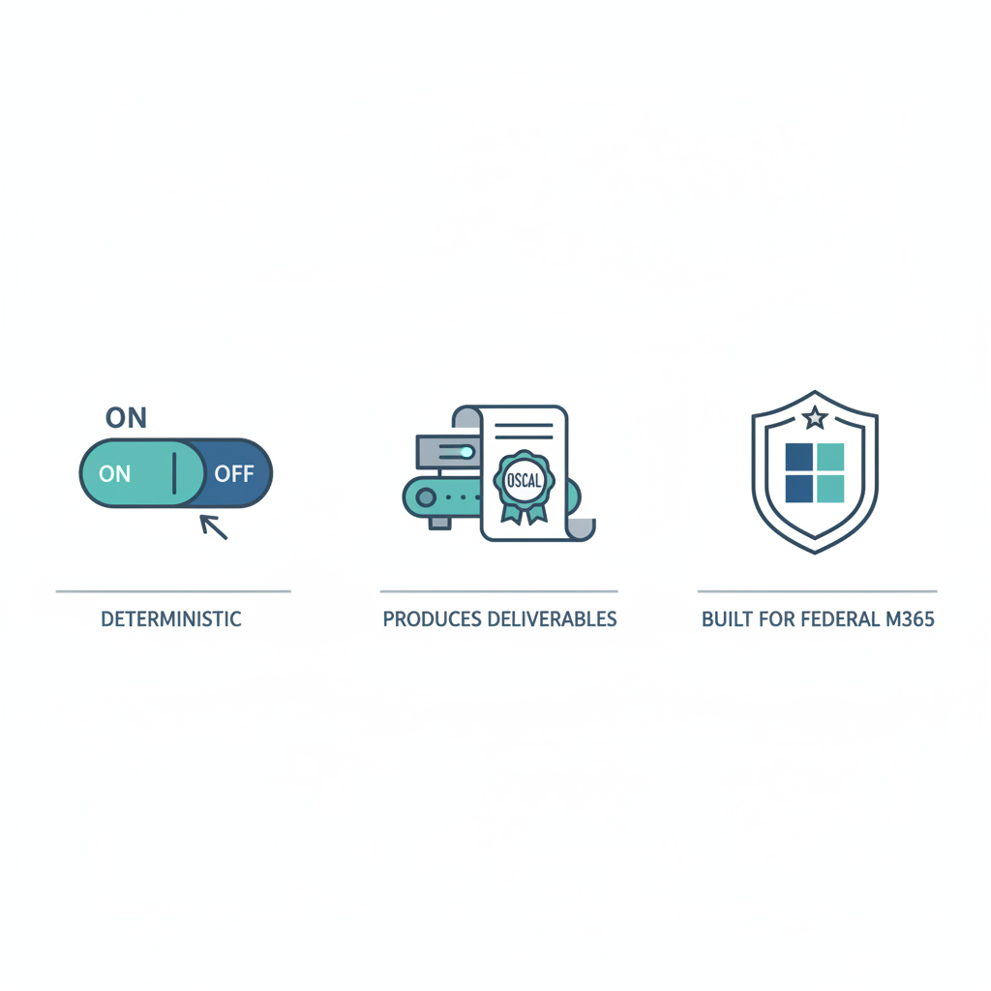
It is deterministic. UIAO does not use sampling, estimation, or spot checks. Every control is evaluated against the actual environment state. The answer is always "compliant" or "not compliant"—never "probably" or "as of last quarter."
It produces the actual deliverables. UIAO does not just tell you what is wrong and leave you to write the report. It generates OSCAL-native System Security Plans, Plans of Action and Milestones, and component inventories in the formats that FedRAMP and CISA actually accept. The paperwork writes itself.
It is built for federal M365 specifically. This is not a general-purpose cloud security scanner that has been bolted onto GCC-Moderate. The entire adapter layer, the control mappings, the evidence chain—all of it was designed from the ground up for the federal M365 ecosystem and its unique constraints.

What We Need From Leadership
UIAO is not a proposal on a whiteboard. The platform exists. The codebase is built. The adapters for Exchange, SharePoint, Teams, Entra ID, Defender, and Intune are written. The KSI evaluation engine runs. The evidence fabric records and signs. What is needed now is the organizational decision to deploy it.
Specifically, we are asking for three things:
1. Authorization to connect UIAO to a GCC-Moderate tenant for a 90-day pilot.
2. A designated compliance team to validate UIAO outputs against their existing manual process, side by side.
3. An executive sponsor to champion the results through the authorization chain.
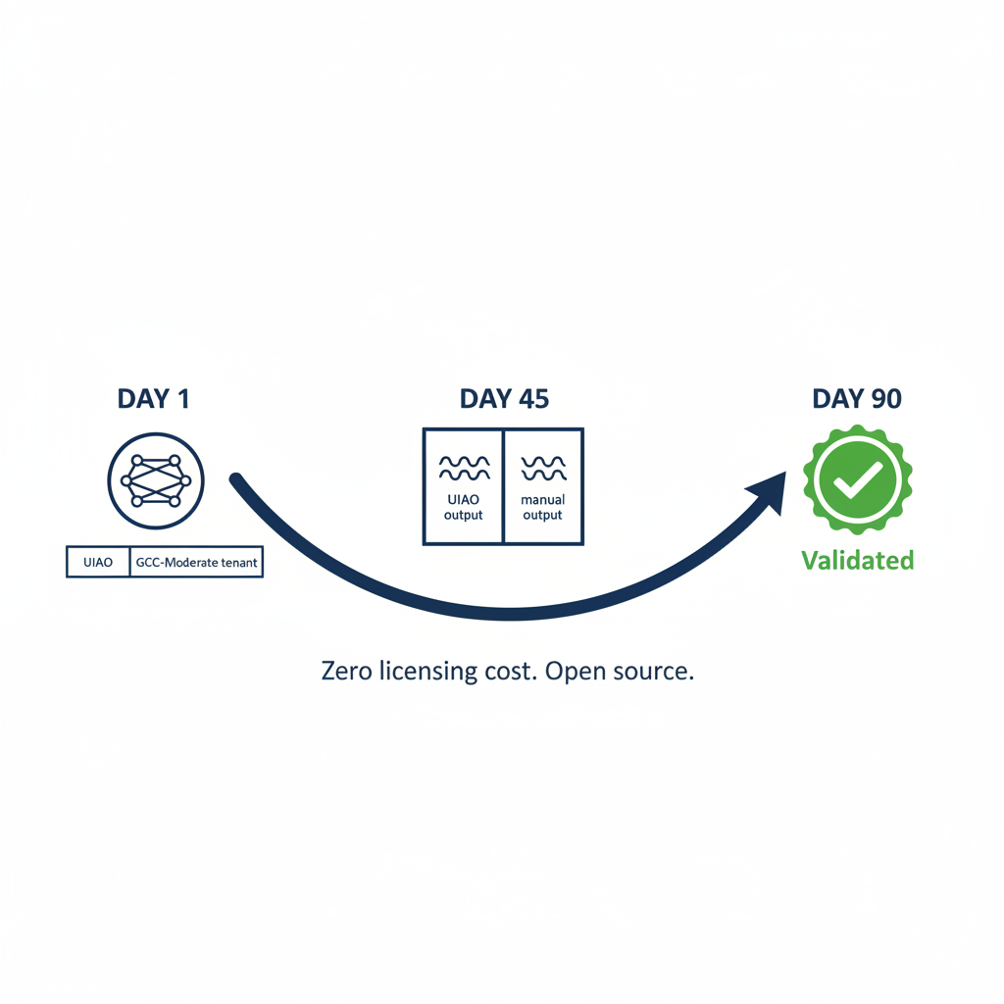
The pilot costs nothing in licensing—UIAO is open source. The investment is staff time to validate the outputs. If the platform does what we say it does, your team will know within 90 days. If it does not, you will have lost nothing but a few hours of evaluation.

UIAO Modernization Program
Generated: 2026-04-12 21:11 UTC • Canonical Source: uiao-core/VISION.md

