


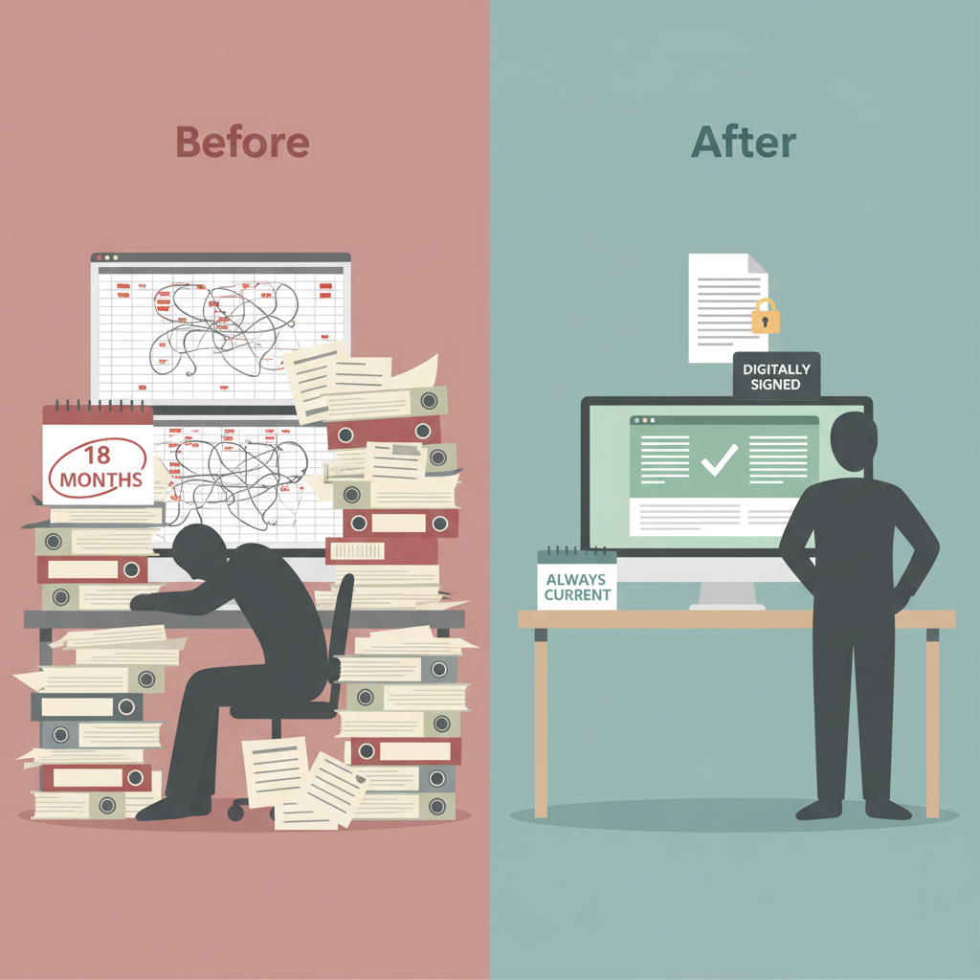


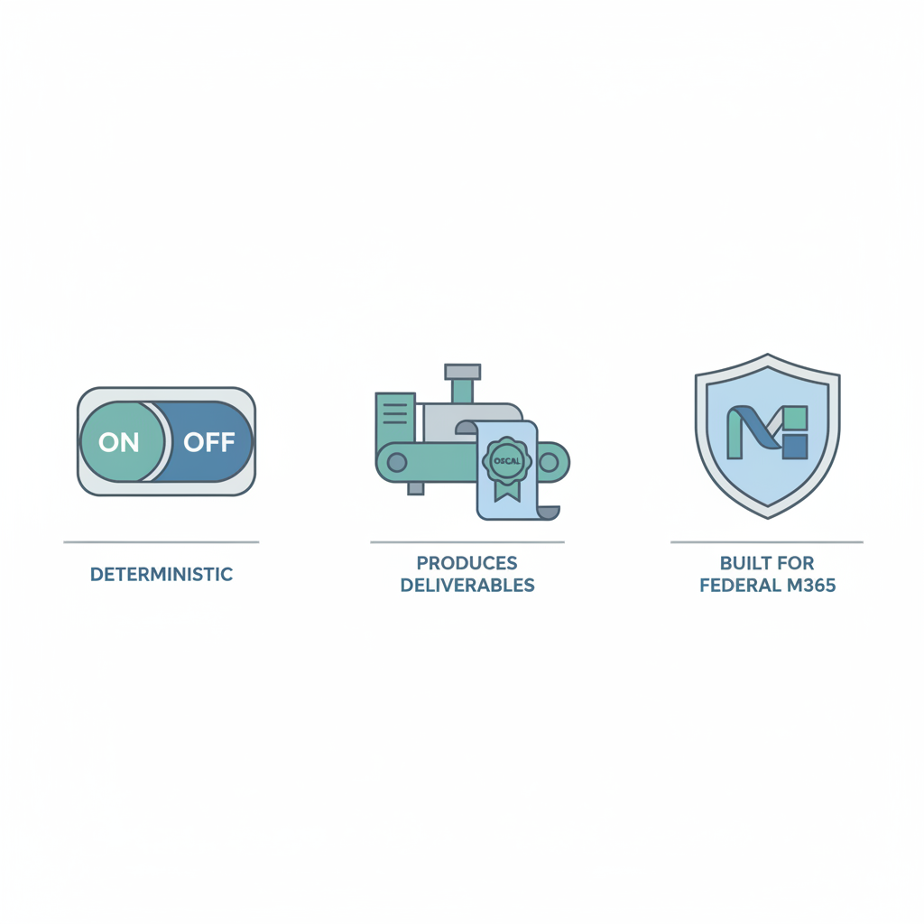

The pilot costs nothing in licensing—UIAO is open source. The investment is staff time to connect a tenant, validate outputs against your existing manual process, and evaluate the results. We anticipate this will require involvement from your security, compliance, and identity teams over the 90-day window. If the platform delivers what we have built it to deliver, your team will have the data to make that case. If it falls short, the pilot ends with no contractual obligation.

UIAO Modernization Program
Generated: 2026-04-12 • Source: UIAO Modernization Program • Version 1.1

