UIAO Mission Statement
A Governance Operating System for Coherence,
Modernization, and Drift‑Free Operations
Document #2 | UIAO Architecture Series

1. Introduction: Why UIAO Exists
Every modern organization eventually reaches a point where its digital environment becomes too complex to govern through documentation, tribal knowledge, or platform‑specific tools. Systems drift. Identities multiply. Addresses lose structure. Documentation becomes outdated the moment it is written. Teams disagree about what objects exist, who owns them, and how they should behave.
This is not a failure of technology.
It is a failure of governance coherence.
UIAO exists to solve this problem at its root. It is a governance operating system designed to define, maintain, and enforce a single, authoritative truth across the entire digital estate. It ensures that identities, addresses, systems, networks, services, documentation, and automation all remain aligned with the organization's intended state.
UIAO is not a monitoring tool.
It is not a CMDB.
It is not a documentation platform.
UIAO is the system that keeps all other systems consistent.
2. The Mission of UIAO
The mission of UIAO is simple to state but profound in impact:
UIAO ensures that every object in the environment is defined correctly, governed consistently, and maintained without drift — enabling modernization, reducing operational burden, and preserving long‑term coherence.
This mission is executed through four pillars:
- Define the truth
- Detect divergence
- Repair reality
- Explain the system
These pillars form the backbone of UIAO's governance model.
3. Visual Foundation: The UIAO Governance OS
[ IMAGE PLACEHOLDER — Image-001-UIAO-Governance-OS-Overview ]
Label: UIAO Governance OS Overview
Description: Shows UIAO above Identity, Address, and Documentation layers, all above Cloud / Network / Automation.
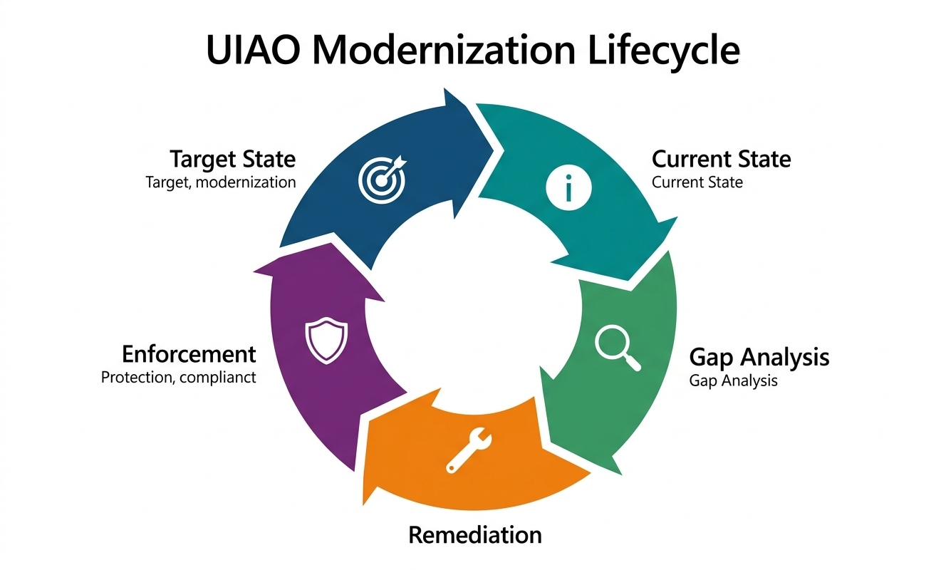

This diagram captures the essence of UIAO's mission:
- UIAO sits above the environment, not inside it.
- It governs identities, addresses, and documentation as first‑class objects.
- It ensures coherence across cloud, network, automation, and infrastructure.
UIAO's mission is to ensure that these layers never drift apart.
4. Mission Pillar One: Define the Truth
UIAO begins by establishing a canonical definition for every object in the environment. This definition is not a document — it is a contract. It describes:
- What the object is
- How it must be named
- Where it belongs
- What attributes it must carry
- What rules govern it
- Who owns it
- Why it exists
[ IMAGE PLACEHOLDER — Image-002-UIAO-Canonical-Object-Record ]
Label: UIAO Canonical Object Record
Description: Shows Identity, Address, Owner, Purpose, Rules, Provenance fields for a canonical object.
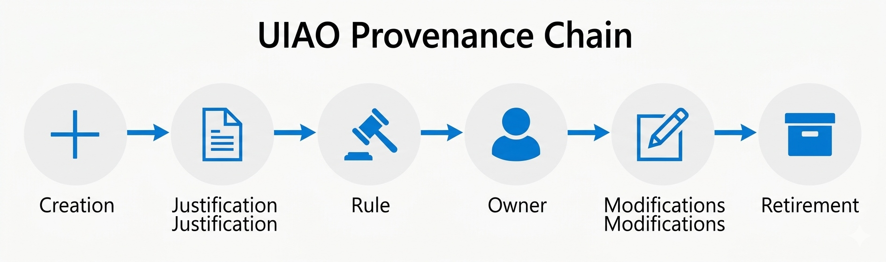

This is the heart of UIAO's mission: to define truth in a way that machines can enforce and humans can understand.
5. Mission Pillar Two: Govern Identity and Addressing
Identity and addressing are the two most fragile foundations of any environment. When they drift, everything else drifts with them.
UIAO's mission is to ensure that:
- Every identity is unique, justified, and governed
- Every address follows a deterministic pattern
- No two systems disagree about the same object
- No address is duplicated, orphaned, or misassigned
[ IMAGE PLACEHOLDER — Image-003-UIAO-Address-Governance-Flow ]
Label: UIAO Address Governance Flow
Description: Shows the five‑stage flow: Request → Validation → Assignment → Enforcement → Provenance.
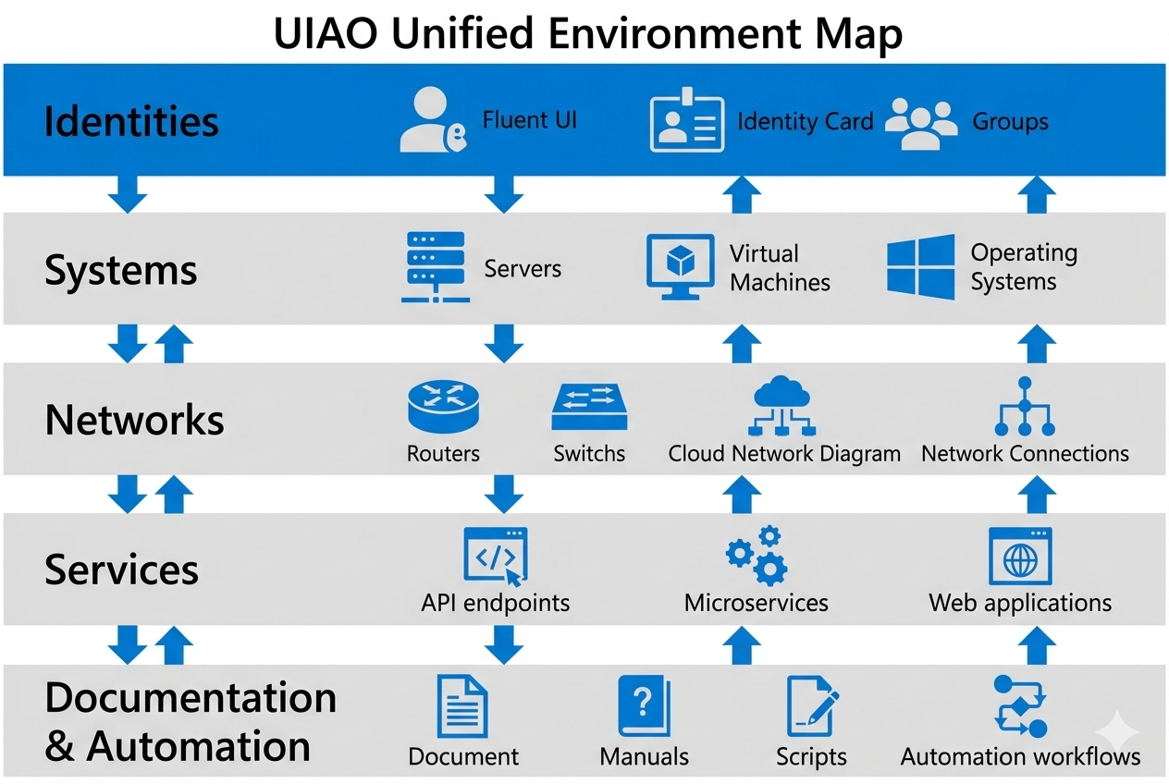

This flow is the governance backbone that prevents entropy.
6. Mission Pillar Three: Detect Drift
Once the truth is defined, UIAO continuously compares the intended state to the actual state. This is the drift detection mission — the core of UIAO's operational purpose.
[ IMAGE PLACEHOLDER — Image-004-UIAO-Drift-Detection-Loop ]
Label: UIAO Drift Detection Loop
Description: Shows the continuous cycle: Intended State → Actual State → Comparison → Drift Found? → Action.
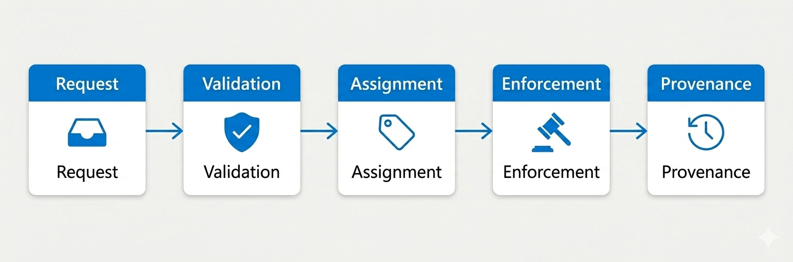

This loop is the heartbeat of UIAO. It ensures that drift is never silent, never invisible, and never ignored.
7. Mission Pillar Four: Repair Reality
Detection is not enough. UIAO's mission includes restoring the environment to its intended state.
[ IMAGE PLACEHOLDER — Image-005-UIAO-Drift-Remediation-Path ]
Label: UIAO Drift Remediation Path
Description: Shows: Drift Detected → Auto‑Remediation → Success? → (Yes) Closure / (No) Human Task → SLA Tracking → Closure.
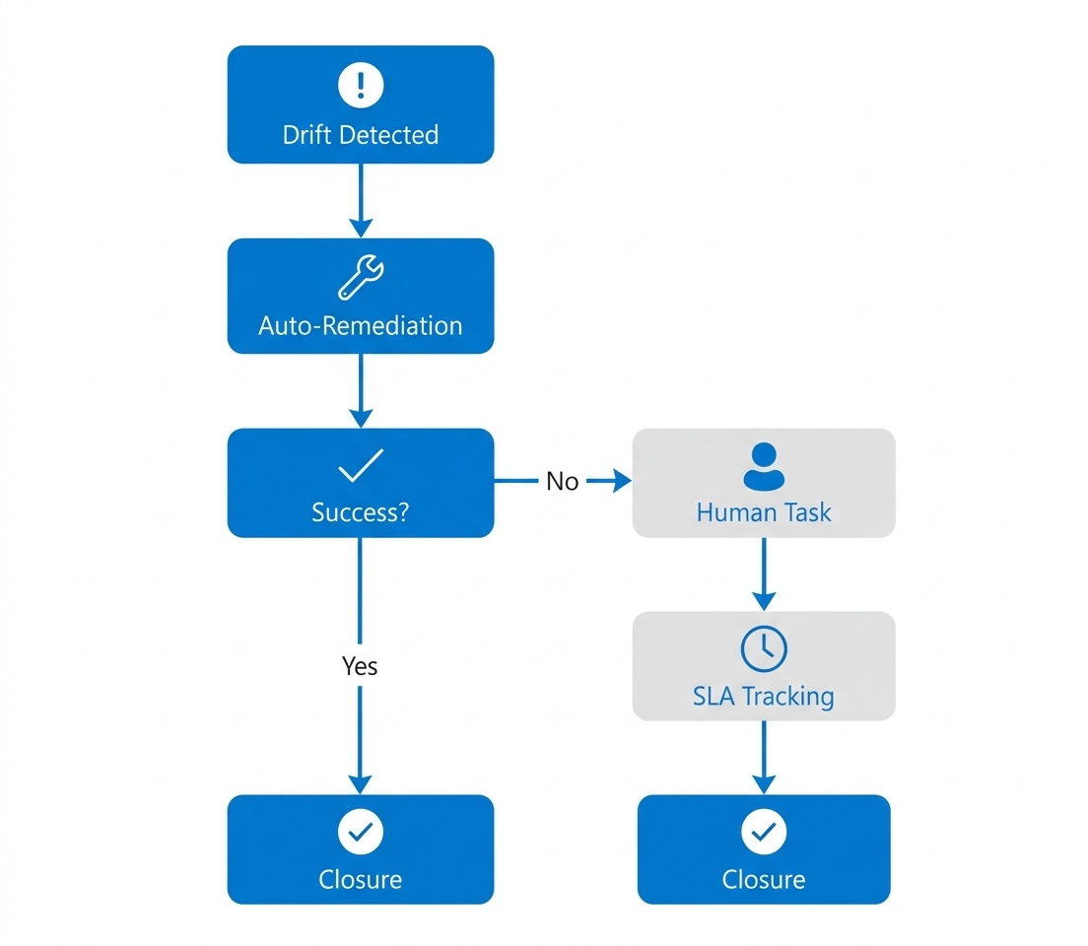

UIAO's mission is to ensure that:
- Drift is corrected automatically when possible
- Human tasks are assigned when necessary
- SLAs are enforced
- Closure is guaranteed
This is how UIAO reduces operational burden and prevents governance collapse.
8. Mission Pillar Five: Maintain Provenance
UIAO ensures that nothing exists without a reason — and that the reason is always known.
[ IMAGE PLACEHOLDER — Image-006-UIAO-Provenance-Chain ]
Label: UIAO Provenance Chain
Description: Shows the full lifecycle: Creation → Justification → Rule → Owner → Modifications → Retirement.
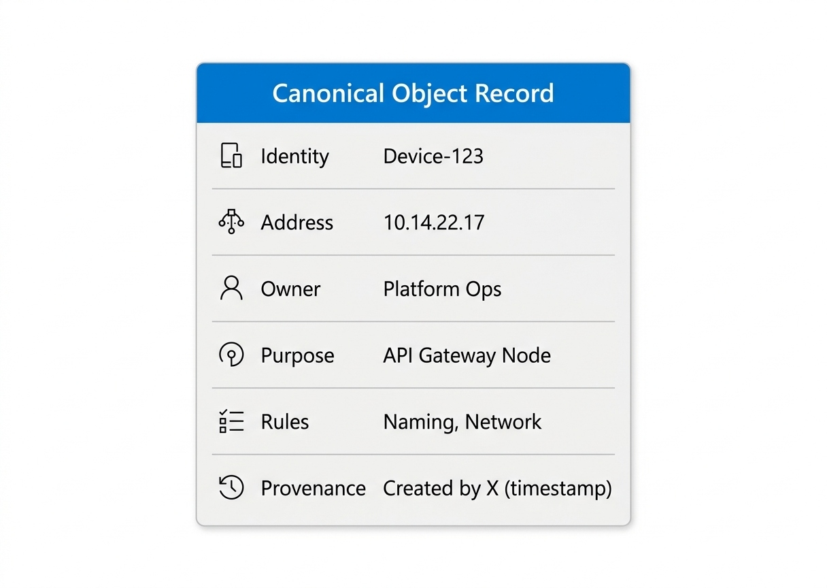

This chain ensures that every object has:
- A creator
- A justification
- A rule
- An owner
- A modification history
- A retirement path
This is how UIAO eliminates "mystery objects."
9. Mission Pillar Six: Map the Environment
UIAO constructs a unified, machine‑readable map of the entire environment. This map is not a diagram — it is a living model.
[ IMAGE PLACEHOLDER — Image-007-UIAO-Unified-Environment-Map ]
Label: UIAO Unified Environment Map
Description: Shows the layered stack: Identities → Systems → Networks → Services → Documentation & Automation, with bidirectional flows.
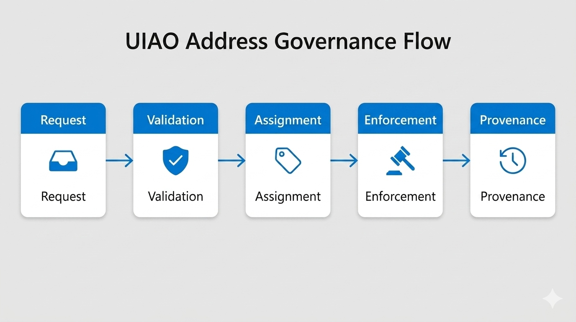

This map is the foundation for modernization, compliance, and operational clarity.
10. Mission Pillar Seven: Drive Modernization
Modernization is not a project. It is a continuous cycle. UIAO's mission is to ensure that modernization:
- Has a target state
- Measures the current state
- Identifies gaps
- Drives remediation
- Enforces the new baseline
[ IMAGE PLACEHOLDER — Image-008-UIAO-Modernization-Lifecycle ]
Label: UIAO Modernization Lifecycle
Description: Shows the five‑phase wheel: Target State → Current State → Gap Analysis → Remediation → Enforcement.
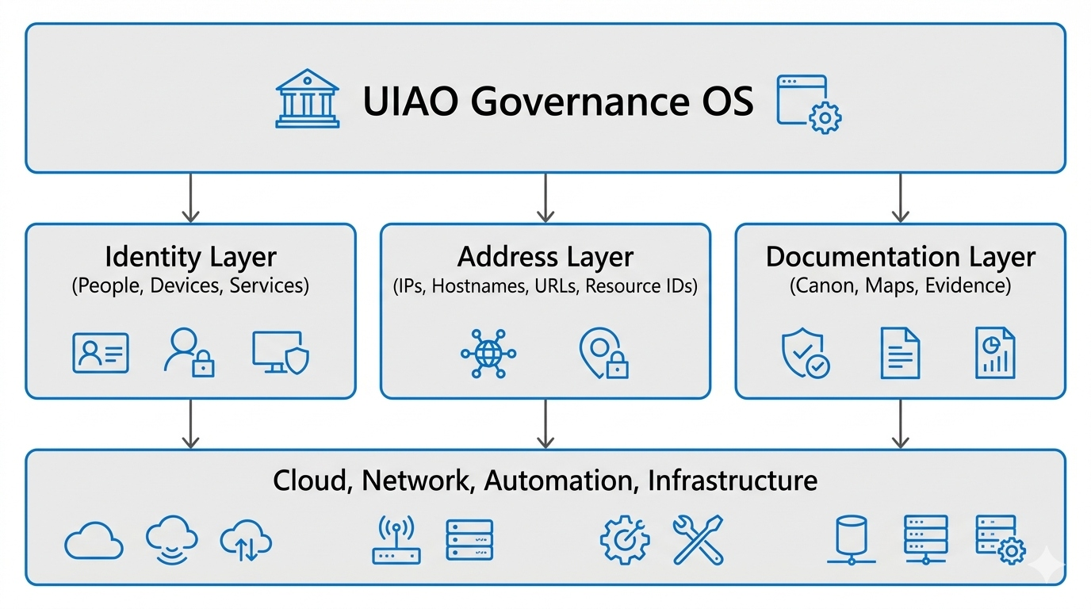

This lifecycle is the modernization engine that keeps the environment evolving without drifting.

11. Conclusion: The Mission in One Sentence
UIAO's mission is to create, maintain, and enforce a single, coherent truth across the entire digital estate — eliminating drift, reducing operational burden, and enabling continuous modernization.

— End of Document #2 —

