Federal Telecommunications Modernization
  - Amazon Connect, Teams Phone, and the Network Architecture That Must Support Them
Michael Stratton
2026-06-29
Table of contents
1. The N8NN: The Front Door to the Agency 3
2. The Physics of Voice: Standards With a Pass/Fail Threshold 3
2.1 ITU-T G.114: The One-Way Delay Limit 4
2.2 MOS and the E-Model: Quantifying Call Quality 4
2.3 Jitter and Packet Loss 5
3. Amazon Connect: Architecture, .com Exception, and Network Dependencies 5
3.1 Platform Overview 5
3.2 The .us vs. .com Decision and the Authorized Exception 5
3.3 What the .com Exception Means Structurally 6
3.4 The Call Path: From Citizen to Agent 6
3.5 The MPLS Hairpin Applied to the N8NN 7
3.6 WebRTC Network Requirements 7
3.7 Asymmetric Routing: The Session Killer Latency Does Not Explain 8
4. Microsoft Teams Phone: Replacing the Legacy PBX in GCC Moderate 9
4.1 What Teams Phone Is 9
4.2 PSTN Connectivity: Direct Routing and the SBC 9
4.3 E911: Federal Legal Requirements 10
4.4 Legacy PBX Migration: Number Porting and Transition 11
5. One Investment: Two Platforms 11
5.1 The Architecture Both Platforms Require 11
5.2 The Hybrid Agent: Two Simultaneous DSCP EF Streams 12
5.2.1 Headset and Browser Configuration 12
5.3 Per-DSCP Steering for the Hybrid Agent Workstation 12
6. Why Direct Internet Access Alone Does Not Satisfy NIST Controls 13
7. FedRAMP Boundary Considerations for Telecommunications 14
7.1 Amazon Connect: .com Boundary Documentation Requirements 14
7.2 Teams Phone: GCC Boundary and PSTN 15
7.3 Amazon Connect vs. Teams Phone: Complementary, Not Competing 15
8. Implementation Roadmap 16
8.1 Phase 1 — Network Foundation (Months 1–3) 16
8.2 Phase 2 — Amazon Connect Deployment (Months 2–5) 17
8.3 Phase 3 — Teams Phone Deployment (Months 4–8) 17
8.4 Phase 4 — Continuous Monitoring (Months 6+) 17
9. Federal Framework Alignment 17

INTERNAL — NOT FOR PUBLIC DISTRIBUTION
For decision makers: This document establishes that the agency’s two most visible telecommunications platforms — the national inbound contact center on Amazon Connect and the internal unified communications platform transitioning to Microsoft Teams Phone — share a single, solvable network problem and a single network solution. Voice quality on the N8NN is not a preference: it is a measurable, auditable obligation with a pass/fail threshold defined by international standard. The SD-WAN investment that fixes Amazon Connect fixes Teams Phone simultaneously. That investment does not need to be made twice.
Four things this document establishes:
- Voice has a pass/fail threshold, not a performance preference. ITU-T G.114 specifies one-way voice delay must not exceed 150 ms. Field office agents in western locations already exceed this limit before a call begins under MPLS hairpin architecture.
- Amazon Connect runs on AWS commercial (.com) by specific authorized exception. The exception is documented in the ATO, must be maintained at each renewal, and carries specific boundary obligations described in this document.
- Teams Phone in GCC Moderate is the correct path for internal telephony replacement. It introduces no new boundary complications but introduces network dependencies identical to Amazon Connect.
- One network modernization investment enables both platforms. SD-WAN local breakout, per-DSCP steering, active-active multipath, and FEC apply to both platforms without modification.

1. The N8NN: The Front Door to the Agency
The N8NN is not a telephone feature. It is the primary channel through which citizens reach the agency. Every call that fails to connect, every conversation degraded by choppy audio, every dropped session during a complex transaction represents a citizen who did not receive the service the agency exists to provide.
Behind the N8NN sits Amazon Connect processing calls on AWS commercial infrastructure, a network carrying voice from the platform to agents at field offices across fifty states, and agents whose ability to hear and be heard clearly is determined entirely by the network segment between their desk and the cloud. That segment — the agency’s own network — is where the problem lives and where the solution must be built.
Why voice exposes network problems that other applications hide: A web application with 200 ms of extra latency loads slowly. A file transfer with 2% packet loss retransmits and completes. A Teams meeting with moderate jitter buffers and recovers. A voice call with 200 ms of one-way delay is barely intelligible. A voice call with 2% packet loss has audible dropouts every few seconds. Voice does not hide network problems behind buffers and retransmissions. It makes them immediately, publicly audible — to the citizen, to the agent, and to the supervisor on quality monitoring. That is why network modernization must begin with voice: voice is the canary.

2. The Physics of Voice: Standards With a Pass/Fail Threshold
Unlike most enterprise applications, voice quality has internationally standardized, measurable pass/fail thresholds that are not preferences or benchmarks but engineering specifications with a direct relationship to intelligibility.
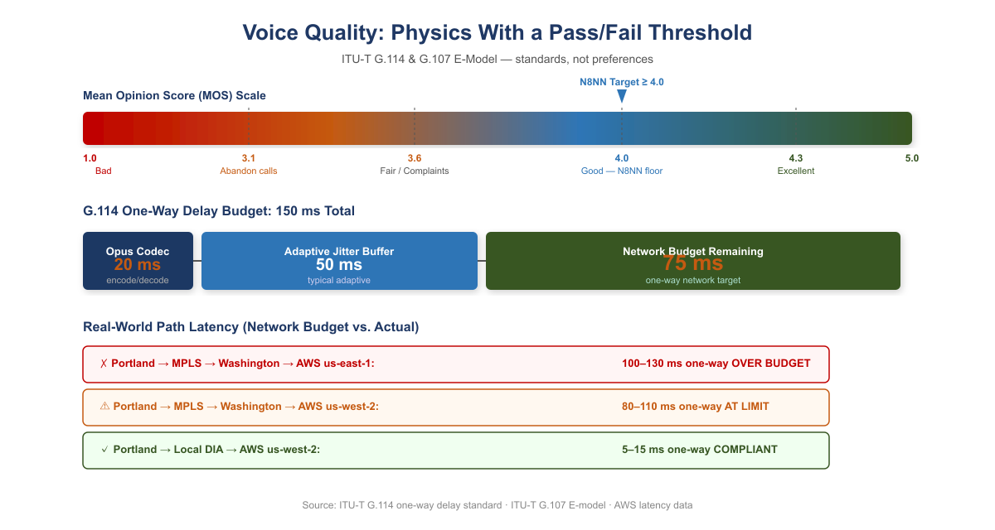
Voice Quality: MOS Scale and G.114 One-Way Delay Budget

2.1 ITU-T G.114: The One-Way Delay Limit
ITU-T G.114 is the international standard governing one-way delay in voice communications. Its specification: one-way mouth-to-ear delay must not exceed 150 ms for most applications. Above 150 ms, talker echo becomes perceptible and conversation degrades. Above 400 ms, the call becomes unusable for interactive conversation. These are not targets — they are ceilings.
The 150 ms limit covers the entire path: codec encoding (~20 ms for Opus), network propagation and queuing, jitter buffer at the receiver (typically 50–80 ms adaptive), and decoding. This leaves approximately 50–80 ms of budget for the network itself. That is the target.

2.2 MOS and the E-Model: Quantifying Call Quality
The ITU-T G.107 E-model translates network conditions into an R-factor (0–100), which maps to the Mean Opinion Score (MOS, 1–5) reported by call quality monitoring systems.
R-Factor | MOS | Quality | User Perception
90–100 | 4.3–5.0 | Excellent | Imperceptible impairment
80–90 | 4.0–4.3 | Good | Perceptible but not annoying
70–80 | 3.6–4.0 | Fair | Slightly annoying
60–70 | 3.1–3.6 | Poor | Annoying
Below 60 | Below 3.1 | Bad | Very annoying; many callers abandon
The N8NN contact center must sustain MOS above 4.0 consistently across all agent locations. Below 3.6 generates citizen complaints. Below 3.1, calls are abandoned and reported.

2.3 Jitter and Packet Loss
Jitter — the variance in packet arrival time — must stay below 30 ms. Jitter buffers compensate by holding packets briefly, but a buffer large enough to absorb 80 ms of variance adds 80 ms of delay, breaching the G.114 ceiling. You can absorb jitter or meet the delay budget; a jittery network forces the choice.
Packet loss above 1% produces audible dropouts. Voice RTP does not retransmit lost packets — they are concealed or skipped. The Opus codec handles occasional single-packet loss gracefully; consecutive losses or rates above 3% produce gaps no concealment algorithm can hide.

3. Amazon Connect: Architecture, .com Exception, and Network Dependencies

3.1 Platform Overview
Amazon Connect is AWS’s cloud-native contact center platform, providing inbound and outbound call handling, IVR via contact flows, skills-based routing, real-time and historical analytics, call recording, and the agent desktop (Contact Control Panel) as a managed SaaS service. Agents access all contact center functionality through a browser-based WebRTC softphone. There is no proprietary hardware at the agent’s desk, no on-premises call processing equipment, and no PBX to maintain.

3.2 The .us vs. .com Decision and the Authorized Exception
AWS structures its federal cloud offerings differently from Microsoft and Oracle:
Provider | Moderate Delivery Model | High / Sovereign Model
AWS | .us infrastructure (separate government regions) | GovCloud (.gov); physically separate, screened personnel
Microsoft | Partitioned .com (GCC Moderate on Azure Commercial) | GCC High / DoD on physically separate infrastructure
Oracle | Partitioned .com (OCI Moderate) | OCI Government Cloud (separate)
Amazon Connect is available on the AWS .us infrastructure. At the time the agency evaluated platforms for the N8NN contact center, the .us version presented operational capability gaps relative to the commercial (.com) version in three categories:
- AI-assisted contact center capabilities: Contact Lens (real-time speech transcription, sentiment analysis, supervisor alerting) and Amazon Q agent assist availability lagged .us at time of evaluation.
- Third-party integration ecosystem: AWS Marketplace integrations for CRM connectors, workforce management, and reporting were predominantly certified for commercial Connect.
- Operational tooling and support maturity: AWS support procedures and feature release cadence in .us lagged commercial, creating a growing capability gap.
Current evaluation required before any new agency deployment. AWS continuously updates its .us infrastructure. The capability gaps identified at the time of this agency’s evaluation may have closed. Any agency evaluating Amazon Connect for a new deployment must conduct a current-state evaluation of .us Connect against its specific requirements before concluding that a .com exception is necessary.

3.3 What the .com Exception Means Structurally
The agency’s use of Amazon Connect on AWS commercial (.com) is the same structural pattern as GCC Moderate on Azure Commercial: a federally authorized service running on commercial infrastructure with FedRAMP Moderate controls applied. AWS commercial data centers are US-based. Data is encrypted in transit and at rest. Amazon Connect holds FedRAMP Moderate authorization. But the personnel screening, physical separation, and elevated control baseline of GovCloud do not apply.
This does not make the deployment less secure — FedRAMP Moderate controls are extensive. It means the authorization boundary is explicitly a commercial environment with federal controls applied, and that boundary must be accurately reflected in the SSP, understood by the AO, and re-evaluated at each authorization renewal.

3.4 The Call Path: From Citizen to Agent
- Citizen dials the N8NN from any PSTN telephone
- Call terminates at an AWS voice connector into Amazon Connect on AWS commercial
- Contact flow answers, runs IVR, and routes to a queue
- Agent selected; Connect establishes WebRTC session to the agent’s browser
- Voice travels: agent desktop → agency network → internet → AWS .com → Amazon Connect → citizen
Steps 1–3 happen inside AWS commercial and are unaffected by the agency’s network. Step 5 — the agent-to-cloud path — is determined entirely by the agency’s network architecture and is where G.114 compliance is won or lost.

3.5 The MPLS Hairpin Applied to the N8NN
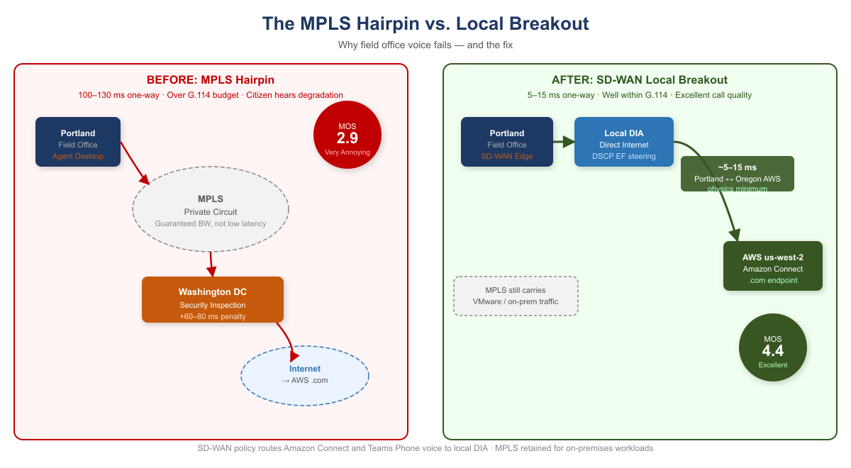
MPLS Hairpin vs. Local Breakout: Before and After
An agent in Portland whose network routes all internet traffic through Washington before egress reaches AWS us-west-2 as follows:
Portland → MPLS → Washington → internet → AWS us-west-2 (.com) → Amazon Connect
One-way network latency: 80–110 ms. G.114 network budget: 75 ms. Over spec. The citizen hears the degradation.
The same agent with local internet breakout:
Portland → local DIA → AWS us-west-2 (.com) → Amazon Connect
One-way network latency: 5–15 ms. Portland and us-west-2 are geographically adjacent. This is the physics minimum for this path, and it is far within budget.

3.6 WebRTC Network Requirements
Parameter | Requirement | Notes
One-way delay | ≤75 ms network budget | G.114 limit minus codec and jitter buffer overhead
Jitter | <30 ms | Above this, buffer compensation breaches delay budget
Packet loss | <1% | Above 1% audible; above 3% unintelligible
Bandwidth per agent | ~100 Kbps | Opus codec including RTP overhead
Protocol | RTP/SRTP over UDP | TCP fallback degrades quality; avoid
DSCP marking | EF (46) | SD-WAN must honor, not remark
NAT traversal | STUN/TURN | Direct UDP path preferred; TURN relay adds latency
Firewall | UDP 3478, 443 outbound | Must reach AWS .com endpoints without hairpin inspection delay

3.7 Asymmetric Routing: The Session Killer Latency Does Not Explain
Asymmetric routing occurs when the outbound path of a session (client to server) and the return path (server to client) traverse different physical or logical routes through stateful network devices. A stateful firewall maintains a session table. When the SYN for a TCP connection passes through Firewall A, Firewall A creates an entry expecting the SYN-ACK to return through it. If the SYN-ACK returns via a different path through Firewall B, Firewall B drops it as unsolicited.
For Amazon Connect WebRTC, asymmetric routing means the TLS handshake that establishes the agent’s voice session may fail completely. The HTTPS session setup for the Contact Control Panel is TCP-based. If the request goes through one stateful device and the response through a different one, the session fails before audio is ever established.
Asymmetric routing produces call failures that look like configuration errors. An agent whose Amazon Connect sessions fail to establish will report “the phone system is broken.” A Teams Phone call that fails at SIP signaling will be attributed to “SBC misconfiguration.” The diagnostic path requires capturing TCP session establishment and verifying that both directions traverse the same stateful devices.
SD-WAN overlay eliminates asymmetric routing as a failure mode. The SD-WAN tunnel is established between two edge devices as a single logical connection. Stateful inspection happens at the tunnel endpoint, which sees both directions. Asymmetric physical routing below the tunnel is structurally invisible to the application.

4. Microsoft Teams Phone: Replacing the Legacy PBX in GCC Moderate

4.1 What Teams Phone Is
Microsoft Teams Phone is the cloud PBX capability within Microsoft 365 that enables Teams to replace a traditional on-premises telephone system — extension dialing, voicemail, call transfer, call queues, auto attendants, and PSTN connectivity, all delivered through the Teams client. For the agency, Teams Phone operates within GCC Moderate, subject to the same FedRAMP Moderate authorization, data residency requirements, and feature availability constraints as the rest of the Microsoft 365 GCC environment.
Teams Phone is not a separate application or interface. An agent answering a Teams Phone call and an agent joining a Teams meeting use the same client, the same audio path, the same DSCP EF marking for audio streams, and the same network dependency on low-latency, low-jitter connectivity to Microsoft’s GCC infrastructure. Fixing the network for Teams meetings fixes it for Teams Phone simultaneously.

4.2 PSTN Connectivity: Direct Routing and the SBC
Connecting Teams Phone to the PSTN requires one of two approaches:
Microsoft Calling Plans — Microsoft provides PSTN connectivity as a licensed add-on. Availability in GCC Moderate should be confirmed for the agency’s specific geographic footprint and number types before committing to this path.
Direct Routing — the agency connects its PSTN carrier to Teams Phone via a certified Session Border Controller. The SBC terminates SIP trunks from the carrier and presents them to Teams via a Microsoft-certified SIP interface. For the agency, which operates existing Cisco voice infrastructure at data center locations, a Cisco CUBE or a cloud-hosted SBC from an AudioCodes or Ribbon-class vendor are the natural candidates.
SBC deployment guidance: Two deployment models are viable. On-premises SBC: Deployed at the Washington data center. All PSTN traffic from any agent location hairpins through the SBC. Familiar operational model; creates a single point of failure. Cloud SBC (hosted by SBC vendor): Runs in the vendor’s FedRAMP-authorized cloud, geographically distributed, with multiple PoPs. Removes the single point of failure. The cloud SBC used with a FedRAMP Moderate system must itself hold a FedRAMP Moderate or High authorization — confirm before procurement.

4.3 E911: Federal Legal Requirements
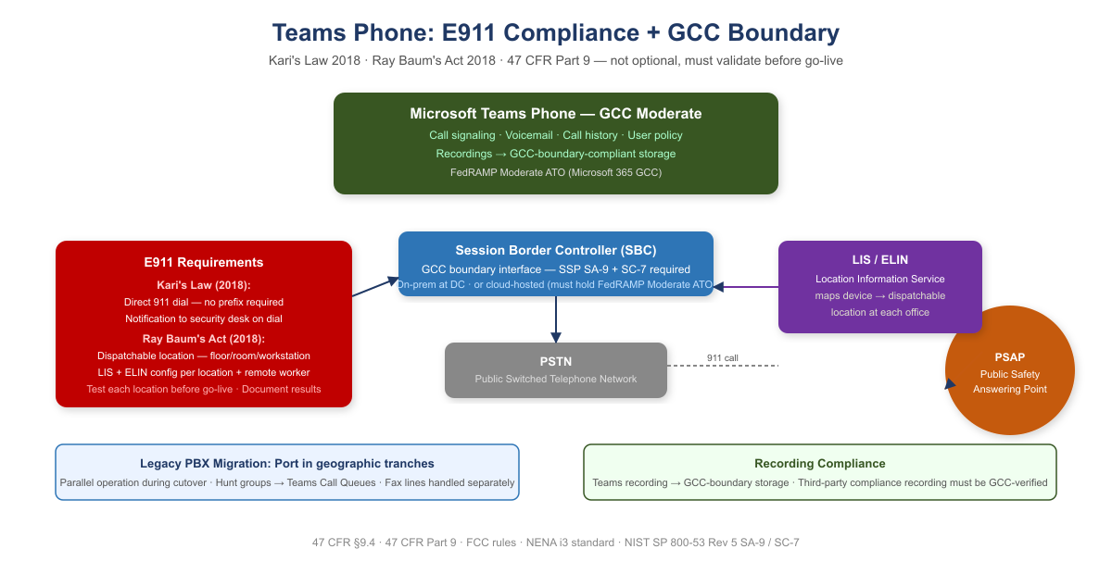
E911 Compliance and Teams Phone GCC Boundary
Two federal laws impose specific requirements on any multi-line telephone system, including cloud PBX:
Kari’s Law (2018): Users must be able to dial 911 directly without dialing an access code or prefix. A notification must be sent to a central point when 911 is dialed. Teams Phone satisfies both requirements when emergency calling policies are correctly configured.
Ray Baum’s Act (2018): The “dispatchable location” — not just a building address but the specific floor, room, or workstation — must be transmitted with the 911 call to the PSAP. Teams Phone supports dispatchable location via the Location Information Service (LIS) and Emergency Location Identification Number (ELIN) configuration.
E911 is not optional and must be validated before go-live. E911 compliance is a federal legal requirement under 47 CFR Part 9. For each location where Teams Phone will be activated, the agency must: (1) configure a Location Information Service entry with dispatchable location, (2) configure an emergency calling policy that routes to the correct PSAP, (3) test 911 dialing and callback from a representative device at that location, and (4) document the test in the deployment record. Remote workers present an additional challenge — location awareness policy must capture the remote worker’s current location at sign-in.

4.4 Legacy PBX Migration: Number Porting and Transition
Porting in tranches. Number porting should be done in geographic tranches — one field office region at a time — rather than as a single nationwide cutover.
Parallel operation. During transition, the legacy PBX and Teams Phone must operate in parallel. Calls to ported numbers must route correctly to Teams. Calls to un-ported numbers must still reach the legacy system.
Hunt groups and call queues. Legacy PBX hunt groups must be recreated as Teams Call Queues. Auto attendant menus must be recreated as Teams Auto Attendants.
Fax lines. Legacy analog fax lines cannot be replaced with Teams Phone without a fax-over-IP (FoIP) solution or a cloud fax service. Fax lines should be inventoried and handled separately from voice number porting.

5. One Investment: Two Platforms

5.1 The Architecture Both Platforms Require
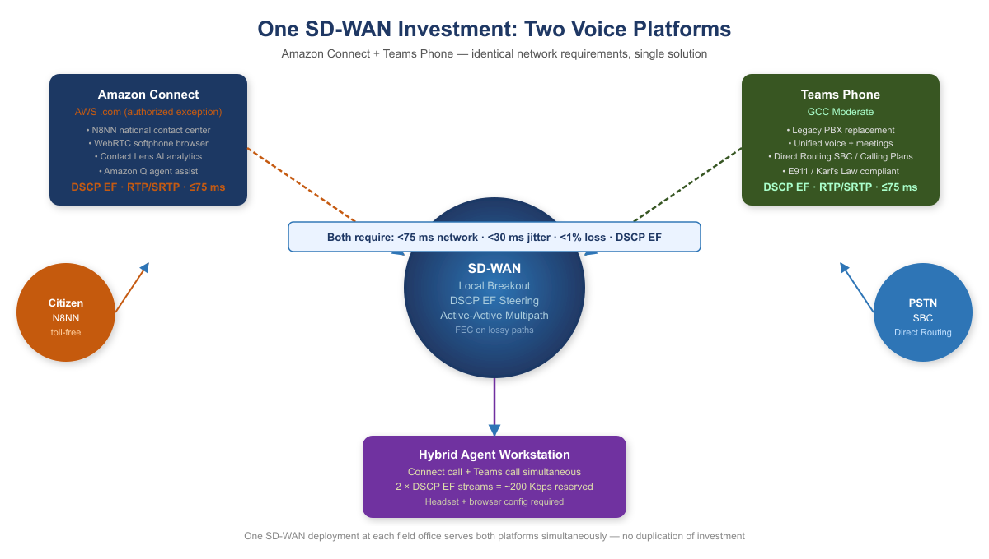
One SD-WAN Investment: Two Voice Platforms
Both Amazon Connect and Teams Phone are cloud SaaS voice platforms. Both generate real-time RTP/SRTP streams. Both are broken by the same MPLS hairpin and repaired by the same network solution. That solution is not simply “add a DIA circuit.” It is Application-Aware Networking — a network architecture in which policy decisions, path selection, security enforcement, and traffic treatment are determined by the full context of a transaction: application identity, user identity, device posture, and behavioral characteristics. Not by source IP and port alone.

5.2 The Hybrid Agent: Two Simultaneous DSCP EF Streams
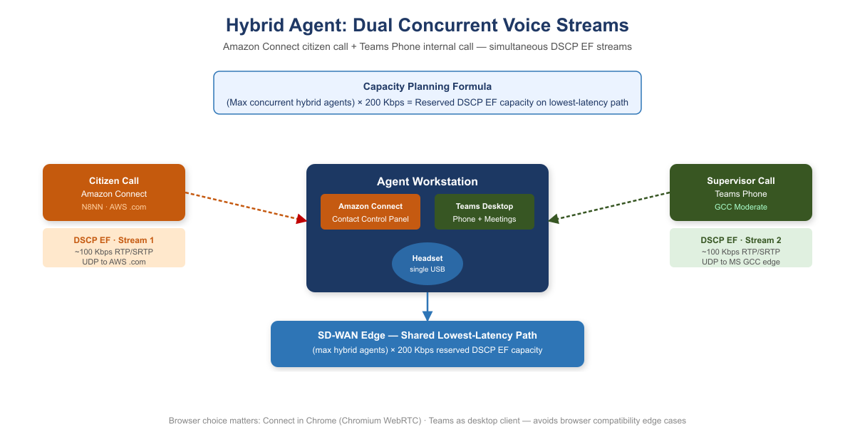
Hybrid Agent: Dual Concurrent Voice Streams
When an agent has an active Amazon Connect call and simultaneously receives a Teams Phone call, the workstation is generating two concurrent voice streams, both marked at the highest QoS priority (DSCP EF). The SD-WAN per-DSCP policy must provide sufficient bandwidth on the lowest-latency path to carry both streams simultaneously.
Capacity planning formula: (maximum concurrent hybrid agents) × 200 Kbps = reserved DSCP EF capacity on lowest-latency path.
At a field office with 20 concurrent hybrid agents, this is 4 Mbps of DSCP EF traffic that must be accommodated on the lowest-latency path at peak.

5.2.1 Headset and Browser Configuration
Browser selection matters: Amazon Connect’s Contact Control Panel is optimized for Chromium-based browsers. Microsoft Teams Phone is optimized for the Teams desktop client. Running Connect in Chrome and Teams as the desktop client avoids browser compatibility edge cases.
Headset standardization: Headset configuration must be standardized across the agent population before go-live on both platforms. Ad hoc headset choices create support complexity and inconsistent audio quality that confounds troubleshooting.

5.3 Per-DSCP Steering for the Hybrid Agent Workstation
A hybrid agent workstation generates three simultaneous traffic classes during active calls:
- Amazon Connect voice (DSCP EF): citizen call audio. Lowest-latency path, unconditionally. FEC enabled if path loss ≥0.5%.
- Teams Phone voice (DSCP EF): supervisor or internal call audio. Same lowest-latency path.
- Contact Control Panel web app and Teams UI (HTTPS): the browser interface for Amazon Connect and the Teams application interface. Highest-throughput path. These tolerate 200–500 ms of latency without affecting call quality and should not compete with voice for the latency-sensitive path.

6. Why Direct Internet Access Alone Does Not Satisfy NIST Controls
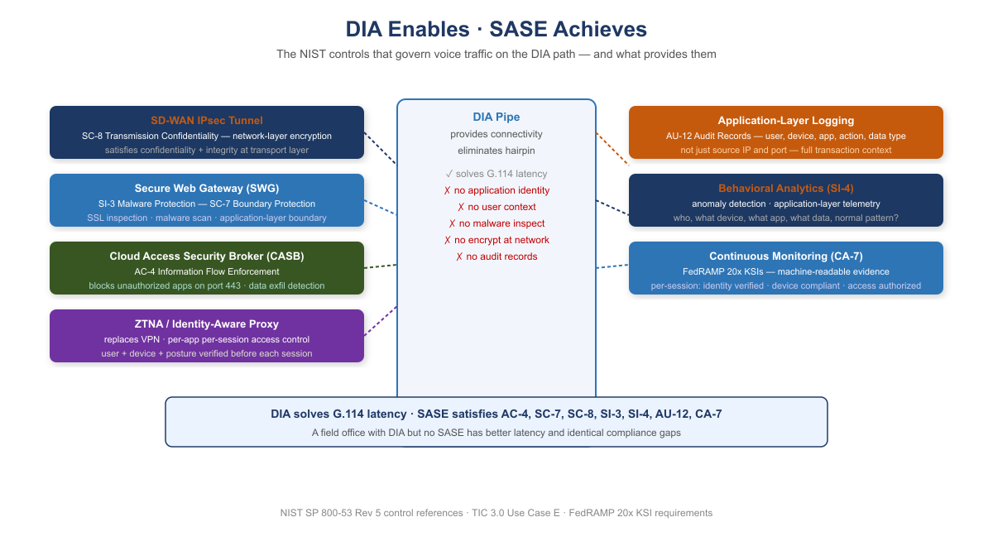
DIA Enables — SASE Achieves: NIST Control Stack
When telecommunications modernization proposals include “we will add DIA at field offices,” the technical response must be precise: DIA is a pipe. It solves the geographic hairpin problem. It does not solve any NIST control requirement.
NIST Control | Requirement | What Provides It
AC-4 | Information Flow Enforcement | CASB — application-layer identification
SC-7 | Boundary Protection | SWG — application-layer inspection and malware scanning
SC-8 | Transmission Confidentiality and Integrity | SD-WAN IPsec tunnel — network-layer encryption
SI-3 | Malware Protection | SWG — SSL inspection and malware scanning
SI-4 | System Monitoring | AAN — application-layer telemetry, behavioral analysis
AU-12 | Audit Record Generation | AAN logging — user, device, app, action, data type, timestamp
CA-7 | Continuous Monitoring | SASE stack — per-session identity, posture, access records
DIA enables; SASE and AAN achieve. For Amazon Connect and Teams Phone, DIA solves the G.114 latency problem by eliminating the geographic hairpin. That is its entire contribution to the compliance picture. A field office deployment that adds DIA without the SASE control stack has better latency and the same compliance gaps. The NIST controls are not satisfied by the pipe. They are satisfied by what governs the pipe.

7. FedRAMP Boundary Considerations for Telecommunications

7.1 Amazon Connect: .com Boundary Documentation Requirements
The agency’s use of Amazon Connect on AWS commercial (.com) requires specific boundary documentation:
- SSP SA-9 documentation: Amazon Connect is an external information system service. The SSP must identify Amazon Connect, its FedRAMP authorization status, the specific authorized exception, and data types (voice audio, call recordings, call metadata, citizen interaction logs).
- Call recordings: Stored in S3 on AWS commercial. Access controls, encryption key management (KMS), and data lifecycle policies must be documented. Recordings containing PII must be classified accordingly, and access logging must satisfy AU-9 requirements.
- CRM and case management integration: API calls between Amazon Connect contact flows and agency systems cross the .com boundary. The data flow diagram in the SSP must trace these calls.
- Agent authentication federation: Agents authenticate to Amazon Connect via the agency IdP (Entra ID in GCC Moderate). The SAML/OIDC federation is a cross-boundary credential flow that must be documented in the SSP.
- ATO exception maintenance: The specific authorization permitting .com Connect must be reviewed at each ATO renewal. The exception is not a permanent waiver; it is a time-bounded, condition-bounded authorization that requires active maintenance.

7.2 Teams Phone: GCC Boundary and PSTN
Teams Phone in GCC Moderate operates within the GCC boundary for all call signaling, voicemail storage, call history, and user policy management. The PSTN interconnect (via Direct Routing SBC or Calling Plans) is a boundary crossing by definition: the PSTN is a public network. The SBC in Direct Routing handles the crossing point. Its configuration must be documented in the SSP as a boundary interface.

7.3 Amazon Connect vs. Teams Phone: Complementary, Not Competing
Dimension | Amazon Connect (N8NN Contact Center) | Microsoft Teams Phone (Internal UC)
Primary function | Citizen-facing inbound contact center | Employee-to-employee and PSTN calling
Users | Contact center agents, supervisors | All agency employees
Call volume | High-volume inbound (thousands concurrent at peak) | Standard enterprise PBX volume
IVR / routing | Sophisticated contact flows, skills-based routing, queuing | Auto attendants and call queues
AI capabilities | Contact Lens (transcription, sentiment, analytics), Amazon Q agent assist | Teams transcription, voicemail transcription (GCC availability varies)
Agent interface | Browser-based Contact Control Panel (WebRTC) | Teams desktop client or browser
Recording | S3 on AWS .com; SA-9 boundary documentation required | GCC-boundary-compliant storage
Authorization | FedRAMP Moderate (AWS .com by specific agency exception) | FedRAMP Moderate (M365 GCC Moderate; partitioned .com)
PSTN connectivity | AWS Voice Connector | Direct Routing SBC or Calling Plans
Voice protocol | WebRTC / RTP / DSCP EF | WebRTC / RTP / DSCP EF
Network requirement | Identical: <75 ms one-way, <30 ms jitter, <1% loss | Identical: <75 ms one-way, <30 ms jitter, <1% loss
SD-WAN solution | Identical: local breakout, DSCP EF steering, multipath, FEC | Identical: local breakout, DSCP EF steering, multipath, FEC
The shared network requirement row is the most operationally significant in this table. The SD-WAN investment that enables Amazon Connect to meet G.114 from all field office locations is the same investment that enables Teams Phone to deliver acceptable call quality. These are not separate network projects. They are one network modernization that enables both platforms.

8. Implementation Roadmap
Prerequisite: no telecommunications migration before network validation. Voice quality failures discovered after contact center or PBX migration are dramatically more expensive to remediate than network infrastructure investments made before migration. No field office should go live on Amazon Connect or Teams Phone until the network foundation for that office is validated against G.114 requirements. Validation means measuring actual one-way latency, jitter, and packet loss from each agent workstation to AWS us-west-2 and to the Microsoft GCC edge, with local breakout active, and confirming all three parameters are within specification.

8.1 Phase 1 — Network Foundation (Months 1–3)
- Deploy SD-WAN at all field offices with contact center agents or significant phone populations
- Configure local internet breakout for Amazon Connect (.com AWS IP ranges/FQDNs) and Microsoft 365 GCC endpoints
- Enable per-DSCP steering: DSCP EF → lowest-latency path; standard HTTPS → highest-throughput path
- Enable FEC on any path with measured loss rate ≥0.5%
- Verify direct outbound UDP to Amazon Connect and GCC endpoints without hairpin or deep inspection delay
- Measure and document G.114 compliance at each agent location before proceeding to Phase 2
- Size DSCP EF capacity for peak hybrid agent load: (max concurrent hybrid agents) × 200 Kbps

8.2 Phase 2 — Amazon Connect Deployment (Months 2–5)
- Confirm .com exception is current in ATO; update SSP SA-9 for Amazon Connect with current architecture
- Design and build contact flows replicating and improving current N8NN IVR routing
- Configure agent authentication via IdP federation (Entra ID GCC Moderate → Amazon Connect)
- Pilot with single queue and agent cohort; measure MOS, jitter, and loss from pilot locations
- Validate call recording pipeline to S3; confirm KMS key management, access controls, and AU-9 logging
- Validate CRM/case management integration; document data flow in SSP

8.3 Phase 3 — Teams Phone Deployment (Months 4–8)
- Confirm Teams Phone feature availability in GCC tenant: Calling Plans availability, voicemail transcription, mobile calling
- Deploy and configure SBC (on-premises or cloud-hosted); validate Microsoft certification and FedRAMP authorization
- Configure E911 with dispatchable location for every office location; verify PSAP connectivity; document testing
- Inventory legacy PBX numbers: classify each as voice, fax, emergency, or special service
- Build Teams Call Queues and Auto Attendants replicating legacy PBX hunt groups and menus
- Port numbers in geographic tranches; maintain parallel PBX operation through each tranche

8.4 Phase 4 — Continuous Monitoring (Months 6+)
- Instrument SD-WAN dashboards to surface G.114 violations by location before they become citizen complaints
- Integrate Amazon Connect Call Analytics with agency SIEM for AU-12 continuous monitoring
- Establish MOS floor SLA (≥4.0) per agent location; alert when sustained MOS drops below threshold
- Review Amazon Connect .com exception at each ATO renewal; evaluate whether .us capability gaps have been resolved

9. Federal Framework Alignment
Concept / Requirement | Federal Mandate | Standard / Reference
Voice one-way delay ≤75 ms (network budget) | Agency SLA obligation; G.114 | ITU-T G.114; ITU-T G.107 E-model
Jitter <30 ms; packet loss <1% | Agency SLA obligation | ITU-T G.107; RFC 3550 (RTP)
Amazon Connect on AWS .com; specific authorized exception | FedRAMP (FISMA); agency ATO | FedRAMP Moderate P-ATO; NIST SP 800-53 Rev 5 SA-9
Amazon Connect .com boundary documentation | FedRAMP; Privacy Act | NIST SP 800-53 Rev 5 SA-9, AU-9, SC-28; agency SSP
ATO exception maintenance at each renewal cycle | FedRAMP ConMon | NIST SP 800-37 Rev 2 CA-7; FedRAMP ConMon requirements
Teams Phone in GCC Moderate boundary | FedRAMP Moderate (M365 GCC) | Microsoft 365 GCC FedRAMP Moderate ATO
E911 direct dialing without prefix (Kari’s Law) | Kari’s Law (2018) | 47 CFR §9.4; FCC rules
E911 dispatchable location (Ray Baum’s Act) | Ray Baum’s Act (2018) | 47 CFR Part 9; FCC rules; NENA i3 standard
Local internet breakout for voice | TIC 3.0, OMB M-22-09 | TIC 3.0 Use Case E; NIST SP 800-207
Per-DSCP steering for voice (DSCP EF) | OMB M-22-09 §4 | RFC 3246 (DSCP EF); IETF RFC 4594
Active-active multipath; sub-second failover | TIC 3.0; OMB M-22-09 | CISA ZTMM v2.0 Networks pillar
SBC as PSTN boundary interface | FedRAMP; agency SSP | NIST SP 800-53 Rev 5 SA-9; SC-7
Call recording access controls and audit logging | FedRAMP; Privacy Act | NIST SP 800-53 Rev 5 AU-9, SC-28; 5 U.S.C. §552a
Agent IdP federation across .com boundary | OMB M-22-09; FICAM | NIST SP 800-63; SAML 2.0 / OIDC federation documentation
Continuous call quality monitoring | FedRAMP ConMon; OMB A-130 | NIST SP 800-37 Rev 2 CA-7; NIST SP 800-53 CA-7

