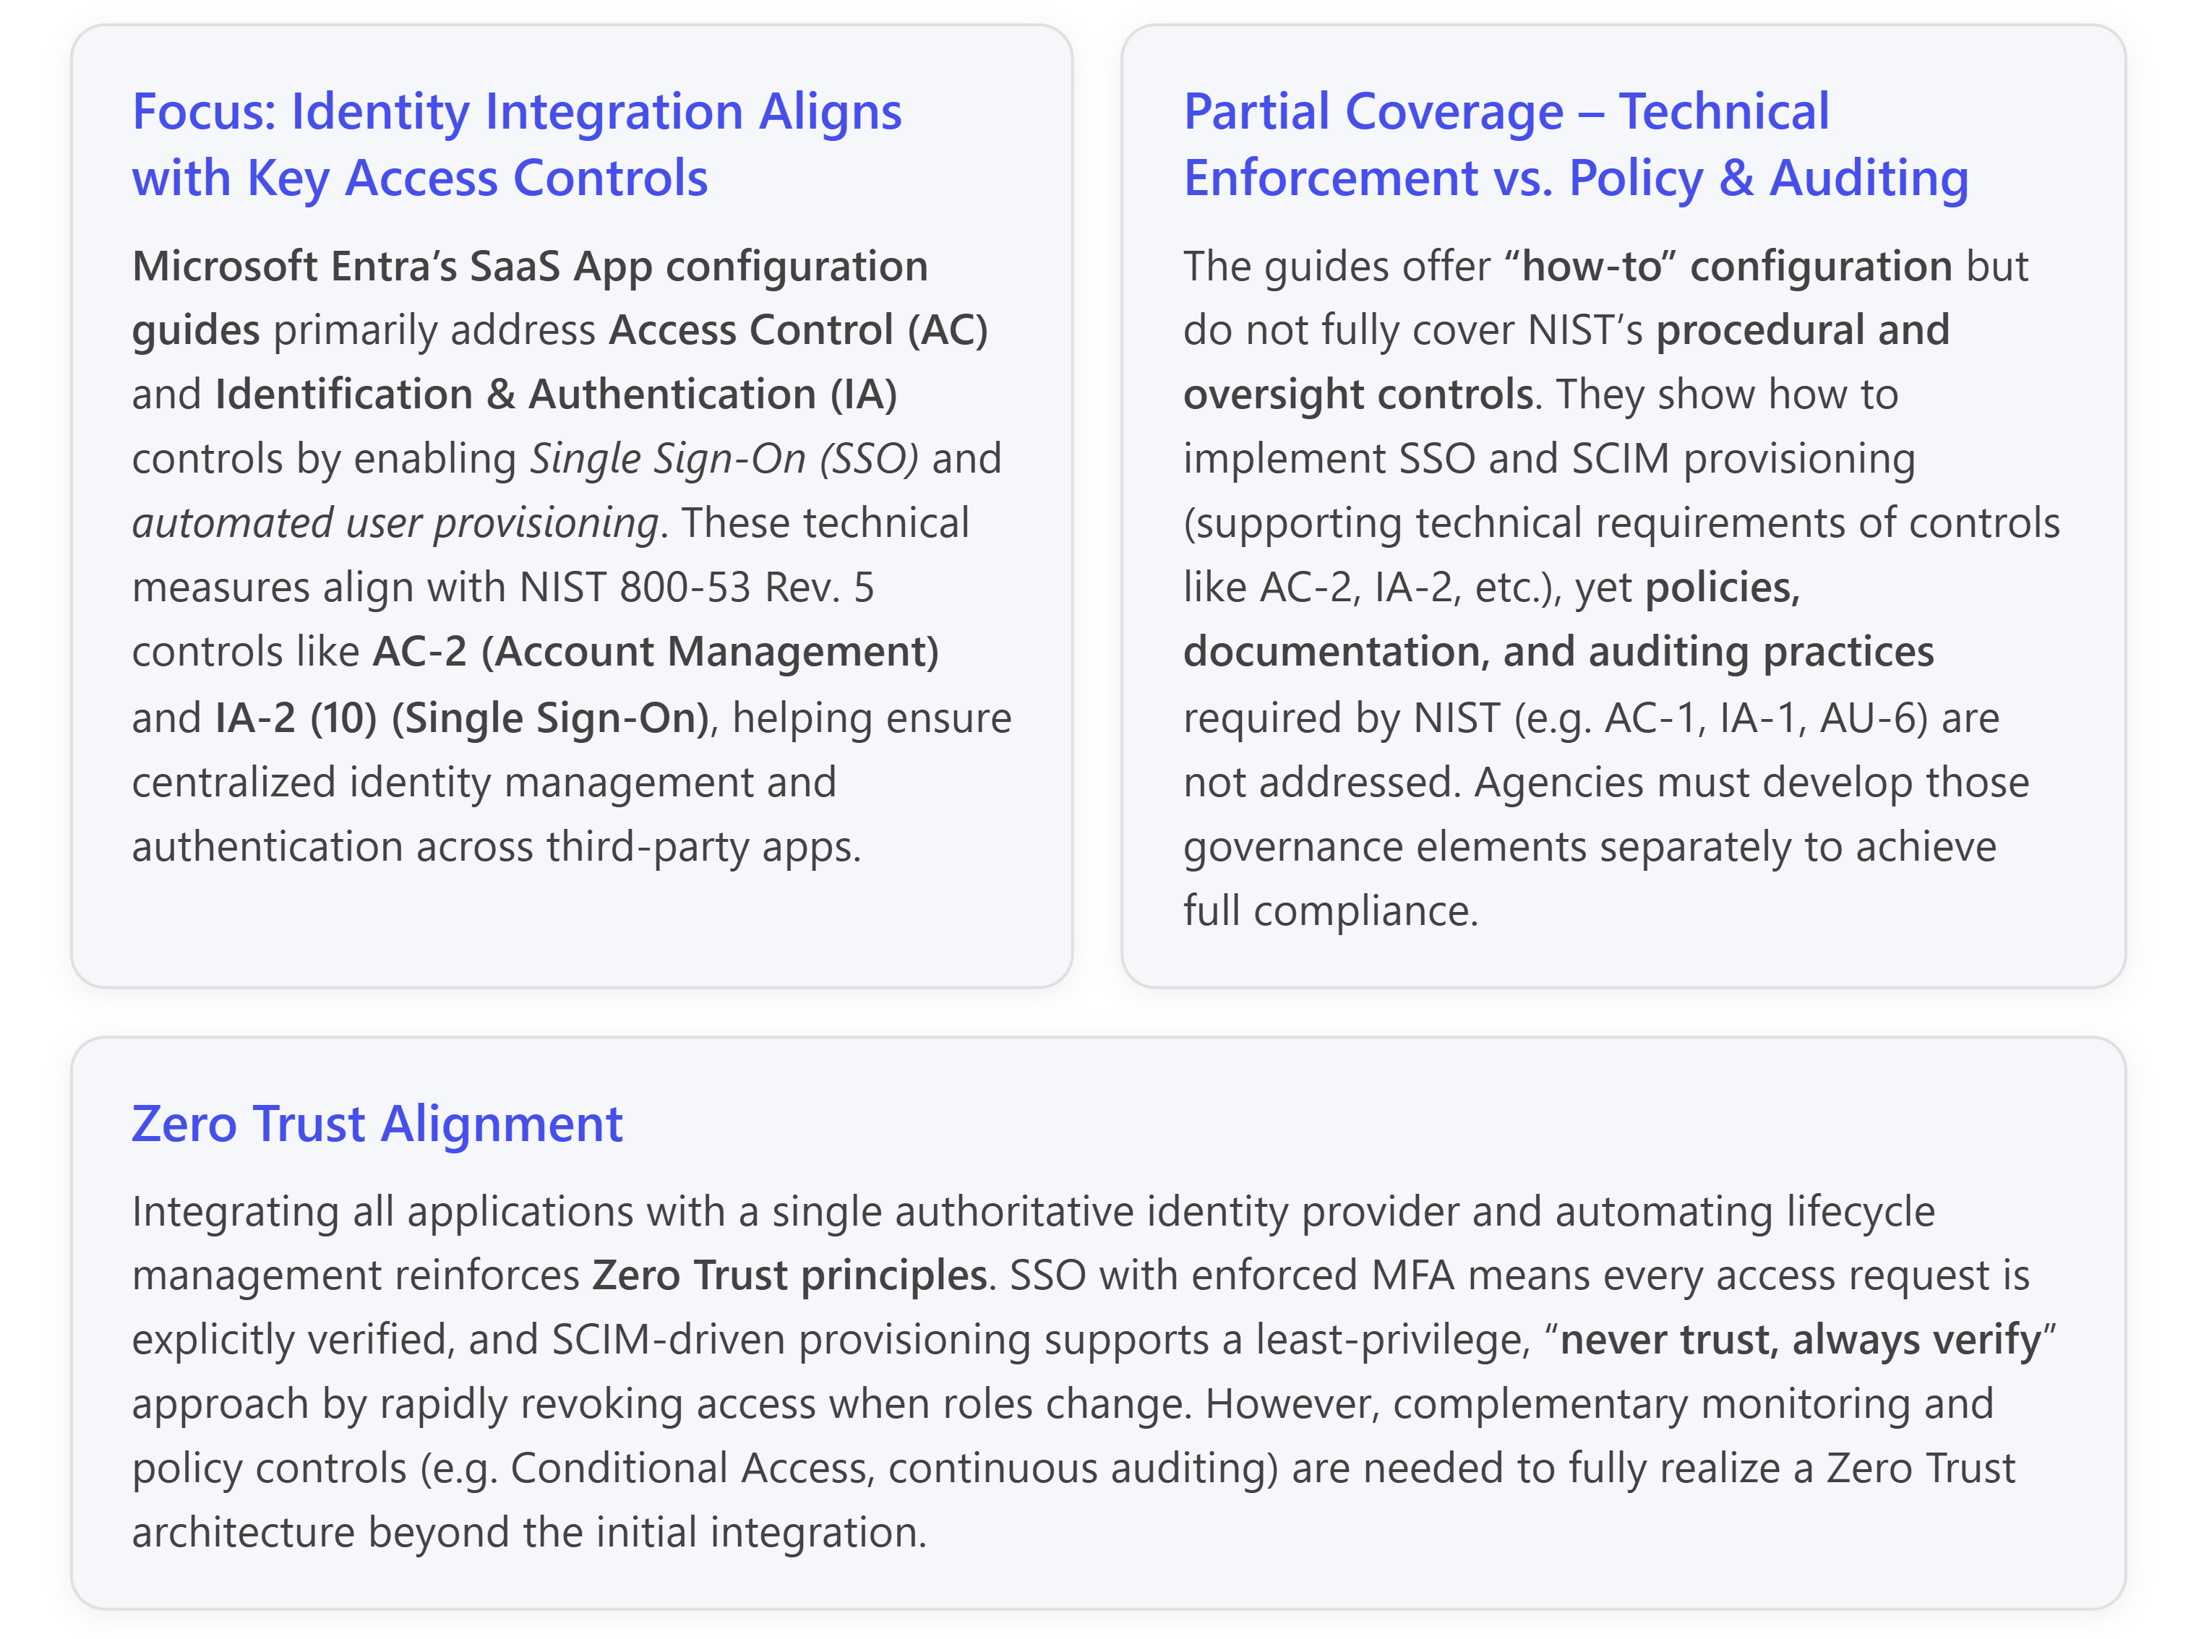

Identity & Access Integration – Alignment with NIST 800-53
The Microsoft Entra SaaS App configuration guides (Microsoft Entra ID is formerly Azure AD) provide step-by-step instructions for integrating third-party software-as-a-service (SaaS) and on-premises applications with your organization’s identity system. In practice, these guides cover two core capabilities:
- Single Sign-On (SSO) using federated authentication standards (e.g. SAML 2.0, OpenID Connect/OAuth) to allow users to login to external apps with their Microsoft Entra (Azure AD) credentials.
- Automated user provisioning using SCIM (System for Cross-domain Identity Management) to synchronize user accounts and roles between Microsoft Entra ID and the SaaS application.
These technical controls map closely to several NIST SP 800-53 Rev. 5 security control families – especially Access Control (AC) and Identification & Authentication (IA):
- Access Control (AC): The guides strengthen AC-2 (Account Management) by centralizing account provisioning and deprovisioning for SaaS apps. When you use Microsoft Entra’s SCIM connectors for automatic provisioning, you are implementing AC-2 and AC-2(1) (Automated Account Management) in a concrete way—user accounts and access privileges in each SaaS application are created, updated, and removed through a centralized workflow. This helps enforce organizational policies for account lifecycle (creation with approval, timely removal upon termination, etc.), and ties into enhancements like AC-2(3)/(4) related to disabling or removing accounts automatically when they’re inactive or the user leaves. For example, Microsoft’s documentation notes that “automatic provisioning includes the maintenance and removal of user identities as status or roles change,” ensuring that when a user’s role is removed or they depart the organization, their access to integrated apps is promptly revoked. By keeping account management centralized, the organization can also satisfy AC-2’s requirements for oversight – e.g. reviewing provisioning logs and managing account privileges centrally (though the documentation doesn’t itself describe the review process; that must be done by administrators via Entra ID’s reporting tools).
Entra ID’s integration of SaaS apps also contributes to AC-3 (Access Enforcement) and AC-6 (Least Privilege). With SSO integration, access to each application is enforced through centrally managed policies (for instance, only users or groups assigned to the app in Entra ID can sign in). Administrators can require explicit user or group assignment for each enterprise app, rather than leaving apps open to all users by default. This practice supports NIST’s least privilege and separation of duties principles (AC-6 and AC-5) by ensuring that only authorized individuals with a need to use a given application are granted access. The guides even encourage assigning application owners in Entra ID for each integrated app, which maps to having defined ownership and role-based access for management functions – an aspect of AC-2 (designating account managers) and AC-5 (segregating duties so that no single administrator has unchecked control) in larger environments.
- Identification & Authentication (IA): Federating a SaaS application to Microsoft Entra ID means that all user authentication is handled by the organization’s identity provider. In NIST terms, this implements centralized Identification and Authentication (IA-2) for all those external systems. In particular, it directly addresses IA-2 (10), which requires organizations to “provide a single sign-on capability” for defined systems. By configuring SSO, users authenticate through one trusted IdP (Entra ID) to access multiple SaaS services, instead of maintaining separate logins. This reduces password proliferation and allows the organization to enforce consistent authentication requirements across all applications. In the Microsoft guide for an AWS integration, for example, the outcomes of enabling Entra SSO are that you can “control in Microsoft Entra ID who has access”, have users automatically sign in with their Entra accounts, and manage accounts centrally – all of which underpin the IA-2 and AC-2 controls around centralized user authentication and account management.
Furthermore, using Entra ID for SSO means agencies can invoke strong authentication measures universally. NIST IA-2 requires multifactor authentication for network access by privileged and (for higher-impact systems) general users. Entra ID supports enforcing MFA (e.g. requiring PIV or authenticator app) and other authentication context rules via Conditional Access policies. By integrating a SaaS app with Entra ID, an organization can ensure that login to the app is subject to the same MFA requirements and identity proofing standards set for its enterprise—contributing to IA-2(1) (MFA for privileged accounts) and IA-2(2) (MFA for remote/network access) controls. In essence, the docs give the technical blueprint to extend your existing compliant authentication and session management controls to all external apps. Another relevant control is IA-4 (Identifier Management), which calls for unique user identification and management of user IDs. Entra ID integration supports this by eliminating local app-specific accounts in favor of a single unique enterprise identity per user, aiding compliance with IA-4 and preventing “identity sprawl” across unmanaged accounts.
- System and Communications Protection (SC): The SSO configurations inherently use secure protocols and cryptography, touching on controls like SC-8 (Transmission Confidentiality and Integrity) and SC-13 (Cryptographic Protection). SSO exchanges occur via TLS-protected channels and involve SAML assertions or OIDC tokens that are digitally signed (and optionally encrypted) by the identity provider. The Microsoft docs note, for example, that SAML tokens are signed with a unique certificate (using SHA-256 by default) and can be configured for encryption. Proper management of these token-signing certificates is advised – the documentation recommends monitoring certificate lifecycles and rolling over certificates within their 3-year validity period. Following this guidance helps an organization partially fulfill SC-17 (Public Key Infrastructure Certificates) and IA-5 (Authenticator Management), which require managing cryptographic keys and authenticators. (The guides assume that certificate issuance and trust chains are handled by Microsoft Entra ID’s built-in certificate authority; agencies should ensure this aligns with their organization-defined certificate policy as called out in SC-17.)
- Audit and Accountability (AU): While the tutorials themselves do not delve deeply into logging or monitoring, integrating apps into Entra ID lays the groundwork for centralized auditing of access. Microsoft Entra ID automatically generates logs for user sign-ins, provisioning actions, and administrative changes. This capability can support AU-2 (Audit Events) and AU-12 (Audit Generation), ensuring that events like authentication attempts and account provisioning actions are recorded. The importance of monitoring is implied in the broader Application Management guidance: organizations are advised to “manage interaction and review activity” through features like entitlement management and to plan for a reporting and monitoring solution leveraging Entra ID’s logs. In a NIST context, this speaks to AU-6 (Audit Review and Analysis) and SI-4 (System Monitoring) – for example, with all SaaS authentications funneling through one IdP, security teams can review consolidated sign-in logs to detect anomalies across all applications. However, this is only partially addressed by the documentation. The how-to guides show where to find and enable these features, but NIST compliance also demands procedural controls – e.g. designated personnel reviewing logs (AU-6), defining audit retention (AU-11), and correlating events centrally (AU-12) – which are beyond the scope of the configuration tutorials. Agencies will need to integrate Entra ID logs with their Security Information and Event Management (SIEM) systems (e.g. via Microsoft Sentinel or other tools) to fully meet AU controls for auditing and incident detection.

Gaps and Out-of-Scope NIST Controls
While the Microsoft Entra SaaS app integration series provides valuable technical guidance to implement SSO and provisioning, it does not by itself guarantee full compliance with all aspects of NIST SP 800-53. Some notable gaps and out-of-scope areas include:
- Policy and Process Controls (AC-1, IA-1, etc.): NIST control families begin with a requirement for documented policies and procedures (e.g., AC-1, IA-1). The Microsoft documentation is a technical “how-to” and does not supply policy templates or procedural guidance. Agencies must separately develop their own access control and identity management policies that, for example, mandate all cloud/SaaS systems use SSO and define how account provisioning is authorized and audited. The importance of formalizing these requirements is underscored by NIST’s guidance for SSO control IA-2(10): organizations need to explicitly scope which apps must use SSO, enforce its use (no alternate logins), and maintain evidence (configuration settings, lists of federated apps, exception approvals, etc.) to pass an audit. The Microsoft tutorials don’t cover such documentation or the requirement to “enforce ‘SSO required,’ not just ‘SSO available’” – that is a policy decision and configuration step left to the implementer. Ensuring that local credentials on the SaaS (if any) are disabled or tightly controlled is critical for compliance but must be handled by administrators outside the basic setup instructions.
- External Service Agreements and Supply-Chain Risk (AC-20, SA-9): Federating a third-party SaaS application to your IdP addresses technical conditions for using that external system securely (for instance, you only allow enterprise data in SaaS apps that support centralized authentication and provisioning). This maps to AC-20 (Use of External Systems), which requires establishing terms and controls for using systems outside the organization’s direct control. By leveraging SSO and SCIM, the organization is effectively imposing certain security requirements on the external service (e.g. the service must trust the enterprise IdP for logins, and user accounts must be managed by the enterprise). However, NIST also expects formal governance around external services – such as SA-9 (External System Services), which calls for due diligence in assessing service providers’ security controls and documenting responsibilities in agreements. The Microsoft Entra integration guides do not address vendor risk assessments, contractual terms, or compliance obligations of the SaaS provider. Those aspects (e.g. ensuring the SaaS app is FedRAMP authorized or meets equivalent controls, per your organizational policy) need to be handled via procurement and vendor management processes outside the scope of the SSO/provisioning setup.
- Access Reviews & Ongoing Governance (AC-2(5), AC-2(7), PE, etc.): The documentation page refers to Microsoft Entra ID Governance integrations, indicating support for features like automated access reviews, separation-of-duty policies, and periodic re-certification of user access. Such features would map to NIST enhancements like AC-2(5) (Account Monitoring for inappropriate/unauthorized accounts) and controls in the Planning (PL) or Audit (AU) families requiring continuous monitoring of account status. But the tutorial list itself does not detail these capabilities. Likewise, NIST controls outside of the identity/access domain – e.g. Awareness and Training (AT), Physical and Environmental Protection (PE), or Contingency Planning (CP) – are not relevant to an app integration guide and are not covered at all. An organization pursuing full compliance must ensure those controls are addressed via other policies, training, and system safeguards.
In summary, the Microsoft Entra SaaS app integration series serves as a strong enabler for meeting technical security controls related to identity and access management. It helps implement central SSO and user provisioning, which directly supports NIST requirements for controlled account management and authentication (notably AC-2 and IA-2(10)) and aligns with the Zero Trust model of unified identity-driven security. The ability to enforce single sign-on for all corporate apps and to automatically provision/deprovision accounts reduces the likelihood of orphaned accounts or disparate credentials, addressing concerns in AC-2, IA-4, and even PS-4/PS-5 (timely removal of access upon termination or role change). Organizations can further leverage Entra’s features to require MFA and device-based Conditional Access for these apps, bolstering compliance with IA-2 enhancements and AC-17 (Remote Access) safeguards.
However, compliance is not achieved by technology configuration alone. NIST 800-53 places equal emphasis on policies, documentation, and oversight. The Microsoft documentation focuses on “how to” configure SSO and provisioning for dozens of specific applications, but it assumes the existence of an overarching policy that, for instance, dictates all cloud services must use enterprise SSO and that specifies who approves new app integrations. It also assumes that administrators will utilize Microsoft Entra’s capabilities (like access reviews, activity logs, and Conditional Access) to fulfill controls around monitoring and restricting access – those tasks are mentioned in concept but left to the reader to implement properly. Therefore, for a comprehensive NIST SP 800-53 compliance and gap assessment, one should treat the Entra ID SaaS app integration guides as addressing the technology portions of controls in the AC and IA families (with some incidental support for AU and SC controls), while identifying that gaps remain in areas such as policy documentation, third-party risk management, auditing, and continuous monitoring. By pairing these technical integrations with robust IAM governance processes and controls (many of which may be implemented via additional Microsoft tools like Entra ID Governance, Conditional Access, and Sentinel logging), an organization can confidently close the loop on NIST control requirements and ensure that connecting a SaaS application to Entra ID truly strengthens its security and compliance posture.
References
[1] SaaS App configuration guides for Microsoft Entra ID - Microsoft Entra ID | Microsoft Learn
[2] NIST 800-53 SCIM Provisioning: Automating Compliance from Day One
[3] What is application management? - Microsoft Entra ID | Microsoft Learn
[4] Regulatory Compliance details for NIST SP 800-53 Rev. 5 - Azure Policy | Microsoft Learn
[5] Configure AWS Single-Account Access for Single sign-on with Microsoft Entra ID - Microsoft Entra ID | Microsoft Learn
[6] NIST SP 800-53: IA-2 (10): Single Sign-on | Daydream
[7] AC-20: Use of External Systems - CSF Tools

