Vol VII Book 05 — Federal Application-Aware Networking — The ServiceNow Compliance App
  - The deployable artifact: a scoped app with connectors, Flows, catalog items, ATF tests, and one assemblable update set
SSA Cloud Services Team
2026-07-14 11:56 ET
INTERNAL — NOT FOR PUBLIC DISTRIBUTION

Draft Proposal — Subject to Review
Developed by the CSI Team (Cloud Services Infrastructure); not yet reviewed or approved by the SSA CIO Office, OIS, or leadership. Date Code: 2026-07-14 11:56 ET
Series Context — Volume VII Book 05. The deployable counterpart to Books 00–04: a scoped ServiceNow app that carries the connectors, Flows, catalog items, control map, ATF tests, and update set implementing the coordination loop. It generalizes the in-repo DDI-provisioning app skeleton (infoblox-ddi-book/servicenow-app/) from provisioning to control compliance — same boundary discipline (in-boundary MID Server, FedRAMP-authorized instance, machine-readable + CI-checked artifacts), new purpose.

What This Document Addresses
Books 00–04 describe the coordination loop as doctrine and control mapping. This book is the artifact that runs it: a scoped app an admin can import into a sub-production instance, wire to the M365 and Azure surfaces through an in-boundary MID Server, and stand up — rather than hand-build from prose. It follows the series’ everything-as-code rule (Vol VI Book 00): the app is an importable update set, its control map is machine-readable data, and its behavior is covered by runnable ATF tests.
Starter skeleton, not a signed product. The scoped app described here ships as an importable DRAFT skeleton at x_ssa_fed_compliance/ — Script Includes, control map (CI-validated against the spine by validate_day2_control_maps.py), Flow blueprints, MID validate script, ATF spec, and update-set spec — registered in the spine’s kits: section so the distribution kit bundles it automatically. Review the records, complete the connector credential aliases and the control map per tenant, pin API versions, and test in a sub-prod instance before any production use. This mirrors the disposition of the DDI app skeleton and the day-2 kit.

App Record Model
The scoped app is x_ssa_fed_compliance. Its records implement the five-step loop (test → detect → raise → actuate-native → close+evidence) as reusable ServiceNow building blocks.
Path (in the app) | Record / artifact | Role
script-includes/ComplianceIngest.js | sys_script_include | Server-side reader — pulls M365 (Graph/SCuBA/Purview) and Azure (Resource Graph / Defender / Update Manager) control state via the MID-routed REST messages; normalizes to a control-finding shape
script-includes/ComplianceReconcile.js | sys_script_include | Matches each finding’s asset to the authoritative IPAM/DDI CI (CM-8 join) before a task is raised; routes unmatched assets to the reconcile-exception queue (Vol VII Book 01)
script-includes/ComplianceGate.js | sys_script_include | Post-actuation validation — re-reads the native surface, confirms closure, and stamps the re-test evidence on the task
rest/ (spec — rest/README.md) | sys_rest_message (+ _fn) | Outbound REST to Microsoft Graph and Azure Resource Manager — endpoint/auth from a credential alias, routed via the MID Server. Exported per tenant per rest/README.md; the XML is deliberately not committed
data/control-map.json | app data (machine-readable) | The finding→(control, task type, approval, actuation, KSI slot) binding — a projection of aan-compliance-spine.yml; CI-checked against the spine
flow/flow-blueprint.md | Flow Designer blueprint | The “Detect & Route Control Drift” flow, the exception-review flow, and the attestation-emit job, with inline Action scripts
mid/compliance-validate.sh | MID Server script | Runs the per-surface read/validate scripts on the in-boundary MID host; emits one JSON verdict
atf/ (spec — atf/README.md) | ATF test suites | Happy-path (drift→task→close→evidence) + negative (unreconciled asset, self-approval block, SLA breach escalation), runnable via test_mode with no live cloud. Built per atf/README.md
update-set/ (spec — update-set/README.md) | update set | The whole app assembled into one importable XML — assembled in sub-prod per update-set/README.md; the XML is deliberately not committed
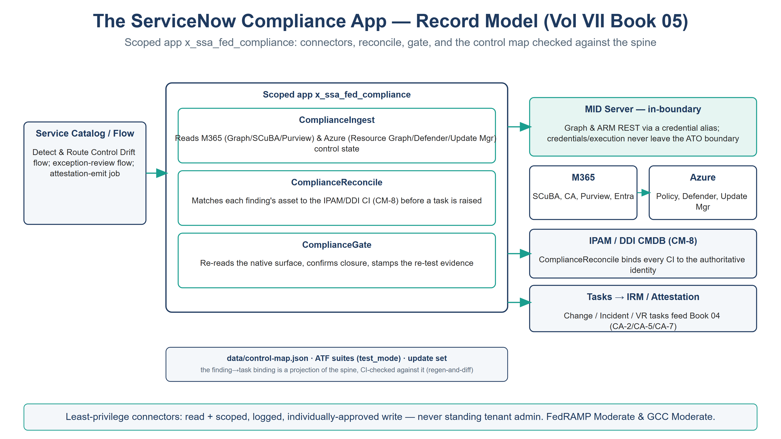
The scoped-app record model — Catalog/Flow triggers the Script Includes; connectors reach M365 and Azure through an in-boundary MID Server; the reconcile binds to IPAM/DDI and tasks feed IRM/attestation

Connectors & Prerequisites
- Microsoft Graph app registration (or managed identity) with read over Conditional Access, directory, and secure-configuration state, plus the narrowly-scoped write used only for approved, logged remediations — never standing tenant admin.
- Azure Resource Manager / Defender / Update Manager read via a scoped service principal or managed identity per subscription.
- A MID Server registered inside the ATO boundary so every callout’s credentials and execution stay in-boundary.
- Discovery / Service Graph Connectors for the CMDB population (Vol VII Book 01); the reconcile job binds their output to IPAM/DDI.
- ServiceNow IRM/GRC for the attestation surface (Vol VII Book 04) — the control tests and POA&M consume this app’s task stream.

Import & Wire-Up
- Create the scoped app x_ssa_fed_compliance (or import the update set) in a sub-prod instance.
- Add the three Script Includes and the two REST Messages.
- Create Connection & Credential aliases x_ssa_fed_compliance.graph and x_ssa_fed_compliance.arm, each with the MID Server selected, pointing at the in-boundary Graph and ARM endpoints (GCC/Gov cloud hosts per the tenant).
- Set app properties: x_ssa_fed_compliance.mid_server, x_ssa_fed_compliance.boundary (fixed to gcc-moderate for this scope), x_ssa_fed_compliance.mid_scripts_dir, and x_ssa_fed_compliance.acknowledge_saas_boundary. Under GCC Moderate the Graph and ARM callouts resolve to the commercial endpoints that serve the GCC Moderate boundary (graph.microsoft.com / management.azure.com, per the series cloud-resolution convention). The GCC High and DoD endpoints are a later follow-up and are intentionally not offered here.
- Load data/control-map.json and run the CI check against aan-compliance-spine.yml so the app’s control bindings match the series SSOT.
- Copy mid/compliance-validate.sh and the per-surface read scripts to the MID host under mid_scripts_dir/<surface>/.
- Build the Flows per flow/flow-blueprint.md, publish the catalog items (control-exception request, POA&M item, remediation change), and run the ATF suites in test_mode before enabling live connectors.

Boundary & Governance
Identical discipline to the rest of the series and the in-repo DDI app: a FedRAMP-authorized ServiceNow instance; the MID Server in-boundary so credentials and execution never leave the ATO boundary; any SaaS-surface reach gated by acknowledge_saas_boundary; and least-privilege connector identities that hold read plus scoped, logged, individually-approved write — never standing admin over the estate being governed. The catalog approval, the change record, the gate verdict, and the CMDB reconcile are the audit evidence.

The Control Map — Data, Checked Against the Spine
The finding-to-task binding lives in data/control-map.json, not in code, so it is reviewable and CI-checked. Each entry corresponds to a control closed in aan-compliance-spine.yml:
// data/control-map.json — finding class → task binding. Projection of the spine.
// Structure: { boundary, catalog: { <finding-class>: {…} } }; CI-validated by validate_day2_control_maps.py.
{
"boundary": "gcc-moderate",
"catalog": {
"m365.baseline.drift": {
"title": "M365 SCuBA / secure-baseline drift", "control": "CM-6",
"task_type": "change", "approval": "owner", "actuation": "platform-native",
"ksi": ["KSI-CMT"], "slot": "slot-06-security"
},
"azure.patch.remediation": {
"title": "Azure patch / flaw-remediation task", "control": "SI-2",
"task_type": "change", "approval": "owner", "actuation": "platform-native",
"ksi": ["KSI-SVC"], "slot": "slot-05-endpoint"
},
"azure.vuln.finding": {
"title": "Defender / MDVM vulnerability finding", "control": "RA-5",
"task_type": "change", "approval": "owner", "actuation": "platform-native",
"ksi": ["KSI-MLA"], "slot": "slot-06-security"
}
// … plus m365.account.exception (AC-2), attest.control.test (CA-2),
// attest.poam.item (CA-5), attest.conmon.rollup (CA-7)
}
}
A CI check (the same regen-and-diff pattern as render_authorities_table.py --check) fails when the app’s control set diverges from the spine’s closures, or when a slot or KSI theme is invalid vocabulary — so the deployable app and the series SSOT cannot silently drift on which controls are covered. Per-entry attribute bindings (the KSI, slot, and task type on a given entry) remain review items, not gate-enforced against specific spine rows.

Closure Necessity

Closure Necessity — the loop has to be an artifact, or it is a slideware promise
Books 00–04 describe the coordination loop; a described loop deploys nothing. This book is the buildable artifact that makes it real — connectors, reconcile job, typed-task flows, ATF coverage, and one update set — carrying the same boundary and change-control discipline the series requires. Without it, “ServiceNow coordinates M365 and Azure compliance” is an intention; with it, it is a scoped app an admin imports, tests, and stands up.

Honest Limits
- The records here are a starter skeleton, not a signed store app; connector scopes, the control map, and API versions are completed per tenant and tested in sub-prod first.
- Connector permission scope is the sharpest risk: the app must resist scope creep toward standing tenant admin. The least-privilege posture is a review item every time a new remediation is automated.
- The ATF test_mode exercises the loop with no live cloud; it validates the workflow, not the native surfaces’ behavior — live-connector validation is a separate, gated step.

Cross-References
- infoblox-ddi-book/servicenow-app/ — the in-repo DDI scoped-app skeleton (Script Includes, REST Message, Flow blueprint, MID gate, ATF, update set) this app generalizes to control compliance.
- Vol VII Book 01 — the CMDB reconcile the app’s ComplianceReconcile.js implements.
- Vol VII Book 02 / 03 — the M365 and Azure loops the Flows and control map encode.
- Vol VII Book 04 — the IRM/GRC attestation surface that consumes this app’s task stream.
- Vol VI Book 00 (Implementation Overview) — the everything-as-code / in-boundary / evidence-emitting deploy model this app conforms to.

Provenance
Draft. x_ssa_fed_compliance, Microsoft Graph, and Azure Resource Manager are deployed examples; the in-boundary-MID, least-privilege-connector, control-map-checked-against-the-spine disciplines are the invariants. This is a vendor-integration skeleton independent of UIAO governance canon. The record-model figure is authored as committed house-style SVG (rasterized to PNG).

