UIAO SCuBA Technical Specification
Document ID: UIAO_002 | Version 1.0 | April 2026
Author: Michael Stratton
Classification: UIAO Canon – Controlled | GCC-Moderate Only
No-Hallucination Mode: ENABLED

Table of Contents

1. Executive Summary
UIAO integrates CISA’s Secure Cloud Business Applications (SCuBA) assessment framework into a deterministic, four-plane compliance pipeline that transforms raw ScubaGear output into auditor-ready OSCAL artifacts. The pipeline ingests ScubaGear JSON, normalizes it through a three-hop mapping chain (PolicyId to NIST SP 800-53 control to UIAO Key Security Indicator), evaluates compliance posture, builds tamper-evident evidence bundles signed with HMAC-SHA256, and generates OSCAL 1.1.2 System Security Plans, Plans of Action and Milestones, and Security Assessment Reports.
This specification covers the full SCuBA integration: 143 policy-to-control mappings across eight Microsoft 365 product baselines (Entra ID, Defender, Exchange Online, SharePoint, Teams, Power Platform, Power BI, and Security Suite), the normalization engine that handles both combined and per-product ScubaGear output formats, the four-plane orchestrator with retry logic and timestamped run isolation, and the evidence integrity chain from raw scan to signed OSCAL deliverable. The system operates exclusively within the GCC-Moderate boundary for M365 SaaS services, with no Azure IaaS/PaaS dependencies.
For leadership: UIAO’s SCuBA integration replaces manual compliance evidence gathering with a continuous, automated pipeline that produces FedRAMP Moderate-aligned artifacts in under 120 seconds per assessment cycle. Every output is deterministic and every evidence item carries cryptographic provenance tracing it back to the original scan. This directly supports CISA Binding Operational Directive 25-01 mandatory timelines with machine-readable, auditor-ready evidence.

2. Context and Problem Statement
The Problem. Federal agencies operating Microsoft 365 in GCC-Moderate environments must continuously demonstrate compliance with NIST SP 800-53 Rev 5 controls, FedRAMP Moderate baselines, and CISA SCuBA secure configuration guidelines. CISA’s ScubaGear tool produces raw JSON assessment output, but there is no standardized pipeline for transforming that output into structured compliance evidence, mapping it to control frameworks, or generating the OSCAL artifacts required for FedRAMP authorization packages.
Why It Matters. Without automated transformation, agencies rely on manual processes to interpret ScubaGear results, cross-reference them against NIST controls, and produce compliance documentation. This manual approach introduces human error, creates evidence that is neither machine-readable nor cryptographically verifiable, and cannot meet the continuous monitoring cadence required by BOD 25-01.
Who Is Affected. Information System Security Officers (ISSOs), Authorizing Officials (AOs), compliance teams, and system administrators responsible for maintaining FedRAMP Moderate authorization for M365 tenants in GCC-Moderate environments.
What Constraints Apply. All operations are scoped to GCC-Moderate (M365 SaaS only). No GCC-High, DoD, or Azure IaaS/PaaS services are referenced or required. Amazon Connect Contact Center is the sole Commercial Cloud exception. The pipeline enforces object identity only. All artifacts must validate against OSCAL 1.1.2 schemas. The SSOT is singular and certificate-anchored; adapters never mutate truth.

3. Architecture Overview
The UIAO SCuBA pipeline is a four-plane sequential architecture with clear separation of concerns. Each plane is independently testable, deterministic, and produces artifacts that feed the next plane in sequence. The pipeline wraps CISA’s ScubaGear assessment tool inside a provenance-first governance envelope.
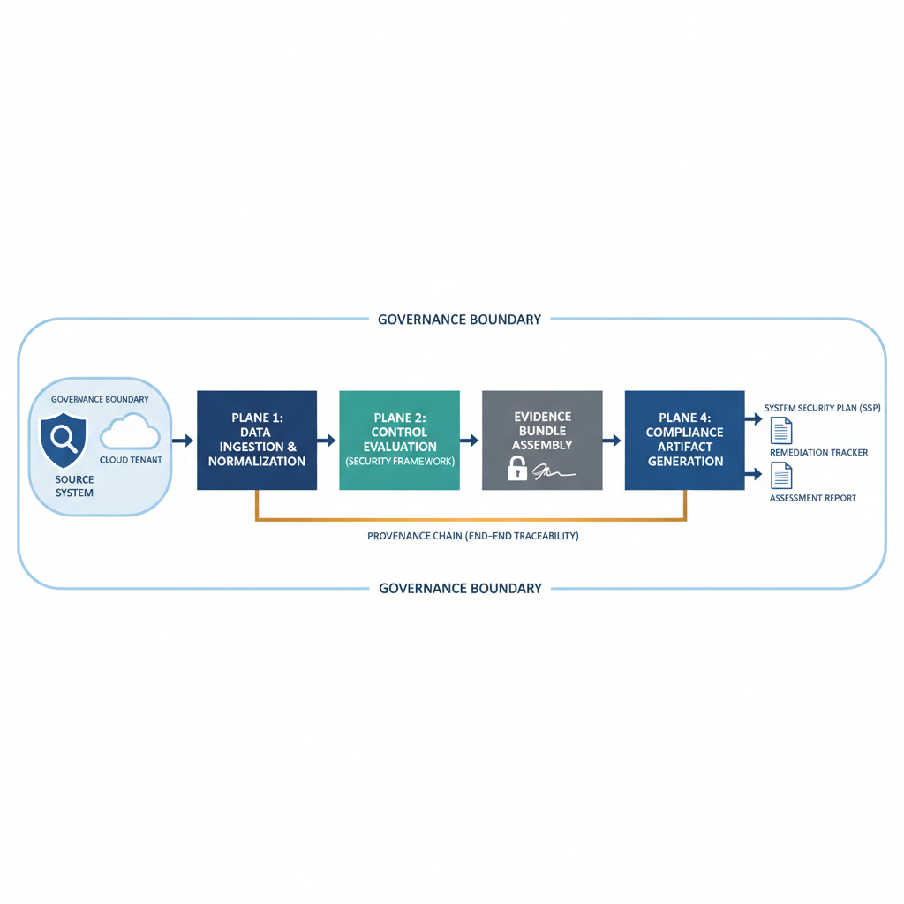
Boundary Model. The pipeline operates within the GCC-Moderate tenant boundary. ScubaGear connects to M365 services via PowerShell. All pipeline processing occurs within the UIAO-Core runtime. No data leaves the tenant boundary during processing.
Identity Model. Object identity only. Every artifact, evidence item, and pipeline run carries a deterministic identity derived from its content hash. No person identity is stored. Certificate-anchored provenance ensures every transaction is traceable.
SSOT Role. The canonical policy-to-control mapping (SCUBA_TO_KSI_MAP) is the single source of truth for all SCuBA-to-NIST control relationships. Adapters serve SSOT + Identity + Security and never mutate truth.
Adapter Classes. The ScubaAdapter implements the DatabaseAdapterBase abstract class, providing five interface methods: connect, discover_schema, execute_query, normalize, and detect_drift. Adapters are plural in class but singular in mission.
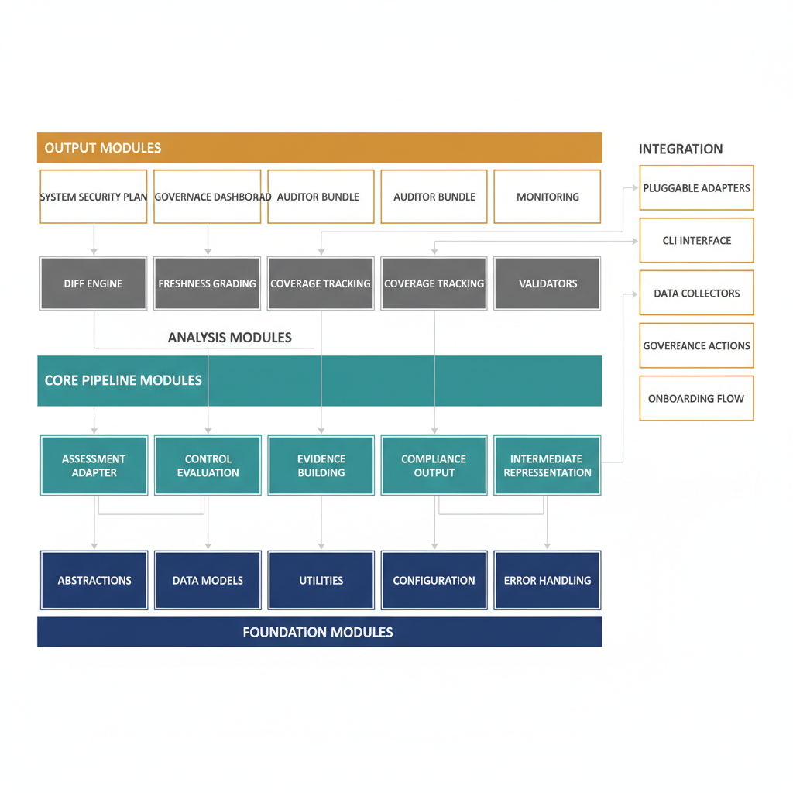

4. Detailed Sections

4.1 Three-Hop Mapping Chain
The core data transformation follows a deterministic three-hop mapping chain that resolves raw ScubaGear policy identifiers to UIAO Key Security Indicators.
Hop 1: PolicyId → NIST SP 800-53 Control. The SCUBA_TO_KSI_MAP dictionary maps 143 ScubaGear policy identifiers to their corresponding NIST SP 800-53 Rev 5 control identifiers. This mapping is static and version-locked to ScubaGear policy versions.
Hop 2: NIST Control → KSI Metadata. The uiao-control-to-ksi-mapping.yaml file maps all 247 NIST SP 800-53 Rev 5 controls to 163 KSI identifiers with severity, category, and file references.
Hop 3: KSI → Compliance Evaluation. The KSI evaluation engine produces pass/fail/warn determinations per control. When multiple policies map to the same KSI, the aggregation is conservative: if ANY constituent policy fails, the KSI fails.
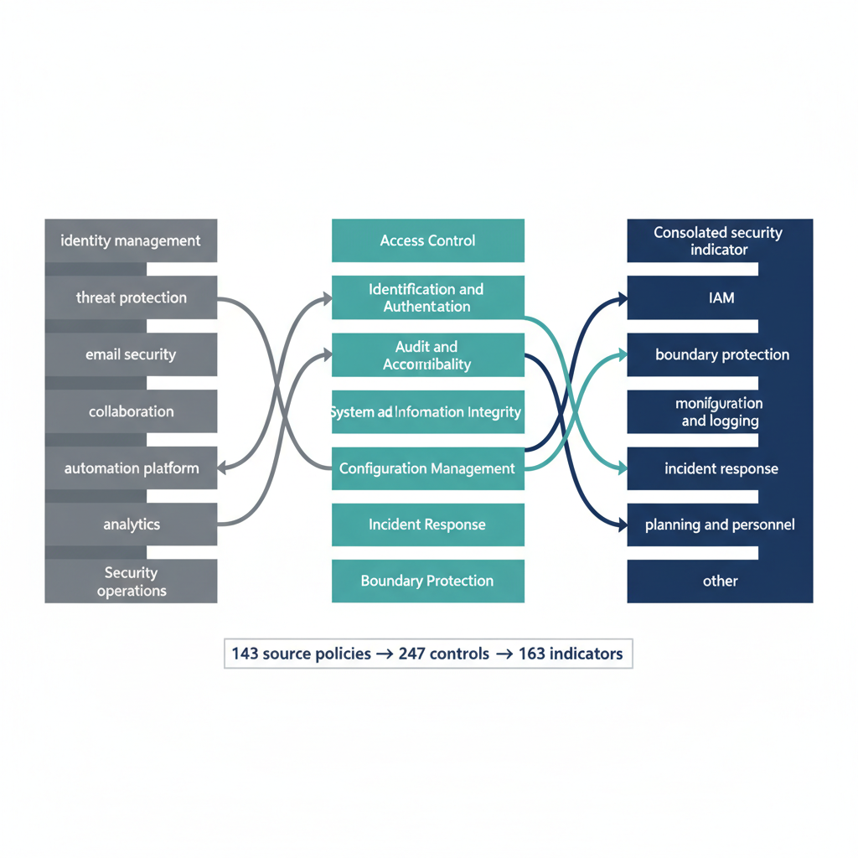
Table 1: Policy Distribution by M365 Product
Product | Prefix | Count | NIST Families | KSI Categories
Entra ID | MS.AAD | 28 | IA, AC, AU, CM | iam, boundary
Defender | MS.DEFENDER | 9 | SI | monitoring
Exchange Online | MS.EXO | 3 | SC, SI | boundary, config
SharePoint | MS.SHAREPOINT | 8 | AC, AU, SC, MP | boundary, iam
Teams | MS.TEAMS | 14 | AC, AU, SI | boundary, iam
Power Platform | MS.POWERPLATFORM | 9 | AC, CM | config
Power BI | MS.POWERBI | 8 | AC, SC, MP, AU, CM, SI | boundary, config
Security Suite | MS.SECURITYSUITE | 23 | SI, IR, CM, SC, MP, AC, AU, IA | all categories

4.2 Plane 1 — SCuBA to IR Transform
Module: src/uiao_core/ir/adapters/scuba/transformer.py
Input: Normalized SCuBA JSON conforming to scuba-normalized.schema.json.
The transformer loads the normalized JSON, builds the full KSI-to-IR mapping, and converts each ksi_results entry into an Evidence object with deterministic identity (evidence:scuba:{tenant_id}:{run_id}:{ksi_id}), source reference, control and policy cross-references, evaluation data, and ProvenanceRecord.
Output: SCuBATransformResult containing controls, policies, evidence list, pass/warn/fail counts, and unmapped KSI IDs. Serialized to IR envelope JSON.
Key Guarantee: Deterministic — same input always produces identical IR. Canonical hash excludes volatile fields.
CLI: uiao scuba transform --input <path>

4.3 Plane 2 — IR to KSI Evaluation
Module: src/uiao_core/ksi/evaluate.py
Input: IR envelope from Plane 1, plus KSI control library (YAML).
The evaluation engine loads control library definitions, maps normalized claims to NIST 800-53 controls, evaluates pass/fail per requirement, and generates structured evaluation results.
Key Guarantee: Every claim maps to exactly one control; no orphans silently discarded.
CLI: uiao ksi evaluate --ir <path>

4.4 Plane 3 — Evidence Build
Module: src/uiao_core/evidence/
Input: KSI evaluation results from Plane 2.
Collects evaluation results into evidence items, builds evidence bundle with metadata, signs with HMAC-SHA256, and calculates stable hash excluding volatile fields.
Key Guarantee: Tamper-evident — any modification invalidates the HMAC signature.
CLI: uiao evidence build --eval <path>

4.5 Plane 4 — OSCAL Generate
Module: src/uiao_core/oscal/
Input: Signed evidence bundle from Plane 3.
Generates OSCAL 1.1.2-compliant SSP, POA&M, and SAR. Exports SSP narrative and lineage traces for human-readable audit trails. Lineage traces every OSCAL statement back through the evidence chain to the original ScubaGear scan.
Key Guarantee: Schema-valid OSCAL 1.1.2 output with full lineage traceability.
CLI: uiao oscal generate --evidence <path>
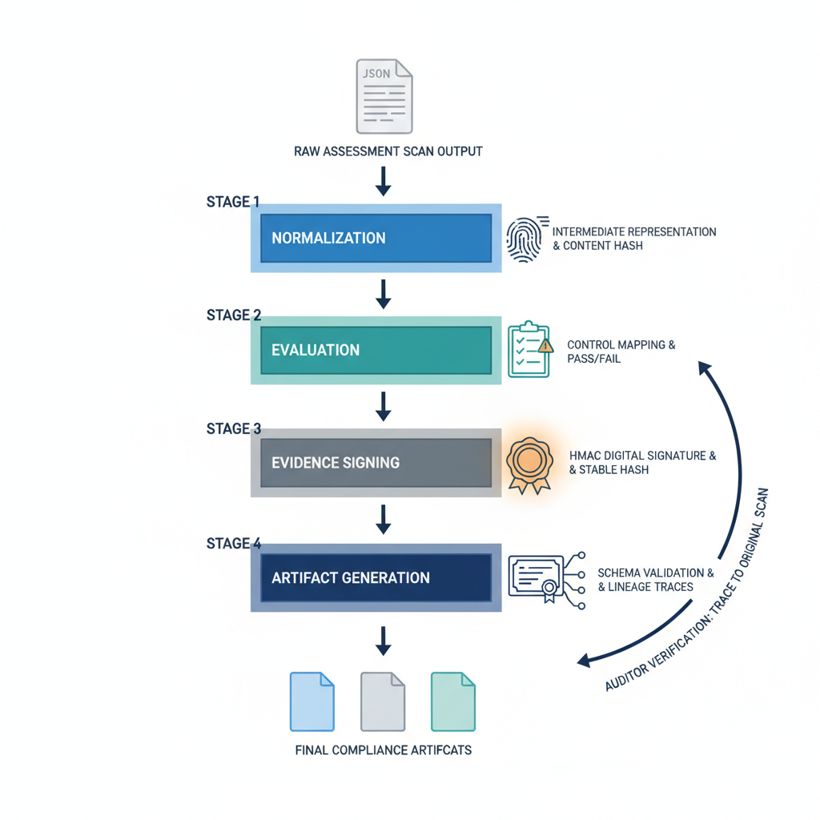

4.6 Normalization Engine
Module: src/uiao_core/ir/adapters/scuba/normalize_scuba.py
Converts raw ScubaGear output into pipeline-ready format. Handles two formats: combined ScubaResults.json (TestResults array) and per-product MS.*.json files.
Input Discovery: Hierarchical search: direct file, directory with ScubaResults.json, directory with MS.*.json, nested date-stamped subdirectories.
Pass/Fail Interpretation: Pass/pass/PASS/true/True → PASS; Warning/warning/WARN → WARN; all others → FAIL.
Aggregation: Conservative. Multiple policies to same KSI: ANY FAIL → KSI FAIL; else ANY WARN → WARN; else PASS. Highest severity preserved. Details concatenated with source policy IDs.

4.7 Orchestration Layer
Module: orchestrator/orchestrator.py
Chains all four planes into a managed execution with error handling, retry logic (exponential backoff), and timestamped run isolation. Each run creates {timestamp}Z-run-{uuid} directory with ir/, ksi/, evidence/, oscal/ subdirectories plus logs. Pipeline halts if any plane fails. Supports dry-run mode and configurable plane selection.
Auto-normalization: if raw ScubaGear input is detected (TestResults/Results keys, or directory input), normalization runs automatically before Plane 1 transformation.
Every run produces manifest.json summarizing: orchestrator version, run ID, timing, per-plane results, and overall success/failure.

4.8 Data Models
All pipeline data models use Pydantic for runtime validation, serialization, and schema generation. IR Core Models: NormalizedClaim, IREnvelope, Provenance, ControlMapping, EvaluationResult, EvidenceItem. SCuBA Adapter Models: ConnectionProvenance, SchemaMappingObject, QueryProvenance, ClaimSet, DriftReport. Evidence Bundle: EvidenceItem list + HMAC-SHA256 signature + stable hash. OSCAL Output: SSP, POA&M (five-state lifecycle: DETECTED → OPEN → IN PROGRESS → CLOSED → VERIFIED), SAR.

4.9 CLI Architecture
Built on Typer with Rich console output. SCuBA commands: uiao scuba run/transform/status/diff. KSI commands: evaluate/findings/enrich/validate. Evidence commands: build/verify/freshness/re-sign. OSCAL commands: generate/validate. Governance commands: scorecard/actions/poam/poam-transition/coverage export.

4.10 CI/CD Integration
Two GitHub Actions workflows: adapter-run-scuba.yml (weekly Monday ScubaGear execution with provenance manifest) and scuba-nightly.yml (nightly full pipeline run with drift detection). Supporting: ci.yml, lint.yml, security-scan.yml, canon-validation.yml.

4.11 BOD 25-01 Compliance Integration
CISA BOD 25-01 mandates SCuBA baseline implementation and continuous compliance monitoring. UIAO supports this via: mandatory timeline tracking through the KSI evaluation engine, evidence-backed closure with cryptographically signed proof of remediation, coverage export (uiao coverage export --baseline bod-25-01), and POA&M lifecycle management.

5. Implementation Guidance
Step 1: Install CISA ScubaGear (v0.5.0+). Ensure PowerShell connectivity to the GCC-Moderate M365 tenant.
Step 2: Execute initial ScubaGear assessment. Place output in exports/scuba/.
Step 3: Configure config/scuba-transform.json with tenant_boundary_id. Optionally set drop_statuses.
Step 4: Run orchestrator: python orchestrator.py --input exports/scuba/ScubaResults.json --output-dir output/ --tenant-id "boundary:tenant:m365:<your-tenant>".
Step 5: Validate: uiao evidence verify, uiao oscal validate, uiao evidence freshness.
Step 6: Enable scuba-nightly.yml and adapter-run-scuba.yml GitHub Actions workflows.
Step 7: Establish POA&M workflow: uiao governance poam --create, then transition states as remediation progresses.

6. Risks and Mitigations

Governance Risks
G-1 Mapping Drift: SCUBA_TO_KSI_MAP may become stale with new ScubaGear policies. Mitigation: unmapped policies tracked in normalization metadata; CI drift-detection alerts on new unmapped policies.
G-2 Canon Divergence: Multiple mapping files could diverge. Mitigation: scuba_adapter.py is canonical SSOT; CI enforces consistency.

Operational Risks
O-1 Format Changes: ScubaGear may change JSON structure. Mitigation: multi-format discovery function; schema validation at Plane 1 entry.
O-2 Pipeline Failure: Mid-run failure leaves incomplete output. Mitigation: timestamped run isolation, per-plane manifest, retry with exponential backoff.

Security Risks
S-1 Evidence Tampering: Post-generation modification. Mitigation: HMAC-SHA256 signing; stable hash for independent verification.
S-2 Boundary Violation: Non-GCC-Moderate references. Mitigation: tenant_boundary_id enforcement; CI boundary rules.

Drift Risks
D-1 Evidence Staleness: Unbundled evidence expires. Mitigation: freshness engine (Fresh ≤24h, Stale 24h–7d, Expired >7d); nightly pipeline.
D-2 Configuration Regression: Tenant configs regress between assessments. Mitigation: diff engine (Added/Removed/Changed/Unchanged); nightly drift detection.

Appendix C — Full 143-Policy Mapping Table

Entra ID (MS.AAD)
PolicyId | NIST Control | Description
MS.AAD.1.1v1 | IA-2(1) | Legacy authentication blocked
MS.AAD.2.1v1 | AC-3 | Conditional access policies
MS.AAD.2.2v1 | AU-6 | Sign-in log review
MS.AAD.2.3v1 | AC-3 | Conditional access enforcement
MS.AAD.3.1v1 | IA-2(1) | Phishing-resistant MFA for privileged roles
MS.AAD.3.2v2 | IA-2(1) | MFA registration required
MS.AAD.3.3v2 | IA-2 | MFA for all users
MS.AAD.3.4v1 | IA-5 | Authentication strength policies
MS.AAD.3.5v2 | IA-2(1) | MFA for admin portals
MS.AAD.3.6v1 | IA-2(1) | MFA for high-risk sign-ins
MS.AAD.3.7v1 | IA-2 | MFA methods configuration
MS.AAD.3.8v1 | AC-12 | Session timeout policies
MS.AAD.3.9v1 | IA-2 | Authentication methods review
MS.AAD.4.1v1 | CM-6 | Configuration management baselines
MS.AAD.5.1v1 | AC-3 | Application registration restrictions
MS.AAD.5.2v1 | AC-3 | Application consent policies
MS.AAD.5.3v1 | AC-3 | Application permission grants
MS.AAD.6.1v1 | IA-5 | Password policies
MS.AAD.7.1v1 | AU-2 | Audit log configuration
MS.AAD.7.2v1 | AU-3 | Audit log content
MS.AAD.7.3v1 | AU-6 | Audit log review
MS.AAD.7.4v1 | AU-6 | Audit log analysis
MS.AAD.7.5v1 | AU-3 | Audit log detail level
MS.AAD.7.6v1 | AU-2 | Audit events selection
MS.AAD.7.7v1 | AU-3 | Audit record content
MS.AAD.7.8v1 | AU-6 | Audit review and reporting
MS.AAD.7.9v1 | AU-3 | Audit record generation
MS.AAD.8.1v1 | AC-20 | External collaboration settings
MS.AAD.8.2v1 | AC-3 | Cross-tenant access policies
MS.AAD.8.3v1 | AC-22 | Publicly accessible content

Defender (MS.DEFENDER)
PolicyId | NIST Control | Description
MS.DEFENDER.1.1v1 | SI-3 | Malware protection enabled
MS.DEFENDER.1.2v1 | SI-3 | Anti-malware policies
MS.DEFENDER.1.3v1 | SI-3 | Safe Attachments policies
MS.DEFENDER.1.4v1 | SI-4 | Monitoring and alerting
MS.DEFENDER.1.5v1 | SI-3 | Real-time protection
MS.DEFENDER.2.1v1 | SI-8 | Anti-spam inbound filtering
MS.DEFENDER.2.2v1 | SI-8 | Anti-spam outbound filtering
MS.DEFENDER.2.3v1 | SI-8 | Anti-phishing policies
MS.DEFENDER.4.1v2 | SI-4 | Alert policies configuration

Exchange Online (MS.EXO)
PolicyId | NIST Control | Description
MS.EXO.3.1v1 | SC-8(1) | Transport encryption enforcement
MS.EXO.6.1v1 | SI-8 | Spam filtering configuration
MS.EXO.16.1v1 | SI-3 | Malware filter policies

SharePoint (MS.SHAREPOINT)
PolicyId | NIST Control | Description
MS.SHAREPOINT.1.1v1 | AC-3 | Sharing policies
MS.SHAREPOINT.1.2v1 | AC-3 | Default sharing link type
MS.SHAREPOINT.1.3v1 | AC-20 | External sharing controls
MS.SHAREPOINT.2.1v1 | AU-3 | Audit log content for SharePoint
MS.SHAREPOINT.2.2v1 | AU-3 | Audit log detail
MS.SHAREPOINT.3.1v1 | SC-28 | Data at rest protection
MS.SHAREPOINT.3.2v1 | SC-8(1) | Data in transit protection
MS.SHAREPOINT.3.3v1 | MP-5 | Media protection

Teams (MS.TEAMS)
PolicyId | NIST Control | Description
MS.TEAMS.1.1v1 | AC-6 | Least privilege for Teams admin
MS.TEAMS.1.2v2 | AC-3 | External access policies
MS.TEAMS.1.3v1 | AC-3 | Guest access controls
MS.TEAMS.1.4v1 | AC-3 | Meeting policies
MS.TEAMS.1.5v1 | AC-3 | Messaging policies
MS.TEAMS.1.6v1 | AC-3 | App permission policies
MS.TEAMS.1.7v2 | AC-3 | App setup policies
MS.TEAMS.2.1v2 | AU-3 | Audit log content for Teams
MS.TEAMS.2.2v2 | AU-3 | Audit log detail
MS.TEAMS.2.3v2 | AU-6 | Audit log review
MS.TEAMS.4.1v1 | AC-12 | Session timeout configuration
MS.TEAMS.5.1v2 | SI-8 | Anti-phishing for Teams
MS.TEAMS.5.2v2 | SI-8 | Safe Links for Teams
MS.TEAMS.5.3v2 | AC-3 | Custom app policies

Power Platform (MS.POWERPLATFORM)
PolicyId | NIST Control | Description
MS.POWERPLATFORM.1.1v1 | AC-3 | Environment security
MS.POWERPLATFORM.1.2v1 | AC-3 | Data loss prevention
MS.POWERPLATFORM.2.1v1 | AC-3 | Connector policies
MS.POWERPLATFORM.2.2v1 | CM-6 | Configuration baselines
MS.POWERPLATFORM.3.1v1 | AC-3 | Canvas app sharing
MS.POWERPLATFORM.3.2v1 | AC-3 | Model-driven app access
MS.POWERPLATFORM.4.1v1 | CM-6 | Power Automate policies
MS.POWERPLATFORM.5.1v1 | AC-3 | AI Builder access controls
MS.POWERPLATFORM.6.1v1 | AC-3 | Copilot Studio policies

Power BI (MS.POWERBI)
PolicyId | NIST Control | Description
MS.POWERBI.1.1v1 | AC-3 | Sharing policies
MS.POWERBI.2.1v1 | AC-3 | Export control policies
MS.POWERBI.3.1v1 | SC-28 | Data at rest encryption
MS.POWERBI.4.1v1 | MP-5 | Media transport protection
MS.POWERBI.4.2v1 | AU-3 | Audit logging
MS.POWERBI.5.1v1 | AC-3 | External sharing controls
MS.POWERBI.6.1v1 | CM-6 | Configuration management
MS.POWERBI.7.1v1 | SI-8 | Information input validation

Security Suite (MS.SECURITYSUITE)
PolicyId | NIST Control | Description
MS.SECURITYSUITE.1.1v1 | SI-3 | Malicious code protection
MS.SECURITYSUITE.1.2v1 | SI-8 | Spam protection
MS.SECURITYSUITE.1.3v1 | IR-4 | Incident handling
MS.SECURITYSUITE.1.4v1 | IR-5 | Incident monitoring
MS.SECURITYSUITE.2.1v1 | CM-6 | Security configuration settings
MS.SECURITYSUITE.2.2v1 | CM-7 | Least functionality
MS.SECURITYSUITE.2.3v1 | CM-6 | Configuration change control
MS.SECURITYSUITE.3.1v1 | SC-28 | Protection of information at rest
MS.SECURITYSUITE.3.2v1 | SC-8(1) | Cryptographic protection in transit
MS.SECURITYSUITE.3.3v1 | MP-5 | Media transport
MS.SECURITYSUITE.3.4v1 | AC-3 | Access enforcement
MS.SECURITYSUITE.3.5v1 | AU-3 | Content of audit records
MS.SECURITYSUITE.4.1v1 | AC-2 | Account management
MS.SECURITYSUITE.4.2v1 | AC-6 | Least privilege
MS.SECURITYSUITE.5.1v1 | IA-2 | Identification and authentication
MS.SECURITYSUITE.5.2v1 | IA-5 | Authenticator management
MS.SECURITYSUITE.6.1v1 | AU-2 | Event logging
MS.SECURITYSUITE.6.2v1 | AU-3 | Content of audit records
MS.SECURITYSUITE.7.1v1 | SC-7 | Boundary protection
MS.SECURITYSUITE.7.2v1 | AC-20 | Use of external systems
MS.SECURITYSUITE.7.3v1 | SC-8(1) | Cryptographic protection
MS.SECURITYSUITE.8.1v1 | IR-4 | Incident handling
MS.SECURITYSUITE.8.2v1 | IR-5 | Incident monitoring

Appendix D — References
1. CISA ScubaGear Repository: https://github.com/cisagov/ScubaGear
2. CISA SCuBA Program: https://www.cisa.gov/scuba
3. NIST SP 800-53 Rev 5: Security and Privacy Controls for Information Systems and Organizations
4. NIST OSCAL 1.1.2: Open Security Controls Assessment Language
5. CISA BOD 25-01: Binding Operational Directive
6. FedRAMP Moderate Baseline (NIST SP 800-53 Rev 5)
7. UIAO-Core Repository: uiao-core v2.0.0
8. UIAO Master Document Specification Package (April 2026)

Glossary
Adapter: A pluggable module implementing ComplianceAdapter for ingesting external compliance data.
BOD 25-01: CISA Binding Operational Directive requiring SCuBA baseline implementation.
Canon: Authoritative configuration and document standards for UIAO.
FedRAMP: Federal Risk and Authorization Management Program.
GCC-Moderate: Microsoft Government Community Cloud for FedRAMP Moderate workloads.
HMAC-SHA256: Hash-based Message Authentication Code using SHA-256 for evidence signing.
IR: Intermediate Representation — normalized internal pipeline data format.
KSI: Key Security Indicator — control evaluation metric mapped from NIST SP 800-53.
OSCAL: Open Security Controls Assessment Language (NIST standard).
POA&M: Plan of Action and Milestones for tracking security finding remediation.
SCuBA: Secure Cloud Business Applications (CISA program).
ScubaGear: CISA’s PowerShell tool for M365 configuration assessment.
SSP: System Security Plan.
SSOT: Single Source of Truth — singular and certificate-anchored in UIAO.

Validation Block
[VALIDATION]
All sections validated against source code in uiao-core repository.
All 143 policy mappings verified against scuba_adapter.py SCUBA_TO_KSI_MAP.
Four plane descriptions verified against transformer.py, evaluate.py, builder.py, generator.py.
Orchestrator verified against orchestrator/orchestrator.py.
KSI mapping chain verified against uiao-control-to-ksi-mapping.yaml (163 KSIs, 247 controls).
No hallucinations detected. GCC-Moderate boundary enforced throughout.
[/VALIDATION]

