Vol IX Book 01 — Federal Application-Aware Networking — Helpdesk & ITSM Catalog
  - The common Entra · M365 · Azure operator tasks as governed, control-mapped ServiceNow catalog items
SSA Cloud Services Team
2026-07-12 15:00 ET
INTERNAL — NOT FOR PUBLIC DISTRIBUTION

Draft Proposal — Subject to Review
Developed by the CSI Team (Cloud Services Infrastructure); not yet reviewed or approved by the SSA CIO Office, OIS, or leadership. Date Code: 2026-07-12 15:00 ET
Series Context — Volume IX Book 01. The highest-volume day-2 surface: the everyday Entra / M365 / Azure help-desk requests — joiner/mover/leaver, credential resets, group and license grants, guest invites. This book turns each into a typed, control-mapped ServiceNow catalog item actuated through the in-boundary MID, so routine operations produce compliance evidence instead of eroding it.

What This Document Addresses
A service desk performs hundreds of identity changes a week. Each one — a new account, a password reset, a group add — is a change to an identity-attributed surface that a control governs (AC-2, IA-5, AC-6). Performed as a portal click by a standing-admin operator, it is ungoverned, unevidenced, and least-privilege only by hope. Multiplied across a week, that is the largest continuous source of control erosion in the estate.
This book expresses those requests as governed catalog items. The machine-readable binding lives in servicenow-day2/helpdesk-control-map.json — each item mapped to its control, approval gate, KSI, and evidence slot, a projection of the compliance spine and CI-checked against it.

The Catalog
Ten items across three families. Each is a request, not a click; each carries the approval gate its control requires.
Catalog item | Control | Approval gate | Note
New account (Joiner) | AC-2 | manager + identity | Provision from the HRIT SSOT (Vol I Book 04); least-privilege baseline
Role/scope change (Mover) | AC-6 | manager + identity | Access review on change; remove stale entitlements
De-provision (Leaver) | AC-2 | manager + identity | Evidenced: disable, revoke sessions, reassign owned objects
Password reset | IA-5 | self-service / service-desk | SSPR where policy allows; else identity-verified gate
MFA-method reset | IA-5 | service-desk + verify | Identity-proofing required; log + alert (social-engineering target)
Account unlock | IA-5 | self-service / service-desk | Repeated unlocks are a Vol VI Book 03 detection signal
Group membership | AC-6 | owner + approver | Time-bound where elevated; access-review linked
License assignment | AC-2 | manager | Group-based licensing preferred
Conditional-Access exception | AC-3 | security approver | Reuse Vol VII Book 02 — mandatory expiry + review
Guest / B2B invite | AC-2 | sponsor + security | Sponsor + expiry
Reuse, don’t reinvent. The Conditional-Access exception item is the same pattern Vol VII Book 02 already models (mandatory break-glass exclusion, expiry, access review). The help-desk catalog invokes it; it does not fork a second CA-exception path.

The Request Loop
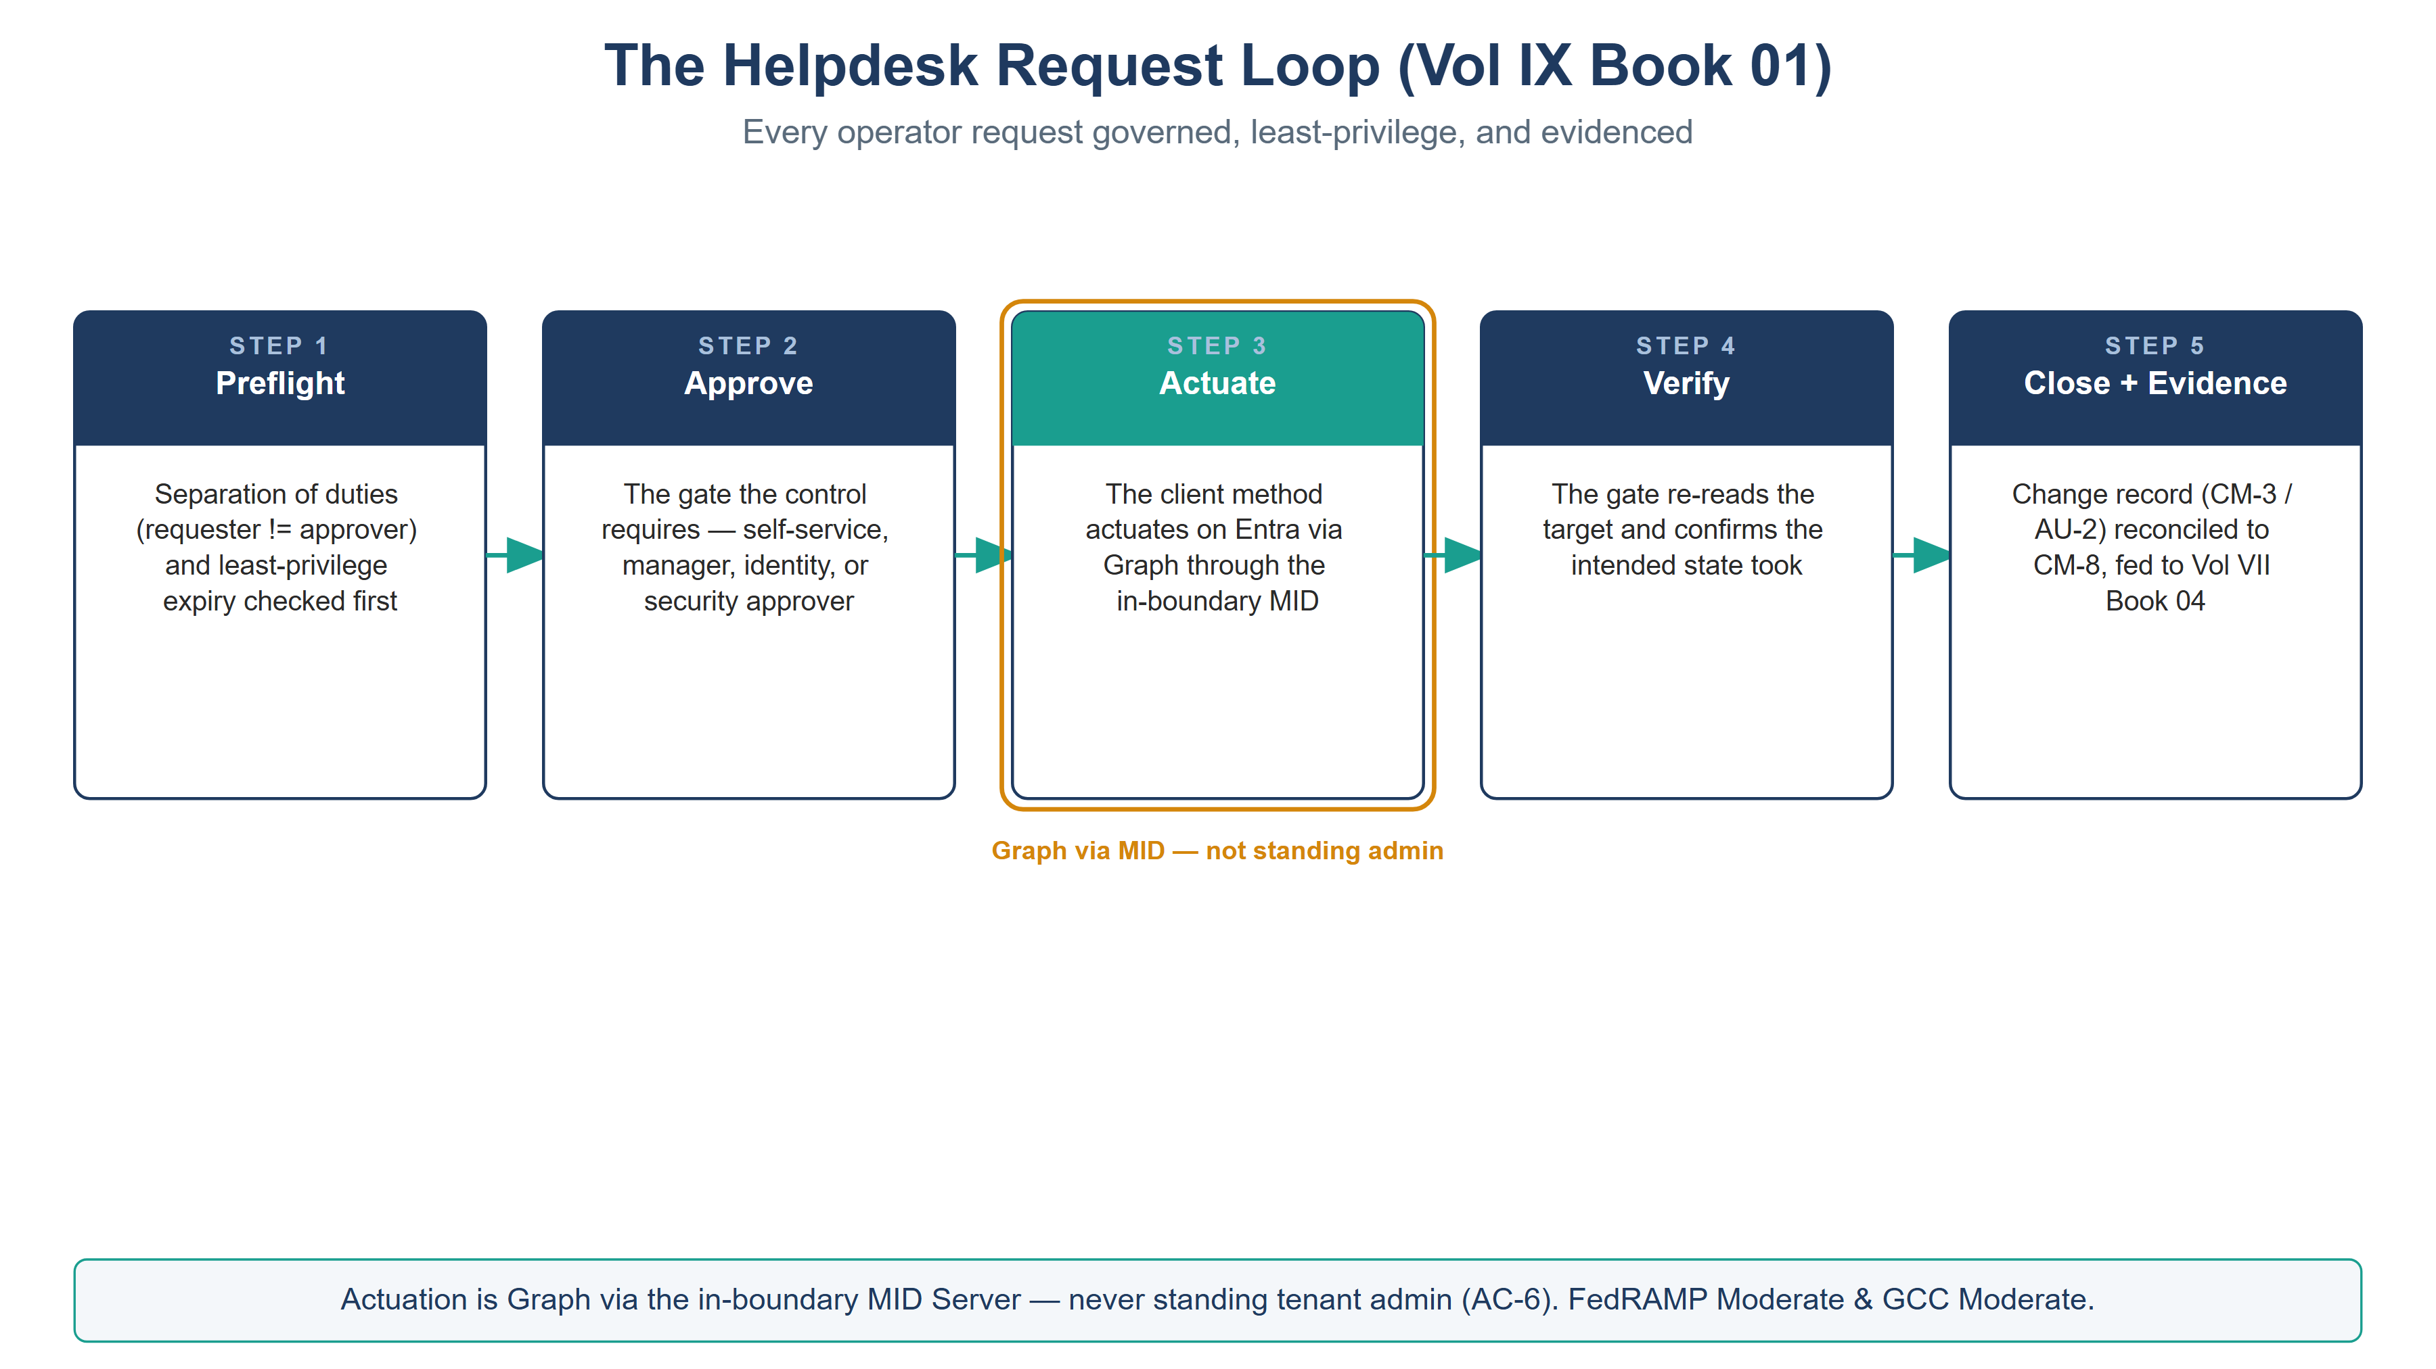
The helpdesk request loop — preflight safety, approve, actuate via the in-boundary MID, verify, close with evidence
Every item runs the same governed loop — the day-2 analogue of the Vol VII compliance loop:
- Request — a typed catalog item against the reconciled identity CI, with the requester, target, and justification.
- Approve — the gate the control requires (self-service, manager, identity, owner, or security approver — per the control map).
- Actuate — Microsoft Graph through the in-boundary MID Server; the connector holds scoped, logged, individually-approved write — never standing tenant admin (AC-6).
- Evidence — the request, approval, and Graph result become a change record (CM-3 / AU-2) reconciled to the CM-8 CMDB, feeding Vol VII Book 04 attestation.
The leaver is the one that fails audits. De-provisioning is an evidenced obligation, not a courtesy: disable the account, revoke active sessions and refresh tokens, and reassign owned objects (groups, app ownerships, mailboxes). A leaver “done” with no evidence trail is an orphaned-credential finding waiting to happen — the exact gap the audited catalog closes.

Closure Necessity

Closure Necessity — the help desk is a control surface, not a convenience
Volumes I and VII establish that verified identity, phishing-resistant auth, and least privilege are the mechanisms. This book makes the routine exercise of those mechanisms governed and evidenced. Without it, AC-2, IA-5, and AC-6 are eroded a hundred small clicks at a time — each unlogged, each least-privilege by hope. The catalog does not add a new control; it stops the highest-frequency operations from quietly dismantling the ones already claimed.

NIST SP 800-53 Rev 5 Control Closure — Authorities Closed Here
Generated from the compliance spine (aan-compliance-spine.yml) by render_authorities_table.py; not hand-edited here.
Authorities Closed Here â€” Helpdesk & ITSM Catalog (Entra Â· M365 Â· Azure) (â€ = Closure-Necessity anchor: no alternate closure path)
Control | Title | Closing mechanism (function, not product) | Accreditation gate | Authority drivers | Evidence slot | FedRAMP 20x KSI | Tool-attestable?
AC-2 | Account Management | Joiner/mover/leaver, guest invite, and license/group requests as governed ServiceNow catalog items over Entra (Graph via in-boundary MID); leaver de-provisioning evidenced | FedRAMP Moderate | NIST SP 800-53 Rev 5; OMB M-22-09 | Identity | KSI-IAM | No
AC-3 | Access Enforcement | Conditional Access exceptions issued only as governed catalog items with a mandatory expiry and a scheduled access review â€” an exception weakens a blocking enforcement control and is treated as such, never granted standing | FedRAMP Moderate | NIST SP 800-53 Rev 5; OMB M-22-09 | Identity | KSI-IAM | No
AC-6 | Least Privilege | Group and privileged-access requests time-bound and access-reviewed; no standing elevation granted by a helpdesk click | FedRAMP Moderate | NIST SP 800-53 Rev 5; OMB M-22-09 | Identity | KSI-IAM | No
IA-5 | Authenticator Management | Password reset, MFA-method reset, and account unlock as identity-verified catalog items (self-service via SSPR where policy allows; else approver-gated) | FedRAMP Moderate | NIST SP 800-53 Rev 5 | Identity | KSI-IAM | No

Honest Limits
- Self-service items (SSPR, unlock) are only as strong as the tenant’s authentication-method policy; a weak SSPR policy is a Vol VI Book 02 configuration concern, not a catalog fix.
- The catalog governs the request; a standing global administrator can still act out of band — Vol VII Book 02 detections and access reviews catch that.
- Substituting the ITSM platform changes the catalog and connector syntax; the request→approve→actuate-via-MID→evidence discipline is invariant.

Cross-References
- servicenow-day2/helpdesk-control-map.json — the machine-readable catalog → control binding this book documents.
- Vol I Book 04 (HRIT Identity SSOT) — the identity source of truth the JML items provision from.
- Vol VII Book 02 — the Conditional-Access exception pattern this catalog reuses; Vol VII Book 04 — where the audited actions become attestation.
- Vol IX Book 03 — app-registration governance (service-principal identity lifecycle, the machine analogue of JML).

Provenance
Draft. ServiceNow, Microsoft Graph, and Entra are deployed examples; the request→approve→actuate-native→evidence discipline is the invariant. Vendor claims cite vendor documentation. The figure above is authored as committed house-style SVG, rendered to PNG at 3× for crisp .docx zoom.

