Vol VII Book 02 — Federal Application-Aware Networking — M365 Federal Control Compliance Automation
  - SCuBA baseline drift, Conditional Access exceptions, and Purview data-protection state, operated as ServiceNow work
SSA Cloud Services Team
2026-07-12 15:00 ET
INTERNAL — NOT FOR PUBLIC DISTRIBUTION

Draft Proposal — Subject to Review
Developed by the CSI Team (Cloud Services Infrastructure); not yet reviewed or approved by the SSA CIO Office, OIS, or leadership. Date Code: 2026-07-12 15:00 ET
Series Context — Volume VII Book 02. The M365 half of the coordination layer. Microsoft 365 is the SaaS control plane — identity, Conditional Access, secure-configuration baselines (CISA SCuBA / BOD 25-01), and Purview data protection. This book operates that surface’s control state as ServiceNow work: drift becomes a tracked task, a task closure produces evidence, and the roll-up feeds attestation (Vol VII Book 04). Actuation stays platform-native — Graph and the M365 policy engines make the change; ServiceNow governs who, when, under what approval, and with what evidence.

What This Document Addresses
The M365 boundary carries a dense set of federal control obligations: phishing-resistant authentication and Conditional Access (IA-2, AC-3), account lifecycle, separation of duties, and least privilege (AC-2, AC-5, AC-6), secure-configuration baselines mandated by CISA SCuBA and BOD 25-01 (CM-6), and data protection through Purview (AC-4, SC-28, AU-10, covered in depth in Vol III Book 05). Each obligation has a tested state and a drift condition, and each drift condition needs an owner, a clock, and a closure record before an assessor will treat the control as operating.
This book shows how M365 control state is turned into ServiceNow work without ServiceNow becoming the M365 admin console. The pattern is uniform across every control family: detect drift on the native surface → raise a typed task against the reconciled CI → route to the owner → verify closure on the native surface → emit evidence.

The M365 Compliance Loop
Every M365 control family runs the same five-step loop. The surface differs; the loop does not.
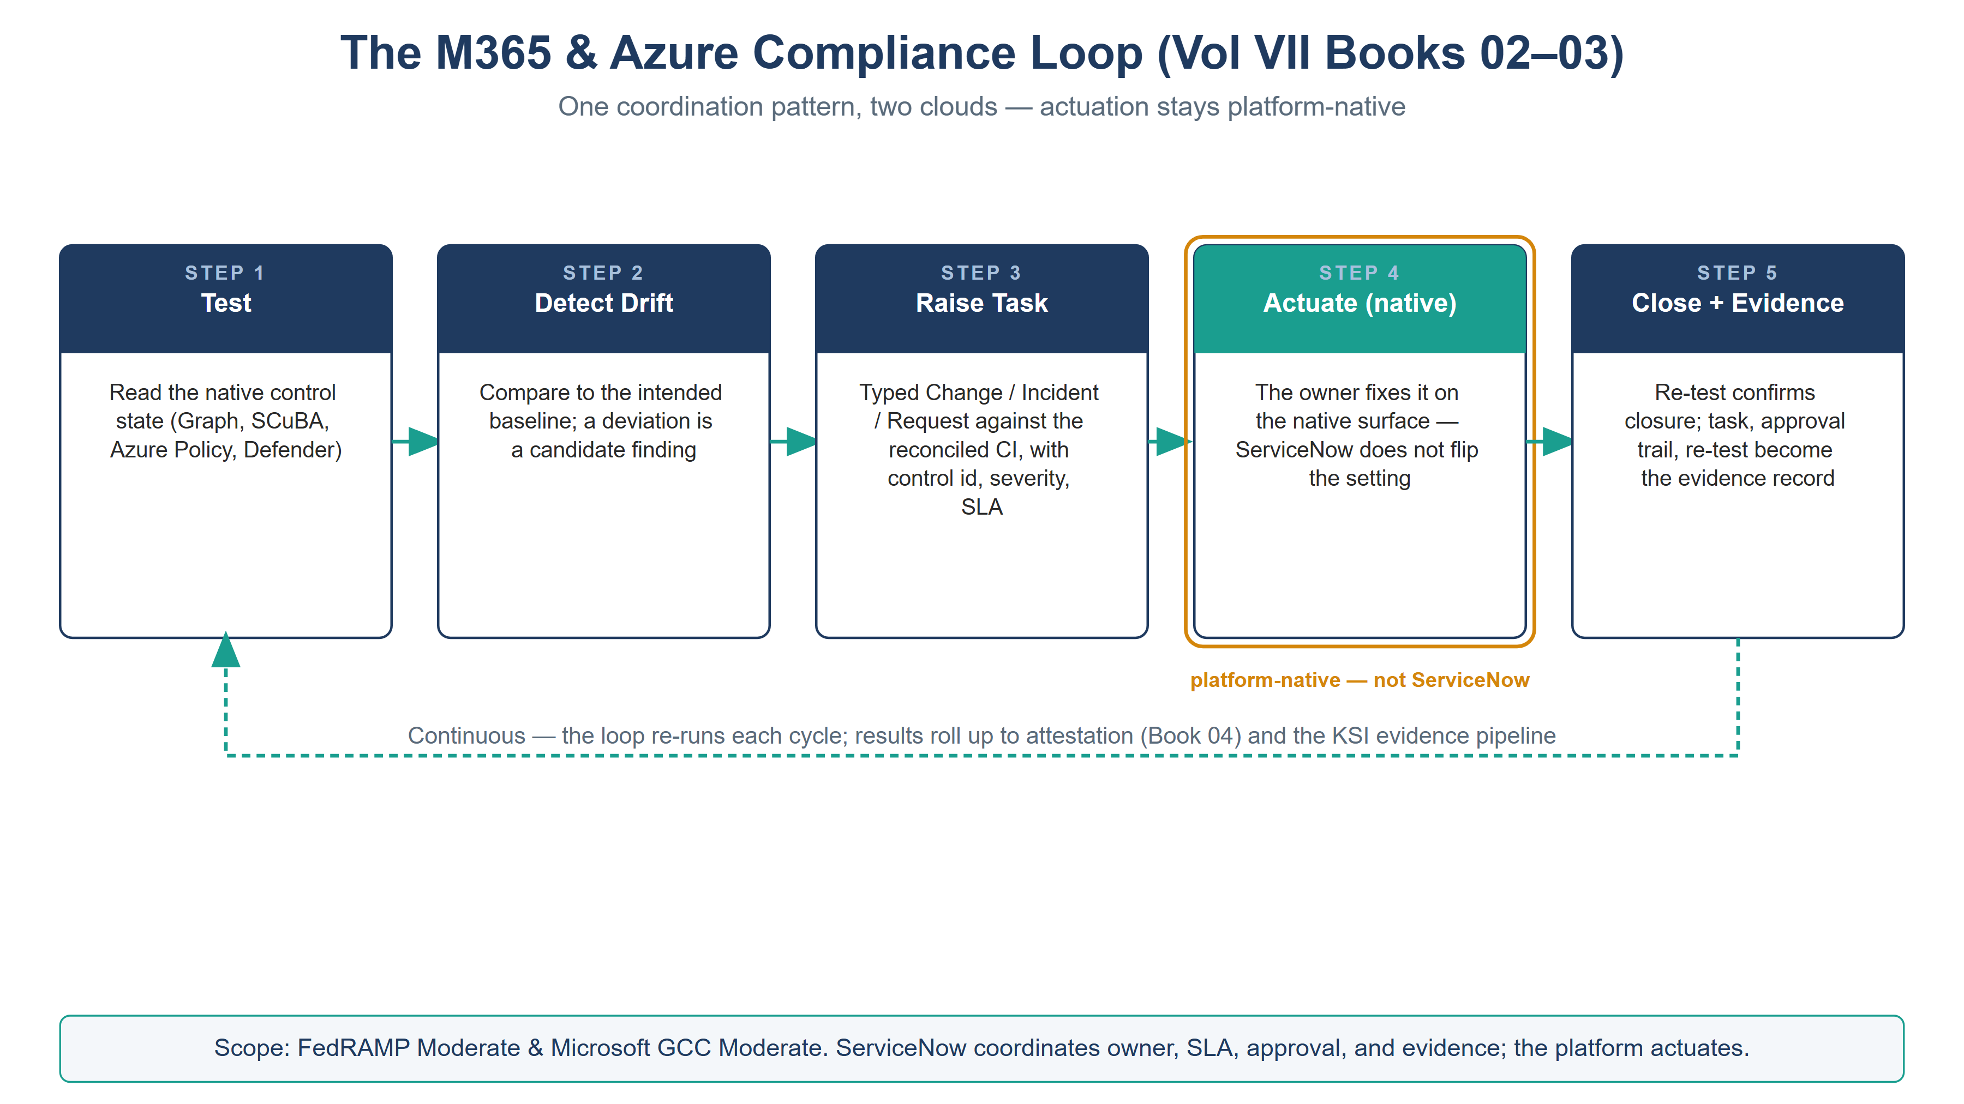
The five-step M365 and Azure compliance loop — test, detect drift, raise task, actuate on the native surface, close with evidence — with actuation marked platform-native
Step | What happens | Where it happens
1. Test | The M365 control state is read — SCuBA/secure-baseline result, CA policy inventory, Purview label/DLP posture | Native (Graph, SCuBA tooling, Purview) — in-boundary read
2. Detect drift | Read state is compared to the intended baseline; a deviation is a candidate finding | ServiceNow (or the native tool, ingested)
3. Raise | A typed task (Incident / Change / Request) is created against the reconciled CI, with control id, severity, and SLA class | ServiceNow
4. Actuate | The owner makes the change on the native surface (Graph / CA / Purview); ServiceNow does not flip the setting | Native — platform actuation
5. Close + evidence | Re-test confirms closure; the task, approval trail, and re-test result become the evidence record | ServiceNow → evidence pipeline
Why ServiceNow does not actuate M365 directly. A workflow platform holding standing write authority over Conditional Access or tenant configuration is itself a privilege-escalation and blast-radius problem (AC-6). The coordination role needs read over control state and task-creation over its own tables — not admin over the estate it governs. Where an automated remediation is genuinely safe and reversible, it is invoked as a scoped, logged, individually-approved action, never as blanket standing access.

Control Family 1 — SCuBA / Secure-Configuration Baseline Drift (CM-6)
CISA SCuBA (operationalized under BOD 25-01) defines secure-configuration baselines for the M365 services. The conformance tooling (ScubaGear and equivalents) measures drift from those baselines; it does not, by itself, own the fix. That gap is exactly the coordination role.
- Test: the SCuBA/secure-baseline assessment runs on a schedule and produces a per-policy pass/fail result.
- Detect + Raise: each new fail becomes a ServiceNow Change (if it needs a controlled configuration change) or Incident (if it is an unexpected regression), tagged with the SCuBA policy id, the mapped NIST control (CM-6), a severity, and the reconciled service CI.
- Actuate: the owning team applies the baseline setting via the M365 admin surface / policy-as-code (Vol VI Book 06 carries the SCuBA-as-code baseline).
- Close: the next assessment pass flips the result to pass; ServiceNow closes the task and stamps the re-test evidence.
The SCuBA finding-to-task mapping is held as data (a control map), so the same finding always raises the same typed task with the same control binding — reproducible, not ad hoc.

Control Family 2 — Account Lifecycle & Conditional Access Exceptions (AC-2)
Identity is the M365 control surface with the most standing human work: joiner/mover/leaver events, privileged-role requests, and Conditional Access exceptions (the break-glass account, a temporary block on a legacy client, a scoped exclusion for a service). Each is an access decision that must be requested, approved, time-bound, and reviewed.
- Request: a JML or CA-exception request enters as a ServiceNow Request with the target identity CI, the justification, and a required expiry.
- Approve: the request routes through the approval chain; a CA-exception request additionally requires a security approver, because an exception weakens a blocking control.
- Actuate: on approval, the identity team applies the change to Entra via Graph (the account provisioned, the exclusion group membership set) — logged, scoped, and reversible.
- Review: every exception carries an expiry; ServiceNow drives the access review that re-attests or revokes it. An expired-but-still-present exclusion is a high-severity finding, not a quiet default.
This is the AC-2 / AC-5 / AC-6 lifecycle expressed as reviewable work: the break-glass exclusion mandated in every blocking CA policy (Vol VI Book 02) is visible in the request record and its review, which a portal screenshot can never prove over time.

Control Family 3 — Purview Data-Protection State (feeds AU-10 / SC-28)
Purview owns the M365 data-protection controls in depth (Vol III Book 05): sensitivity labels, DLP policy, and the audit trail behind AU-10 and SC-28. The coordination role here is narrower — Purview is the actuation and evidence engine — but two workflows still belong in ServiceNow:
- DLP-override and mass-label-change review. A user override of a DLP block, or a mass label-removal/decrypt event, is a Vol III Book 05 detection and a ServiceNow Incident with a review task — the human-judgment step the detection cannot make.
- Label/DLP policy change control. A change to the label taxonomy or a DLP rule is a compliance-affecting change; it carries a ServiceNow Change record (CM-3) so the data-protection posture has an approval trail, not a silent edit.
Purview state (label coverage, DLP policy version, audit-retention configuration) is ingested as attestation input feeding CA-7, so the data-protection control shows as operating with evidence, not merely configured.

Continuous Monitoring Roll-Up (CA-7)
Each loop above emits its result — the SCuBA pass/fail, the exception review outcome, the Purview posture read — into the continuous-monitoring feed. ServiceNow rolls these into a per-control M365 posture that Vol VII Book 04 turns into attestation and KSI evidence. The point of the roll-up is that CA-7 is satisfied by actioned monitoring: drift that becomes a task that becomes closure that becomes evidence, not a dashboard nobody works.

Closure Necessity

Closure Necessity — SCuBA measures the gap; someone must own the close
The conformance tooling (ScubaGear and equivalents) proves where M365 deviates from the secure baseline — it authors no fix and owns no clock. The architecture and Vol VI baseline-as-code establish the mechanism; its sufficiency is what the Vol VI Book 08 validation harness demonstrates. This book is what makes M365 closure operating: every deviation gets an owner, an SLA, an approval trail, and a re-tested evidence record. Remove it and SCuBA becomes a report that is read and not acted on — the exact conformance-tooling coverage gap the series names (Theme E), one surface at a time.

NIST SP 800-53 Rev 5 Control Closure — Authorities Closed Here
Generated from the series compliance spine (aan-compliance-spine.yml) by render_authorities_table.py; not hand-edited here. These are coordination closures — the M365 control state operated as tracked work — not a re-closure of the identity/data mechanisms Volumes I, III, and VI already own.
Authorities Closed Here — M365 Federal Control Compliance Automation († = Closure-Necessity anchor: no alternate closure path)
Control | Title | Closing mechanism (function, not product) | Accreditation gate | Authority drivers | Evidence slot | FedRAMP 20x KSI | Tool-attestable?
AC-2 | Account Management | Joiner/mover/leaver and Conditional-Access exception requests raised, approved, and access-reviewed as ServiceNow tasks over the Entra estate | FedRAMP Moderate | NIST SP 800-53 Rev 5; OMB M-22-09 | Identity | KSI-IAM | No
CA-7 | Continuous Monitoring | M365 control-test results (Graph, SCuBA, Purview) ingested as attestation tasks feeding the KSI evidence pipeline | FedRAMP Moderate | NIST SP 800-53 Rev 5; NIST SP 800-137; FedRAMP 20x KSIs | Telemetry | KSI-MLA | No
CM-6 | Configuration Settings | SCuBA / secure-baseline drift on the M365 SaaS surface raised as a ServiceNow Incident/Change task and tracked to closure (actuation stays platform-native) | FedRAMP Moderate | NIST SP 800-53 Rev 5; CISA SCuBA; CISA BOD 25-01 | Security / supply chain | KSI-CMT, KSI-SVC | No

Honest Limits
- A ServiceNow task closes when the native re-test passes — so the loop is only as trustworthy as the test. A SCuBA check that does not cover a setting leaves a blind spot ServiceNow cannot see; test coverage is a Vol VI Book 08 concern.
- Automated remediation on the M365 surface is used sparingly and always scoped and logged; the default is human-actuated change with an approval trail, because standing write authority over Conditional Access is a control weakness in itself.
- Purview is the data-protection actuation and evidence engine; ServiceNow coordinates the human-judgment and change-control steps around it, not the classification itself.

Cross-References
- Vol VI Book 02 (Identity & Access as Code) — the Conditional Access / PIM policy this book governs the exceptions and reviews for.
- Vol VI Book 06 (Configuration Baselines & Hardening) — the SCuBA-as-code baseline whose drift this book routes.
- Vol III Book 05 (Data Protection — Purview) — the data-protection controls this book coordinates the review and change-control steps for.
- Vol VII Book 01 — the reconciled CIs every M365 task is raised against.
- Vol VII Book 04 — where the M365 posture roll-up becomes attestation and KSI evidence.

Provenance
Draft. Microsoft 365, Graph, SCuBA/ScubaGear, and Purview are deployed examples; the detect→raise→actuate-native→close→evidence loop is the invariant. Vendor claims cite vendor documentation (see References). The compliance-loop figure is authored as committed house-style SVG; further per-book figures follow in the PPTX→DOCX sync pass.

References
Claim | Source
SCuBA secure-configuration baselines for M365 (BOD 25-01) | CISA SCuBA — https://www.cisa.gov/scuba
Microsoft 365 secure-configuration assessment (ScubaGear) | https://github.com/cisagov/ScubaGear
Conditional Access & Entra account management via Graph | Microsoft Learn — https://learn.microsoft.com/graph/api/resources/conditionalaccesspolicy
Purview data-protection (labels, DLP, audit) | Microsoft Learn — https://learn.microsoft.com/purview/
ServiceNow as workflow/CMDB/evidence coordination hub | Expansion Plan §16 — inbox/Application Aware Networking/AAN_Series_Expansion_Plan_Substrate_Accreditation.md

