Vol VII Book 03 — Federal Application-Aware Networking — Azure Federal Control Compliance Automation
  - Azure Policy, Defender for Cloud, and Update Manager control state, operated as ServiceNow work
SSA Cloud Services Team
2026-07-12 15:00 ET
INTERNAL — NOT FOR PUBLIC DISTRIBUTION

Draft Proposal — Subject to Review
Developed by the CSI Team (Cloud Services Infrastructure); not yet reviewed or approved by the SSA CIO Office, OIS, or leadership. Date Code: 2026-07-12 15:00 ET
Series Context — Volume VII Book 03. The Azure half of the coordination layer. Azure is the IaaS/PaaS control plane — resource configuration (Azure Policy), security posture (Defender for Cloud / MDVM), and flaw remediation (Update Manager, with Arc for hybrid reach). This book operates that surface’s control state as ServiceNow work, on the identical loop as the M365 book. Actuation stays platform-native — Azure Policy remediation tasks, Defender recommendations, and Update Manager runs make the change; ServiceNow governs ownership, SLA, approval, and evidence.

What This Document Addresses
Where M365 is a SaaS boundary the agency configures but does not host, Azure is a boundary the agency both configures and populates with its own workloads — so it carries the resource-configuration, vulnerability, and patch obligations directly: baseline configuration and settings (CM-2, CM-6), flaw remediation (SI-2), and vulnerability monitoring (RA-5). Azure’s native stack actuates all three; the coordination role is to make each one owned, clocked, approved where it changes state, and evidenced. CM-2’s registered closure sits in Vol III Book 03 (Patch & Systems Management); this book touches CM-2 only through Azure Policy’s actuation of that baseline, so its Authorities Closed Here table registers the coordination closures CM-6, SI-2, and RA-5.
This book runs the same five-step loop as Vol VII Book 02 — test → detect drift → raise a typed task against the reconciled CI → actuate on the native surface → close with evidence — over the three Azure control engines. The loop is deliberately identical across surfaces: one coordination pattern, two clouds, so the evidence and the assessor-facing story are uniform.
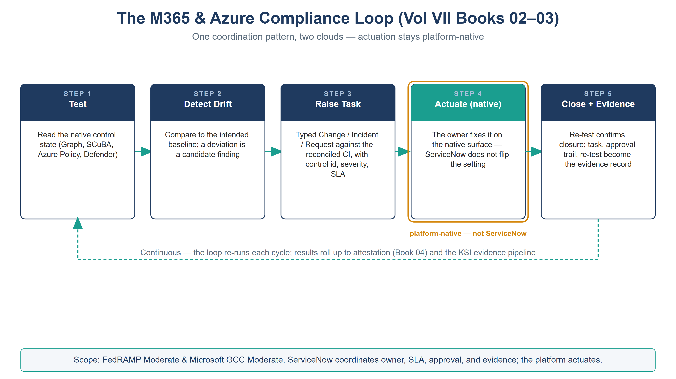
The five-step compliance loop, identical for Azure — test, detect drift, raise task, actuate on the native surface, close with evidence — with actuation marked platform-native

The Azure Control Engines and Their Coordination Role
Azure engine | Owns (actuation) | Control | ServiceNow coordination role
Azure Policy | Resource configuration compliance; deployIfNotExists/modify remediation | CM-2, CM-6 | Non-compliant resource → Change/remediation task against the CI; track native remediation to closure
Defender for Cloud / MDVM | Posture recommendations; workload & image vulnerability findings | CM-6, RA-5 | Recommendation/finding → prioritized Vulnerability-Response task; SLA by exposure
Update Manager (+ Arc) | Guest-OS patch assessment and deployment | SI-2, SI-2(2/3) | Patch result → Change/Incident; SLA-class task keyed to KEV/exposure
Arc is bounded, by doctrine — and this volume’s scope is Azure + Arc-for-hybrid. Azure Arc extends Update Manager and policy to hybrid Windows/Linux guest OS inside the GCC Moderate boundary; it does not patch ESXi, firmware, or a managed database service (Management-Plane Coordination Doctrine, Vol 0 Book 00). This volume coordinates the Azure and Arc-managed-hybrid surface only. Other CSPs (AWS, OCI, VMware) reconcile into the same ServiceNow SI-2 queue in a later follow-up (their native stacks are catalogued in Vol III Book 03); ServiceNow already coordinates a single queue, so adding those surfaces later needs no rework here.

Control Engine 1 — Azure Policy (CM-2 / CM-6)
Azure Policy continuously evaluates resource configuration against assigned definitions and can remediate a subset natively (deployIfNotExists / modify). The coordination role covers the rest — and the change control around all of it.
- Test: policy compliance state is read per assignment/resource (compliant / non-compliant / exempt).
- Detect + Raise: a non-compliant resource becomes a ServiceNow Change (for a controlled configuration change) tagged with the policy definition, the mapped control (CM-2/CM-6), severity, and the reconciled resource CI. An exemption is not silent — it is a request with an approver and an expiry, so a policy exception is reviewable (the same discipline as an M365 CA exception).
- Actuate: native Azure Policy remediation runs, or the owning team applies the configuration through infrastructure-as-code (Vol VI Book 01/06). ServiceNow does not write the resource.
- Close: the next evaluation flips the resource to compliant; ServiceNow closes and stamps the evidence.

Control Engine 2 — Defender for Cloud / MDVM (CM-6 / RA-5)
Defender for Cloud is the Azure posture engine (CSPM) and the vulnerability source for Azure workloads (MDVM) within the GCC Moderate boundary; Vol III Book 04 owns the posture architecture and Vol III Book 02 owns the assessment doctrine. (Defender for Cloud’s multi-cloud CNAPP reach is a later follow-up, out of scope here.) The coordination role turns its Azure findings into prioritized, owned remediation work.
- Test + Detect: Defender recommendations (misconfiguration) and MDVM findings (workload/image vulnerabilities) are read via the security-posture API.
- Raise: each finding becomes a ServiceNow Vulnerability Response task against the reconciled CI, with a severity and an SLA class derived from exposure and KEV status — the risk-based prioritization CISA BOD 22-01 and the four-variable model (BOD 26-04) call for.
- Actuate: the owning team remediates on the native surface — a configuration fix, an image rebuild (Vol VI Book 01), or a patch (Update Manager, below).
- Close: the finding clears on the next Defender assessment; ServiceNow closes the task, and the mean-time-to-remediate becomes an SI-2(3) / KSI metric.

Control Engine 3 — Update Manager + Arc (SI-2)
Azure Update Manager assesses and deploys guest-OS patches across Azure and, via Arc, hybrid Windows/Linux servers inside the GCC Moderate boundary. It is the SI-2 actuation engine for the guest OS; the coordination role reconciles its results into change/incident work with the SLA discipline SI-2(3) requires.
- Test: Update Manager’s assessment reports missing updates per machine, classified (critical / security / other).
- Raise: a missing critical/security update becomes a ServiceNow Change (scheduled maintenance) or Incident (an out-of-cycle KEV exposure), with an SLA class keyed to KEV/exposure — the BOD 26-04 model. The same SLA discipline is what other-CSP patch queues will reconcile into when they are added later (Vol III Book 03).
- Actuate: Update Manager deploys the patch in the approved maintenance window; ServiceNow does not push the update, it schedules and governs it.
- Close + evidence: post-deployment assessment confirms the update landed; the Change record, approval, window, and re-assessment become the SI-2(2) machine-readable remediation-status evidence.
Scan is not remediation, and remediation is not the record. Vol III Book 02 measures the gap (RA-5); Update Manager and the native stacks close it (SI-2); this book is the record and clock — the owned task, the approved window, the SLA, and the closure evidence. Three distinct jobs; conflating them is how a “patched” estate still fails an assessment for want of evidence.

Continuous Monitoring Roll-Up (CA-7)
Each engine’s loop emits its result into the continuous-monitoring feed: policy-compliance percentage, open Defender findings by severity and age, patch SLA conformance. ServiceNow rolls these into a per-control Azure posture that Vol VII Book 04 turns into attestation and KSI evidence, keyed to the same reconciled asset identity the M365 posture uses — so the two clouds produce one compliance picture, not two.

Closure Necessity

Closure Necessity — Azure actuates; the estate still needs an owner and a clock
Azure Policy remediates, Defender recommends, Update Manager patches — the native stack is genuinely sufficient to change state. What it does not supply is the governance wrapper: who owns this finding, by when, under whose approval, with what evidence. Strip the coordination layer and Azure’s own consoles show green while the authorization package has no owned-and-evidenced record an assessor can trace. CM-6, SI-2, and RA-5 are closed by Azure; they are operated — owned, clocked, evidenced — here.

NIST SP 800-53 Rev 5 Control Closure — Authorities Closed Here
Generated from the series compliance spine (aan-compliance-spine.yml) by render_authorities_table.py; not hand-edited here. Coordination closures — the Azure control state operated as tracked work — not a re-closure of the posture/patch mechanisms Volumes III and VI own.
Authorities Closed Here — Azure Federal Control Compliance Automation († = Closure-Necessity anchor: no alternate closure path)
Control | Title | Closing mechanism (function, not product) | Accreditation gate | Authority drivers | Evidence slot | FedRAMP 20x KSI | Tool-attestable?
CM-6 | Configuration Settings | Azure Policy / Defender-for-Cloud recommendations raised as ServiceNow remediation tasks; Azure-native remediation actuates, ServiceNow tracks to closure | FedRAMP Moderate | NIST SP 800-53 Rev 5; CISA SCuBA | Security / supply chain | KSI-CMT | No
RA-5 | Vulnerability Monitoring and Scanning | Defender for Cloud / MDVM findings on Azure workloads flow to ServiceNow Vulnerability Response as prioritized remediation tasks | FedRAMP Moderate | NIST SP 800-53 Rev 5; CISA BOD 22-01 | Security / supply chain | KSI-MLA | No
SI-2 | Flaw Remediation | Azure Update Manager patch results reconciled into ServiceNow Change/Incident with SLA-class tasks keyed to KEV/exposure (actuation platform-native) | FedRAMP Moderate | NIST SP 800-53 Rev 5; CISA BOD 26-04 | Endpoint | KSI-SVC, KSI-MLA | No

Honest Limits
- A task closes when the native re-evaluation passes; Azure Policy/Defender assessment latency means “closed” can lag actual state by an evaluation cycle. Evidence timestamps record the cycle, not the instant.
- Arc governs guest OS only; ESXi, firmware, and managed-service patching reconcile in from their own native stacks (Vol III Book 03). Treating Arc as the whole management plane is a doctrine violation the reconcile-exception queue is meant to catch.
- Native Azure Policy auto-remediation (deployIfNotExists/modify) still carries a Change record — automated actuation does not waive change control (CM-3); it makes the change record’s actuator the policy engine rather than a person.

Cross-References
- Vol III Book 02 (Vulnerability Management) — the assessment half whose findings this book routes to remediation tasks.
- Vol III Book 03 (Patch & Systems Management) — the SI-2 queue this book’s Update Manager results reconcile into (Azure/hybrid now; other CSPs in a later follow-up).
- Vol III Book 04 (Cloud-Native Posture) — the Defender for Cloud posture architecture this book coordinates findings from.
- Vol VI Book 01/06 (Landing Zone / Baselines as Code) — the IaC that actuates many Azure remediations.
- Vol VII Book 01 — the reconciled CIs every Azure task is raised against; Vol VII Book 04 — where the Azure posture roll-up becomes attestation.

Provenance
Draft. Azure Policy, Defender for Cloud, MDVM, Update Manager, and Arc are deployed examples; the detect→raise→actuate-native→close→evidence loop is the invariant, identical to the M365 book. Vendor claims cite vendor documentation (see References). The compliance-loop figure is authored as committed house-style SVG; further per-book figures follow in the PPTX→DOCX sync pass.

References
Claim | Source
Azure Policy compliance & remediation | Microsoft Learn — https://learn.microsoft.com/azure/governance/policy/
Microsoft Defender for Cloud (CSPM/CNAPP, MDVM) | Microsoft Learn — https://learn.microsoft.com/azure/defender-for-cloud/
Azure Update Manager (guest-OS patch) | Microsoft Learn — https://learn.microsoft.com/azure/update-manager/
Azure Arc (hybrid guest-OS reach) | Microsoft Learn — https://learn.microsoft.com/azure/azure-arc/
Risk-based remediation prioritization (KEV; four-variable model) | CISA — https://www.cisa.gov/known-exploited-vulnerabilities-catalog
ServiceNow as workflow/CMDB/evidence coordination hub | Expansion Plan §16 — inbox/Application Aware Networking/AAN_Series_Expansion_Plan_Substrate_Accreditation.md

