{{todays date}}

{{UIM Adjuster}} Via Fax: {{UIM Adjuster fax}}
{{UIM Insurance company}} Via Fax: {{UIM Insurance fax}}

RE: Our Client(s): {{client name}}
Your Insured: {{insured name}}
Date of Loss: {{date of accident}}
Claim No.: {{UIM claim number}}

Dear Mr. UIM Adjuster las name}}:

This letter is being forwarded to your attention via certified mail per KRS 304.39-320. Please be advised that the insurance company for the at-fault driver, {{BI Insurance company}}, has offered to settle this claim for the total policy limits available under the applicable insurance policy.

Per the Kentucky Statute referenced above, please advise this office within (30) days of receipt of this correspondence whether my client has your “consent to settle” and may execute a full and final release or, alternatively, whether you wish to “retain your subrogation rights” by paying to the insured the amount of the written offer.

Please be advised my client(s) are making a UIM claim under the applicable insurance policies. Therefore, this letter should serve as notice under all applicable insurance policies. Also, I am requesting a full copy of all policies in the above referenced household. I look forward to hearing from you in the near future.

Please feel free to contact me at any time.
Sincerely,
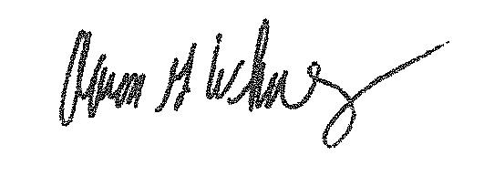
Aaron Whaley
Whaley Law Firm

