Name: Johnathan Van Vliet Mark _____________________/50

Brief introduction __/3
The following document describes the dynamic weather and difficulty systems within the game Just Fishing by Starfish Studios. These two systems are written together because they are both a part of and dependent upon one another.
Due to several factors and events within the game, some of which are random, a fishing trip may be more or less difficult than usual. This system manages that difficulty to keep gameplay new and exciting.

Use case diagram with scenario __14

Use Case Diagrams
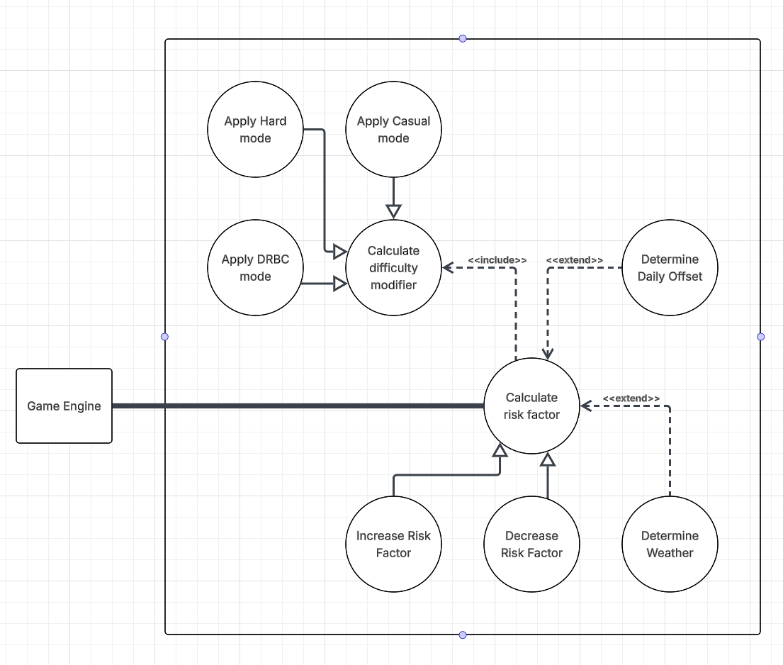

Scenarios
Name: Increase Risk Factor
Summary: Increases the risk factor by a certain amount
Actors: Game engine
Preconditions: Player performs a risky behavior
Basic sequence:
Step 1: Choice data is received
Step 2: Risk factor information is retrieved
Step 3: Risk factor data is calculated by adding the new value to the old one
Exceptions:
1: Risk factor reaches maximum value, at which point the player hits a loss condition
Post conditions: Risk factor is sent to game engine which uses it to determine the success rate of other actions. UI is updated with new risk factor.
Priority: 1*
ID: RF_INC

Name: Decrease Risk Factor
Summary: Decreases the risk factor by a certain amount
Actors: Game engine
Preconditions: Player performs a safer behavior
Basic sequence:
Step 1: Choice data is received
Step 2: Risk factor information is retrieved
Step 3: Risk factor data is calculated by subtracting the new value from the old one
Exceptions:
Step 1: Risk factor reaches minimum value, at which point the value is kept at the minimum value
Post conditions: Risk factor is sent to game engine which uses it to determine the success rate of other actions. UI is updated with new risk factor.
Priority: 1*
ID: RF_DEC

Name: Determine Daily Risk Offset
Summary: Randomly generates an offset to the current risk factor and adds it to the current risk factor
Actors: Game engine
Preconditions: A new day begins
Basic sequence:
Step 1: Get current risk factor
Step 2: Generate random offset
Step 3: Add offset to current risk factor
Exceptions:
1: The game ends, at which point the days stop counting and the risk calculation stops
Post conditions: Risk factor is sent to game engine which uses it to determine the success rate of other actions. UI is updated with new risk factor.
Priority: 2*
ID: RF_DAY

Name: Determine weather
Summary: Randomly determines the weather each morning. The weather will increase or decrease the risk factor
Actors: Game engine
Preconditions: A time of day is reached or a new day begins
Basic sequence:
Step 1: Generate random number
Step 2: Determine weather conditions using random number
Step 3: Add offset to current risk factor
Exceptions:
1: The same weather conditions are determined, in which case the risk factor is not changed.
2: The game ends, at which point time stops moving and weather stops changing.
Post conditions: Risk factor is sent to game engine which uses it to determine the success rate of other actions. UI is updated with new risk factor. Background assets and sound change to reflect
Priority: 3*
ID: RF_WEA

Name: Calculate difficulty modifier
Summary: Modifies risk factor based on current difficulty
Actors: Game engine
Preconditions: Risk factor is changed
Basic sequence:
Step 1: Detect risk factor change
Step 2: Modify risk factor based on selected difficulty
Exceptions:
1: Casual mode is selected, which results in no change
Post Conditions: The Game Engine uses the new risk factor rather than the pre-adjusted one.
Priority: 3*
ID: RF_DIF

*The priorities are 1 = must have, 2 = essential, 3 = nice to have.

Data Flow diagram(s) from Level 0 to process description for your feature _______14

Data Flow Diagrams
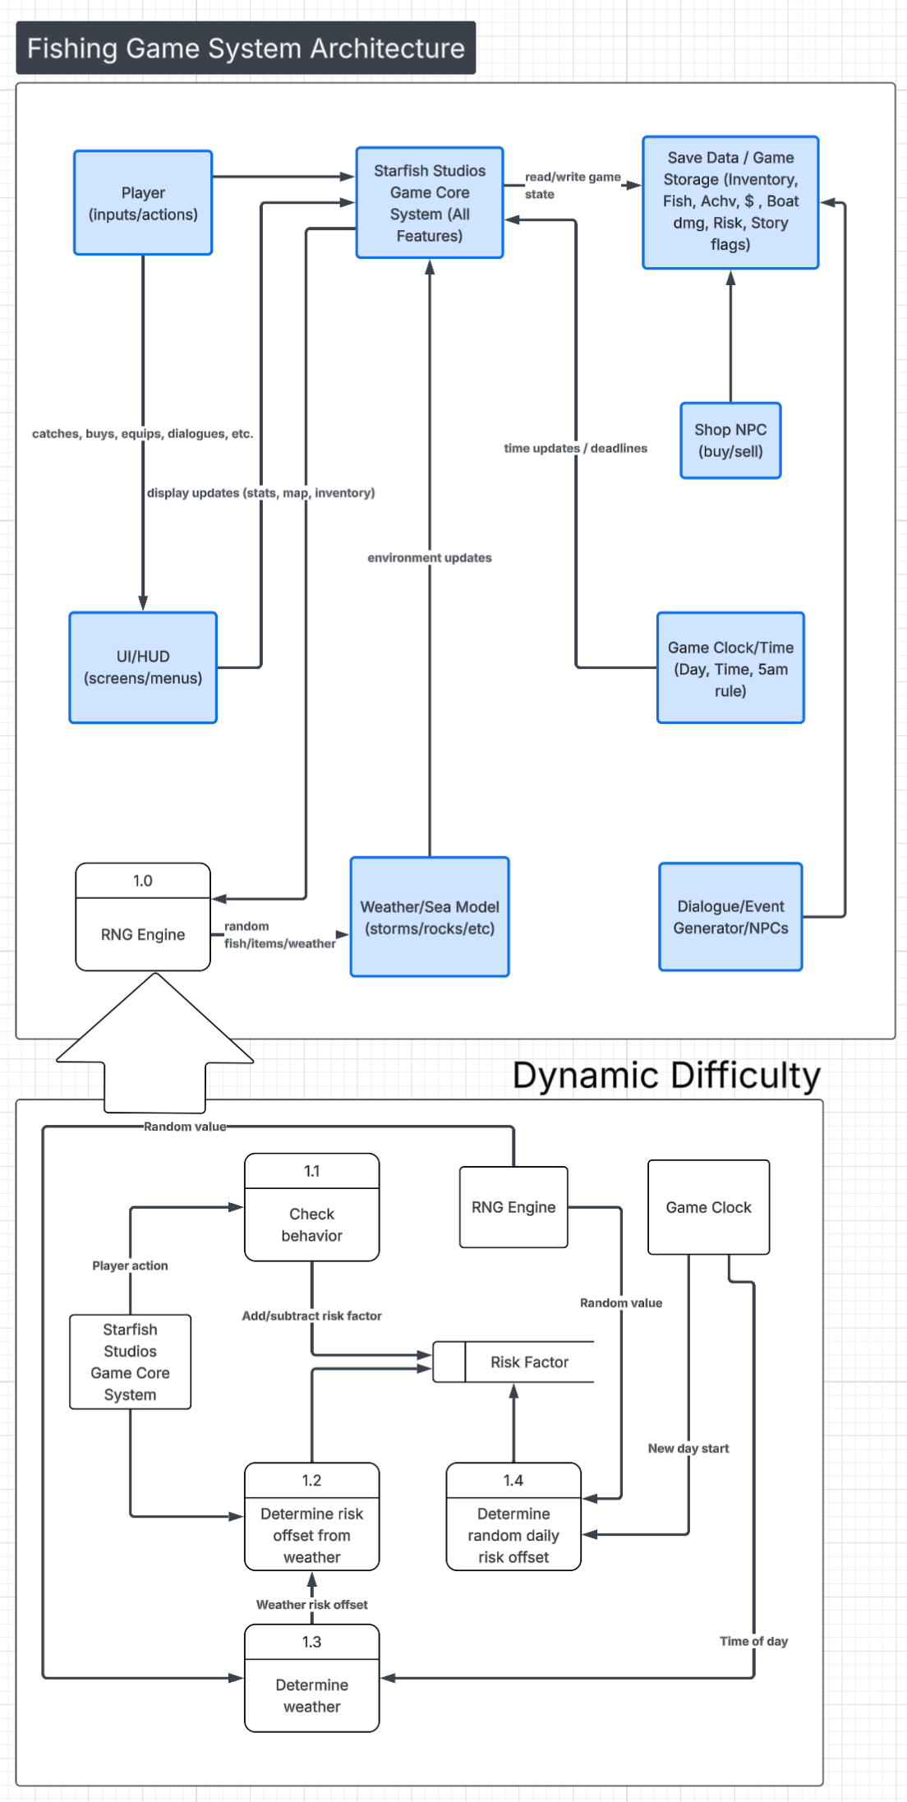

Process Descriptions
// INITIALIZATION
GLOBAL RiskFactor = 0.0
GLOBAL CurrentWeather = "Clear"

FUNCTION MainDifficultyLoop():
WHILE GameIsRunning:
// 1.1 CHECK BEHAVIOR (Player Action Input)
player_risk = GameCore.GetPlayerActions()
behavior_offset = CheckBehavior(player_risk)

// Update Risk Factor based on skill/actions/luck
// behavior_offset can be positive or negative
RiskFactor += behavior_offset

// 1.2 & 1.3 WEATHER AND TIME
current_time = GameClock.GetTimeOfDay()
CurrentWeather = DetermineWeather(current_time)
weather_offset = CalculateWeatherRisk(CurrentWeather)
RiskFactor += weather_offset

// 1.4 DAILY RANDOMIZATION
IF GameClock.IsNewDayStart():
random_seed = RNGEngine.GetRandomValue()
daily_offset = DetermineDailyOffset(random_seed)

// behavior_offset can be positive or negative
RiskFactor += daily_offset

GameCore.ApplyDifficulty(RiskFactor)

WAIT(Next)

Acceptance Tests ________9

Success-Based Dynamic Difficulty
Test Num | Description | If | Then
TEST 1 | Player is being risky | Process risky actions | Behavior offset is positive and risk factor increases
TEST 2 | Player is being safe | Process safe actions | Behavior offset is negative and risk factor decreases
Risky actions will be simulated by feeding the game engine with an extreme number of randomized risky behavior value. The resulting risk value will then be logged.
Environmental Difficulty
Test Num | Description | If | Then
TEST 3 | Weather transitions | Weather changes states, such as from “stormy” to “clear” | Weather offset is changed and risk factor is changed accordingly
TEST 4 | Time of day reaches a threshhold | Time of day reaches dusk/night | Risk factor increases drastically

Daily Randomization
Test Num | Description | If | Then
TEST 5 | New day is triggered | It is a new day | The system pulls a random seed from the RNG Engine and applies an offset to risk factor
TEST 6 | New day is not triggered | It is not a new day | The system does nothing and continues

Timeline _________/10
Example:

Work items
Task | Duration (Days) | Predecessor Task(s)
1. Requirements Collection | 2 | -
2. Action Risk Calculation | 6 | 1
3. Weather Design | 1 | 1
4. Riskiness Database Construction | 2 | 2
5. Programming | 4 | 4,3
6. Integration and Balancing | 4 | 5
7. User Documentation | 2 | 4
8. Testing | 3 | 6
9. Installation | 2 | 6, 8

Pert diagram
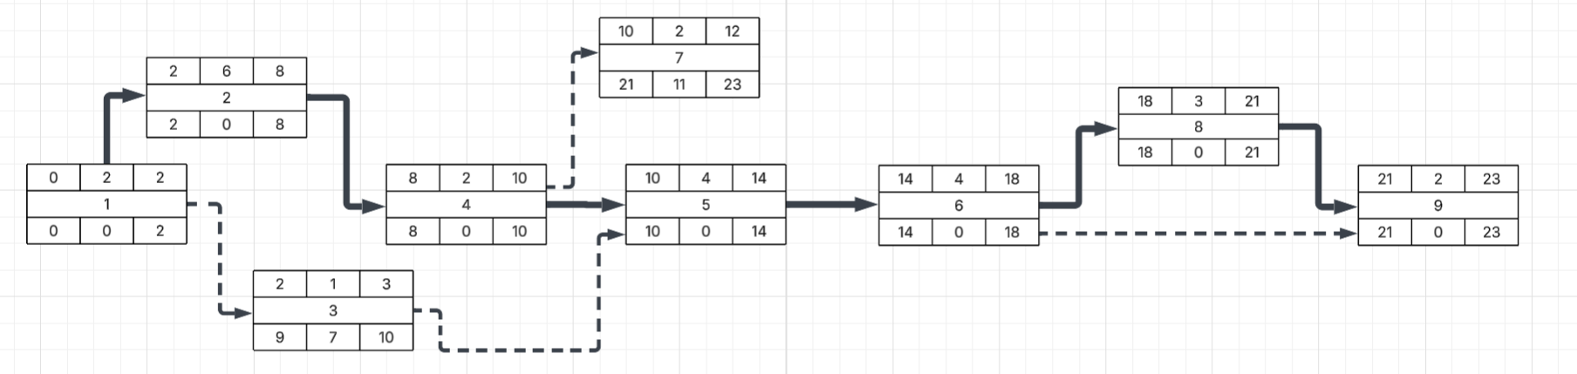

Gantt timeline
