TO: Profs. J. Hung and V. Nelson

FROM: Cameron Shea and Jake Neal

SECTION: Wednesday, 3:00 p.m.

DATE: 8 February 2019

SUBJECT: PWM Waveform Generation and Motor Driver

For the previous lab, the objective was to create and debug Pulse Width Modulation (PWM) signals with a programmable timer. The eleven duty cycles were selected with the keypad, and the chosen duty cycle was displayed on LEDs in binary.

The objective of the most recent lab was to design and test an amplifier that drives a D. C. Motor. This “motor drive” was constructed using a NPN Transistor, a flyback diode, and several resistors. The circuit, as well as a version with a dummy load, is found in Figure 1 and Figure 2.

*Testing Procedure*

For the previous lab, the hardware setup was verified in accordance with the lab manual. LEDs were also confirmed to be in proper operational order. Following this, several errors were found in our program; several instances of ‘_’ were corrected to ‘->’, and the output was set to OFF instead of ON, which was corrected. The program was then run on the *Discovery* board, and proper operation was demonstrated to a TA. All applicable keypad buttons were pressed and values measured at several frequencies.

In the most recent lab, our amplification circuit was added to the board, as shown in Figure 2. Power and Ground in our circuits were first checked, then double and triple checked. Then, the output pin for the PWM signal was connected to the Oscilloscope, and operation was verified. It was then found that when comparing the circuit with the dummy load, and then with the actual DC motor, changed the current I­­c to be much greater. Next, the oscilloscope was used to measure the Tachometer signal and compare both its amplitude and frequency to PWM duty cycle. This section was then repeated with a different frequency.

*Results*

For the previous lab, the Duty Cycle percentage was recorded in relation to key pressed, and the result is shown in Table 1. This confirmed not only that the program and circuitry was functioning properly, but that our results were extremely accurate.

For the most recent lab, the duty cycle selection was compared to Tachometer frequency (Figure 3) and amplitude (Figure 4) at 1kHz. This was repeated for 666Hz, and the results are shown in Figures 5 and 6. As can be seen, the slope of tachometer frequency or amplitude for both PWM frequency selections is approximately linear, but is zero or close to zero until 20% Duty Cycle. This demonstrates that our motor speed selection is working properly and moderately accurately, with the exception that at 10% Duty Cycle, the motor provides too much resistance to turn.

*Summary*

The data suggests that not only do the programs function properly, but that the timing involved is accurate for both the PWM signal and the Duty Cycles within it. It also shows that our keyboard has maintained full and accurate functionality, and that our amplifier is properly amplifying our chip output.

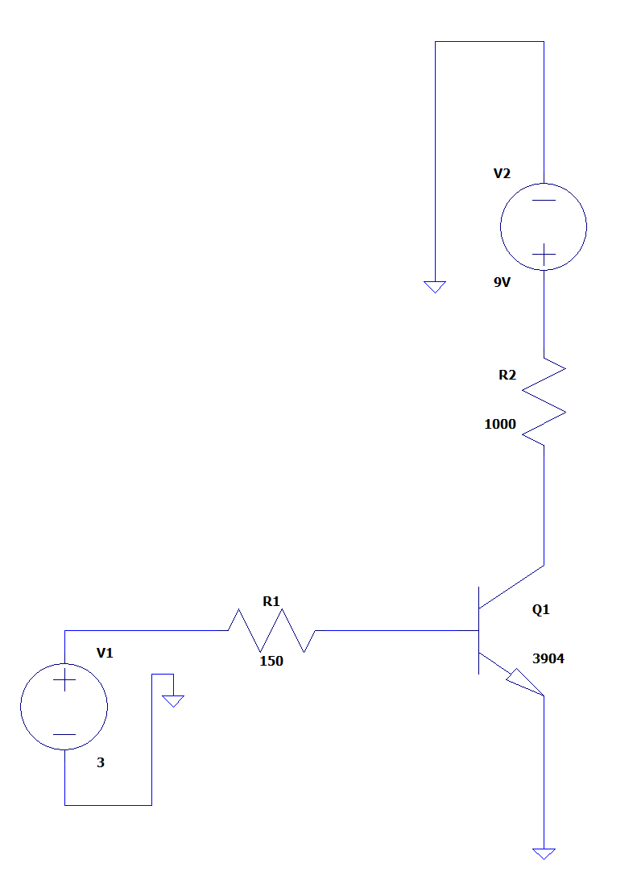

Figure 1. Amplifier circuity with Dummy 1kΩ Load. V1 is pin output.

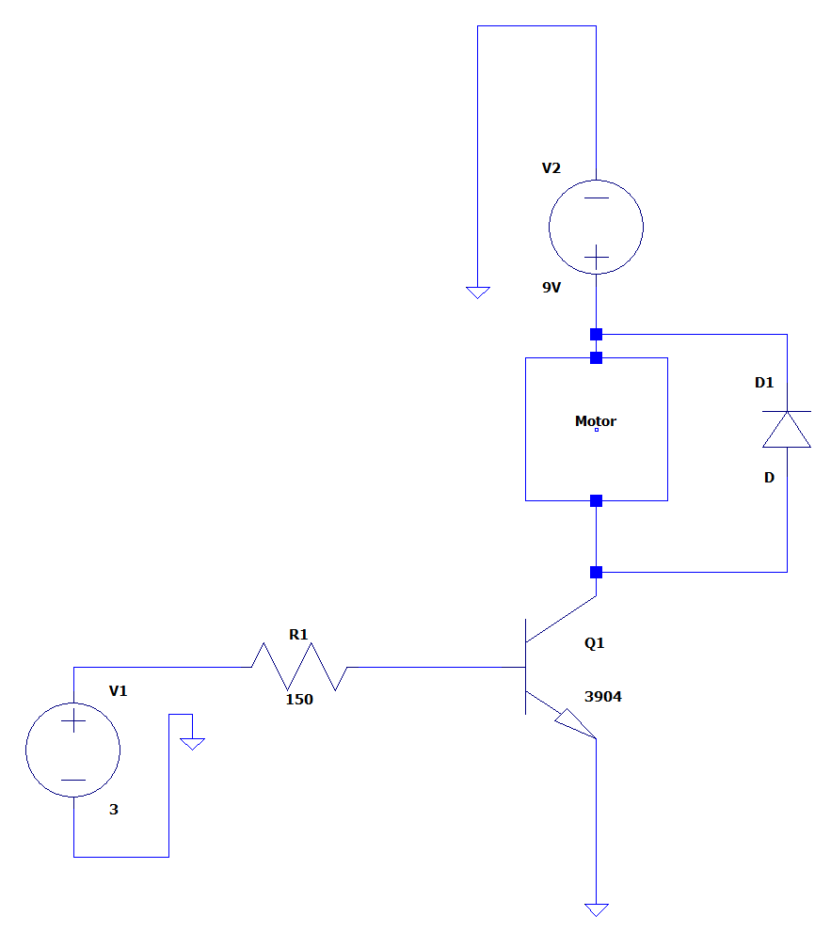

Figure 2. Amplifier circuity with Motor load and Flyback Diode. V1 is pin output.

|  |  |
| --- | --- |
| Key Selection | Duty Cycle (%) |
| 0 | 0 |
| 1 | 10 |
| 2 | 20 |
| 3 | 30 |
| 4 | 40 |
| 5 | 50 |
| 6 | 60 |
| 7 | 70 |
| 8 | 80 |
| 9 | 90 |
| A | 100 |

Table 1. Key Selection versus Duty Cycle percentage measured

Figure 3. Tachometer Frequency vs Duty Cycle selection at 1kHz

Figure 4. Tachometer Amplitude vs Duty Cycle selection at 1kHz

Figure 5. Tachometer Frequency vs Duty Cycle selection at 666Hz

Figure 6: Tachometer Amplitude vs Duty Cycle selection at 666Hz