《 机器学习 》实验报告

专业,学号 |  | 电子信息202530131052 |  | 姓名 | 张俊杰
实验题目 | 基于决策树算法的电信客户流失预测实验报告
实验时间 | 2026.3.17 |  | 实验地点 | 卓越工程师学院EB407
实验成绩 |  |  | 实验性质 | □验证性 □设计性 ☑综合性
教师评价：
□算法/实验过程正确； □源程序/实验内容提交 □程序结构/实验步骤合理；
□实验结果正确； □语法、语义正确； □报告规范；
其他：
评价教师签名：
- 实验目的
本实验旨在使用决策树算法对电信客户流失数据进行预测，重点掌握以下技能：
1. 理解并实现数据预处理：标签编码、独热编码、缺失值处理和特征缩放
2. 掌握处理类别不平衡问题的方法（使用class_weight='balanced'）
3. 运用GridSearchCV进行决策树超参数调优
4. 全面评估模型性能：准确率、精确率、召回率、F1-Score、混淆矩阵、ROC曲线和AUC值
- 实验项目内容
2.1 数据集描述
使用Telco Customer Churn数据集，该数据集包含7043条电信客户记录，每条记录包含21个特征，目标是预测客户是否会流失（Churn: Yes/No）。
2.2 数据预处理
（1）标签编码（Label Encoding）：对具有逻辑顺序的特征进行编码
Contract（合约类型）：Month-to-month → 0, One year → 1, Two year → 2
（2）独热编码（One-Hot Encoding）：对无等级之分的分类特征进行编码
特征包括：gender, Partner, Dependents, PhoneService, MultipleLines, InternetService, OnlineSecurity, OnlineBackup, DeviceProtection, TechSupport, StreamingTV, StreamingMovies, PaperlessBilling, PaymentMethod
（3）缺失值处理：TotalCharges列有11个空值，使用中位数（1397.47）填充
（4）特征缩放：使用StandardScaler对数值特征（tenure, MonthlyCharges, TotalCharges）进行标准化处理
2.3 类别不平衡处理
由于数据集中不流失客户（No: 73.46%）远多于流失客户（Yes: 26.54%），使用class_weight='balanced'参数自动调整类别权重，给少数类（流失客户）更高的损失权重。
2.4 超参数调优
使用GridSearchCV结合5折交叉验证进行超参数搜索，参数空间如下：
max_depth: [3, 5, 7, 10, None]
min_samples_split: [2, 5, 10, 20]
min_samples_leaf: [1, 2, 5, 10]
max_features: ['sqrt', 'log2', None]
criterion: ['gini', 'entropy']
三、实验过程或算法（源程序，正文宋体小四，单倍行距，1.25倍，代码格式使用Times New Roma）
源程序:

```python
import pandas as pd
import numpy as np
from sklearn.model_selection import train_test_split, GridSearchCV
from sklearn.tree import DecisionTreeClassifier
from sklearn.preprocessing import StandardScaler, LabelEncoder
from sklearn.metrics import (
classification_report,
confusion_matrix,
roc_curve,
auc,
accuracy_score,
roc_auc_score,
)
import matplotlib.pyplot as plt
import seaborn as sns
import os
import sys
from datetime import datetime

OUTPUT_DIR = "output"
AUC_REQUIREMENT = 0.80

def setup_output_directory():
os.makedirs(OUTPUT_DIR, exist_ok=True)

def log_message(message, log_file=None):
timestamp = datetime.now().strftime("%Y-%m-%d %H:%M:%S")
formatted_msg = f"[{timestamp}] {message}"
print(formatted_msg)
if log_file:
log_file.write(formatted_msg + "\n")
log_file.flush()

def load_data(filepath):
log_message(f"Loading data from {filepath}")
df = pd.read_csv(filepath)
log_message(f"Data loaded successfully. Shape: {df.shape}")
return df

def explore_data(df):
log_message("Exploring dataset...")

info = {
"total_samples": len(df),
"columns": list(df.columns),
"dtypes": df.dtypes.to_dict(),
"missing_values": df.isnull().sum().to_dict(),
"target_distribution": df["Churn"].value_counts().to_dict(),
}

for col in df.columns:
if df[col].dtype == "object":
unique_vals = df[col].unique()
if "Unknown" in unique_vals or " " in unique_vals:
log_message(f"Column '{col}' has 'Unknown' or blank values")

return info

def preprocess_data(df, log_file):
log_message("Starting data preprocessing...", log_file)
df = df.copy()

if "customerID" in df.columns:
df = df.drop("customerID", axis=1)
log_message("Dropped customerID column", log_file)

df["TotalCharges"] = pd.to_numeric(df["TotalCharges"], errors="coerce")
missing_total = df["TotalCharges"].isnull().sum()
if missing_total > 0:
median_total = df["TotalCharges"].median()
df["TotalCharges"] = df["TotalCharges"].fillna(median_total)
log_message(
f"Filled {missing_total} missing TotalCharges with median: {median_total:.2f}",
log_file,
)

label_encoder = LabelEncoder()
contract_mapping = {"Month-to-month": 0, "One year": 1, "Two year": 2}
df["Contract"] = df["Contract"].map(contract_mapping)
log_message(f"Label encoded 'Contract': {contract_mapping}", log_file)

categorical_cols = df.select_dtypes(include=["object"]).columns.tolist()
categorical_cols = [c for c in categorical_cols if c != "Churn"]
log_message(f"One-Hot Encoding columns: {categorical_cols}", log_file)

df = pd.get_dummies(df, columns=categorical_cols, drop_first=True)
log_message(f"Data shape after encoding: {df.shape}", log_file)

df["Churn"] = df["Churn"].map({"Yes": 1, "No": 0})

X = df.drop("Churn", axis=1)
y = df["Churn"]

scaler = StandardScaler()
numeric_cols = ["tenure", "MonthlyCharges", "TotalCharges"]
X[numeric_cols] = scaler.fit_transform(X[numeric_cols])
log_message("Applied StandardScaler to numeric features", log_file)

return X, y, scaler

def get_param_grid():
param_grid = {
"max_depth": [3, 5, 7, 10, None],
"min_samples_split": [2, 5, 10, 20],
"min_samples_leaf": [1, 2, 5, 10],
"max_features": ["sqrt", "log2", None],
"criterion": ["gini", "entropy"],
}
return param_grid

def train_model(X_train, y_train, log_file):
log_message("Initializing Decision Tree with class_weight='balanced'", log_file)

base_model = DecisionTreeClassifier(class_weight="balanced", random_state=42)

param_grid = get_param_grid()
log_message(f"Parameter grid: {param_grid}", log_file)

log_message("Starting GridSearchCV with 5-fold cross-validation...", log_file)
grid_search = GridSearchCV(
estimator=base_model,
param_grid=param_grid,
cv=5,
scoring="roc_auc",
n_jobs=-1,
verbose=1,
)

grid_search.fit(X_train, y_train)

log_message(
f"GridSearchCV completed. Best Score (ROC-AUC): {grid_search.best_score_:.4f}",
log_file,
)
log_message(f"Best Parameters: {grid_search.best_params_}", log_file)

return grid_search.best_estimator_, grid_search

def evaluate_model(model, X_test, y_test, log_file):
log_message("Evaluating model on test set...", log_file)

y_pred = model.predict(X_test)
y_pred_proba = model.predict_proba(X_test)[:, 1]

accuracy = accuracy_score(y_test, y_pred)
roc_auc = roc_auc_score(y_test, y_pred_proba)

log_message(f"Accuracy: {accuracy:.4f}", log_file)
log_message(f"ROC-AUC Score: {roc_auc:.4f}", log_file)

report = classification_report(y_test, y_pred, target_names=["No", "Yes"])
log_message("\nClassification Report:\n" + report, log_file)

cm = confusion_matrix(y_test, y_pred)
log_message(f"\nConfusion Matrix:\n{cm}", log_file)

fpr, tpr, thresholds = roc_curve(y_test, y_pred_proba)
roc_auc_value = auc(fpr, tpr)

metrics = {
"accuracy": accuracy,
"roc_auc": roc_auc,
"classification_report": report,
"confusion_matrix": cm,
"fpr": fpr,
"tpr": tpr,
"roc_auc_value": roc_auc_value,
}

return metrics, y_pred, y_pred_proba

def plot_confusion_matrix(cm, save_path):
plt.figure(figsize=(8, 6))
sns.heatmap(
cm,
annot=True,
fmt="d",
cmap="Blues",
xticklabels=["No Churn", "Churn"],
yticklabels=["No Churn", "Churn"],
)
plt.title("Confusion Matrix - Decision Tree", fontsize=14)
plt.ylabel("Actual", fontsize=12)
plt.xlabel("Predicted", fontsize=12)
plt.tight_layout()
plt.savefig(save_path, format="pdf")
plt.close()
print(f"Confusion matrix saved to {save_path}")

def plot_roc_curve(fpr, tpr, roc_auc, save_path):
plt.figure(figsize=(8, 6))
plt.plot(
fpr, tpr, color="darkorange", lw=2, label=f"ROC curve (AUC = {roc_auc:.4f})"
)
plt.plot(
[0, 1], [0, 1], color="navy", lw=2, linestyle="--", label="Random Classifier"
)
plt.xlim([0.0, 1.0])
plt.ylim([0.0, 1.05])
plt.xlabel("False Positive Rate", fontsize=12)
plt.ylabel("True Positive Rate", fontsize=12)
plt.title("ROC Curve - Decision Tree", fontsize=14)
plt.legend(loc="lower right", fontsize=11)
plt.grid(True, alpha=0.3)
plt.tight_layout()
plt.savefig(save_path, format="pdf")
plt.close()
print(f"ROC curve saved to {save_path}")

def save_metrics(metrics, best_params, log_file):
data_summary_path = os.path.join(OUTPUT_DIR, "data_summary.txt")
with open(data_summary_path, "w") as f:
f.write("=== Dataset Exploration Summary ===\n")
f.write(f"Total Samples: {len(y)}\n")
f.write(f"\nTarget (y) Distribution:\n")
f.write(f" No: {(y == 0).sum()} ({(y == 0).sum() / len(y) * 100:.2f}%)\n")
f.write(f" Yes: {(y == 1).sum()} ({(y == 1).sum() / len(y) * 100:.2f}%)\n")
print(f"Data summary saved to {data_summary_path}")

best_params_path = os.path.join(OUTPUT_DIR, "best_params.txt")
with open(best_params_path, "w") as f:
f.write("=== Best Parameters from GridSearchCV ===\n")
for key, value in best_params.items():
f.write(f"{key}: {value}\n")
print(f"Best parameters saved to {best_params_path}")

classification_report_path = os.path.join(OUTPUT_DIR, "classification_report.txt")
with open(classification_report_path, "w") as f:
f.write("=== Classification Report ===\n")
f.write(metrics["classification_report"])
print(f"Classification report saved to {classification_report_path}")

model_eval_path = os.path.join(OUTPUT_DIR, "model_evaluation.txt")
with open(model_eval_path, "w") as f:
f.write("=== Model Evaluation Summary ===\n")
f.write(f"Best Params: {best_params}\n")
f.write(f"Accuracy Score: {metrics['accuracy']:.4f}\n")
f.write(f"ROC-AUC Score: {metrics['roc_auc']:.4f}\n")
f.write(f"\nNote: AUC requirement is >= {AUC_REQUIREMENT}\n")
requirement_met = "YES" if metrics["roc_auc"] >= AUC_REQUIREMENT else "NO"
f.write(f"Requirement Met: {requirement_met}\n")
print(f"Model evaluation saved to {model_eval_path}")

return (
classification_report_path,
best_params_path,
model_eval_path,
data_summary_path,
)

def main():
global y

setup_output_directory()

log_file_path = os.path.join(OUTPUT_DIR, "log.txt")
log_file = open(log_file_path, "w")

log_message("=" * 60, log_file)
log_message("Telecom Customer Churn Prediction - Decision Tree", log_file)
log_message("=" * 60, log_file)

data_path = "WA_Fn-UseC_-Telco-Customer-Churn.csv"
df = load_data(data_path)

info = explore_data(df)

X, y, scaler = preprocess_data(df, log_file)

X_train, X_test, y_train, y_test = train_test_split(
X, y, test_size=0.2, random_state=42, stratify=y
)
log_message(f"Train size: {len(X_train)}, Test size: {len(X_test)}", log_file)
log_message(
f"Train target distribution: No={sum(y_train == 0)}, Yes={sum(y_train == 1)}",
log_file,
)
log_message(
f"Test target distribution: No={sum(y_test == 0)}, Yes={sum(y_test == 1)}",
log_file,
)

model, grid_search = train_model(X_train, y_train, log_file)

metrics, y_pred, y_pred_proba = evaluate_model(model, X_test, y_test, log_file)

cm_path = os.path.join(OUTPUT_DIR, "confusion_matrix.pdf")
plot_confusion_matrix(metrics["confusion_matrix"], cm_path)

roc_path = os.path.join(OUTPUT_DIR, "roc_curve.pdf")
plot_roc_curve(metrics["fpr"], metrics["tpr"], metrics["roc_auc_value"], roc_path)

save_metrics(metrics, grid_search.best_params_, log_file)

log_message("=" * 60, log_file)
log_message("Training and evaluation completed successfully!", log_file)
log_message("=" * 60, log_file)

log_file.close()

print(f"\nAll outputs saved to {OUTPUT_DIR}/")

if __name__ == "__main__":
main()
```
四、实验结果及分析和（或）源程序调试过程（正文宋体小四，单倍行距，1.25倍，代码格式使用Times New Roma）
4.1 数据集摘要
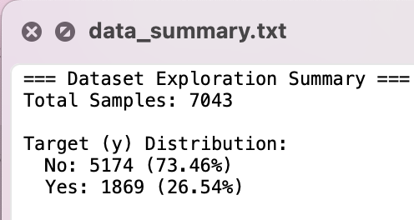
数据集中不流失客户占73.46%，流失客户占26.54%，存在明显的类别不平衡问题。
4.2 数据预处理结果
（1）删除了customerID列
（2）TotalCharges列有11个缺失值，使用中位数1397.47填充
（3）Contract列进行标签编码：{'Month-to-month': 0, 'One year': 1, 'Two year': 2}
（4）对14个分类特征进行独热编码，编码后特征数量为30个
（5）对数值特征进行标准化处理
数据集划分：
训练集：5634条（No: 4139, Yes: 1495）
测试集：1409条（No: 1035, Yes: 374）
4.3 超参数调优结果
GridSearchCV共搜索480种参数组合，使用5折交叉验证，最终找到最优参数：
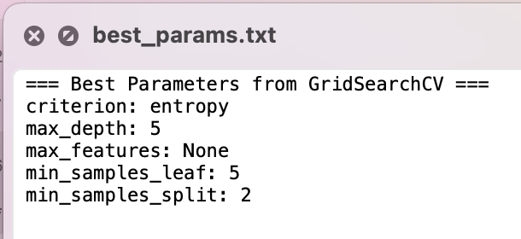
最优模型在交叉验证中的ROC-AUC得分为：0.8278
4.4 模型评估结果
（1）分类报告
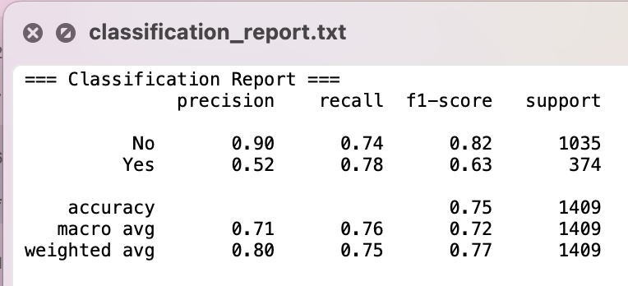
（2）混淆矩阵
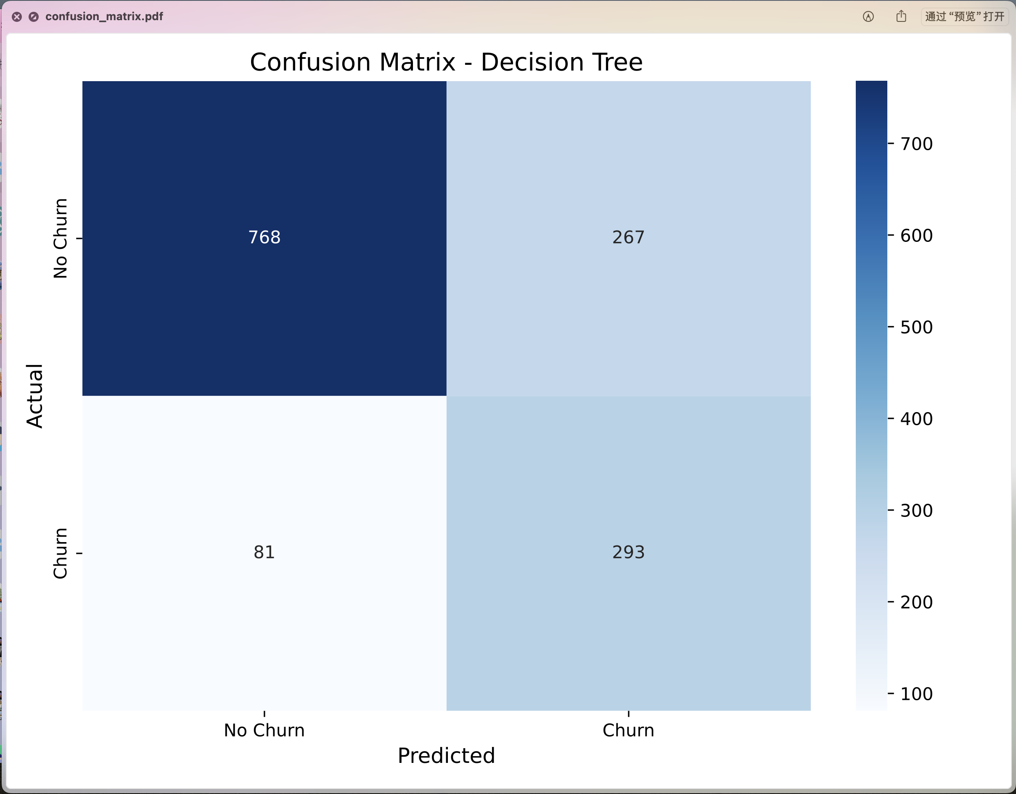
（3）ROC曲线
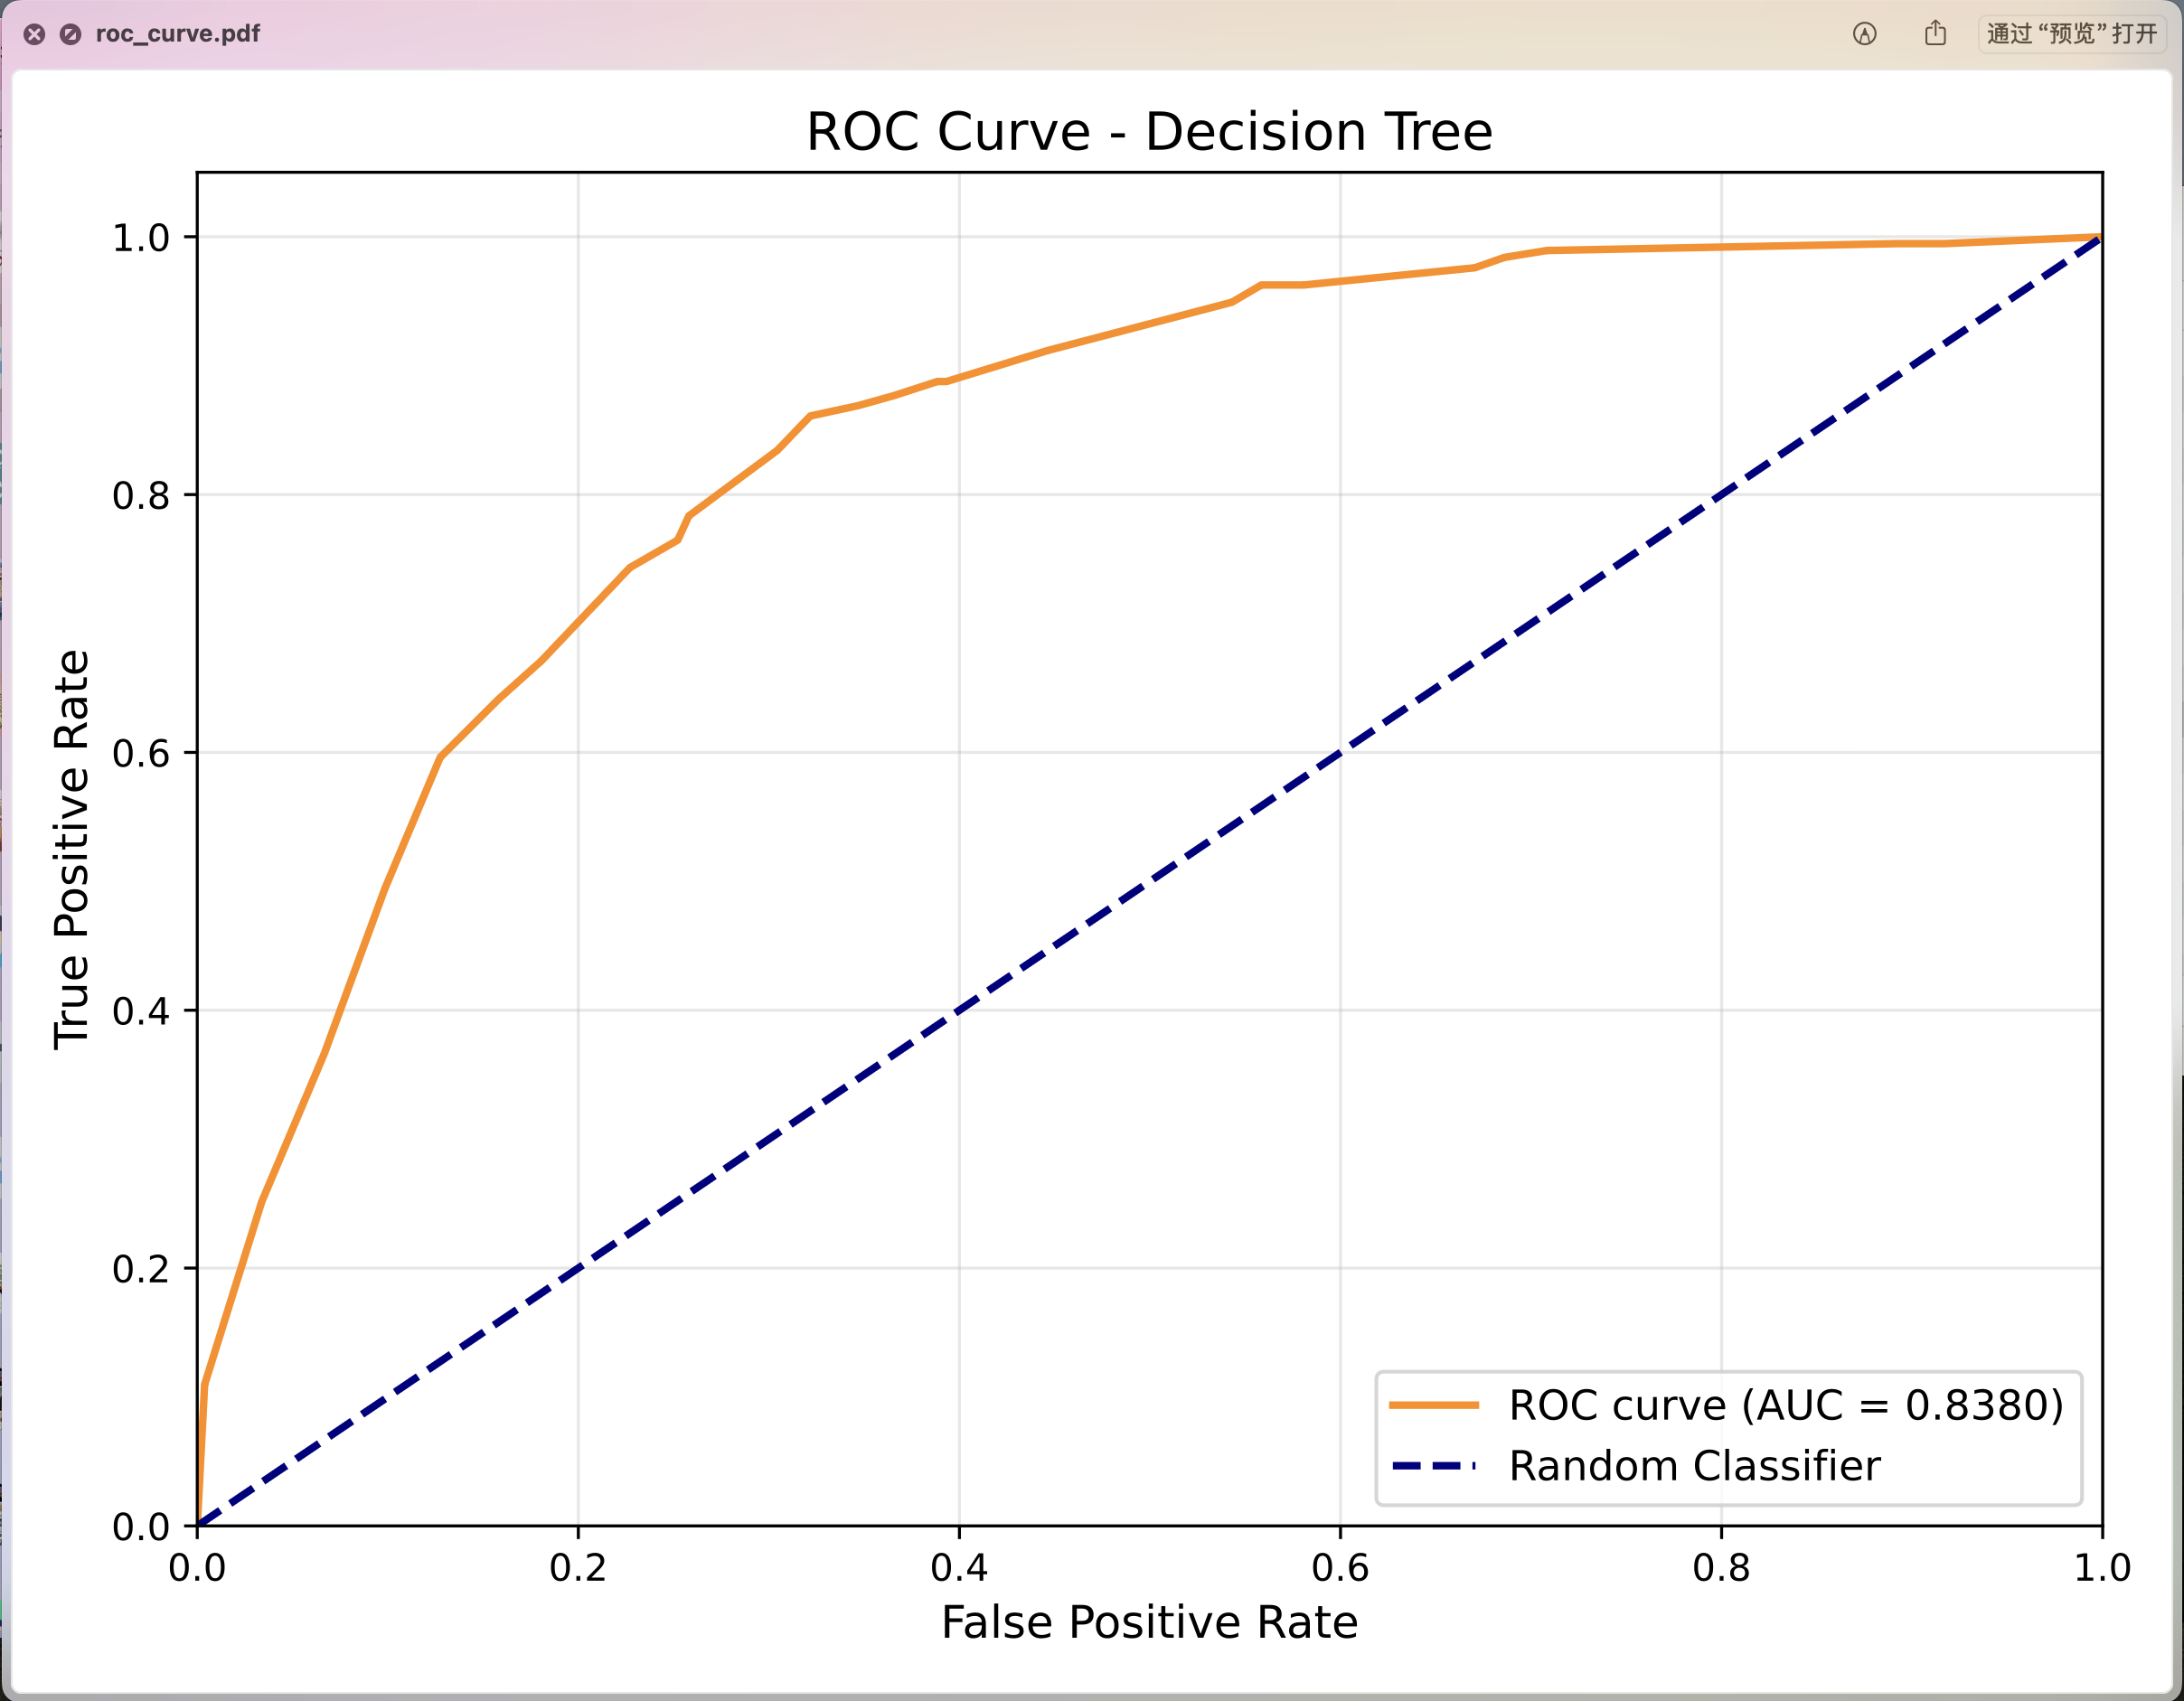
（4）模型评估摘要
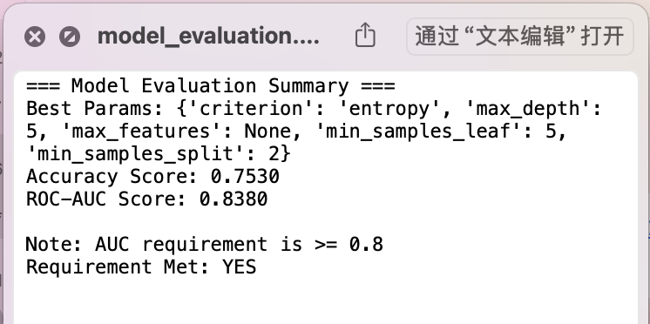
4.5 结果分析
（1）准确率（Accuracy）：0.7530
在类别不平衡的情况下，准确率不能全面反映模型性能
（2）ROC-AUC值：0.8380
满足AUC ≥ 0.80的要求
说明模型具有较好的区分正负样本的能力
（3）精确率（Precision）：
不流失客户（No）：0.90
流失客户（Yes）：0.52
模型对不流失客户的预测更准确
（4）召回率（Recall）：
不流失客户（No）：0.74
流失客户（Yes）：0.78
使用class_weight='balanced'后，模型能够识别出78%的流失客户
（5）F1-Score：
不流失客户（No）：0.82
流失客户（Yes）：0.63
流失客户的F1-Score相对较低，但考虑到AUC表现良好，模型整体可用
（6）混淆矩阵分析：
真阴性（TN）：768 - 正确预测不流失
假阳性（FP）：267 - 误报为流失
假阴性（FN）：81 - 漏报流失客户
真阳性（TP）：293 - 正确预测流失
模型漏报率较低（81/374 ≈ 21.7%），对业务来说这是重要的指标
4.6 结论
本实验成功使用决策树算法构建了电信客户流失预测模型：
1. 通过数据预处理（标签编码、独热编码、缺失值处理、特征缩放）将原始数据转换为模型可用的格式
2. 使用class_weight='balanced'参数有效处理了类别不平衡问题
3. 通过GridSearchCV找到最优超参数组合：AUC达到0.838，满足≥0.80的要求
4. 模型能够识别78%的流失客户，对业务具有实际应用价值

