CS
COC251
F014855

Hashi Game (Sudoku-type puzzle)

by

Alec Holden

Supervisor: Dr Ana Salagean

Department of Computer Science
Loughborough University

May/June 2023

Contents
1 Project Description 3
2 Research 5
3 Further Information About Hashi 9
4 Unity 11
4.1 About Unity 11
4.2 Key Terms 11
5 Creating the GUI 12
5.1 Grid 12
5.2 Nodes 15
6 Implementing the Game Interface 17
6.1 Bridges 17
6.2 Win Condition 23
6.3 Creating Puzzles 25
7 Creating the solver 26
7.1 Adding Bridges from Solver 26
7.2 Initial Rule 27
7.3 Iterative Rule 29
7.4 Neighbouring 1s 31
7.5 Handling Neighbours Blocked by Intersection 33
7.6 Re-calling Initial Rule 35
7.7 Back Tracking 38
7.8 Slow Solve Algorithm 43
8 Conclusion 44

Project Description

For this project, I made a digital version of the game Hashi. I planned on making an interface that would allow the user to play the game with a few predetermined boards. If I had enough time, I was going to also add in a hint system and a solver that can solve the puzzle for the user. In the end, I managed to create the solver but not the hint system. I made this game using the game engine Unity which uses C# as the programming language.

Rules of Hashi:
- Connect nodes by up to two bridges so that the total number of bridges touching any node is equal to the number on the node.
- Do this for all nodes.
- The player wins when all nodes have the correct number of bridges, and they are all joined together.
- Bridges can only be placed vertically or horizontally (not diagonally).
- Bridges cannot cross over each other.

Example of a hashi board with all the bridges in the right place (solved state).
Example of a hashi board with no bridges (initial state).

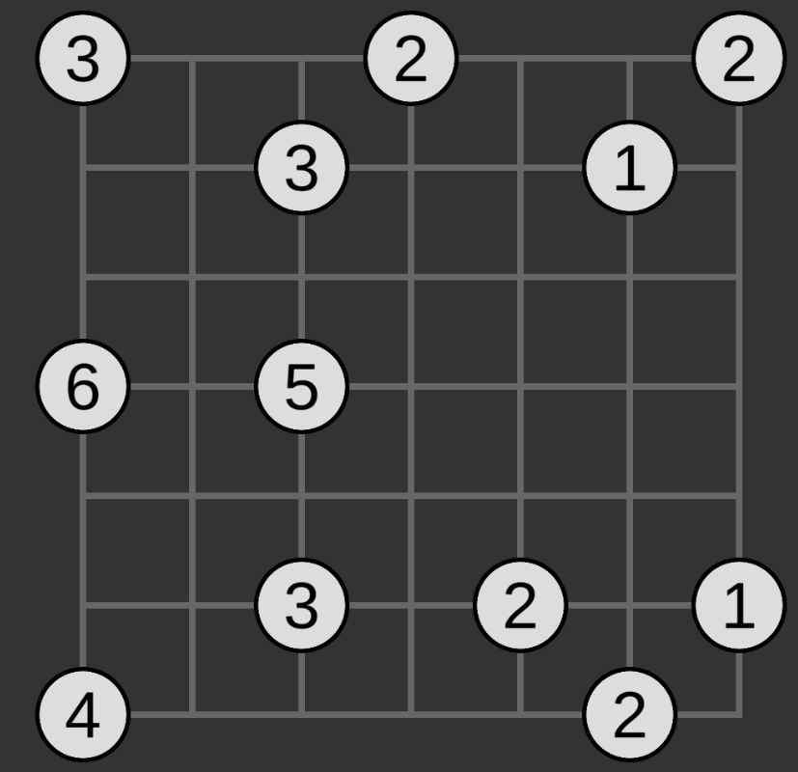
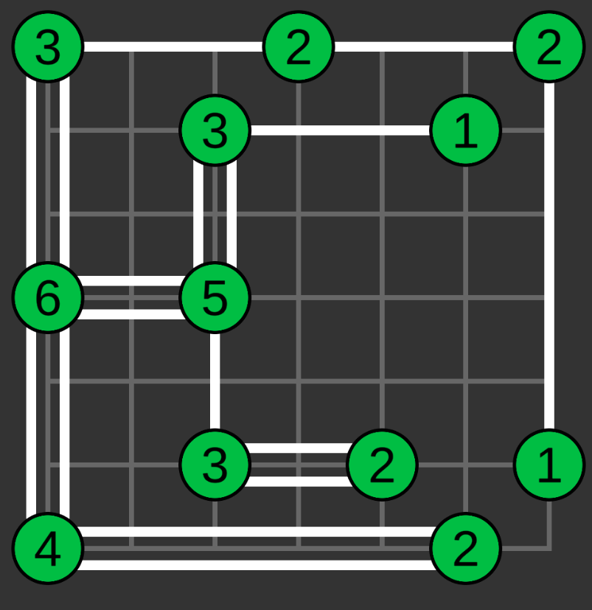

The interface consists of:
- A grid that the nodes are place on.
- Nodes containing a number from 1 to 8 (representing the number of bridges required).
- Bridges connecting nodes.

The player can create bridges by clicking on one node and dragging to another node. They’re not allowed to connect nodes diagonally or have overlapping bridges. The user is only able to place a maximum of two bridges between a pair of nodes. The program automatically detects when the win condition for the game has been met and will end the game. A random board from the predetermined set of boards is used each time the user plays the game.

I planned on adding a hint system that would consist of a button that the player can press to get a hint. This would have told the player how many bridges there are between a random pair of nodes that currently have the wrong number of bridges (or no bridges yet). The hint system would have used the puzzle solver to come up with a hint. Due to time constraints, I didn’t end up implementing this.

The solver completes the whole puzzle for the player. I figured out what the best techniques are to solve hashi puzzles and then implemented them into an algorithm to solve the puzzle automatically.

I tested the program after each step to check that the functionality was working correctly.

Research

Before I started programming the game, I looked at some other version that other people have created online. I will use this to see if there are any elements from these other versions that I might want to implement in my version.

The first version I looked at was on https://www.puzzle-bridges.com/

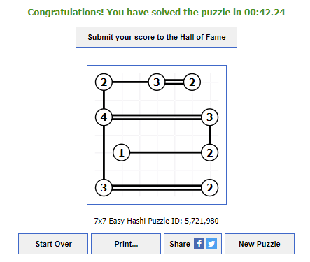

This version allows you to left click to add one bridge or right click to add two bridges. I like this feature as it makes it easier to place bridges quickly. If you try to add a bridge that intersects with another bridge, the game prevents you from doing this. Stopping the player from placing invalid bridges can be helpful for newer players who are still learning the rules of the game. It also includes a timer so you can see how long it took you to solve the puzzle. This adds an extra challenge to the game where you can try to solve a puzzle as quickly as possible.

The next version I tried was https://www.conceptispuzzles.com/index.aspx?uri=puzzle/hashi
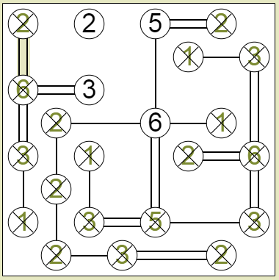

This version crosses out nodes and changes their number green when they have the correct number of bridges attached. I like this feature as it indicates to the player which nodes have been completed which makes it easier to see which nodes still need more bridges. This version also prevents the player from connecting more bridges to a node once it has the correct number of bridges connected. I found this feature to be frustrating because if you make a mistake, you may want to add extra bridges to a node and then remove the ones that you think are incorrect. However, with this feature you cannot do that.

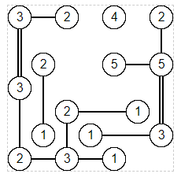
After that I looked at https://www.hashi.info/

This version had no indication when a node had the correct number of bridges. This made it more difficult to keep track of where I still needed to place bridges. When connecting nodes together, this version would show the bridge being built between the two nodes as you drag the cursor across the screen. This doesn’t necessarily assist the player in any way, but it is definitely more visually appealing. It also prevented intersecting bridges from being built.

The final version I looked at was https://puzzlemadness.co.uk/hashi/medium

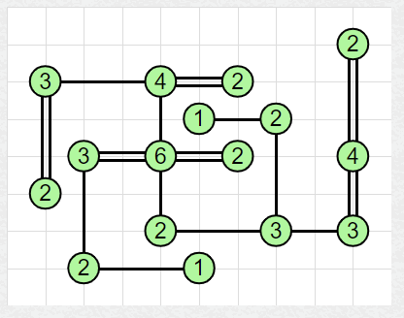

This version includes a grid in the background. This makes it easier to tell which nodes are horizontally and vertically next to each other meaning that they can be connected with bridges consequently providing the player with a small amount of assistance. This version also included a scoring system where the player gets 5 points for every bridge they place. Then there is a leader board showing the players that have the highest score. While this is an interesting concept it isn’t something that I plan on implementing in my project as I would prefer to focus on other areas like making a solving algorithm.

From these versions of the game, I plan on using the colour change to green when a node has the correct number of bridges connected. I will also turn the node red to indicate when there are too many bridges connected. In addition, I plan on using the feature from the first version where you can use right click to place two bridges at once. I think this feature makes sense since you can have up to two bridges between any two nodes. I plan on using a click and drag method to connect nodes that visually shows the bridges being drawn from the starting node and moving in the direction of the cursor. In order to stop bridges from being placed anywhere, I will prevent the user from placing bridges in any location that is invalid (e.g., intersecting bridges). I will place a grid behind the nodes to indicate which ones can be connected. This grid will also come in handy for testing as I can use it to check if the nodes are appearing in the correct location on the grid.

Further Information About Hashi

The following includes further information about the game hashi that I have found out that isn’t necessarily required to play the game but may come in handy with programming or just building an understanding of how the game works.

From looking at many different sources of the game hashi, I have realised that two nodes are never place directly next to each other vertically or horizontally. I believe that this is done to leave a space for the bridges to be placed.

One of the rules of hashi is that, in order for the puzzle to be solved, not only do the nodes have to have the correct number of bridges connecting to them but also all the nodes have to be connected to each other. Most of the time, when solving a puzzle, all the nodes will be connected anyway by the time they all have the correct number of bridges. However, this is not always the case. Below is an example that I figured out to demonstrate this.

All nodes have the correct number of bridges, but they are not all connected.
To reach the solution, nodes should be connected like this instead.

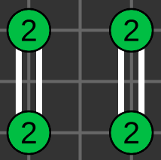
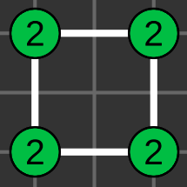

For a given hashi puzzle there is only supposed to be one unique solution but by simply placing nodes that can connect to each other and giving them values, this is not enough to prevent a puzzle from having multiple different solutions. Below is an example I came up with to show this.

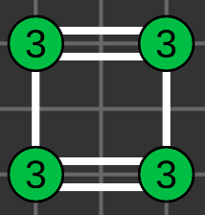
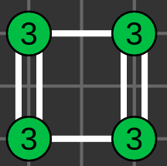
This square of 3s can be connected in two different ways, both of which lead to a solution.

Unity

About Unity
For this project, I will be using Unity. Unity is a game engine that assists in the creation of games. It does this by providing the user with tools and an interface that were designed with game development in mind. Unity uses c# as a programming language. I already have some past experience with unity, so I won’t have to learn an entirely new system. However, I believe that by using unity, I will be able to progress faster than if I were to hard code everything which means that I will be able to get more done within the timeframe of this project.

Key Terms
The following is a list of terms used in unity that are mentioned in this report:
- Component – A piece of code attached to a game object.
- Scene – A visual grid showing all of the game objects currently in the game.
- Game object – Objects in the scene that can hold components. All game objects have the transform component by default that is used to set the position, rotation, and scale of the object.
- Script – A code file that can be attached to a game object as a component.
- Coroutine – A function that includes a wait command that halts the program for a set amount of time or until a condition is met.
- Vector2 – An array of 2 float values representing x and y coordinates.
- Collider – A type of component attached to a game object that is used to detect collisions with that object and another object or with that object and the cursor.

Creating the GUI

Grid
First, I created a square grid using the line renderer component in Unity. This component allows you to input an array of coordinates and then it draws a line from point to point in the scene using these coordinates. For example setting the coordinates to (0, 1), (0, 0) and (1, 0) will create an “L” shape.
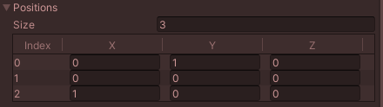



This tool can be used to draw any shape using only straight lines. You may notice that there is also an option to set a z coordinate but since this project will be in 2D, I will just leave this as 0. Using the line renderer tool, I wrote a script to draw a grid with the line renderer. It works by moving in a zigzag back and forth along the board whilst moving one place up each time.



This works by using that a for loop that loops once for each point. Then the position of the point is calculated. In the following code, you can see that the positioning of a point is dependent on it’s divisibility by four. This is because the pattern repeats every four points. First, there is a line going right to left, then up one space on the right side of the grid, then left to right, then up on space on the left side of the grid. The grid starts at (0, 0), then goes to (width, 0) where width is the number of vertical lines on the grid. The next point will be (width, 1) and then (0, 1)

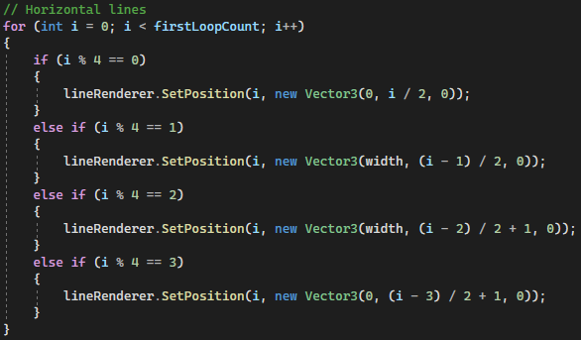

Then this snake-like pattern continues in the other direction, moving from top to bottom, along one space to the left, and then back up.
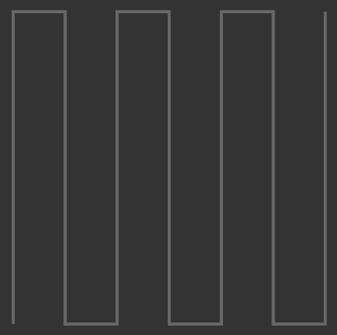

Putting these two previous images together creates the full grid.

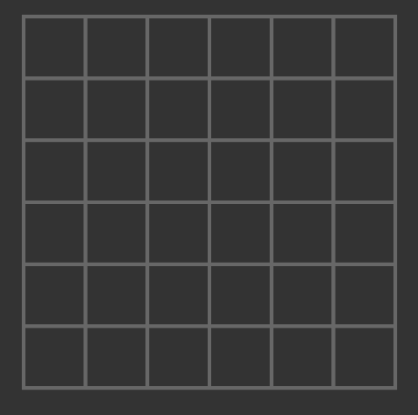

It would be much simpler to just draw a grid by hand and place it in the scene. However, coding it this way means that I can change the size of the grid (changing the number of rows and columns). This will allow for different size puzzles.

If the width of the grid is even, there has to be an extra point between the two zigzag sections. This is because, with an even number of lines, the first zigzag will end in the top left corner whereas with an odd number, it will end in the top right corner. To keep the same starting position for the second zigzag, an extra point is added to move the line to the top right corner.

Finally, I wrote another script for the camera that positions it in the centre of the grid so that the grid appears in the centre of the screen. It also ensures that the whole grid will be visible on the screen.

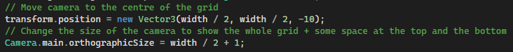

Nodes
To store the nodes and their values, I created a 2d array of integers called nodeValues. Each position in the array represents a position in the grid. In each position, there is a 0 if there is no node and a number from 1 to 8 if there is a node. This number represents the value of the node.
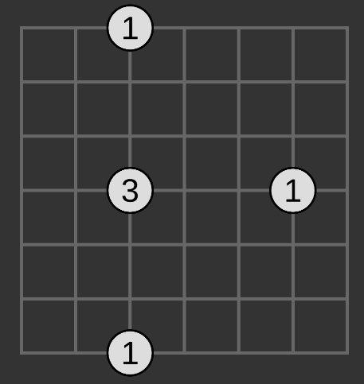
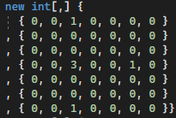

This 2d array is then used in a script called GameManager to create another 2d array of game objects called nodeObjects. This array is the same size as nodeValues and stores a game object for every node in the grid. A 0 from nodeValues is left as a null value in nodeObjects and a game object is instantiated in the position of every non-zero value. These game object contain a script that stores their own value taken from nodeValues.

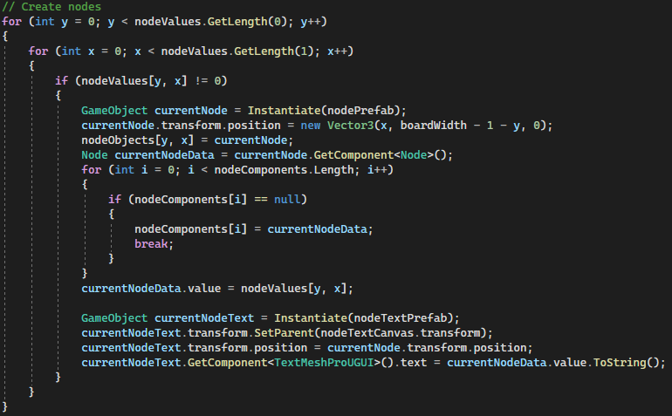
In the screenshot above, there is another array called nodeComponents. This is simply used as an easy way to access the scripts attached to each node later on in the project.
In Unity, text is displayed from a special type of game object called a canvas. A game object called Node_text is instantiated when a node is added to nodeObjects. This is set as a child of the Node_text_canvas (which is just a canvas holding all the node text) and the value of the is displayed from this game object in the position of the corresponding node.

Implementing the Game Interface

Bridges
I created a script used by each node that stores their value, a reference to all neighbouring nodes and a reference to all connected bridges in each direction. This means that from any given node, I can access the neighbouring node game objects and the bridge game objects of all the connected bridges. Storing this information with each node will make it easier to program the connection of bridges between nodes. Later I will store more information with each node as I further develop functionality.

Before implementing the bridges, I added a colour change function that slightly changes the colour of a node when hovering over it. This is just to give the player a clear indication that they can interact with the nodes, and it makes it obvious which node is currently selected.

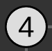

Hovering
Not hovering



This was done by adding a collider component to the nodes and using it to detect collisions between the node and the cursor.

To create bridges, I added more code to the node script that creates a bridge game object with a line renderer when clicking on a node. The line renderer has two points. The first is set to the location of the node that was clicked on and the second is set in another script on the bridge. This script has a FollowCursor function that gets the location of the cursor and constantly updates the second point of the bridge to the cursor’s location. This way the bridge will track the cursor allowing the player to draw a bridge.
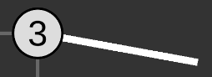

When the player lets go of the mouse click the FollowCursor function is no longer called so the second point on the bridges line renderer stops updating. At this point, the AddOneBridge function is called. This function is for left clicks, there is also another function (AddTwoBridges) that is called if the player right clicks which works the same except it adds two bridges instead of one. The AddOneBridge function checks that a few conditions have been met before storing a reference to the bridge in the nodes that it connects. Otherwise, the bridge will be deleted. In order to keep the bridge, the cursor must end (when the player lets go of mouse click) hovering over a node that is different from the starting node when the bridge was first created. If this condition is met, then the second point of the bridge will be moved to the centre of the second node. Next, the function checks if the node that the cursor ends on is a neighbouring node to the node that the cursor started on.

If any of these conditions were not met, the RemoveInvalidBridge coroutine runs. This coroutine turns the bridge red, waits for a quarter of a second, and then destroys the bridge game object. This is done to indicate that the bridge was placed incorrectly.
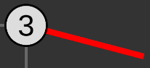

If all the conditions were met, the function then checks how many bridges are already between the two nodes that the player is trying to place a new bridge between. If there are no bridges, the bridge is simply referenced in the node scripts of the nodes at either end of the bridge. If there is already one bridge, the new bridge is also referenced and then the two bridges a moved slightly so that the player can see bother of them (otherwise they would be on top of each other). If there are already two bridges, adding a third will delete all bridges set the references of the bridges to null.

One bridge between nodes.
Reference to the bridge stored in array of bridges to the right for the node with value 2.

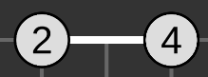
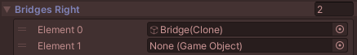

Two bridges between nodes.
Reference to both bridges stored in array of bridges to the right for the node with value 2.

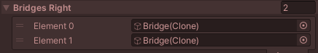



Third bridge adding removing all bridges.
Both bridge references are removed.

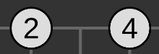

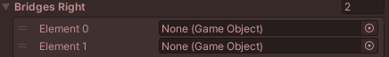

After this, the function CheckBridgeCount is called once for each of the two nodes where a bridge got added or removed. This function counts the number of bridges connected to a given node. If the number of bridges connected to a node is each to the value of the node (the number written on it) then it changes colour to green. This indicates to the player that they don’t need to add any more bridges to this node. If there are move bridges connected to the node than its value, the node turns red. This tells the player that they need to remove bridges that are connected to this node. The colour will revert back if bridges are removed. We store the number of connected bridges with each node to use later in the completion check.

Correct number of bridges connected to node with value of 2.
Too many bridges connected to node with value of 2.

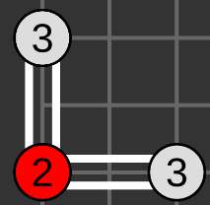



So far, the player can place bridges between nodes and the player if prevented from connecting a bridge to diagonal nodes and nodes through other nodes. This is because the connected nodes have to be neighbours.

Bridge through a node prevented (in the image, the player is trying to create a bridge from the node with value 3 to the node with value 2 passing through the node with value 4).

Diagonal bridge prevented.

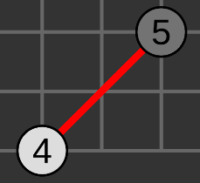

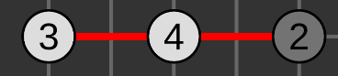

However, the player should also no be able to place intersecting bridges. In order to prevent this, we store the points (location of each end) of every bridge in a list of arrays of vector2s. Each list element is an array of length 2 storing the coordinates of either end of a bridge. This list is called bridgePoints. When a new bridge is created the AddBridgePoints function runs. This function first checks if the new bridge is in the exact location of another bridge. If it is, then the player must be trying to connect a second bridge between two nodes that already share a bridge. Therefore, the bridge is allowed, and it also doesn’t need to be added to bridgePoints since we already have a bridge in the same location. If the new bridge is not in the same location as another bridge, we then check if it intersects with any other bridge. When checking if the lines intersect a slightly smaller bridge is used for the coordinates as bridges that are next to each other do touch but this is allowed.

For example, these two bridges intersect right at the end, behind another node. This is allowed so we don’t want this to be prevented.

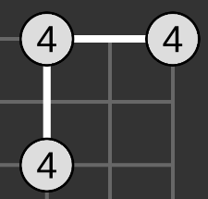
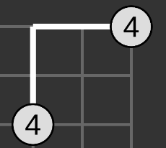

If when using a subsection of the bridges they still intersect, the new bridge is destroyed. Otherwise, the new bridge is added to the bridgePoints list. When a bridge is removed from the board, it is also removed from the list.

Win Condition
After a new bridge is placed, the CheckForCompletion function is called. This function first checks that all nodes have the correct number of bridges attached to them. Since we already have this information from earlier (CheckBridgeCount function), this is easy to do. Then we have to check if all of the nodes are connected to each other. That is to say that for any given node there is a path to all other nodes. The neighbours of each node are already stored along with a reference to any bridges that there are between them. Therefore, to check if the nodes are connected, we simply start at the first node and set it as connected. I added a Boolean called isConnected in the node script to do this. This node is added to a list called searchList. Then we check which nodes have bridges connected them to this node. All of these nodes have their Boolean isConnected set to true. The first node is removed from searchList, and all the connected nodes are added to searchList. Then we take the next starting element of searchList now that the first node has been removed and find all of it’s connected neighbours. If they are not already connected, we set them to isConnected is true and add them to searchList. If they are already connected, then they have already been searched so we can ignore them. We once again remove the first element of searchList and repeat.

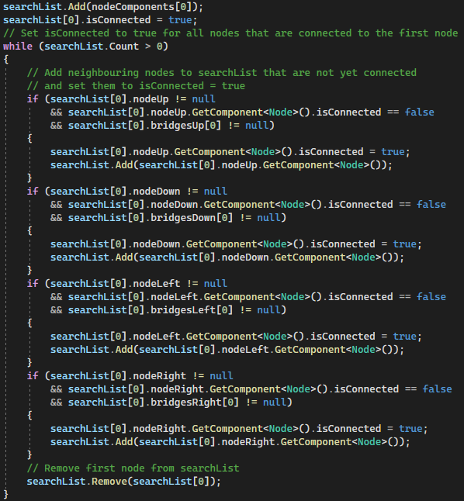

Once there are no more elements in searchList we check if all the nodes have isConnected = true. If they don’t then the puzzle has not yet been completed and nothing else happens. If they are all true, then the puzzle has been completed.

Creating Puzzles
I created 10 different puzzles for the player to have a go at and set a random puzzle to appear each time. I created the puzzles by first drawing a grid and placing some nodes on it in random positions. I had to ensure that every node had at least one neighbour. Then I drew either one or two bridges between the nodes until every node was connected to every other node. From here, I simply had to figure out what value each node should have based on the number of bridges connected to that node.

Once the puzzle is complete the player can press a button to go to another puzzle.

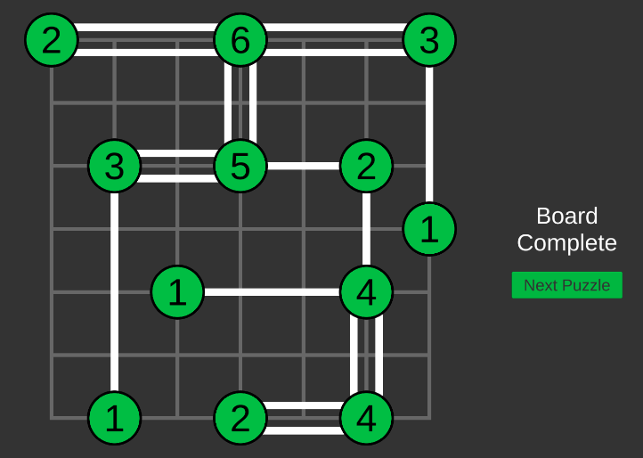

Creating the solver

First, I added a new variable to the node script called neighbourCount to store the number of neighbours a node has. This will be useful for creating the solver as some of the techniques used to solve a puzzle are based on the number of other nodes that a node can connect to.

Next, I created a button that the player can press to automatically solve the puzzle. When pressed, this button runs a function from the GameManager script called SolvePuzzle.

Adding Bridges from Solver
I created a ClearBridges function that it called at the start of the SolvePuzzle function. This simply removes all bridges from the board, removes all references to these bridges and clears out the bridgePoints list.

Then I created another function that will be called many times by the SolvePuzzle function called AddSolverBridge. This function adds bridges between nodes in the same way as the AddOneBridge function from the node script. However, it doesn’t not use mouse inputs to figure out where to place bridges. Instead, it takes as input two game objects which will be the two nodes which a bridge should be placed between.

Initial Rule
Now to start actually solving the puzzle. Initially the algorithm, checks to see if any bridges can be placed with one hundred percent certainty without knowing the location of any other bridges. For example, if there is a node with value 1 that only has 1 neighbour, then we have to connect 1 bridge to that neighbour. If a node has a value of 2 and only one neighbour, then we have to connect 2 bridges to that node. If a node has a value of 3 and can connect to only 2 other nodes, then we know that it must have at least 1 node to the other 2 nodes. There is a rule like this for every value of a node 1 through 8.

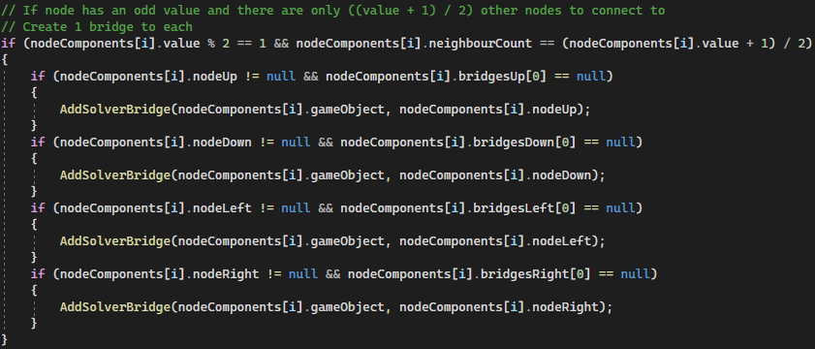

We could chain if statements for every different node value but it’s easier to group all odd values together and all even values together. Then for odd values, we check if (the value + 1) / 2 is equal to the number of neighbours that the node has. If so, we know that there will definitely be at least one bridge to every neighbour.
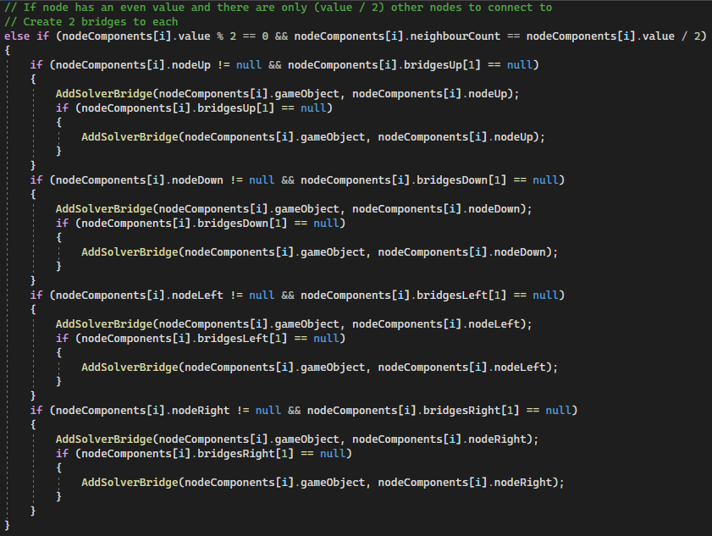
For even values we check if the neighbour count is half the value of the node. If so, we know that there must be two bridges connected to all neighbouring nodes. We make sure to only add bridges if they aren’t there already.

Iterative Rule
Next, we need to iterate through every node multiple times to see where we can add more bridges. I created some new variables for the node script to help with this. We have an isAvailable boolean for each direction to check if we can connect more bridges to the node in that direction (set to false if there is no node in that direction). Also, we have a variable storing an integer value called availableNeighbourCount. This stores the number of available neighbours.

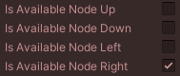
Only one node is available for this node. Therefore, the availableNeighbourCount is set to 1.

Now if a node has only one available node, we know that all remaining bridges from the node must connect to its single available node. So, we iterate through every node and for each node that has only one available neighbour, we connect one or two bridges (how ever many are required) to its available neighbour.
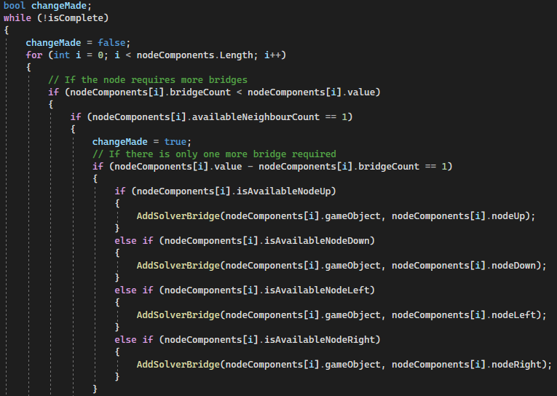

This section of code iterates through the nodes repeatedly until the puzzle is solved. I also added a boolean here called changeMade which is set to false at the start and true when a change is made (bridges are added). This is used to prevent freezing if the solver cannot solve a puzzle by breaking the loop. Otherwise, the while loop would never terminate.

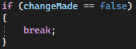
At the end of the loop if no changes have been made the while loop ends.

Neighbouring 1s
In the following puzzle, the solver cannot solve it since there are no nodes with only one available node. However, a node with a value of 1 cannot connect to another node with a value of 1 as they would no longer be able to connect with the rest of the nodes. This is because, for a solution to be valid, all nodes must connect to all other nodes.

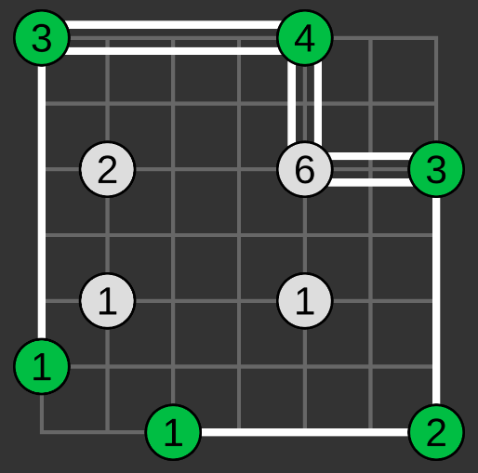

To fix this, I added a new rule where if a node with a value of one has a neighbour with a value of one, then this neighbour is not available (the available neighbour boolean for that direction is set to false). Now the solver can solve the puzzle.

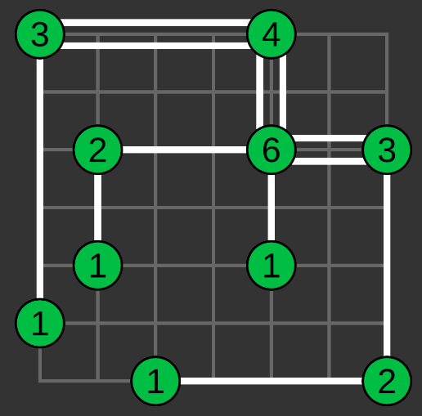

Handling Neighbours Blocked by Intersection
The solver was not able to solve the following puzzle. However, some of the nodes can only connect to one other node even though they have more than one available neighbour. This is because bridges cannot intersect. So, the node with a value of 1 in the upper middle of the puzzle can only connect to the 4 above it and not to the 2 below it (since it would intersect with another bridge). If the solver knew about the intersection, it would be able to solve this puzzle.

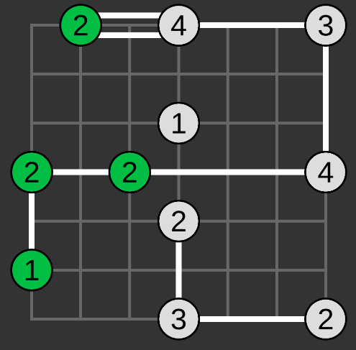

To fix this, I added a new function called CheckIfBridgeBlocksNeighbours. This function is called every time a new bridge is created by the solver. If the bridge is horizontal, it checks for each node between the ends of the bridge horizontally if a given node and any of its vertical neighbours intersects with the new bridge. For a vertical bridge it checks if each node between the ends of the bridge vertically intersects the bridge with any of their horizontal neighbours.

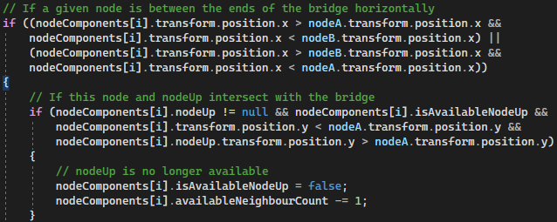
This is a section of the function to check if a given node and the node above that node intersect with the new bridge. If there is an intersection, the node above becomes no longer available since we cannot connect to this node without the bridges intersecting. We also lower the availableNeighbourCount by 1. Back in the example puzzle the node in the middle with value 1 now only has one available neighbour and so it must connect to that node. From here the solver can solve the entire puzzle.

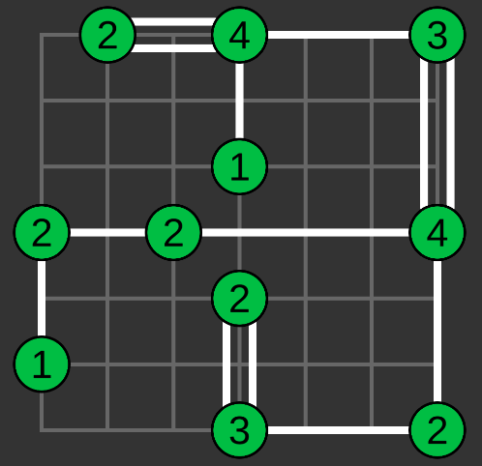

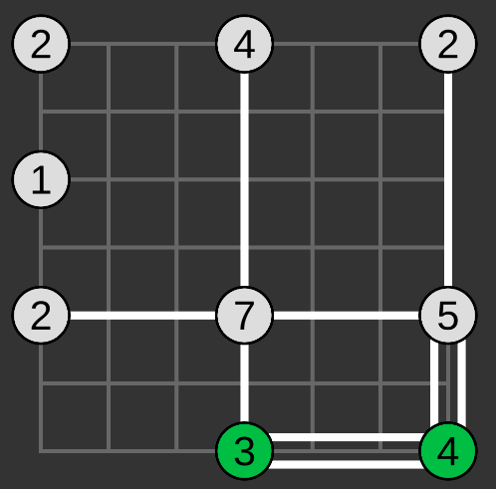
Re-calling Initial Rule
The following puzzle cannot yet be solved by the solver.

The solver gets stuck at this stage because there are no nodes with only 1 available neighbour. However, the node with a value of 7 in the middle must connect 2 bridges to all neighbours except for the 3 below it in order to have the correct number of bridges. This is like doing this initial solver rule on the node with a value of 7 but treating it as a node with a value of 6 and only using available neighbours. If the node had a value of 6 and there was no node with a value of 3, then the 6 node would connect 2 bridges to all 3 neighbours.

To implement this, I created a new variable stored by each node called nonAvailableBridgeCount. This stores an int value representing the number of bridges a node has between neighbouring nodes that are no longer available. When a node becomes full (has the right number of bridges connected to it), we call the GetNodesToRedoInitalSolver function that calls the RedoInitialSolver function for each of the node’s neighbours. This function redoes the initial solver step. When the nodes with a value of 3 becomes the full, this function is called for the node with a value of 7. This node has 3 available neighbours, and we take its (value – nonAvailableBridgeCount) treated as the value of the node. So here we have a value of 6 and 3 available neighbours, so 2 bridges are connected to each available neighbour.

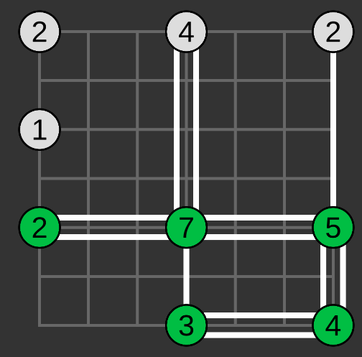

From here, the solver is able to complete the whole puzzle.
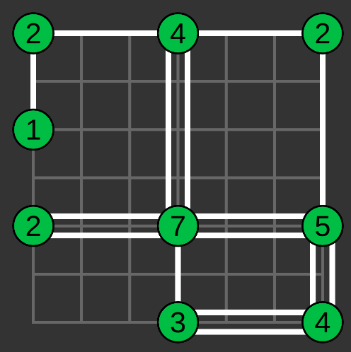

Back Tracking
Even with all the techniques implemented so far, the solver is still not able to solve every puzzle. With some puzzles, the solver will come to a stage where the only way to progress is to try a certain combination of bridges to see if it leads to a solution. Then, if there isn’t a solution it will need to revert back to the state that the board was at when it tried a possible combination of bridges, and now it must try a different combination. This will then repeat for every possible combination of bridges until the correct solution is found. The solver may also have to do this multiple times in one puzzle.

First, I created a class called NodeStateData. This stores all the information about a node at the current state. This includes the number of bridges in each direction, nonAvailableBridgeCount, availableNeighbourCount and which neighbouring nodes are available. Then I created a variable called saveStates. This stores a list of lists of NodeStateData. Each list of NodeStateData is storing the data for every node on the board. This creates a state. Then these states are put into the second list storing a list of states that can be returned to if the solver tries a possible bridge combination that doesn’t lead to a solution.

Similarly, for these bridge combinations, I created a class called BridgeOption. This stores how many bridges should be added in each direction (as 4 int values, one for each direction) as well as the index of the node where the bridges should be added. Then I created a variable called tryBridgeOptions. This stores a list of lists of BridgeOptions. Each list of bridge options stores every possible combination of bridges that could be added to a node to make it full (meaning the number of bridges attached to it is equal to its value). These lists are then stored in another list which allows the solver to branch out by if it gets stuck while trying one bridge options and has to create more from a different node. This creates a tree like structure of bridge options.

Next, I coded the potential bridge options. This required writing a lot of if statements in order to add the right bridge options. A node can only bridge towards a neighbouring node if it is available and the number of bridges that can be added in each direction depends on the number of bridges that still need to be added to the node. If the node only requires one more bridge this is quite simple.
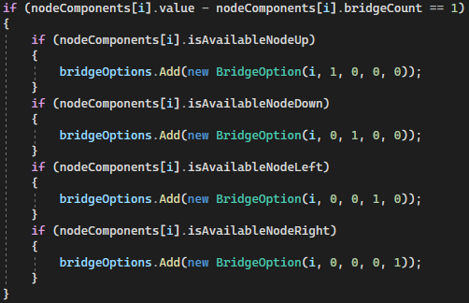

We can simply add one bridge in each direction that has an available node. In the screenshot, i represents the index of the node and the 4 integer values are the number of bridges in each direction. From left to right, they are up, down, left, right. I then coded the rest of the bridge options for node that need more bridges attached. I created bridge options for nodes requiring anywhere from 1 to 6 bridges. This is because, even though a node can have up to 8 bridges attached, if it requires 8 bridges then we already know that it must have to bridges in each direction. Likewise, for a node with a value of 7, it must have at least one bridge in each direction. This has already been covered by the initial solver rule so by the time the solver requires backtracking, there won’t be any nodes that require more than 6 bridges.

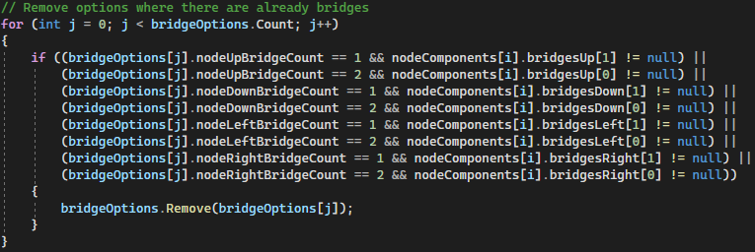
After creating all of these bridge options, I realised that some of these options are invalid because there may already be bridges better the node and some of its available neighbours meaning that more bridges cannot be added in these directions. Therefore, these bridge options are removed.

In order to change the state of the board, I created a ChangeState function. This function removes all the bridges on the board and then adds bridges back in according to the data stored in a list of all the node states that is passed into the function. Then all the rest of the data for each node is set to what it was at this state.

For executing the bridge options, I created a function called TryNextBridgeOption that takes the next BridgeOption to be executed and adds the bridges to a node based on the data stored in that bridge option. In order to determine which bridge option is next, I created a list of integers called currentBridgeOptionsIndex. This stores an integer value representing the index of the current bridge option for each list of bridge options in the tryBridgeOptions list. This goes up by one each time a next bridge option is tried. The list of bridge options in tryBridgeOptions that will be executed next is always the rightmost list as this is the list of options at the greatest depth. This may be easier to understand by looking at an example.

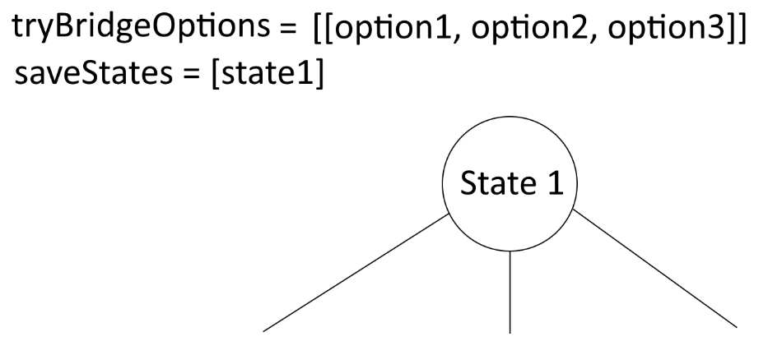
Here the solver has reached a point where it cannot go further using the basic solving rules and has the rely on backtracking. Is saves the current state of the board as state 1. A total of 3 bridge options are generated for a node and option 1 is tried first.

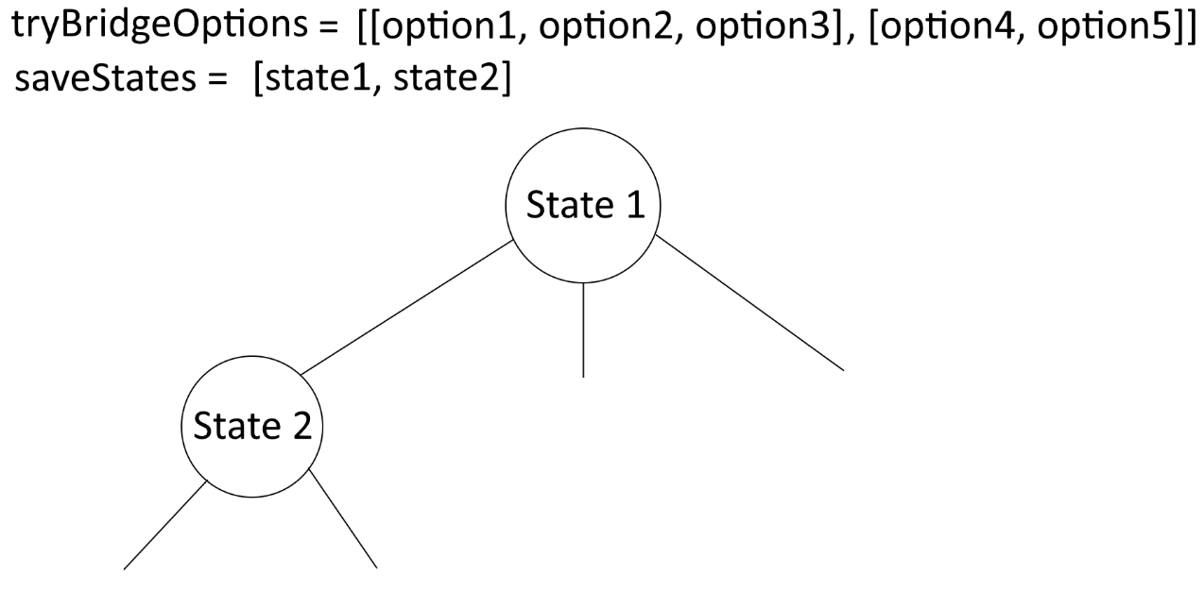
Later on, the solver gets stuck again and has to generate more bridge options. The current state is saved to saveStates, and the list of bridge options is added to the end of tryBridgeOptions. Now these bridge options at the end of the list are tried before going back to the previous bridge options created at state 1.

Neither of the bridge options from state 2 lead to a solution so now they are removed from tryBridgeOptions and state 2 is removed from saveStates. Now the state is reverted back to state 1 and the option 2 can be tried since this list of bridge options is now the last list in tryBridgeOptions. This continues until the solution if found.
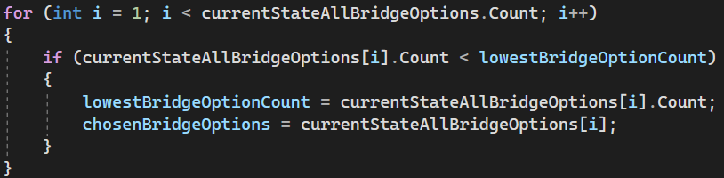
Currently, the backtracking algorithm takes the first non-full node and adds bridges to that node. In order to make the backtracking algorithm more efficient, I changed it to calculate which node has the fewest number of bridge options. This will mean that less options have to be tried in order to reach the solution.

This is easily done by calculating all the potential bridge options for each non-full node and then finding out which one has the lowest number of bridge options and selecting that as the node to add bridges to. In the screenshot, currentStateAllBridgeOptions is a list of lists of bridge options for each node, lowestBridgeOptionCount is the number of bridge options that the node with the lowest number of bridge options has and chosenBridgeOptions is a list of the bridge options corresponding to this node.

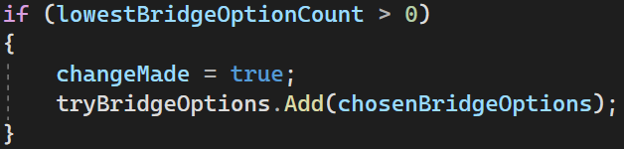
Then the chosen bridge options are added to tryBridgeOptions. However, if the node with the lowest number of bridge options is 0 then no bridge options are added to tryBridgeOptions. The boolean changeMade is also not set to true which will the result in the current bridge option from the previous depth of bridge options to end. This is because a non-full node having no bridge options can only occur when a bridge option at a previous depth doesn’t lead to a solution as this can leave a singular node that isn’t full even though all of its neighbouring nodes are full.

Now the solver is able to solve puzzles where there is no obvious solution, and it has to try different options. This means that the solver is now capable of solving any puzzle. I tested it on all the puzzles I’ve made, and a few larger puzzles and it was able to solve them all.

Slow Solve Algorithm
Finally, I created an alternative version of the solve algorithm. This algorithm uses all the same methods as the regular solve algorithm, but it pauses after each step. This algorithm is intended to demonstrate the methods that the solver is using at each step to help understand how it works.

I made the slow solve algorithm by copying the regular solver functions and changing them to coroutines. This means that I can add delays into the code to stop after each step. I did this by creating a boolean variable called continueSolve. After the solver has finished one step, continueSolve is set to false and the code only continues once continueSolve is set back to true.
Then when the user presses the “next step” button, it calls the NextSolveStep function which sets continueSolve back to true and the solver continues.


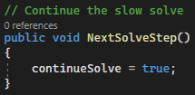

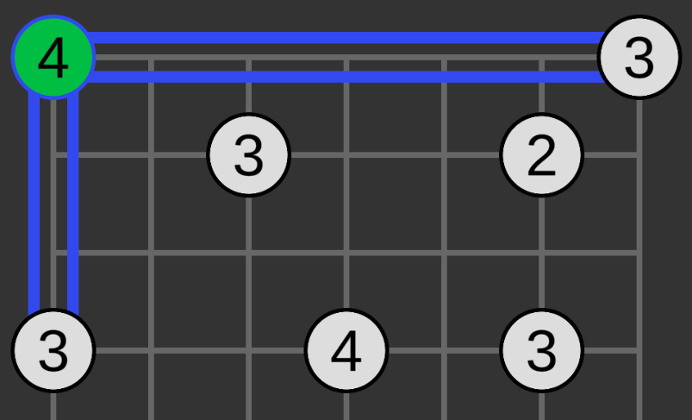
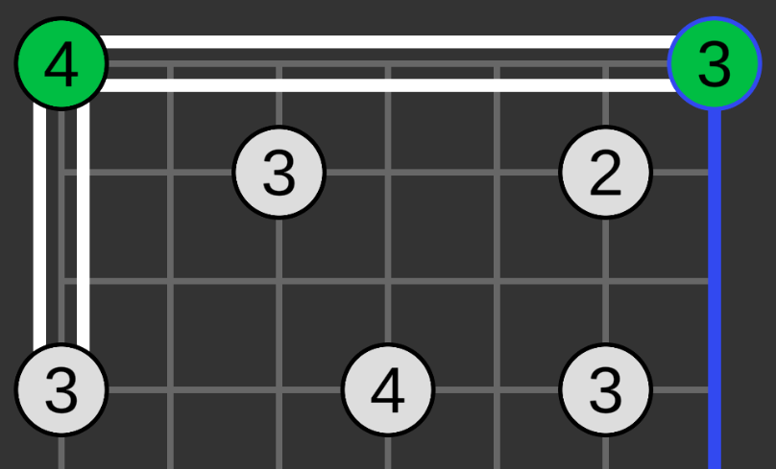
I also changed the colour of the border around the node that the solver is adding bridges to and the bridges that are being added. They are then set back to their default colours on the next step.
First step
Second step

Conclusion

In conclusion, I think this project went very well. I managed to finish almost all of the functionality that I originally planned on implementing only missing the hint system that was supposed to assist the user if they got stuck by putting one bridge in the correct place that they don’t already have.

I created a user interface that allows me to create puzzles and display them on the screen with a grid system that can be of any size and nodes that can be placed in any location on the grid. The user can create bridges between the nodes by holding left click to create one bridge, or right click to create two bridges and then dragging to another node. The program will automatically remove any invalidly placed bridges and only allow bridges place horizontally or vertically between nodes with crossing over other bridges. I created a function to check if the board has been completed meaning that all nodes have the correct number of bridges attached and all nodes connected. Then I made a few sample puzzles to test the program with.

After the interface, I created the solver algorithm that uses methods that I figured out from completing hashi puzzles in order to automatically solve the puzzle. On all puzzles tested, the algorithm finishes very quickly so there is no delay where the user has to wait for the puzzle to be solved.

In addition to the original plan, I also implemented the slow solve algorithm. I decided to add this in as I though that it would be useful to help understand what exactly the solving algorithm is doing and what order it is doing each step in. The original solving algorithm just solves everything instantly which is great if you just want to know the solution, but having the slow solve algorithm helps to see how the solving algorithm works. You may be useful to you as a marker to see how the solver works, and it could also be useful to someone that wants to learn how to solve hashi puzzles. Since I used the techniques that I use to solve hashi puzzles to create the solver, another user could look at how the solver completes puzzles in order to figure out how they can solve them.

Given more time, I would have implemented the hint system to assist the player in solving the puzzle if they got stuck. I also would have liked to create a puzzle generator that could take in some inputs (e.g., board size, number of nodes) and automatically generate a random puzzle. This would have been a nice feature to have as it would allow for the program to be used endlessly as there would be infinite different possible puzzles to solve.

