

**Tutorial Group Z35 AI Assignment 2**

**Done by:**

Teng Yao Long (U2121909D)

Chua Jing Jie Justin (U2122610G)

Ang Wai Kit Anson (U2122935D)

Exercise 1: The Smart Phone Rivalry (15 marks)

sumsum, a competitor of appy, developed some nice smart phone technology called galacticas3, all of which was stolen by stevey, who is a boss of appy. It is unethical for a boss to steal business from rival companies. A competitor of is a rival. Smart phone technology is business.

1. Translate the natural language statements above describing the dealing within the Smart Phone industry in to First Order Logic (FOL). (5 marks)

Facts

1. company(sumsum).
2. company(appy).
3. competitor(sumsum,appy).
4. develop(sumsum, galacticas3).
5. smartphonetech(galacticas3).
6. boss(stevey,appy).
7. steal(stevey,galacticas3,sumsum).

Rules

1. ∀x competitor(x,appy)⇒rival(x).
2. ∀x smartphonetech(x)⇒business(x).
3. ∀x,y,z,e boss(x,y) ∧ company(y) ∧ steal(x,z,e) ∧ business(z) ∧ develop(e,z) ∧ company(e) ∧ rival(e) ⇒ unethical(x)

2. Write these FOL statements as Prolog clauses. (5 marks)

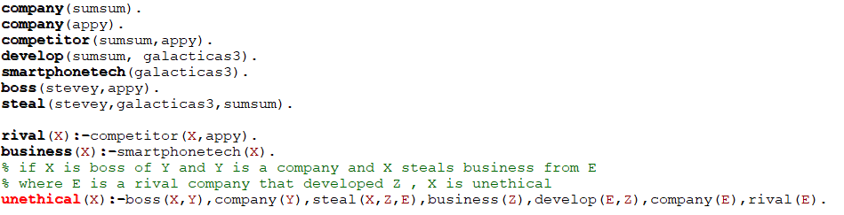

3. Using Prolog, prove that Stevey is unethical. Show a trace of your proof. (5 marks)

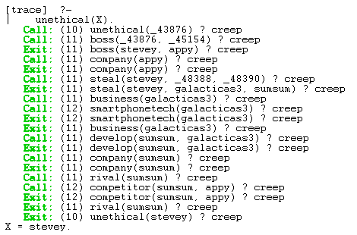

Exercise 2: The Royal Family (10 marks)

The old Royal succession rule states that the throne is passed down along the male line according to the order of birth before the consideration along the female line – similarly according to the order of birth. queen elizabeth, the monarch of United Kingdom, has four offsprings; namely:- prince charles, princess ann, prince andrew and prince edward – listed in the order of birth.

1. Define their relations and rules in a Prolog rule base. Hence, define the old Royal succession rule. Using this old succession rule determine the line of succession based on the information given. Do a trace to show your results. (5 marks)

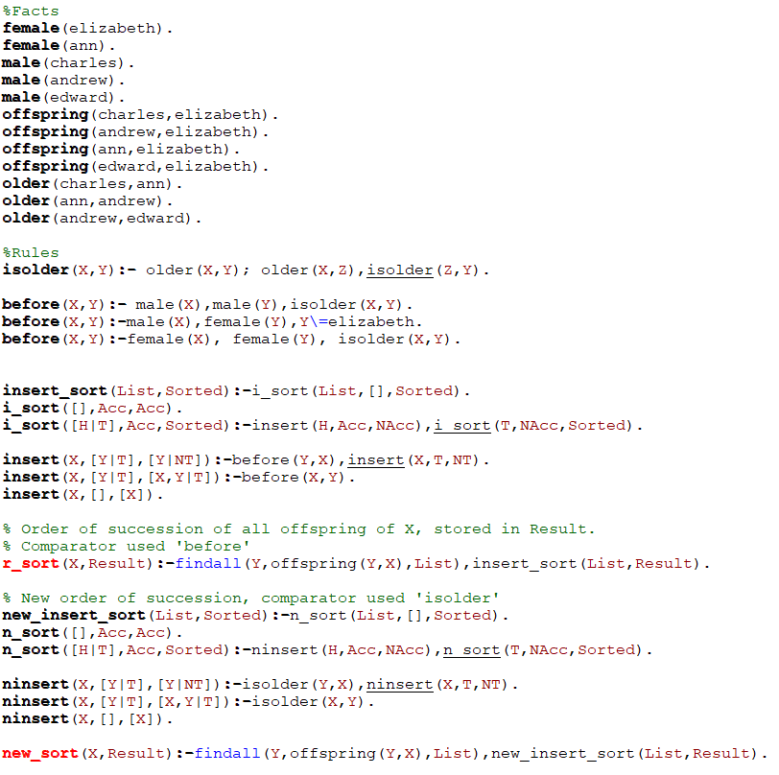

Trace:

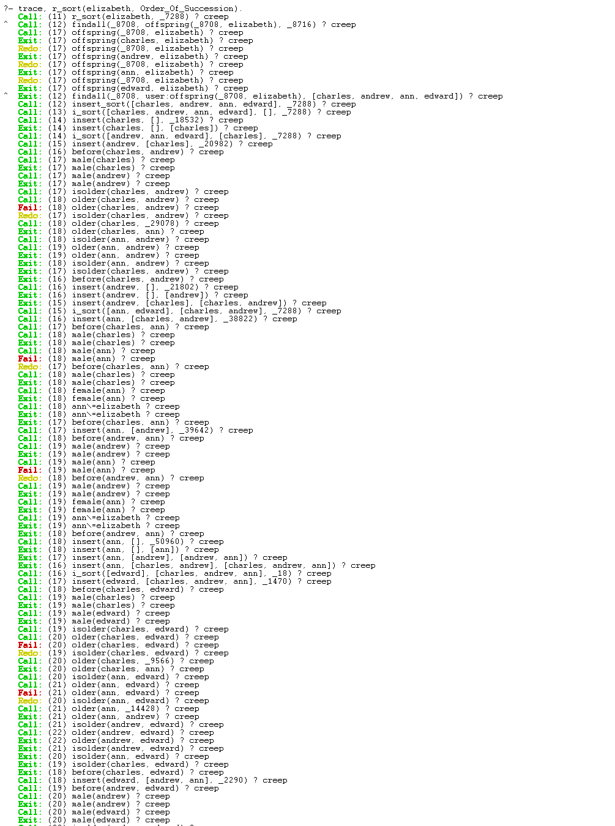

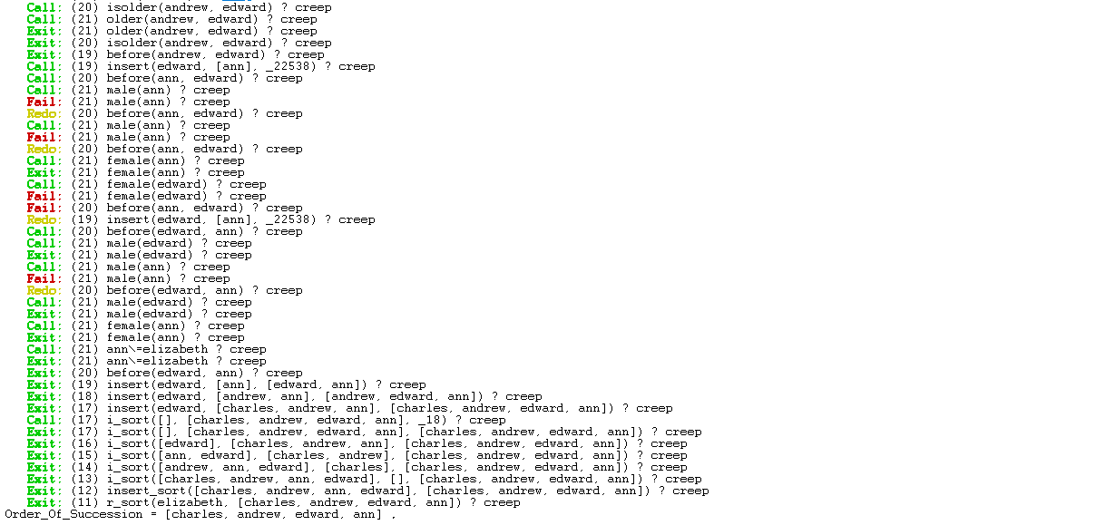

Result of trace: Order_Of_Succession = [charles, andrew, edward, ann] .

2. Recently, the Royal succession rule has been modified. The throne is now passed down according to the order of birth irrespective of gender. Modify your rules and Prolog knowledge base to handle the new succession rule. Explain the necessary changes to the knowledge needed to represent the new information. Use this new succession rule to determine the new line of succession based on the same knowledge given. Show your results using a trace. (5 marks)

Since now the throne is passed down according to order of birth irrespective of gender, our comparator for the sort now would be comparing the order of birth. isolder rule is shown in first image of this question.

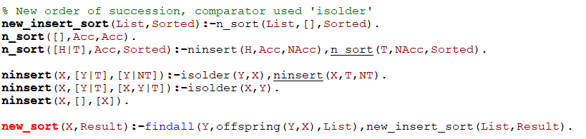

New trace:

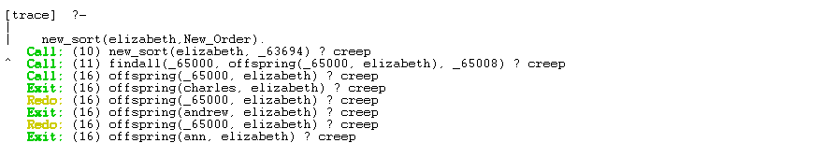

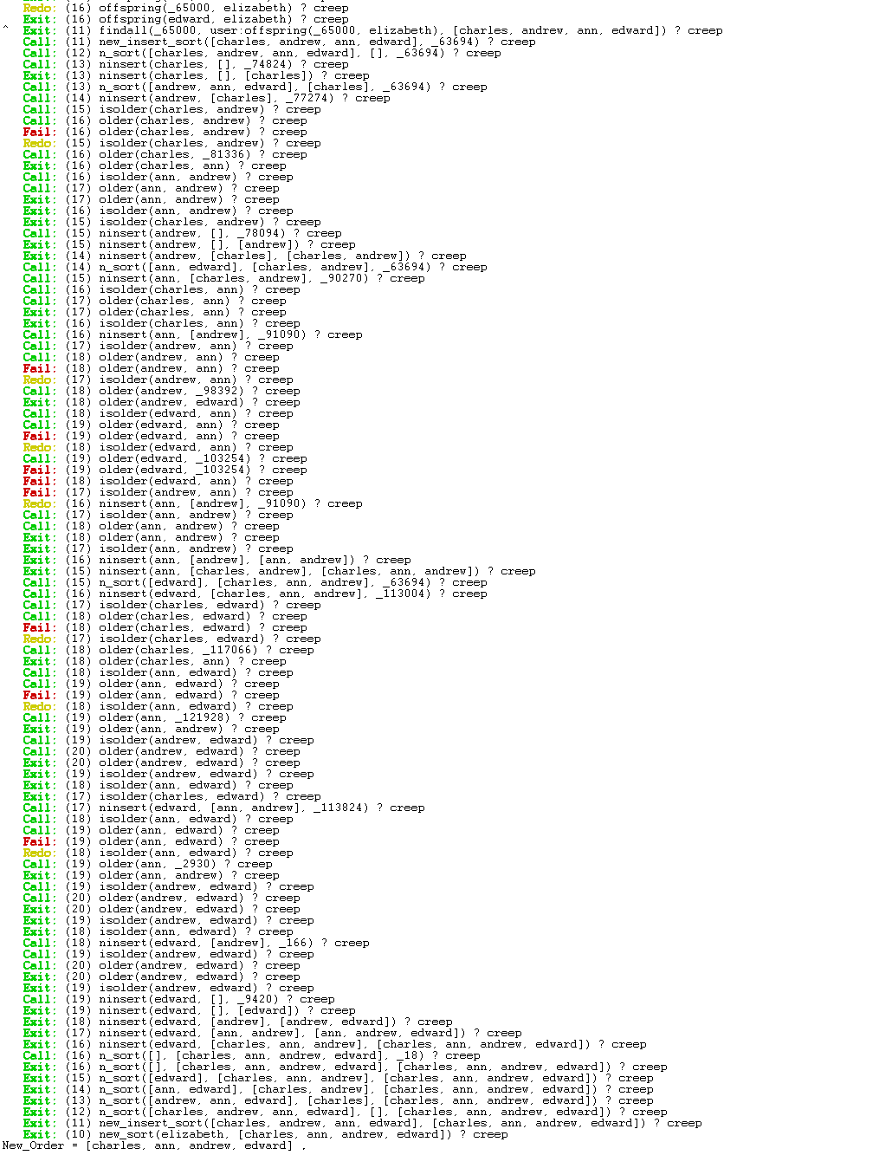

Result of trace: New_Order = [charles, ann, andrew, edward]