1. Go to path (where **csv_processing.bat** is saved) directly using windows.

Ex: “C:\Users\Administrator\Desktop\ccc”

Double click the “csv_processing.bat” file. Following window opens. Click on “Upload File” button.

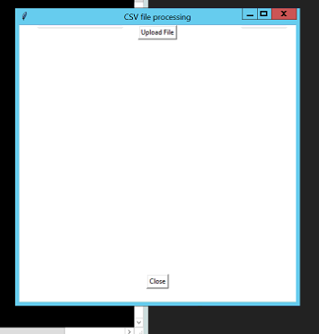

1. Choose the file **(.zip or .csv format**) using window Input files can be loaded from any path.

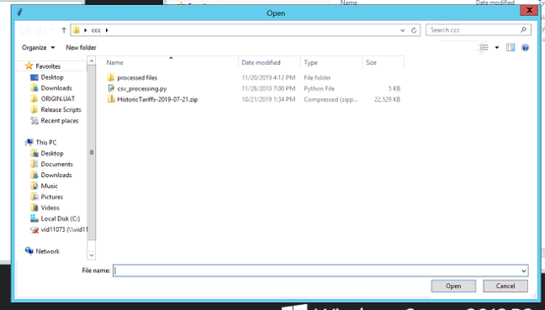

1. File processing starts.

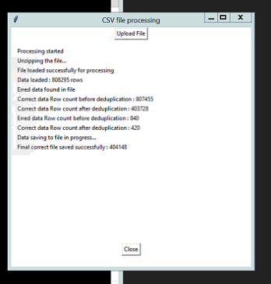

1. Final processed file will be saved in “**processed files**” folder in same path where input file is located.

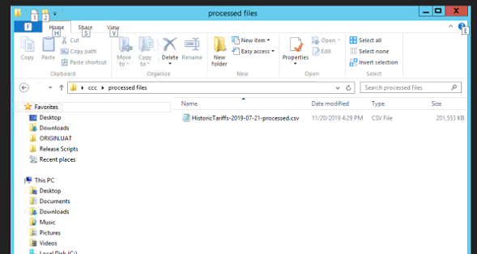

1. Close the window by clicking on “**Close**” button.