# Introduction

This report describes the design and implementation of the Inertial Measurement Unit (IMU) used to capture the movement of the wheel loader’s cabin. The reason for developing the IMU was that it was deemed too expensive to buy one. The starting point for the design was Xsens’ MTi-10 IMU, adapted to the needs of the project, and Mikael Larsmark’s AVR development board.

# Design

It was decided to use the Atmel AT90CAN128 microcontroller as MCU, because of the students’ familiarity of it from earlier work. The gyroscopes chosen were Analog Devices’ ADXRS450, which gives digital outputs via SPI communication. The chosen accelerometer was Analog Devices’ ADXL325, which gives an analog output. Among all the sensors investigated these were the ones that most closely matched the specifications of the MTi-10[1].

For the communication between the IMU and the wheel loader PC, it was decided to use serial via USB, using FTDIs UART-to-USB converting chip FT232RL.

The power supply to the IMU can be switched between power from the USB and external power. Both of these are filtered and regulated to 3.3 V. Meaning that the entire card is driven at 3.3V (except for the FT232RL which takes 5V directly from the USB and 3.3V to drive its I/O to the microcontroller).

For the programming interface to the microcontroller both the ISP and the JTAG pins were put on the card as pin headers, for further work it could also be possible to write a bootloader and thereafter program the MCU via USB.

The resistors and capacitors are all of size 0603 except the 0 Ω resistance connecting the analog and digital ground planes.

## Gyroscopes

The ADXRS450 can only measure rotation along one axis [2], so three of them were needed. There are two packages available, one standing (LCC_V) to measure the x- and y-axes, and one lying down (SOIC_CAV) to measure the z-axis.

Apart from a performance close to that of the gyroscopes on the MTi-10, there were several other reasons for choosing the ADXRS450. The first was that it is digital, and because of this it is possible to include information other than the angular rate data in the SPI transmission. It has for example a self-test function which can report problems during operation and thus it is possible to flag potentially flawed data.

According to the data sheet they need a few external components to work properly [2]; these are shown in Figure 1, and included on the IMU. Of these components the inductor between supply voltage and pin VX deserves special mention since it is required to be 560 µH rather than 470 µH when operating at 3.3 V. The diode chosen was Diodes Inc.’s 1N4148W, simply because of it having a breakdown voltage higher than 24 V, and other reasonable specifications.

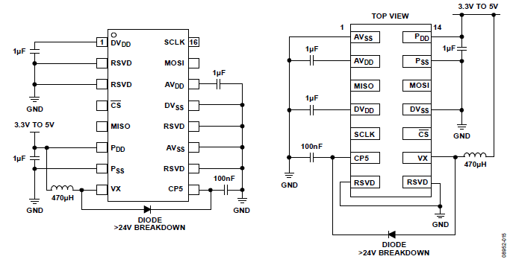

Figure 1 Gyroscope application circuits

## Accelerometer

The accelerometer chosen for the IMU was Analog Devices’ ADXL325. This measures in the desired range of ±5 g with reasonable nonlinearity (±0.2 % of full scale). It also measures all three axes simultaneously, so only one was needed.

It is analog however, and one reason for this is that it is not recommended to use SPI communication with more than three devices. Also, rotations were considered more critical and more sensitive to measurement error, so better gyroscopes were prioritized and a cheaper accelerometer was chosen to reduce the total cost.

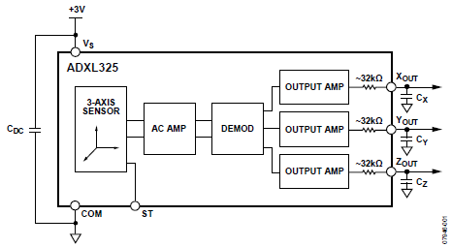

Figure 2 Accelerometer application circuit

The accelerometer needs capacitances on the outputs, as shown in figure 2, to implement a low-pass filter for antialiasing and noise reduction. Since the IMU was intended to mimic the MTi-10, its accelerometer bandwidth of 375 Hz was used for the calculations, arriving at capacitor values of 10 nF (formula for calculations taken from the data sheet [3]).

## USB Chip

# References

[1] <http://www.xsens.com/en/general/mti-10-series>

[2] Analog Devices ADXRS450 Data Sheet

[3] Analog Devices ADXL325 Data Sheet