Tourplanner
Backend development protokoll

Project setup was done a second time after first presentation-feedback with a cleaner separation of “./Tour_Planner/backend” and “./Tour_Planner/frontend”.
Backend started with adapting login-code from previous project, changing the package-structure from hexagonal to match recommendations from learning-material.
Added endpoint to delete user which allows Postman integration-test starting and ending with same state of db. Added openapi-spec for existing and planned endpoints for simultanous frontend-development.

Drafted db-model with the intention to allow further development of the application beyound given requirements like “No sharing of anything to other users”.

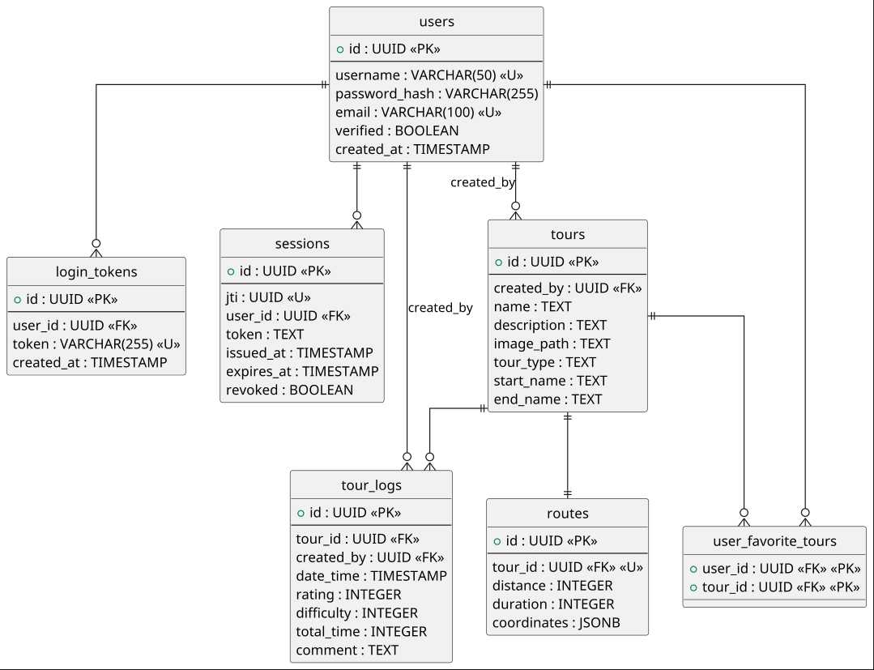
The “user_favorite_tours”-table is used to address the requirement “add a unique feature” and is – like the rest of db – intended to work also in a possible future with shared tours.
The files: “tourplanner-openapi.yaml”, “Tour_Postman.json” and “db.puml”, as well as a shell-generated “project_structure.txt” are treated as fundamental project documentation and updated after every relevant change.
API-endpoints are:

/api/user/register: post
/api/user/login: post
/api/user/logout: post
/api/user: delete

/api/tours: post, get
/api/tours/favorites: get
/api/tours/not-favorites: get
/api/tours/{tourId}: get, put, delete

/api/tours/{tourId}/logs: get, post
/api/tours/{tourId}/logs/{logId}: put, delete

/api/tours/{tourId}/route: get

/api/tours/{tourId}/image: post, get
/api/users/me/favorites/{tourId}: post, delete

Endpoint “/api/tours” provides minimalistic name & uuid while “/api/tours/favorites” and “/api/tours/not-favorites” also provide “tour_type”, which is internally handled as enum.

Image-Upload triggers update of “image_path” thus allowing later requests for the image.

