Nathaniel Sipple

Professor Torres

Date you turned it in

IT 0100

Lab 2

* Copy parts A, B, and C from Canvas
* Add notes and screenshots
* Can you reproduce the lab with the questions and your screenshots with notes?
* If your boss asked you for this, did you provide the answer with context?

#### Part A:

* Go to the website for Best Buy
  + Choose a Business Computer (with similar specs as our campus lab computers)
  + Choose a Computer that cost at least $1,000 dollars
  + Ensure that you choose one with enough specs
  + Describe why you chose this computer
    - Best tower that I could find for the price, and one of the few that met the baseline specs
  + 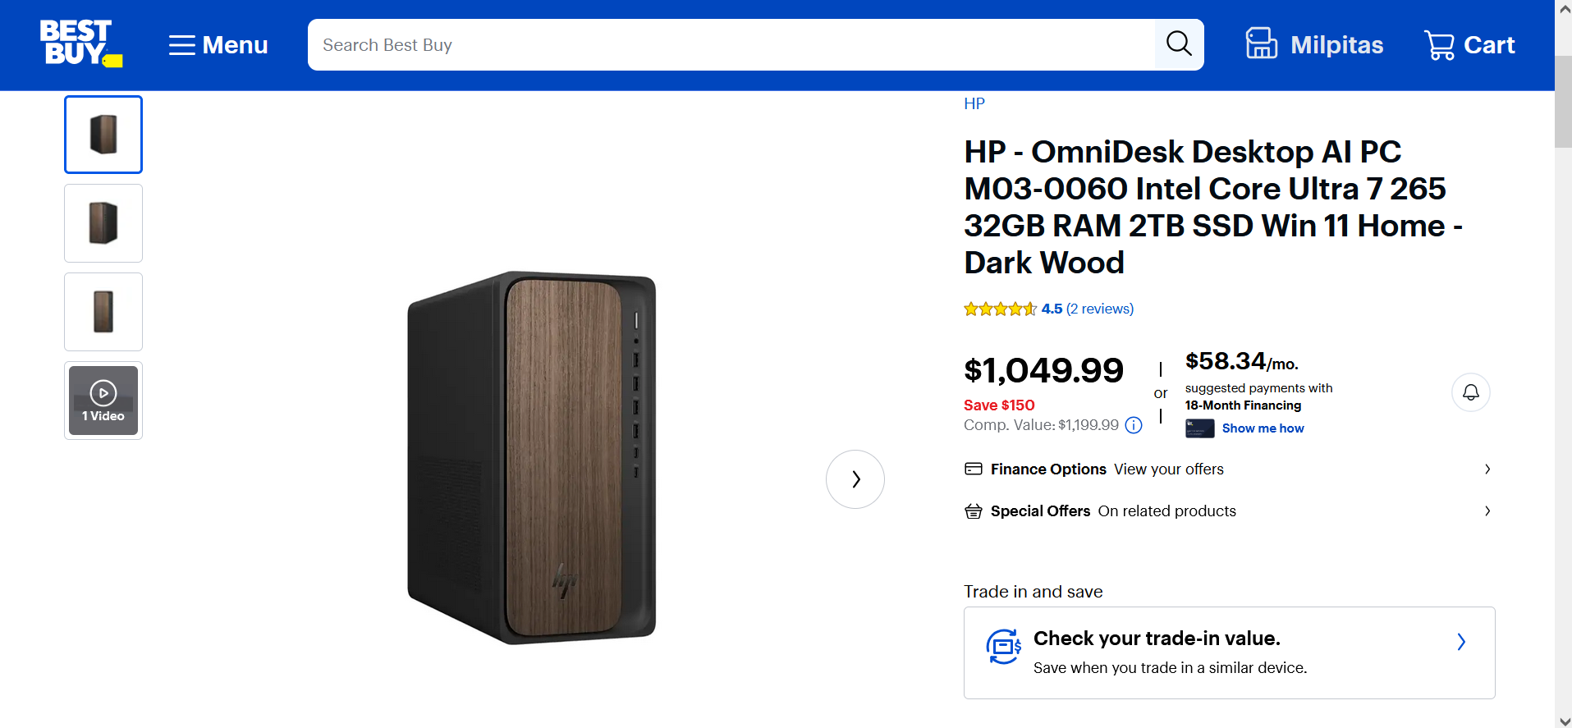
* Go to the Newegg website
  + Research a motherboard that is similar to the Best Buy computer
  + Research memory requirements and CPU requirements for the motherboard
  + Research power supply and Tower requirements for your motherboard
  + Complete the spreadsheet with your specs

| Home Computer |  |  |  |  |
| --- | --- | --- | --- | --- |
| Parts | Model | Specs | Max Specs | Cost |
| Case | Phanteks XT PRO ATX Mid Tower Case |  |  | 69.99 |
| Building Cost |  |  |  | 100 |
| Motherboard | Gigabyte H610M S2h Intel LGA 1700 |  |  | 97.99 |
| Processor | Intel Core i7-14700K 3.4 GHz 20-Core Processor |  |  | 299.99 |
| Memory | Crucial Pro Overclocking 32 GB (2 x 16 GB) DDR5-6000 CL36 Memory |  |  | 84.99 |
| HD/Storage | Crucial P3 Plus 2 TB M.2-2280 PCIe 4.0 X4 NVME Solid State Drive |  |  | 119.99 |
| Power Supply | Montech CENTURY II 850 W 80+ Gold Certified Fully Modular ATX Power Supply |  |  | 89.99 |
| Keyboard/Mouse | AmazonBasics KU-0833 +MSU0939 Wired Standard Keyboard With Optical Mouse |  |  | 19.99 |
| OS | Microsoft Windows 11 Home OEM - DVD 64-bit |  |  | 119.99 |
| Additional Items |  |  |  |  |
|  |  |  | Total Cost | 1002.92 |
| Similar Built Computer |  |  | Cost | 1049.99 |

* + Discuss why you chose the specs that you did
    - Determined what the motherboard supported and simply chose parts the most similar to the specs of the prebuilt.

#### Part B:

* Go to the Digitalstorm gaming website
  + Choose and configure a Gaming Computer (Your dream gaming computer)
  + Money is no object for this exercise
  + Ensure that you choose one with enough specs
  + Describe why you chose this computer and specs
    - I could have gone more expensive but I chose these specs based on what I know what I will use this computer on (Heavy gaming)
  + 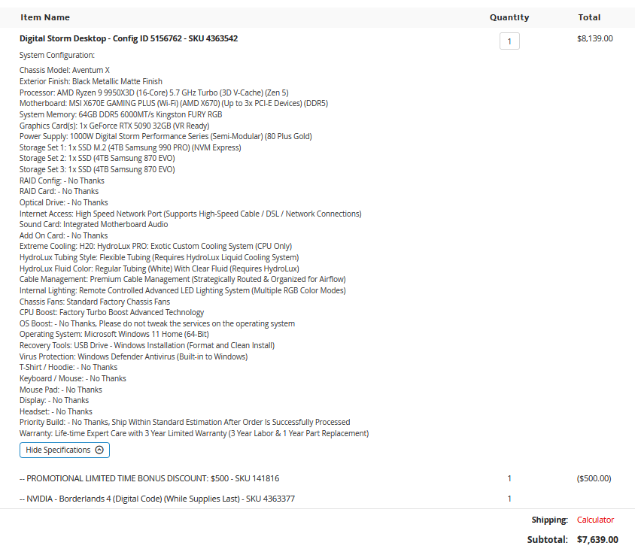
* Go to the Newegg website  
  + Research a motherboard that is similar to the Digitalstorm computer
  + Research memory requirements and CPU requirements for the motherboard
  + Research power supply and Tower requirements for your motherboard
  + Complete the spreadsheet with your specs
  + Discuss why you chose the specs that you did
    - There really wasn't much I could do since all the specs of the prebuilt were already top of the line so I just tried my best to match the specs as closely as possible

| Home Computer |  |  |  |  |
| --- | --- | --- | --- | --- |
| Parts | Model | Specs | Max Specs | Cost |
| Case | NZXT H5 Flow (2024) ATX Mid Tower Case |  |  | 89.99 |
| Video Card | Asus ROG Astral GeForce RTX 5090 32 GB Video Card |  |  | 3299.99 |
| Motherboard | Gigabyte X870E AORUS ELITE WIFI7 ATX AM5 Motherboard |  |  | 299.99 |
| Processor | AMD Ryzen 9 9950X3D 4.3 GHz 16-Core Processor |  |  | 689.99 |
| Memory | Kingston FURY Beast 64 GB (2 x 32 GB) DDR5-6000 CL40 Memory |  |  | 365.99 |
| HD/Storage | Samsung 9100 PRO 4 TB M.2-2280 PCIe 5.0 X4 NVME Solid State Drive |  |  | 367.99 |
| Power Supply | Corsair RM1000e (2023) 1000 W 80+ Gold Certified Fully Modular ATX Power Supply |  |  | 179.99 |
| Keyboard/Mouse |  |  |  |  |
| OS | Microsoft Windows 11 Home OEM - DVD 64-bit |  |  | 119.99 |
| Additional Items | Samsung 870 Evo 4 TB 2.5" Solid State Drive x2 |  |  | 518 |
|  |  |  | Total Cost | 5931.92 |
| Similar Built Computer |  |  | Cost | 7639 |

#### Part C:

* Given the above research, answer the below questions in detail:
  + is it cheaper to build your pc or to buy it (why/why not)
    - For business computers, there is only a small difference in price between a prebuilt and a built computer, I would personally go prebuilt simply so I wouldn't have to deal with the hassle of different warranties on all the different parts. For the personal computer there is a significant difference between the prebuilt and the built computer.
  + what did you learn after completing this lab?
    - Generally the higher the price the more money that is saved from building it yourself, however for practical uses its better to buy prebuilts for businesses since it all has a single warranty which is easily organized, as well as each computer being uniform which in the case of 10+ computers can make maintenance easy.

#### Part D:

* Setup a GitHub account: [https://github.com/Links to an external site.](https://github.com/)
* Create a public/private key with putty (puttygen) (ensure you create a passphrase)
* Upload your public key to your GitHub account
* Provide your GitHub username **(I am setting up a secure lab environment for you to log onto using putty)**
  + **Wherabot** [**https://github.com/Wherabot**](https://github.com/Wherabot)