Nathaniel Sipple

Professor Torres

Date you turned it in

IT 0100

Lab 4

* Copy parts A, B, and C from Canvas
* Add notes and screenshots
* Can you reproduce the lab with the questions and your screenshots with notes?
* If your boss asked you for this, did you provide the answer with context?

#### Part A: Log on to "EACH" system in [Netlab](https://netlabve2.flc.losrios.edu/)

#### [Links to an external site.](https://netlabve2.flc.losrios.edu/)

#### NDG A+ v4, Lab 1

* Log on to netlab environment and change the below,
  + Change the IP's on all systems to the 10.0.50.0/24 subnet
  + 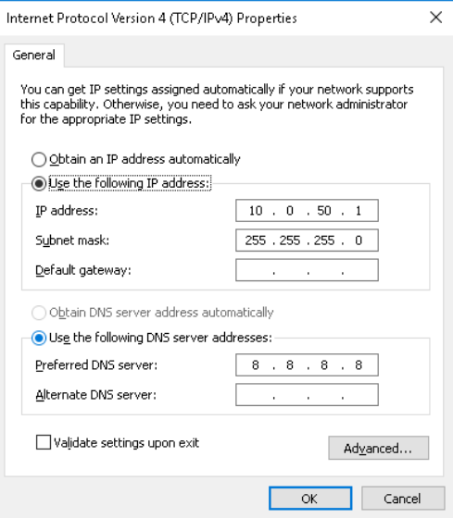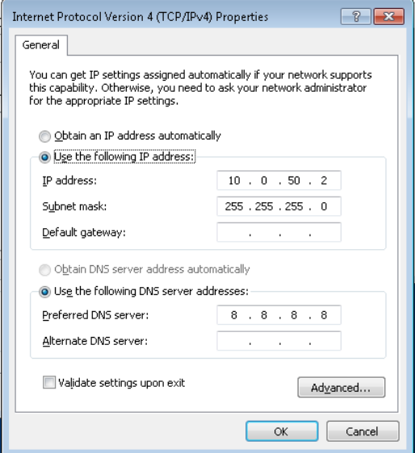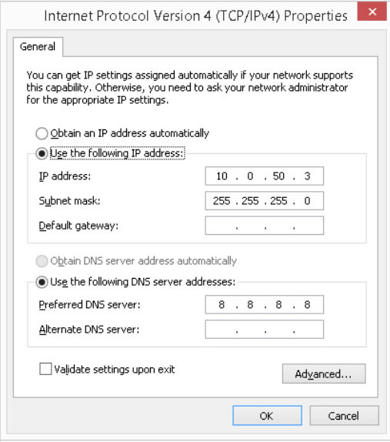
  + Change the hostnames to computer1, computer2, and computer3
  + 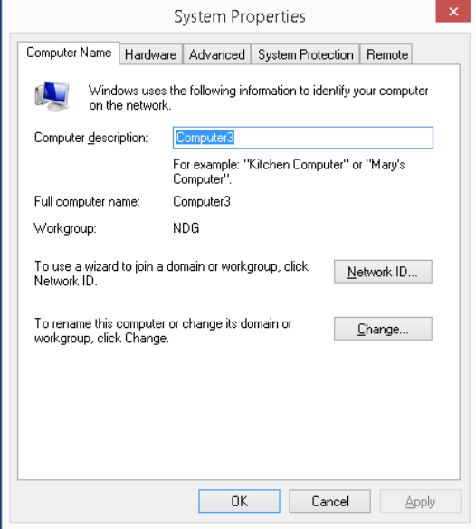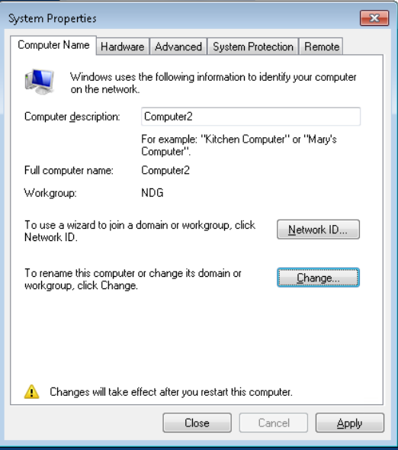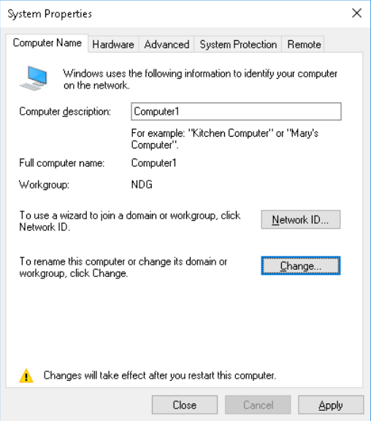
  + Ensure that you can ping all systems
  + 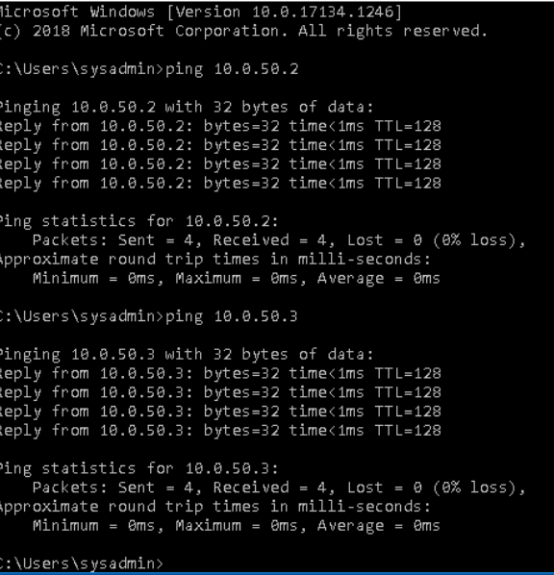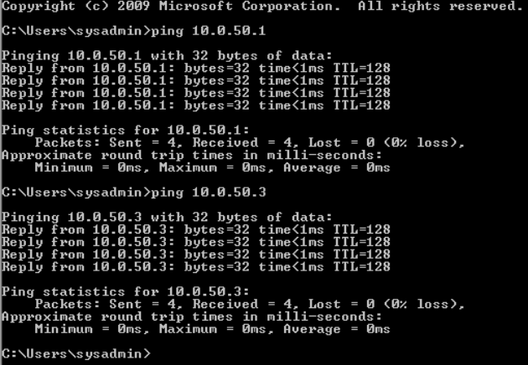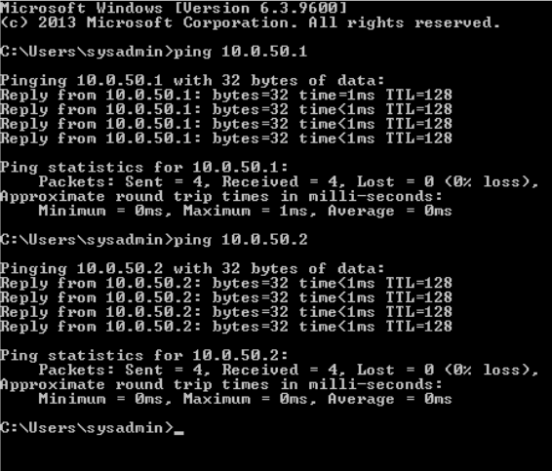
* From your home computer, Ping Google and interpret the output
* Each line shows response times(in ms) = how long it took to reach the google server
* TTL = how many hops remain before packet expires
* Packet loss should be 0 percent
* 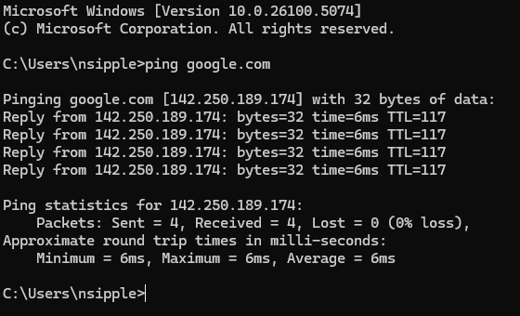
* From your home computer, Traceroute Google and interpret the output
* Displays each router or gateway your packet takes to reach google
* Shows round trip time for each hop
* 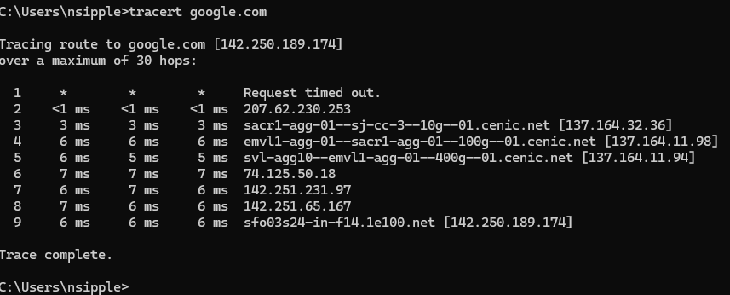

#### Part B: Log on to "EACH" system in NISGTC Linux+ Series 1, Lab 1

* Log on to netlab environment and change the below,
  + Change the IP's on all systems to the 10.0.60.0/24 subnet
  + 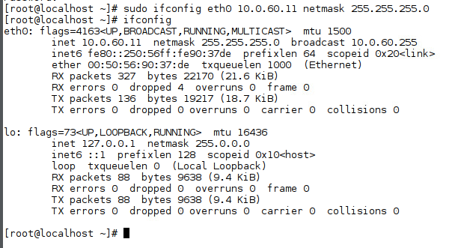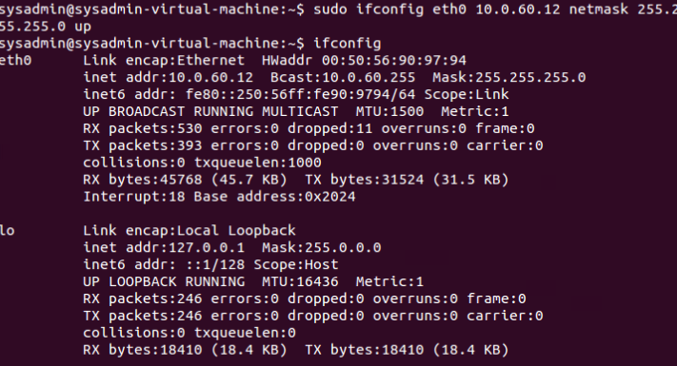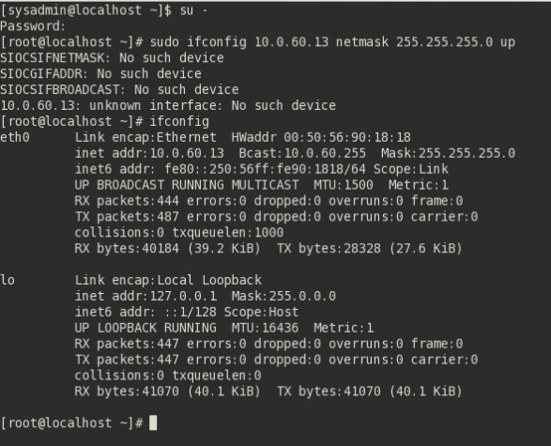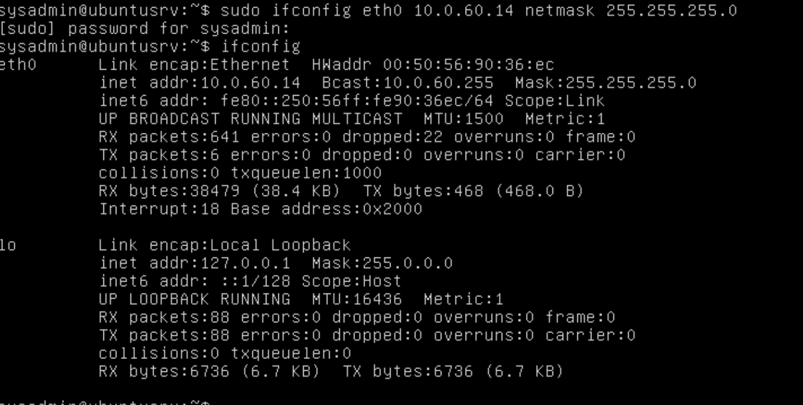
  + Change the hostnames to computer1, computer2, computer3, computer4
  + 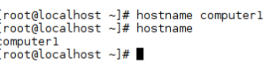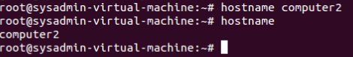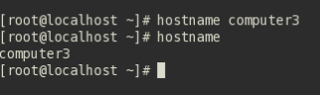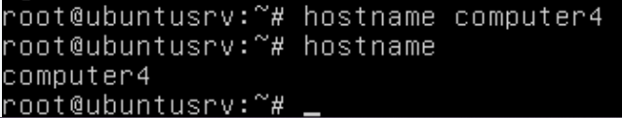
  + Ensure that you can ping all systems
  + 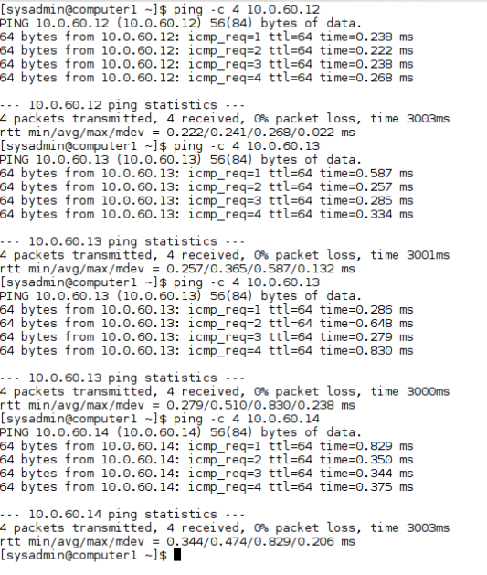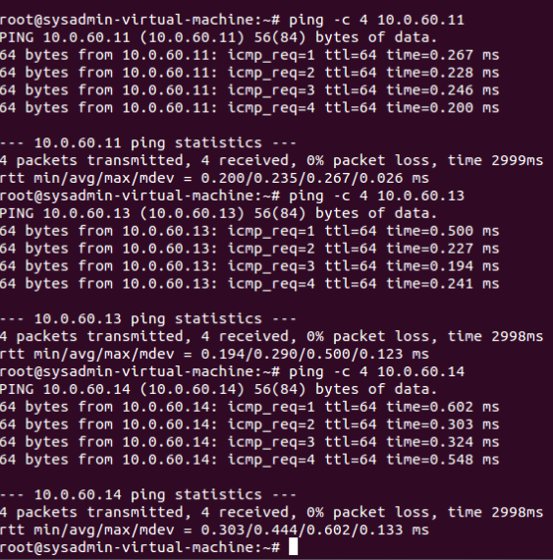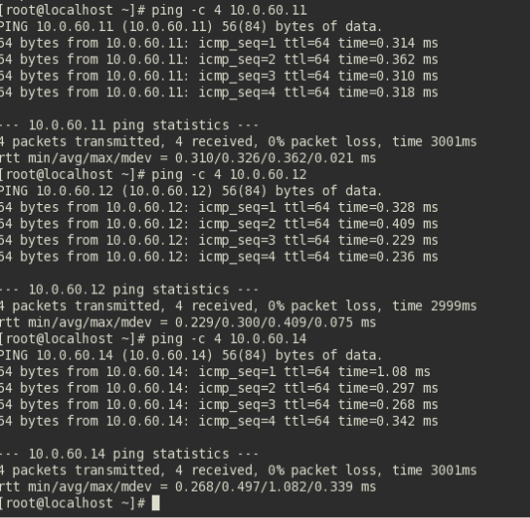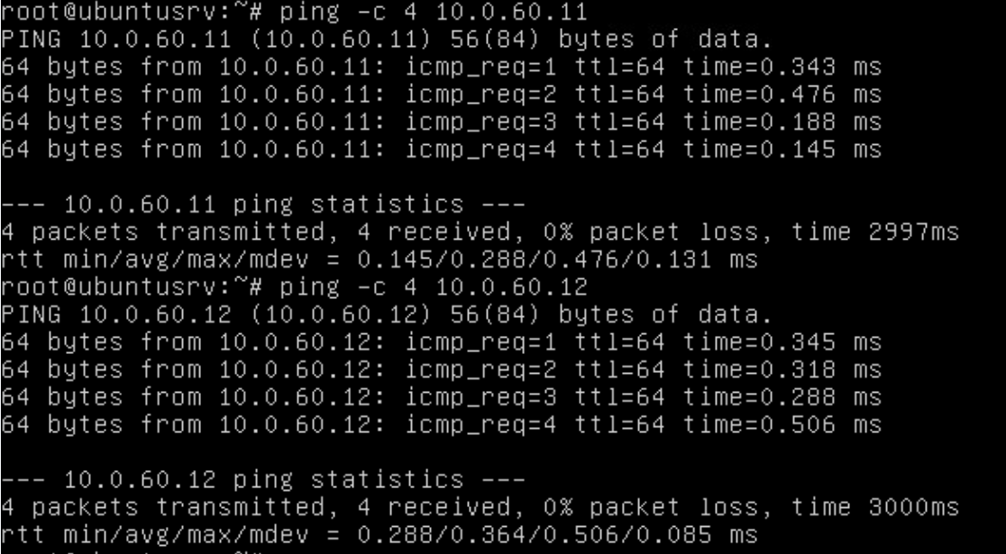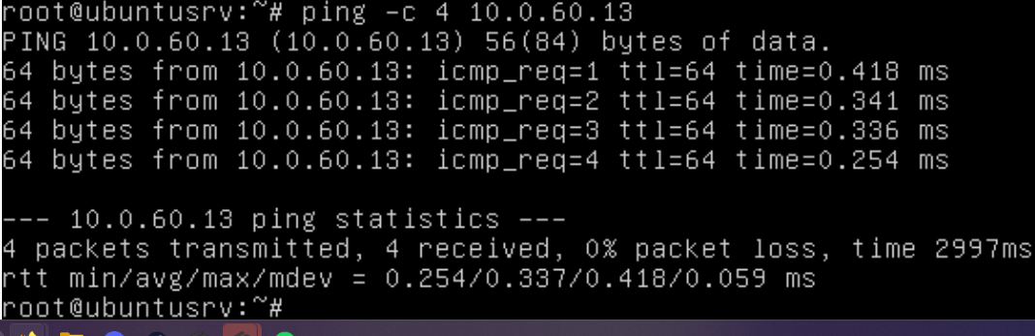

#### Part C:

* Explain the below terms "in your own words", in detail to someone who does not know about computers
  + DNS
    - Similar to a list of addresses for each website, each website has an IP address, in order to make it easier to remember these addresses we use names like [google.com](http://google.com), the DNS just translates this to its actual IP address.
  + DHCP
    - Automatically assigns an ip address to an device
  + Subnet
    - Similar to a neighborhood of addresses inside a city, the city is the whole network and the neighborhood is the subnet. This helps makes things efficient
  + Subnet Mask
    - Similar to a map of which houses belong in a neighborhood. It decides which IP addresses are local and outside, if a computer wants to talk to another computer, it checks the subnet mask to see if the address is in the same subnet or not
  + Default Gateway
    - Like a gate in a community, you can talk to all computers in the subnet directly, but in order to access outside the subnet you have to go through the default gateway - the gate
  + Default Route
    - A location that the computer sends stuff to if the computer does not know how to send the packets into the original destination
  + Static Route
    - A manually set route that tells the computer how to reach a certain network
  + ARP
    - If you know the Ip address but don't know the hardware address, the ARP maps IP addresses to a Mac address so that data can be received
  + OSI Model
    - A seven layer cake that shows all the different steps or “cogs” in a process or machine
  + TCP/IP Model
    - A simpler version of the OSI model that runs on the internet today rather than a teaching tool.

#### Part D: SierraLab

* Log on via SSH to our SierraLab network (207.62.230.146:2222).
* Use the password you set up with your public/private key
* Ensure that your putty is setup to use your private key
* Once you log on, ssh to the Windowsbox (ssh it100student@windowsbox.com)
* **Password is Computersrock1**
* Answer the below questions with screenshots

1. Use the whoami command to see who you are

  
2. Use the dir command to see what is here

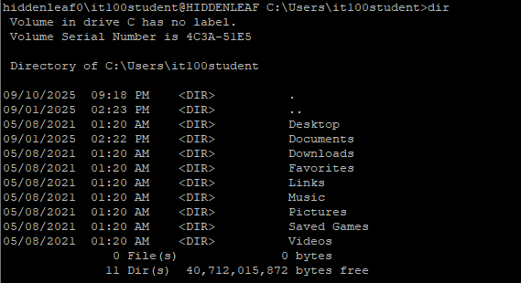  
3. Use the hostname command to view your hostname

  
4. Use the ipconfig command to retrieve your IP address(es)  
 a) What is the MAC address of your system

  
 b) What is the default gateway of your computer

  
 c) What is the subnet mask of your computer

  
 d) What is the DHCP server for your computer

  
 e) When what the IP of your computer obtained

  
 f) When does the IP of your computer expire

  
5. Use the ipconfig command to display DNS information

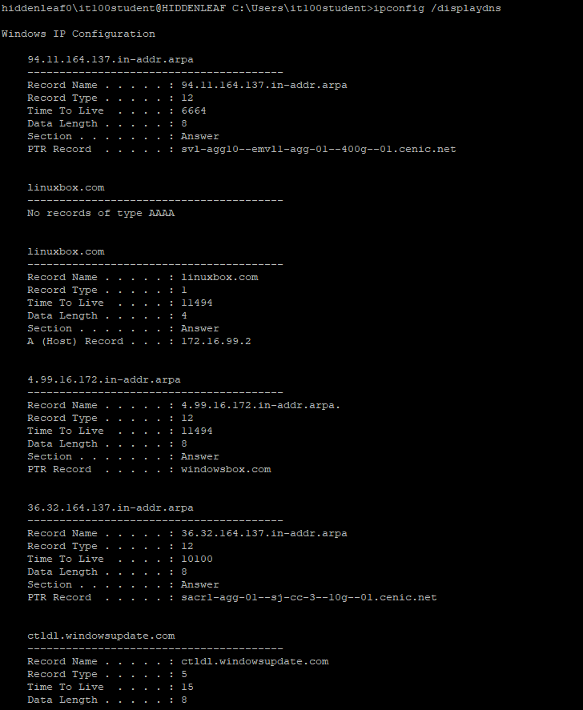  
6. Use the ping command to ping google

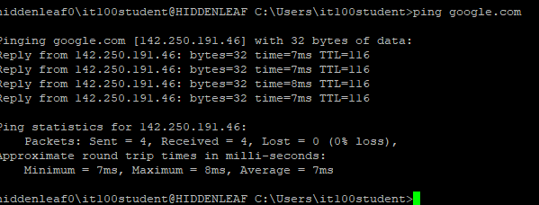7. Use the ping command to ping the default gateway

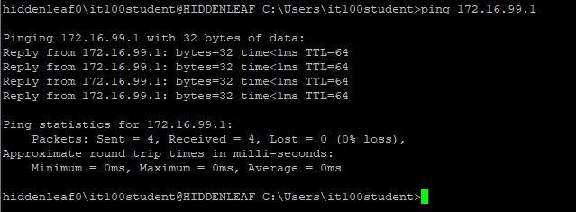  
8. Use the traceert command to see how many hops away google is

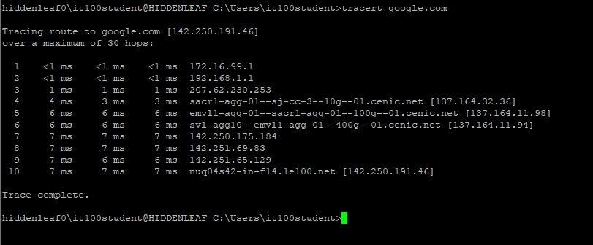

#### Part E: SierraLab

* Log on via SSH to our SierraLab network (207.62.230.146:2222).
* Use the password you set up with your public/private key
* Ensure that your putty is setup to use your private key
* Once you log on, ssh to the Linuxbox (ssh it100student@linuxbox.com)
* **PasSsword is Computersrock1**

1: type the command pwd. This will print the current working directory. it is where you are at

  
2: type the command w, this list who is logged on to this system

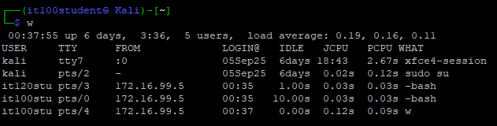  
3: type the command ls, this tells you what files/folders are here



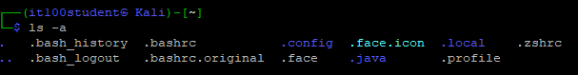  
4: type the command cat README, this list the contents of this file

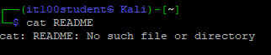  
5: type the command whoami, this tells you who you are logged on as

  
6: type the ifconfig command to get your IP address

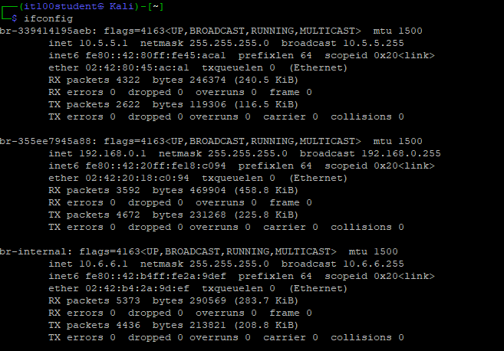  
7: type the route command to get your routing table

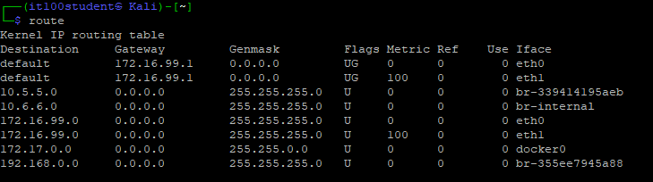  
8: type the command to get your disk size

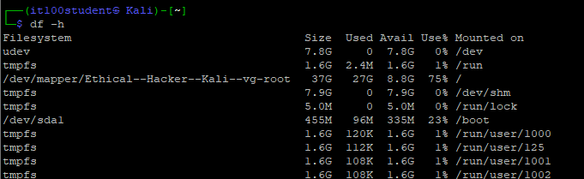  
9: type the command to get your total memory

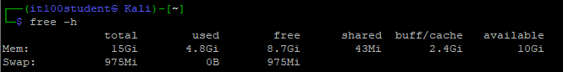  
10: type the command to get processor information



