Nathaniel Sipple

Professor Torres

Date you turned it in

IT 0100

Lab 5

* Copy parts A, B, and C from Canvas
* Add notes and screenshots
* Can you reproduce the lab with the questions and your screenshots with notes?
* If your boss asked you for this, did you provide the answer with context?
* The purpose of this lab is to understand network configurations

#### Part A:

* Find the port numbers for the below ports, state what they do, and how you connect/use these ports:
  + FTP
    - Port 21, Transfers files between computers over TCP/IP network, Connect via command line or FTP client like Filezilla
  + SSH
    - Port 22, Provides secure remote login and command execution with encryption, Connect via SSH command or tools like PuTTY
  + Telnet
    - Port 23, Provides remote text-based login to another computer, Connect via Telnet command
  + SMTP
    - Port 25, Sends outgoing email between mail servers, Connect through mail server configuration
  + DNS
    - Port 53, Translates domain names into IP addresses, Connect automatically when browsing or use tools like nslookup/dig
  + DHCP
    - Port 67, DHCP server assigns IP addresses automatically, Client connects by requesting an IP when set to automatic
    - Port 68, DHCP client receives IP configuration, Happens automatically during network setup
  + HTTP
    - Port 80, Transfers unencrypted web pages and data, Connect via web browser using http://
  + POP3
    - Port 110, Downloads emails from a server to a local client, Connect via mail client (POP3 account setup)
  + NetBIOS/NetBT
    - Port 137, NetBIOS name service for Windows networking, Connects automatically when browsing network shares
    - Port 138, NetBIOS datagram service for messaging and broadcasts, Used automatically by Windows LAN services
    - Port 139, NetBIOS session service for file/printer sharing, Connect by mapping shared drives in Windows
  + IMAP
    - Port 143, Retrieves and manages emails on the server (IMAP), Connect via mail client (IMAP setup)
    - Port 993, Secure IMAP with encryption, Connect via mail client with SSL/TLS enabled
  + SNMP
    - Port 161, Queries devices for monitoring and management (SNMP), Connect via SNMP management tools
    - Port 162, Receives SNMP traps/alerts from devices, Connect via SNMP monitoring systems
  + LDAP
    - Port 389, Accesses and manages directory services (LDAP), Connect via authentication systems or ldapsearch tools
    - Port 636, Secure LDAP with encryption, Connect via LDAP clients with SSL/TLS
  + HTTPS
    - Port 443, Transfers encrypted web pages and data securely, Connect via web browser using https://
  + SMB/CIFS
    - Port 445, Provides Windows file and printer sharing (SMB/CIFS), Connect by browsing to \servername\share
  + RDP
    - Port 3389, Allows graphical remote desktop access to Windows systems, Connect via Remote Desktop client (mstsc)

#### Part B:

* Using the online network diagram software <https://app.diagrams.net/>
* [Links to an external site.](https://app.diagrams.net/)
* , draw 2 network diagrams. One diagram should have all of the below components in your local area network. The second diagram should show what you have moved to the cloud, with what is left over. Ensure that you give your opinion/view as to what is happening:
  + Router
  + Switch
  + Server
  + Desktop
  + Wireless router
  + DNS and DHCP server
  + Web server
  + Load balancer
  + Cloud services (AWS, office365)
  + Virtual machines
  + Spam gateways
  + Proxy server
  + IoT systems
    - Subnet range for your systems: 10.0.75.0/24
* LAN Diagram: 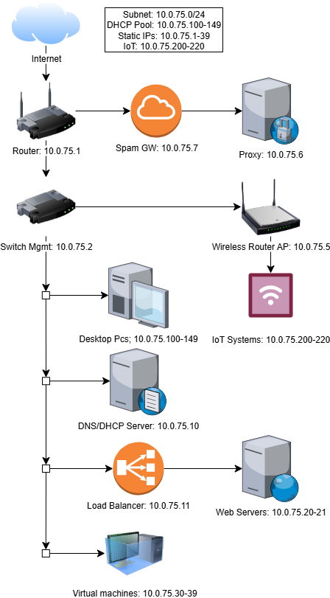
* Cloud Diagram: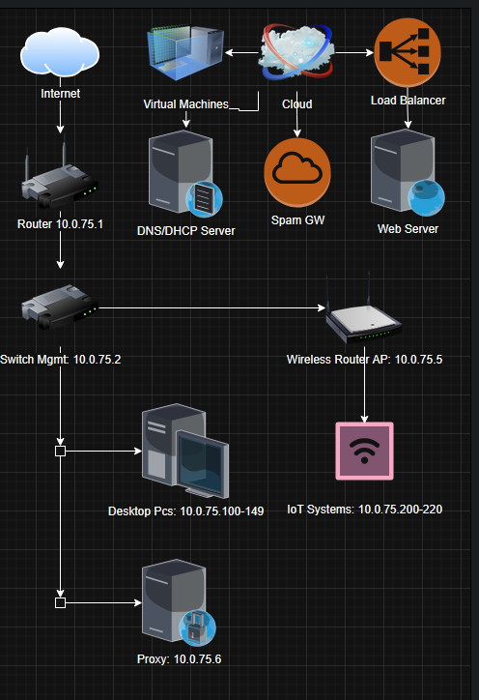

#### Part C:

* Using your internet service provider as a reference, determine the network speeds in your house/apartment.
  + what options are available, what are the speeds
    - 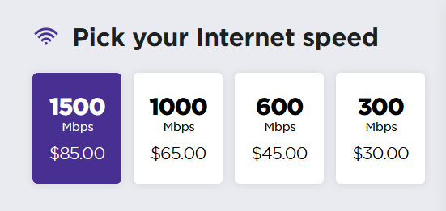
    - 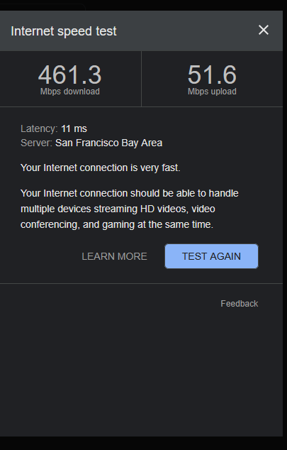
    - Currently have the 1gbit/second plan
  + what can you do at each speed
  + 
* compare the above information for home and for business
  + What additional features are there for businesses
  + 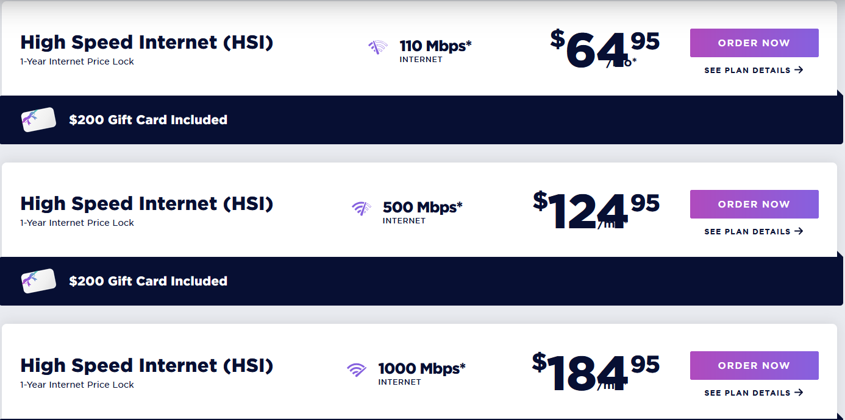
  + Why are business services so expensive
  + Business Internet usually comes with SLAs which is a contract with the Isp to guarantee internet speeds, so that the speed my be consistent as well as they have multiple safeties in play if the internet goes out

#### Part D: SierraLab: ssh to Windows Box

* Log on via SSH to our SierraLab network (207.62.230.146:2222).
* Use the password you set up with your public/private key
* Ensure that your putty is setup to use your private key
* Once you log on, ssh to the Windowsbox (ssh it100student@windowsbox.com)
* **Password is Computersrock1**
* Answer the below questions with screenshots

1. Use the wmic to view the serial number
   1. 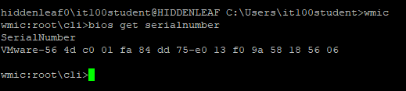
2. Run the below command and explain the output: wmic cpu get caption, name, deviceid, numberofcores, maxclockspeed, status
   1. 
   2. Caption/Name: Processor brand/model
   3. DeviceID: Identifier for the CPU
   4. NumberOfCores: Physical cores
   5. MaxClockSpeed: Maximum clock frequency in MHz.
   6. Status: Should show OK if the CPU is working properly.
3. Utilize wmic to list the total system memory
   1. 
4. Utilize wmic to get hard drive partition details
   1. 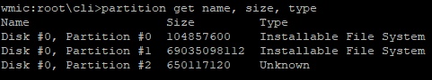
5. Utilize wmic to get a list of all install products/software
   1. 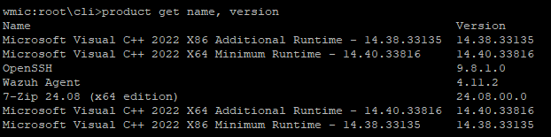
6. Utilize wmic to get full system information
   1. 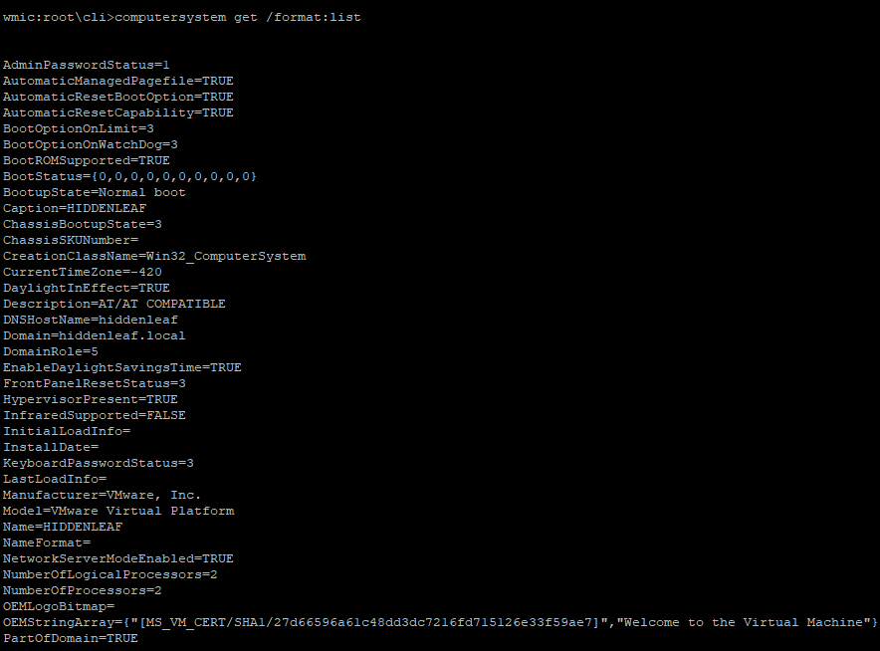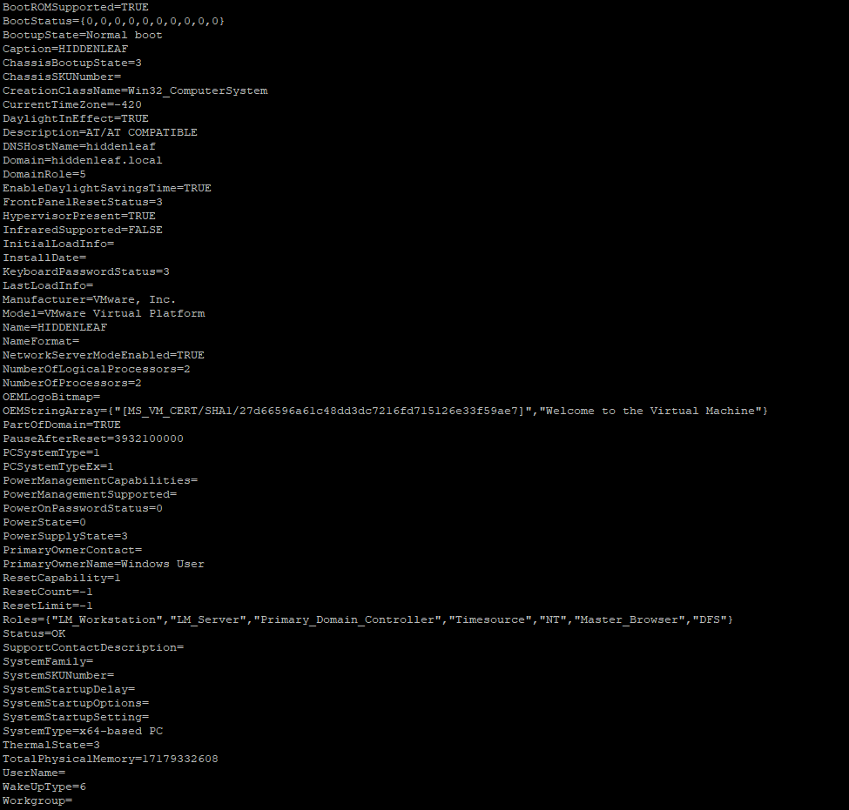
7. Utilize wmic to find updates applied
   1. 
8. Utilize wmic to get a list of local accounts
   1. 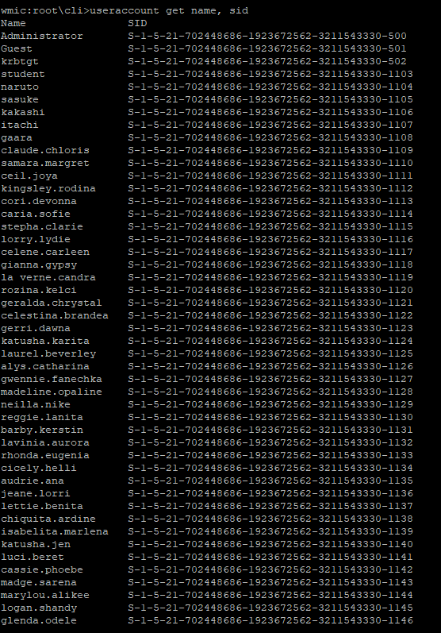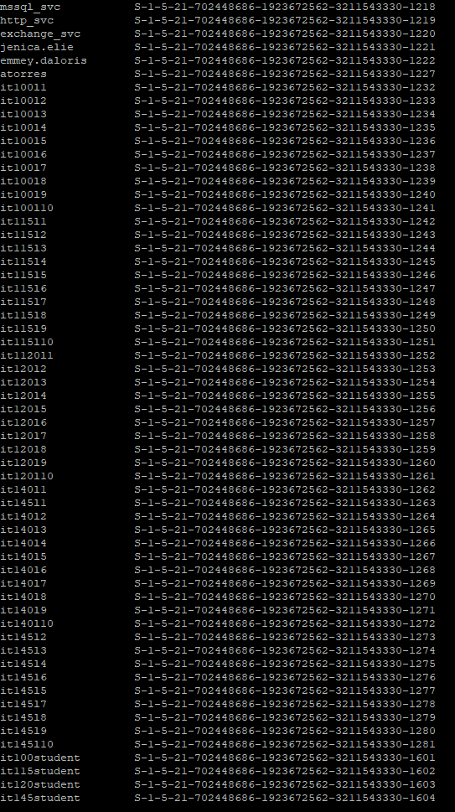
9. List the help center for wmic
   1. 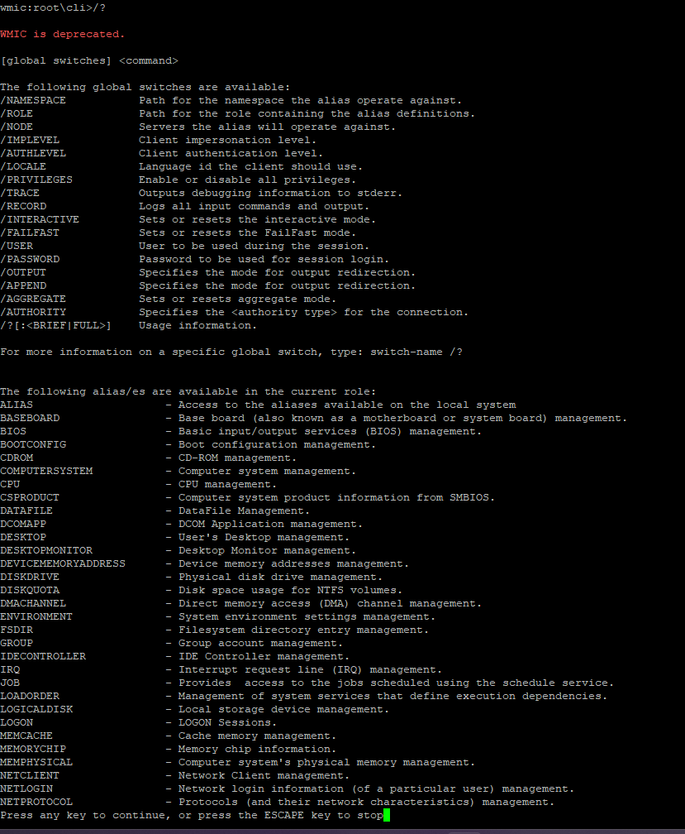
10. Use wmic to get the OS build and version
    1. 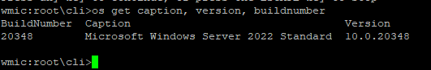

#### Part E: SierraLab: ssh to Linux Box

* Log on via SSH to our SierraLab network (207.62.230.146:2222).
* Use the password you set up with your public/private key
* Ensure that your putty is setup to use your private key
* Once you log on, ssh to the Linuxbox (ssh it100student@linuxbox.com)
* **Password is Computersrock1**

1: type the comand to get a list of running processes

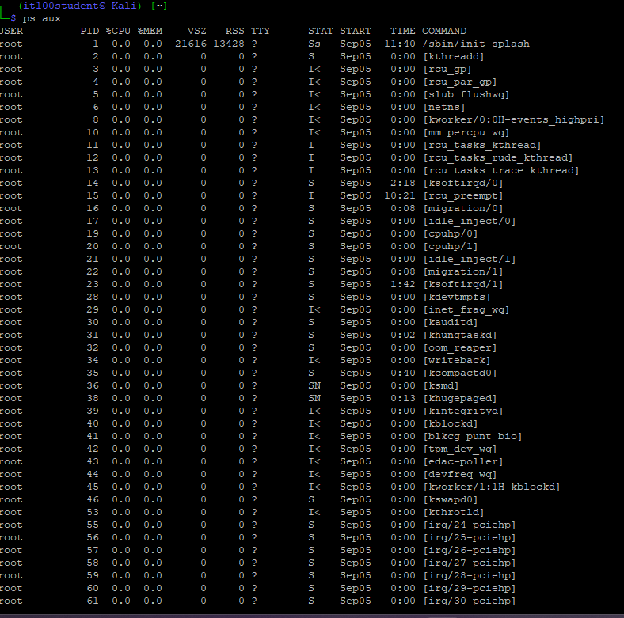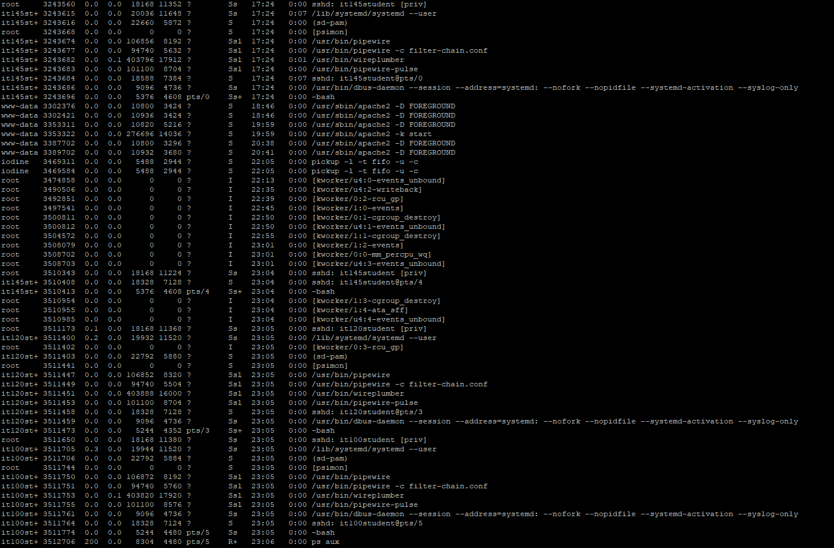

2: type the command to see real time processes running

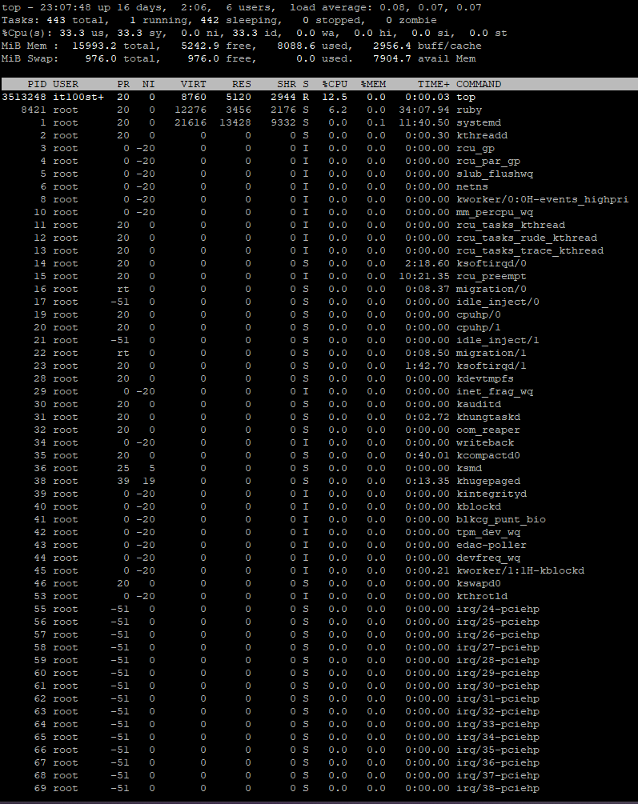

3: type the command to show how long the system has been up

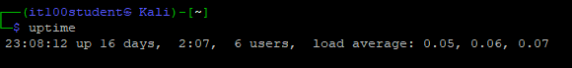

4 type the command to show kernel info



5: type the command to show how much total memory is in the systems

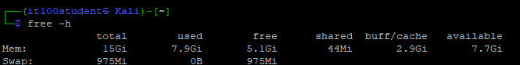

6: type the command to show processor details on the system

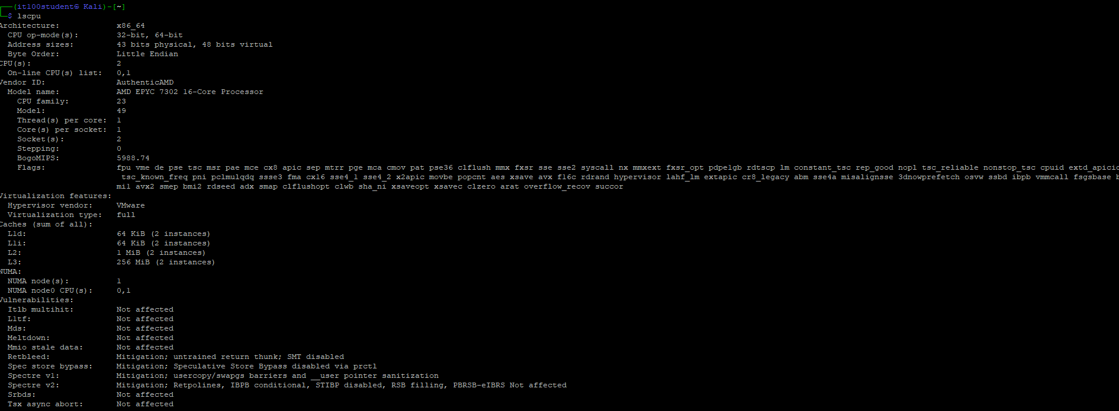

7: type the command to show all user accounts on the system

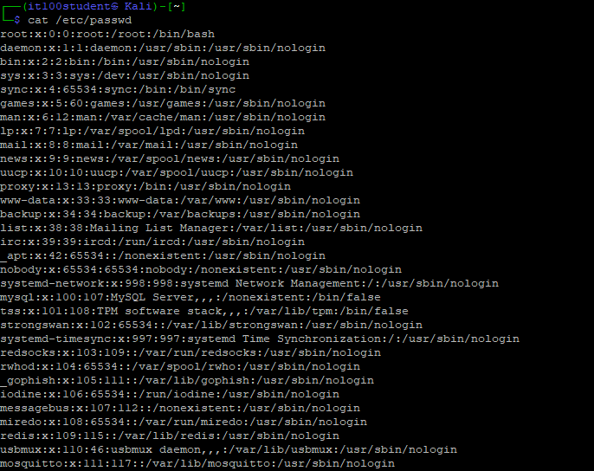

8: type the command to show all hard drive partitions on the system

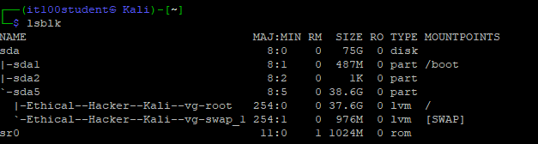

9: type the command to show any wireless interfaces on the system

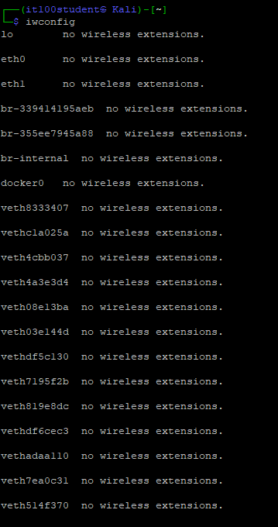

10: type the command to show any and all pci devices connected

