Nathaniel Sipple

Professor Torres

8/19/2025

IT 0100

Lab 1

* Copy parts A, B, and C from Canvas
* Add notes and screenshots
* Can you reproduce the lab with the questions and your screenshots with notes?
* If your boss asked you for this, did you provide the answer with context?

#### Part A:

* Research jobs that require the CompTIA A+ Certification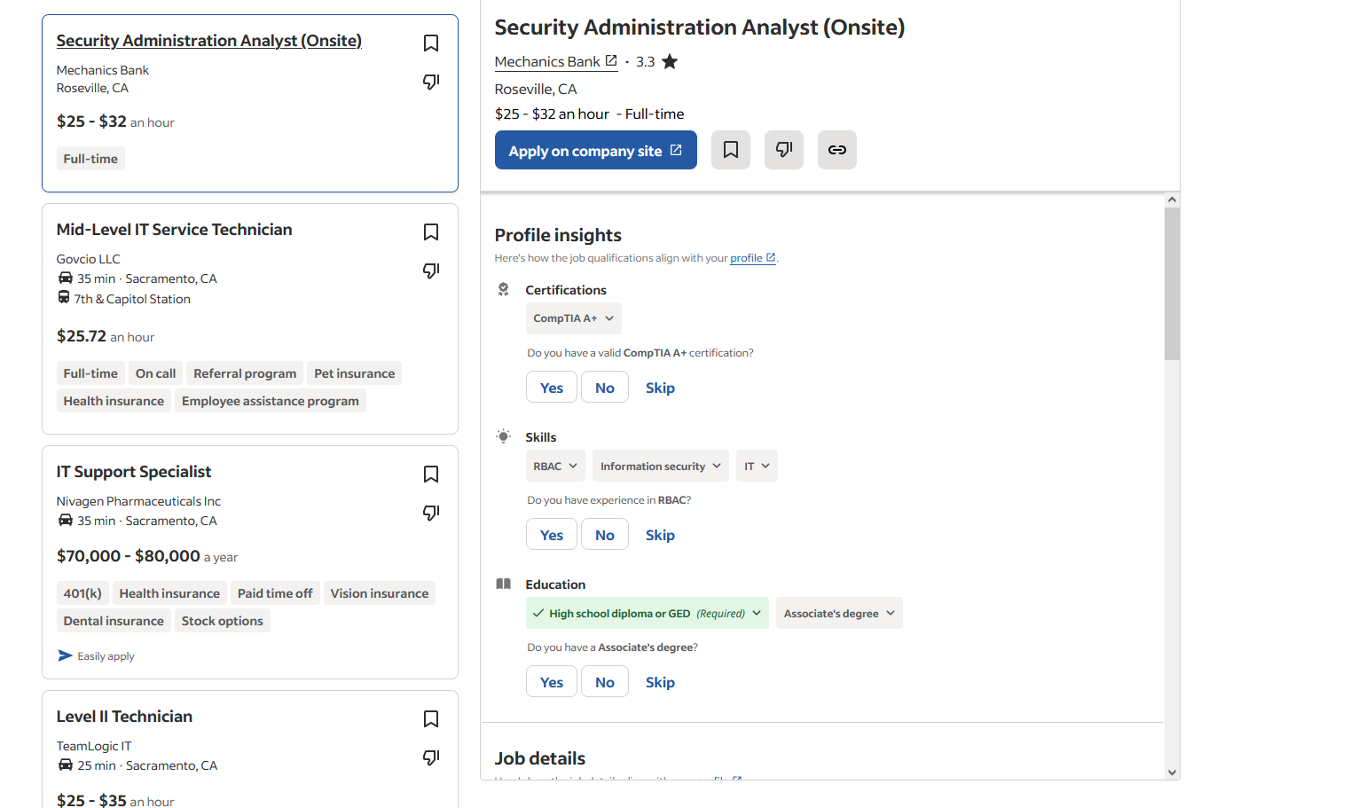
  + What additional qualifications are needed for the jobs?
    - Highschool Diploma/GED, Associates Degree, 1-5 years of IT experience, CompTIA Network+, CompTIA Server+, CompTIA Security+.
  + What is the salary range for the jobs?
    - 52-80k a year
  + What features made the jobs stand out?
    - Many don't require a college degree, just experience and certifications, some(like the pharmaceutical company) requires a public trust clearance background check.

#### Part B: [Netlab](https://netlabve2.flc.losrios.edu/)

#### [Links to an external site.](https://netlabve2.flc.losrios.edu/)

* Log on to Netlab NDG A+ V4,lab01, and perform the below exercise
  + Schedule two hours of lab time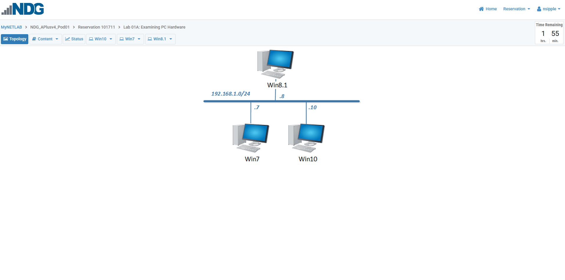
  + Log on to all systems
  + Un-dock one system 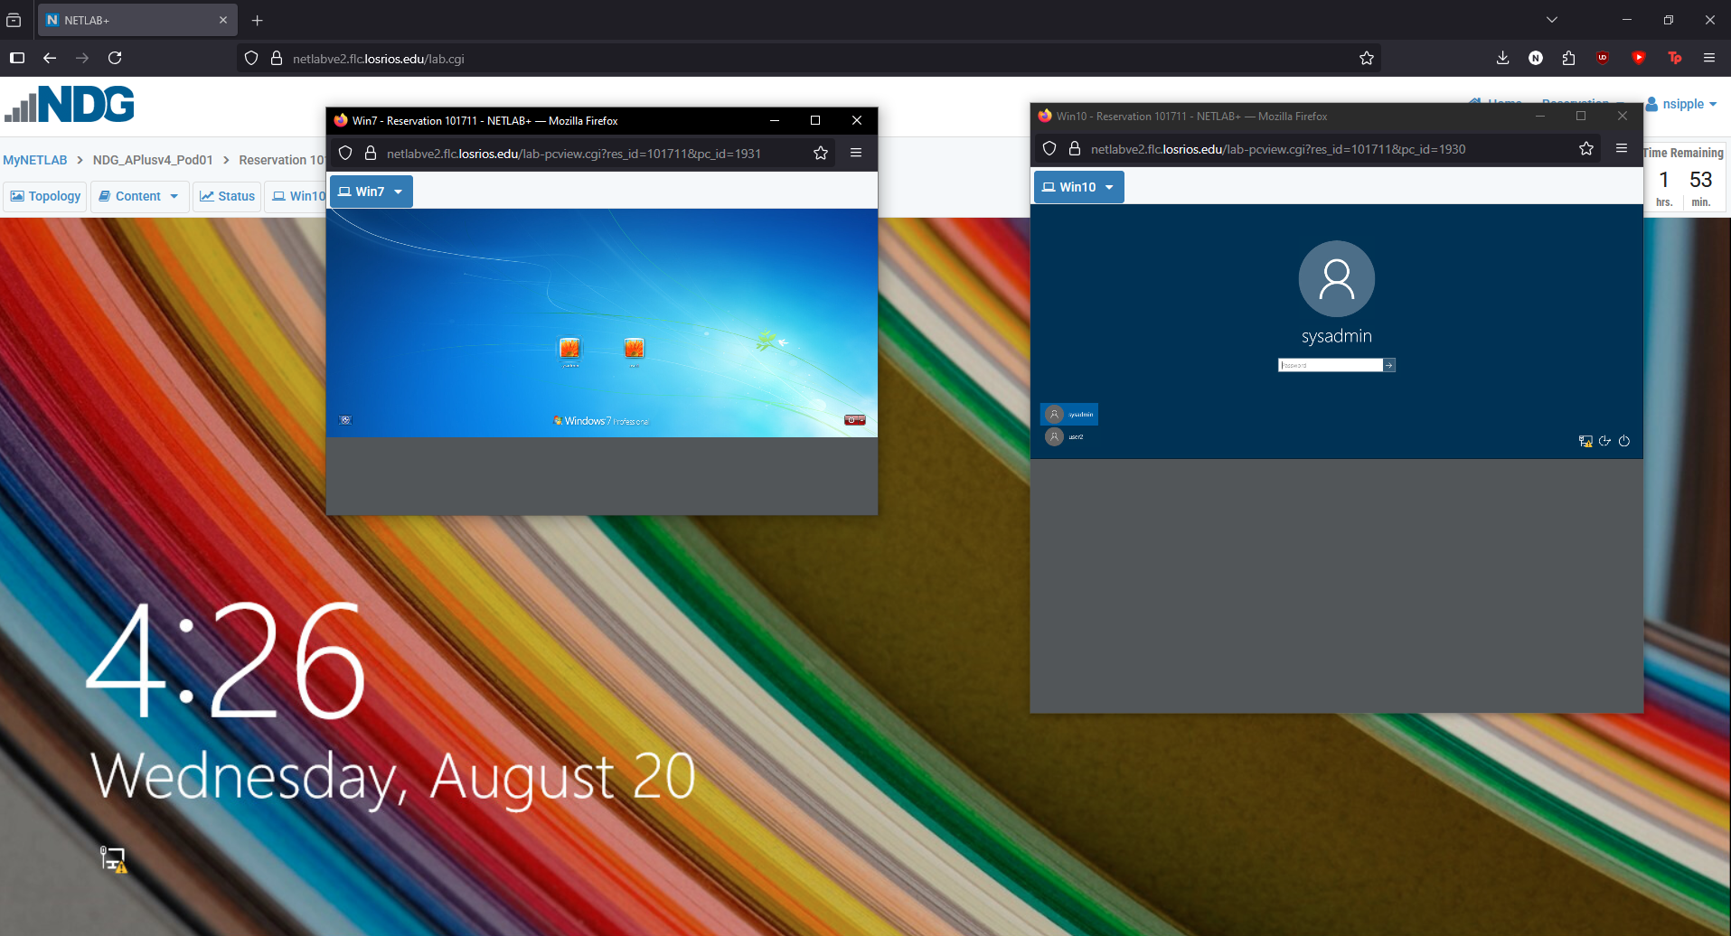
  + Ping all other systems from each system to confirm connectivity to all endpoints.
    - Ping from Win10 to Win7 & Win8.1 - No errors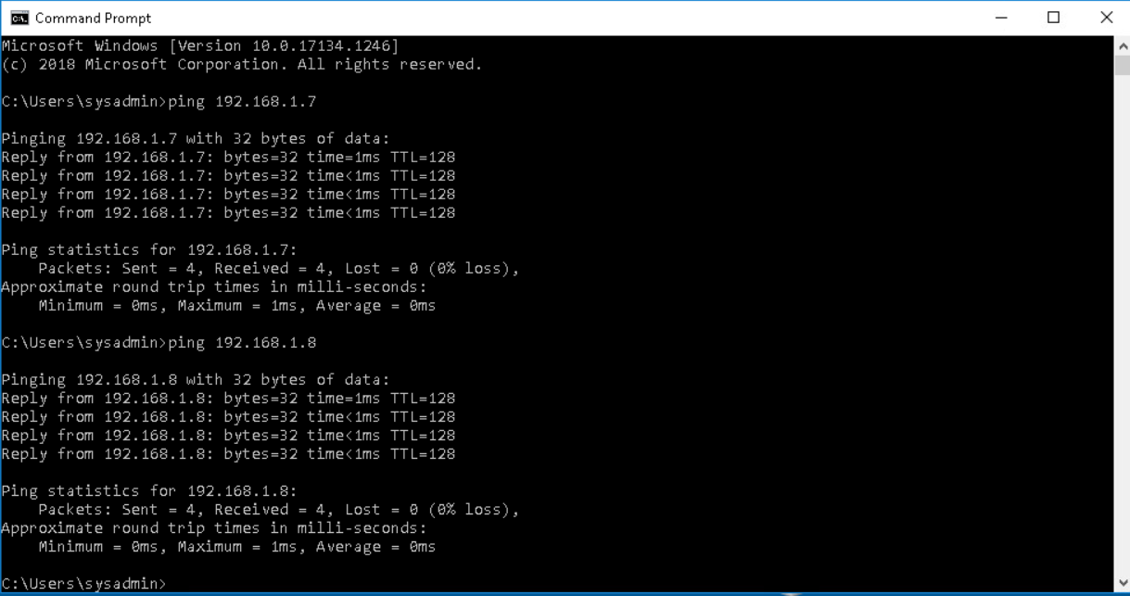
    - Ping from Win7 to Win8.1 & Win10 - No errors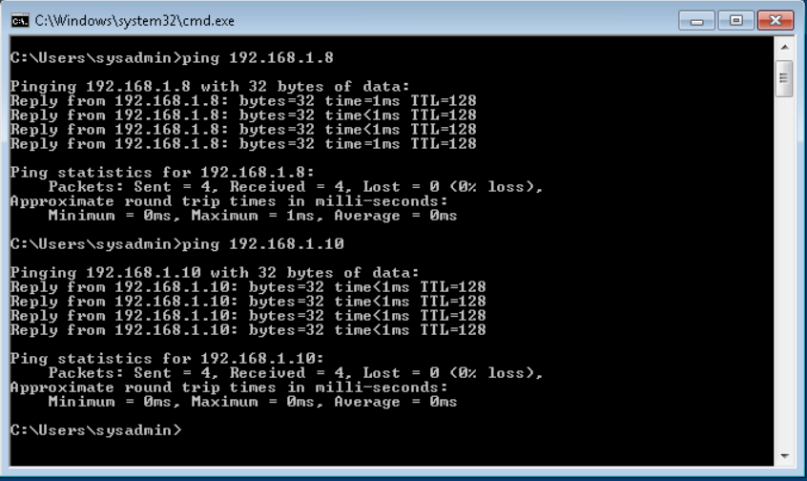
    - Ping from Win8.1 to Win7 & Win10 - No errors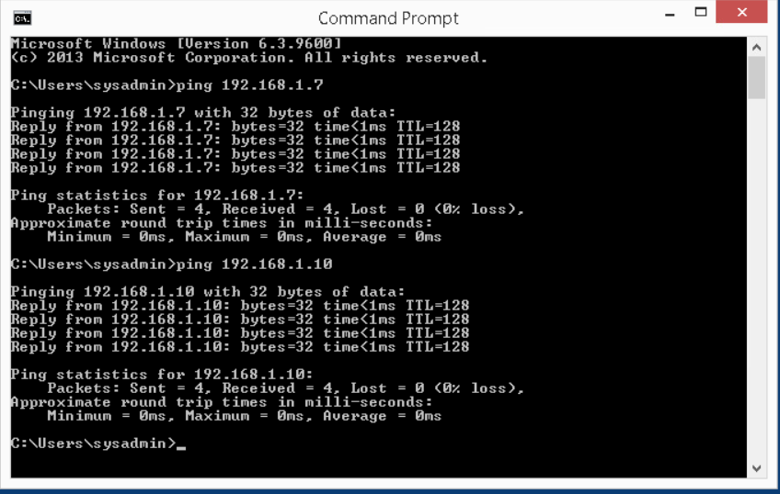

#### Part C:

* Share your anticipated learning outcomes from this class.
  + I think I'm most excited about learning the ins and outs of operating systems as well as the hardware of different devices other than desktop computers - primarily servers and laptops. I am also excited to learn about scripting and see what the potential is for automating certain tasks.
* Highlight notable aspects from the initial lecture.
  + The certifications were the most interesting part - especially with how technology changes so fast that what you study for certifications become outdated, and how getting into IT requires constant schooling which I was not aware of.