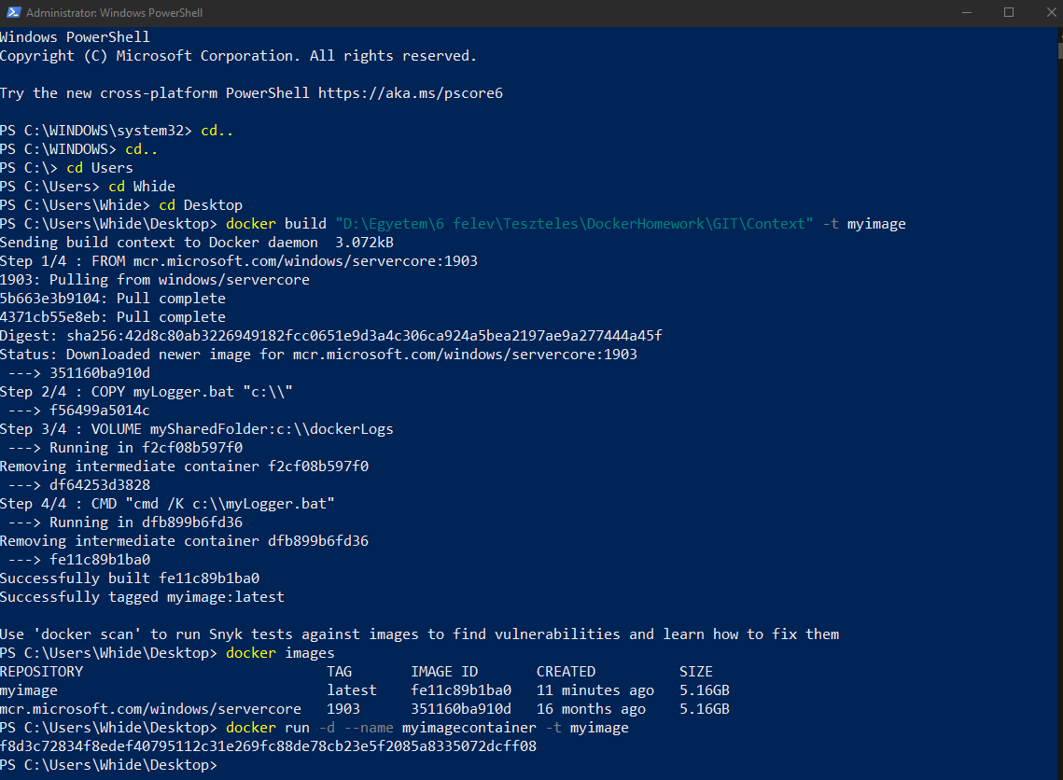

1. Running the build command (path differs from the GIT repository since I moved the files into the correct folder later)
   1. Docker build „D:\Egyetem\6 felev\Teszteles\DockerHomework\GIT \Context” –t myimage
2. Second command was to create the container file and run it.
   1. Docker run –d –name myimagecontainer –t myimage

Logs:

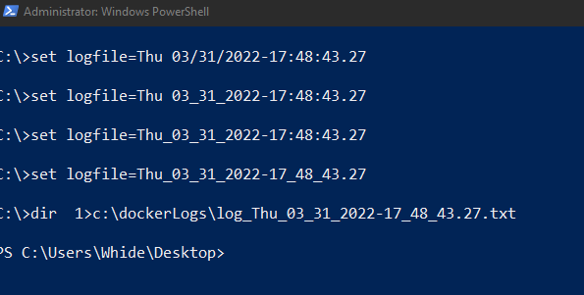

The outputs of the docker logs command to see what my batch file done.

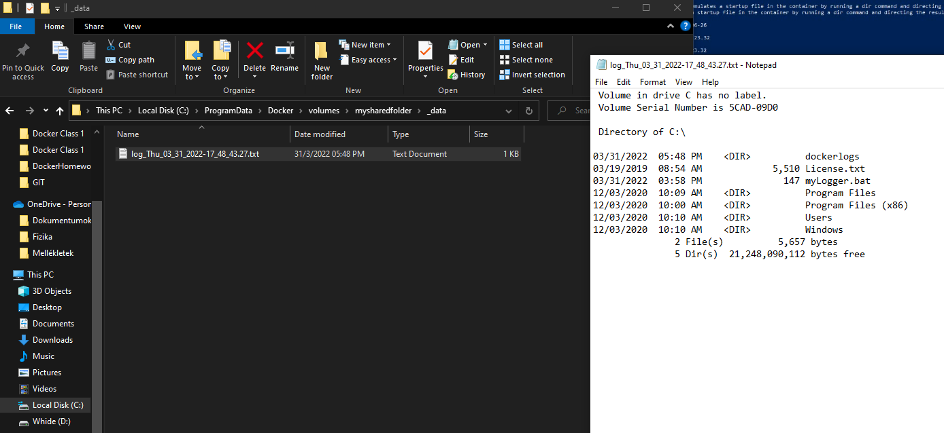

The output log file in the shared folder between the host and the container.

The Dockerfile and the Batch file:

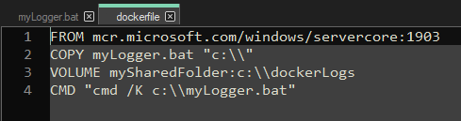

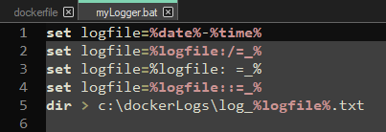

Konténer push Docker HUB-ra

