# Azure Cluster Creation:

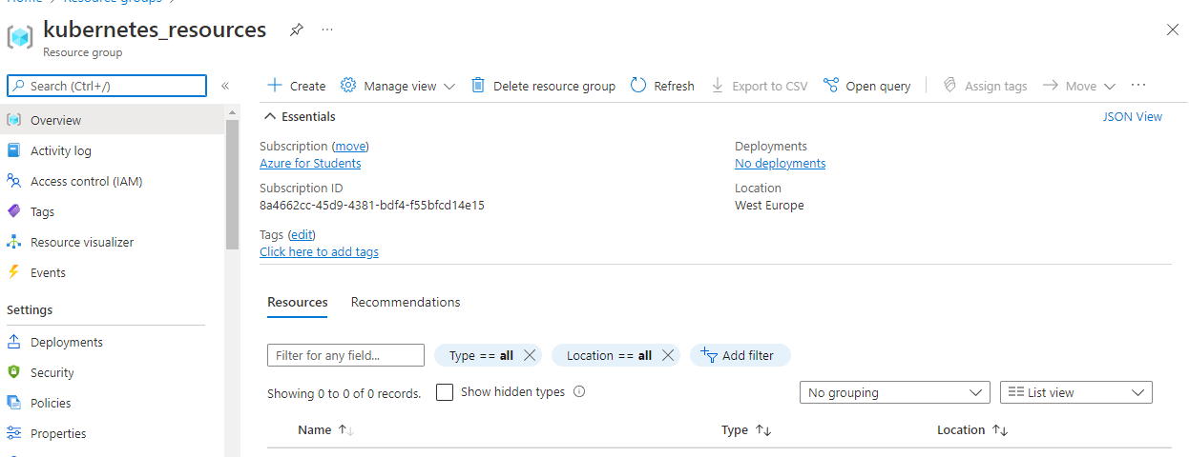

## Created a resource group for kubernetes

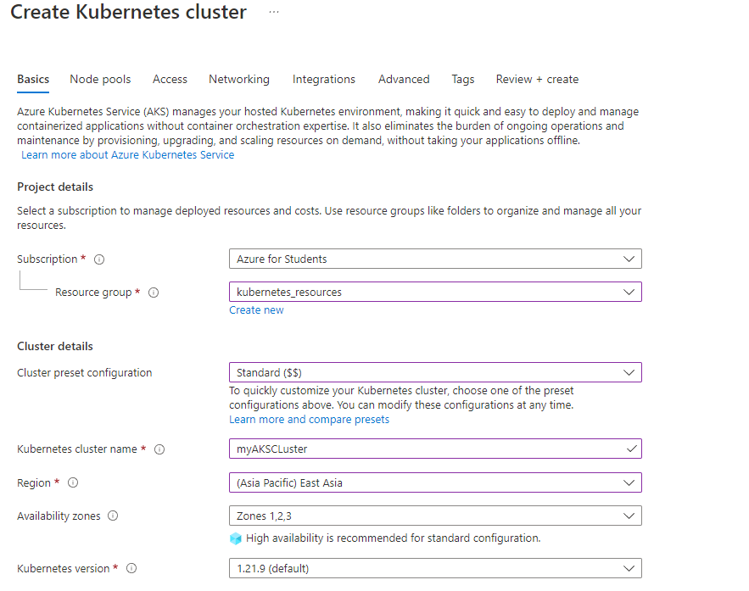

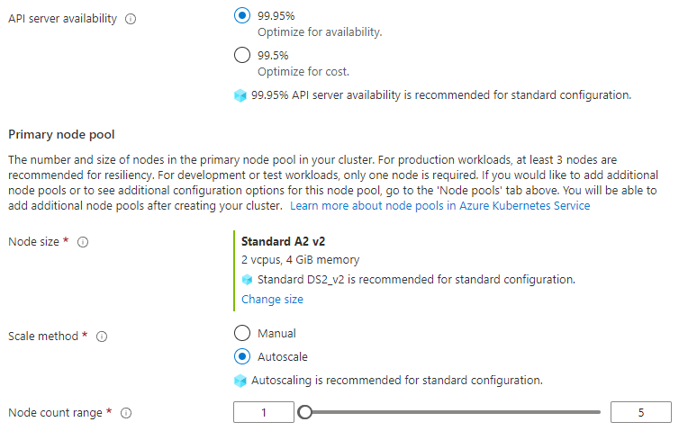

## The settings for the Kubernetes Cluster (I had to change the location to Asian in order to proceed)

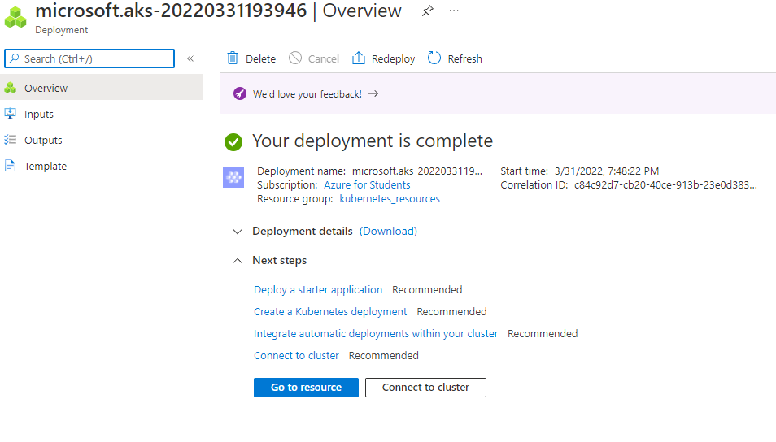

## Deployed Kubernetes Cluster

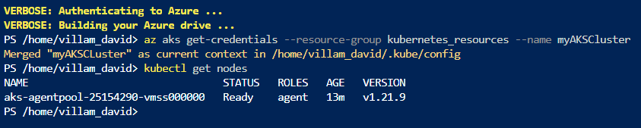

## Checking whether our kubernetes is up and running.

# Azure Cluster Deployment

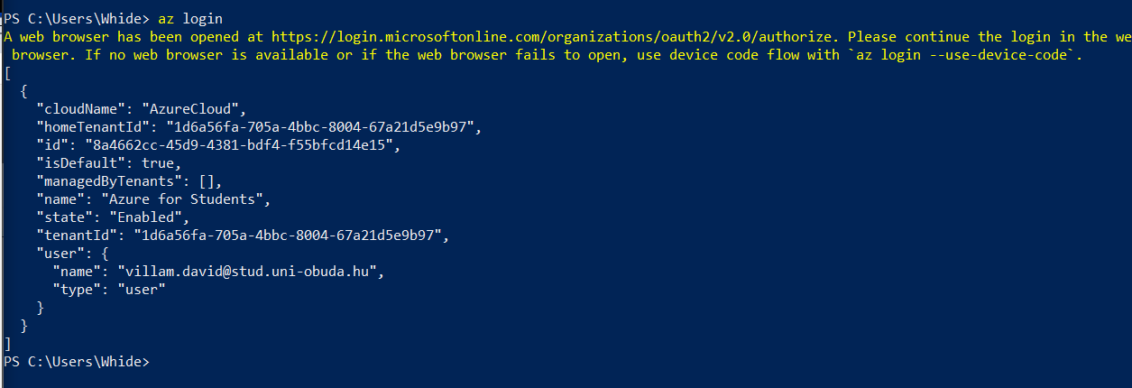

## Successful login on my PC’s powershell

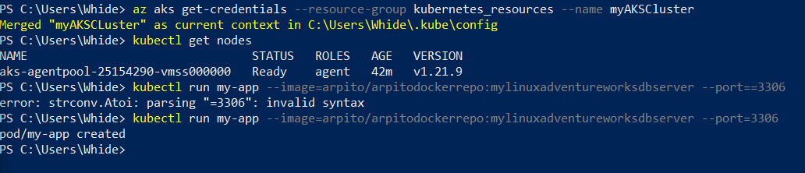

## Pod created

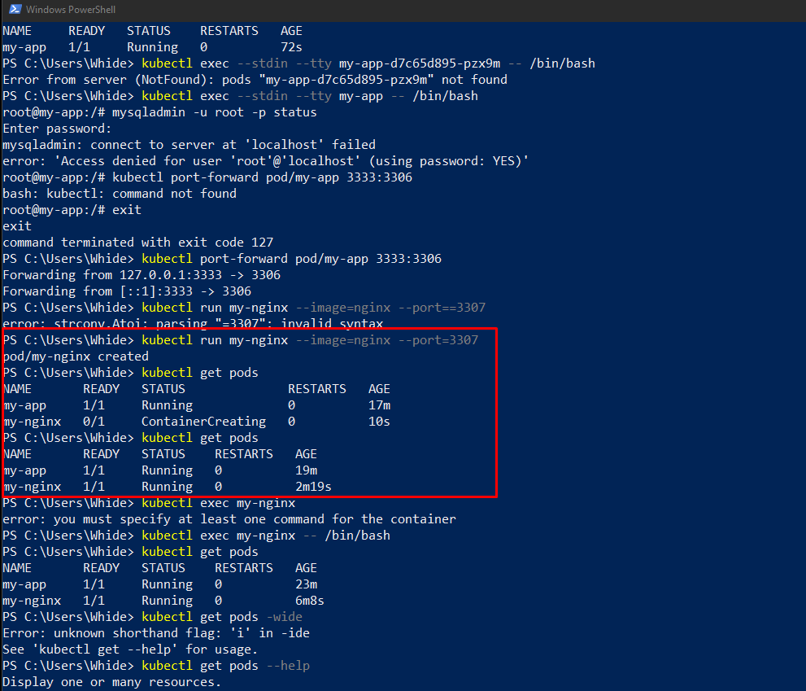

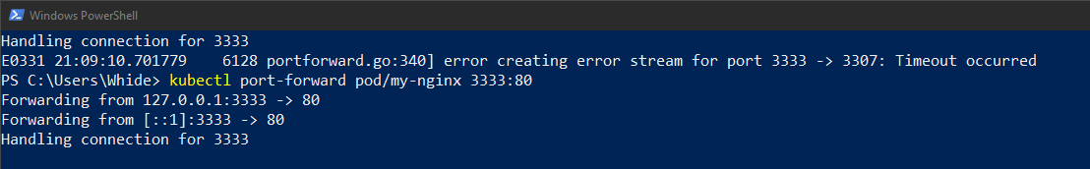

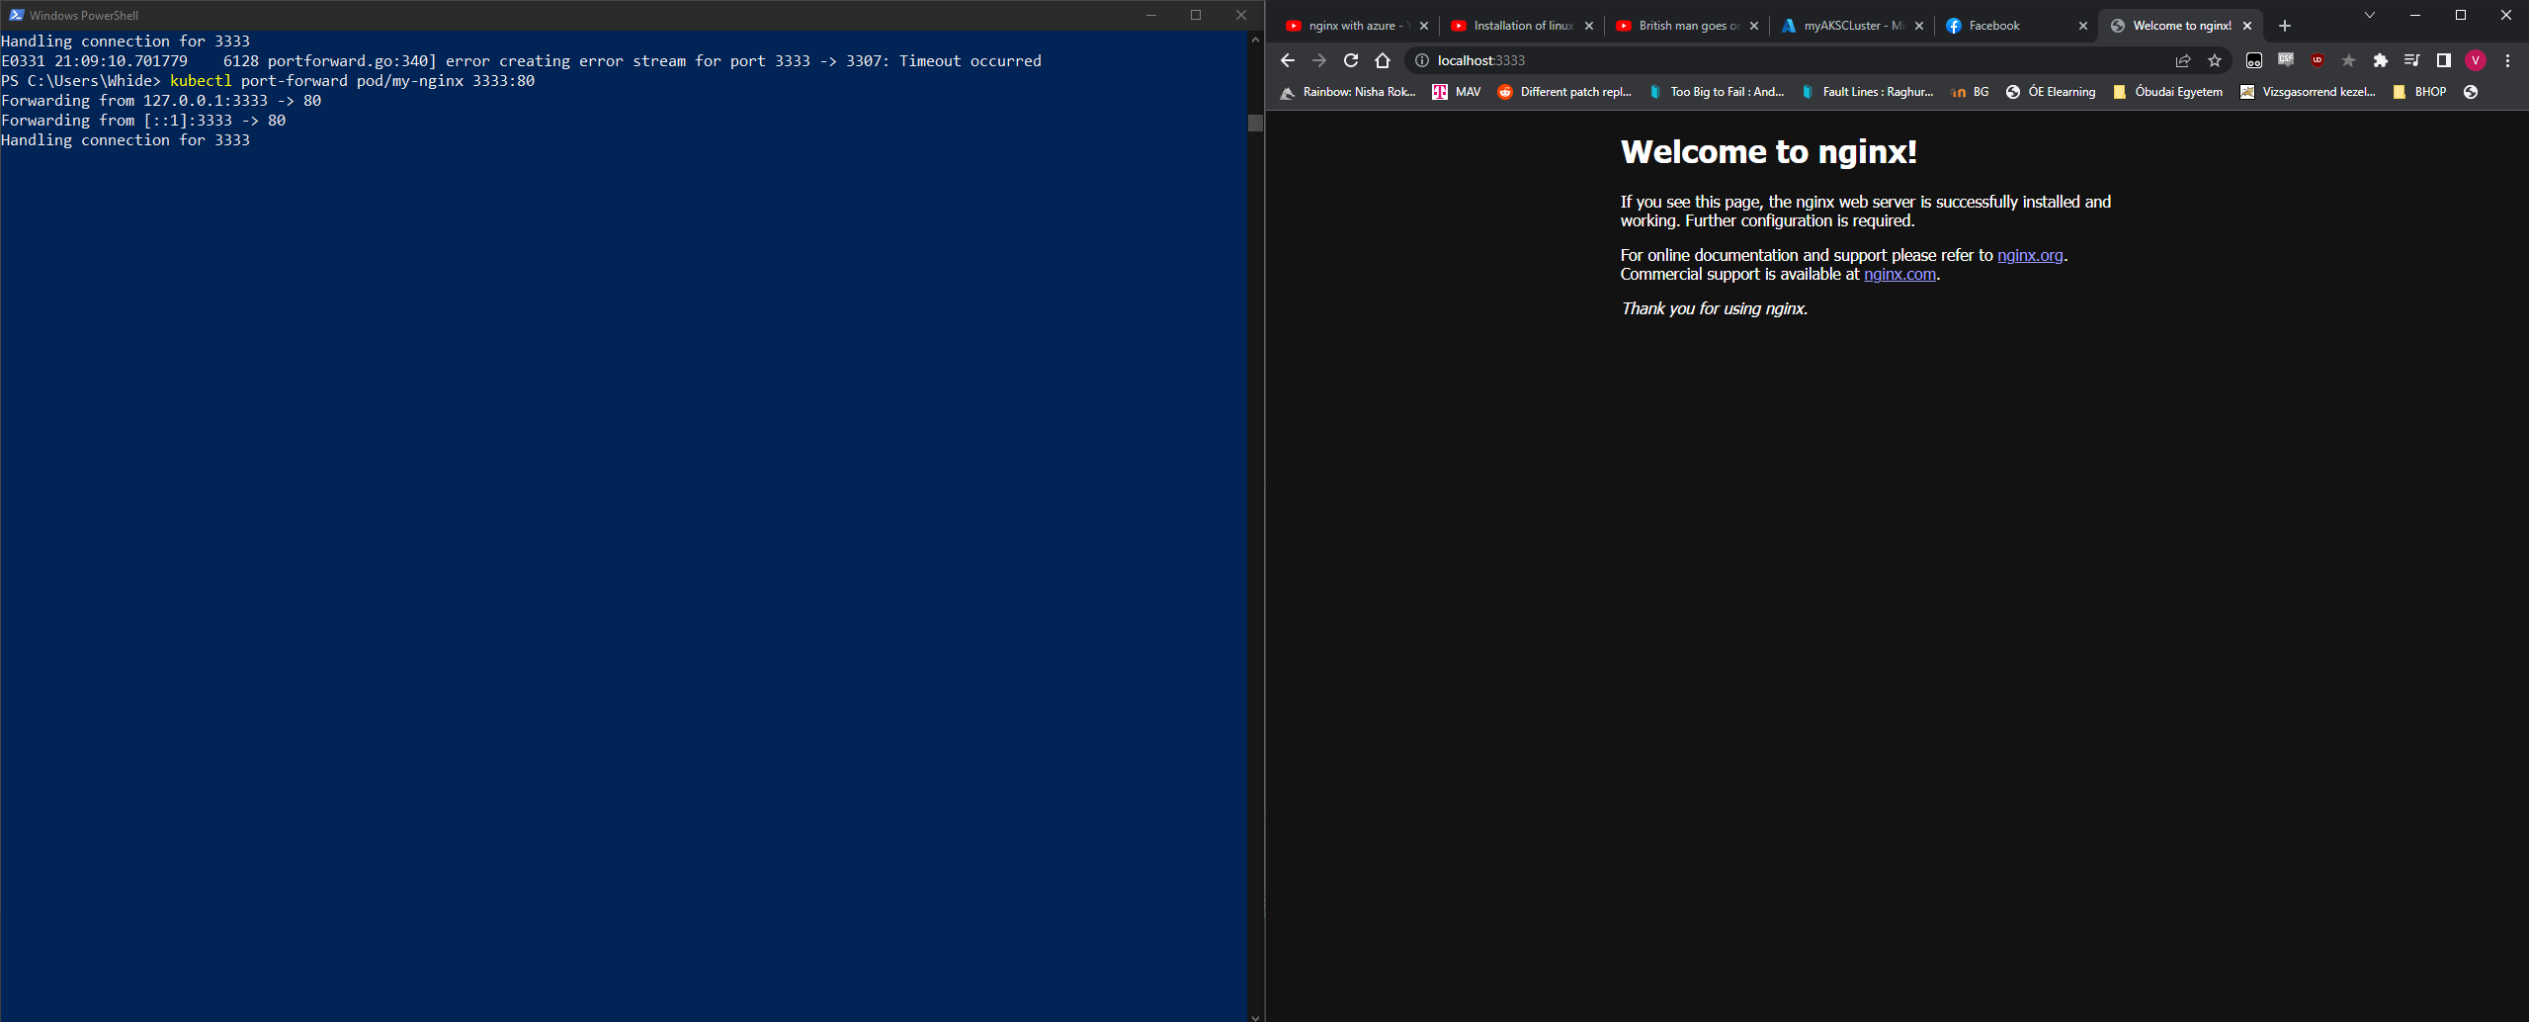

After some trial and error I finally noticed that I was redirecting to the 3307 port instead of the default HTML port 80, now the Welcome page for the nginx site works.