Deploy Server:

* Install JRE (minimum JRE 7)
* Install Mysql 5.7 software
  + Set up initial database and tables

On windows🡪Start🡪 mysql client:

"C:\Program Files\MySQL\MySQL Server 5.7\bin\mysql.exe" "--defaults-file=C:\ProgramData\MySQL\MySQL Server 5.7\my.ini" "-uroot" "-p"

* + Provide root password to prompt

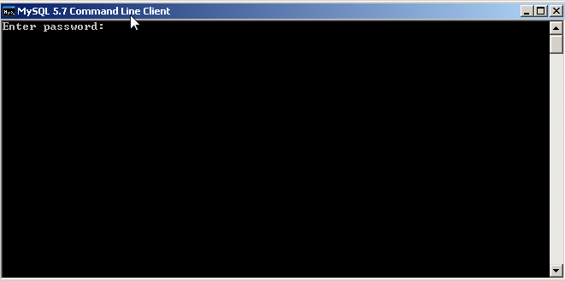

* + “source Auction_Server\src\main\resources\create_db_schema.sql”
* Install tomcat using windows installer.
  + <http://apache.mivzakim.net/tomcat/tomcat-9/v9.0.0.M10/bin/apache-tomcat-9.0.0.M10.exe>
  + Default CATALINA_HOME =C:\Program Files\Apache Software Foundation\Tomcat 9.0
  + Validate that tomcat is running <http://localhost:8080/>
* Deploy application contents into tomcat folders
* Copy Auction_Project\Servers\Tomcat v9.0 Server at localhost-config\server.xml to %CATALINA_HOME%\conf
* Copy Auction_Project\Servers\Tomcat v9.0 Server at localhost-config\ context.xml to %CATALINA_HOME%\conf
* Copy Auction_Project\Auction_Server\target \Auction_Server.war file into %CATALINA_HOME%\webapps
* Wait 1-2 minute till application will deploy and extraxts in to folders
* Copy JDBC driver into server lib folder

%CATALINA_HOME%\webapps\Auction_Server\WEB-INF\lib\mysql-connector-java-5.1.5.jar into %CATALINA_HOME%\lib

* Restart tomcat %CATALINA_HOME%\bin\shutdown.bat
* Start tomcat tomcat %CATALINA_HOME%\bin\startup.bat
* Test server with this URL <http://localhost:8080/Auction_Server/>

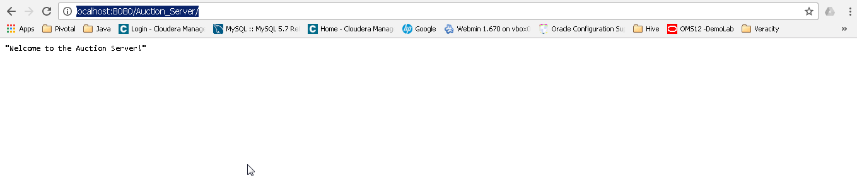

Deploy Client: