**Tinkercad** is a popular 3D modeling, circuitry-simulating, and block-coding software package that’s accessible for free via a web browser.

**What is Setup? What type of code is written in the setup block?**

In Arduino programming, the setup() function is a built-in function that is called once at the beginning of a program. It is typically used to initialize variables, pin modes, and start libraries. For example, you might use the setup() function to set a pin as an input or output, or to begin communication with a device like a sensor or display.

**What is Loop? What type of code is written in the Loop block?**

the loop() function is a built-in function that is called repeatedly after the setup() function has been called.

The loop contains statements that are executed repeatedly. The section of code inside the curly brackets is repeated depending on the value of variables.

**pinMode ( )**

he pinMode(pin, mode) function is used to configure a digital pin as an input or an output. The pin parameter is the number of the digital pin that you want to configure, and the mode parameter is the direction of the pin (either INPUT or OUTPUT).

INPUT : Configures the specified pin to be an input pin. This means that the pin can be used to read the state of a button, sensor or other input device.

OUTPUT : Configures the specified pin to be an output pin. This means that the pin can be used to control the state of an LED, motor or other output device.

**digitalWrite()**

the digitalWrite(pin, value) function is used to write a digital value (HIGH or LOW) to a specified digital pin. The pin parameter is the number of the digital pin that you want to write to, and the value parameter is the value that you want to write to the pin (HIGH or LOW).

**Delay()**

the delay(ms) function is used to pause the execution of the program for a specified number of milliseconds. The ms parameter is the number of milliseconds that the program should pause for.

**Serial.begin()**

The Serial.begin() function without a parameter sets the baud rate to the default value of 9600 bits per second. Baud rate is the number of bits per second that are transmitted on a serial communication line.

Once the serial communication is initialized, you can use the serial monitor to send and receive data between the Arduino and the computer. Serial communication is one of the ways to get data in and out of an Arduino board and it can be used to debug, or print out sensor data, or other information that can be helpful when working on a project.

**map()**

the map() function is used to convert a value from one range of values to another. It takes in three arguments: the value to be mapped, the range of the input value, and the range of the output value. The function then returns the mapped value, which is in the new range.

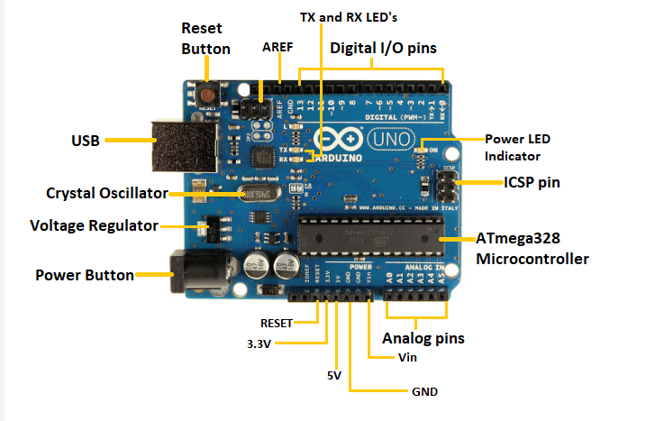

* ATmega328 Microcontroller- It is a single chip Microcontroller of the ATmel family. The processor code inside it is of 8-bit. It combines Memory (SRAM, EEPROM, and Flash), Analog to Digital Converter, SPI serial ports, I/O lines, registers, timer, external and internal interrupts, and oscillator.
* ICSP pin - The In-Circuit Serial Programming pin allows the user to program using the firmware of the Arduino board.
* Power LED Indicator- The ON status of LED shows the power is activated. When the power is OFF, the LED will not light up.
* Digital I/O pins- The digital pins have the value HIGH or LOW. The pins numbered from D0 to D13 are digital pins.
* TX and RX LED's- The successful flow of data is represented by the lighting of these LED's.
* AREF- The Analog Reference (AREF) pin is used to feed a reference voltage to the Arduino UNO board from the external power supply.
* Reset button- It is used to add a Reset button to the connection.
* USB- It allows the board to connect to the computer. It is essential for the programming of the Arduino UNO board.
* Crystal Oscillator- The Crystal oscillator has a frequency of 16MHz, which makes the Arduino UNO a powerful board.
* Voltage Regulator- The voltage regulator converts the input voltage to 5V.
* GND- Ground pins. The ground pin acts as a pin with zero voltage.
* Vin- It is the input voltage.
* Analog Pins- The pins numbered from A0 to A5 are analog pins. The function of Analog pins is to read the analog sensor used in the connection. It can also act as GPIO (General Purpose Input Output) pins.

**what is dashboard**

A dashboard is a user interface that displays information in a visual and organized way, typically using charts, graphs, and other types of data visualizations. Dashboards are used to provide users with a quick and easy way to access and analyze data, and they are commonly used in business intelligence, data analytics, and other fields where data needs to be easily understood and acted upon. Some examples of common types of dashboards include financial dashboards, marketing dashboards, and operational dashboards.

**Chart Types:** Excel dashboards can include a wide variety of chart types, such as bar charts, line charts, pie charts, scatter plots, and more, to display data in a visually appealing and easy-to-understand format.

**Pivot Table:** Pivot tables are a powerful feature in Excel that allow users to summarize and reorganize large amounts of data in a flexible and user-friendly way. They can be used to create dynamic reports, cross-tabulations, and pivot charts.

**Slicer:** A slicer is a type of filter that allows users to quickly filter and view data in a pivot table or pivot chart. Slicers are interactive and allow users to select one or more items from a list to filter the data.

**Heat Map:** A heat map is a type of data visualization that uses color to represent data values. It can help to quickly identify patterns and trends in large data sets and can be used in Excel dashboards to represent data in a visually appealing way.

**KPI (Key Performance Indicator):** A KPI is a metric used to measure the performance of an organization or process. Excel dashboards can include KPIs to provide users with a quick and easy way to understand the performance of a business or organization.

**DAQ**

DAQ stands for Data Acquisition, which refers to the process of measuring physical or electrical phenomena, such as temperature, pressure, voltage, or current, and converting this information into a digital signal that can be processed and analyzed by a computer.

The main components of a DAQ system typically include sensors, signal conditioning, data acquisition hardware, and software. Sensors are used to measure the physical or electrical phenomena and convert it into an electrical signal, signal conditioning is used to prepare and condition the signal for acquisition, data acquisition hardware is used to convert the electrical signal into a digital signal that can be read by a computer, and software is used to control the DAQ system, process the data, and display the results.

DAQ systems are widely used in various industries such as manufacturing, automotive, aerospace, energy, and research fields. Applications of DAQ include scientific experiments, process control, vibration analysis, and monitoring of remote locations.

**What is the Arduino UNO and what are its main features?**

* The Arduino UNO is a microcontroller board based on the ATmega328P microcontroller. It is a widely used board in the Arduino family and is considered to be the "standard" Arduino board. Some of its main features include:
* Microcontroller: The ATmega328P microcontroller is a powerful and versatile chip that can be programmed using the Arduino programming language.
* Input/Output: The Arduino UNO has 14 digital input/output pins, 6 of which can be used as PWM (pulse-width modulation) outputs and 6 analog inputs, a 16 MHz quartz crystal, a USB connection, a power jack, an ICSP header and a reset button.
* Power: The Arduino UNO can be powered by an external power supply or through the USB connection to a computer.
* Programming: The Arduino UNO can be programmed using the Arduino Software (IDE), which is a simple and user-friendly software that allows you to write, upload, and debug code.
* Community: The Arduino UNO is an open-source platform, and as such, there is a large community of users and developers constantly contributing to the platform, providing documentation, tutorials, libraries, and support.
* Compatibility: The Arduino UNO is compatible with a wide range of sensors, actuators, and other peripherals. This allows for the creation of a wide range of projects and applications.
* Small size: The Arduino UNO board is small in size and can easily be integrated into various projects and prototypes.
* Low cost: The Arduino UNO is relatively inexpensive, making it accessible to a wide range of users, from hobbyists and students to professionals and businesses.

**What are some common uses for the Arduino UNO?**

* Robotics: The Arduino UNO can be used to control motors, servos, and other actuators, making it a popular choice for building robots and other automated machines.
* Home automation: The Arduino UNO can be used to control lights, appliances, and other devices in a smart home setup.
* Sensor data acquisition: The Arduino UNO can be used to read data from sensors such as temperature, humidity, light, and motion sensors, and then process and display the data.
* Interactive projects: The Arduino UNO can be used to create interactive projects such as games, musical instruments, and other interactive devices.
* Industrial control: The Arduino UNO can be used in industrial applications such as process control, machine monitoring, and data logging.
* Internet of Things (IoT): The Arduino UNO can be used to connect to the internet and interact with other devices and web services.
* Education: The Arduino UNO is widely used in education as a tool for teaching programming, electronics, and problem-solving skills.
* DIY projects: The Arduino UNO can be used in a wide variety of DIY projects, from simple LED blinkers to more complex projects such as automated plant watering systems and weather stations.
* Prototyping: The Arduino UNO can be used as a development platform for prototyping and testing new ideas and products.
* Art and design: The Arduino UNO can be used to create interactive art and design projects, such as kinetic sculptures and interactive installations.

**Are there any limitations to using the Arduino UNO for certain types of projects?**

Yes, there are limitations to using the Arduino UNO for certain types of projects. The Arduino UNO has a limited amount of memory and processing power, and may not be suitable for projects that require a lot of memory or high-speed processing. Additionally, the Arduino UNO does not have built-in Ethernet or WiFi connectivity, so it may not be suitable for projects that require internet connectivity. It also has a limited number of digital and analog inputs and outputs, which can be a limitation for projects that require a lot of input and output capabilities. If your project requires more resources you may consider using an arduino board with more memory and processing power such as Arduino Mega, Due or Teensy.