Scene One:

Our main character is your average run of the mill office worker that lives in a well off part of the city when one day a murder turns the gaze of the feds/popo/rozers to his apartment block. The following raid with complete lack of respect for any amount of privacy our MC deserves, allows the feds/popo/rozers to break into his apartment with zero warning.

Our MC wasn't involved in the murder but as collateral damage the feds discovered his one light in the darkness that his bleak, uneventful, paper pushing slavery allows. Upon seeing the illicit item the feds stop to ticket him seemingly forgetting about the murder and going home.(Was there really a murder or were the government making it up as a vector to raid homes?) dun dun duhhh!

Scene Two:

Now sickened by the void left by his old patched up waifuBot3000 from the days long gone before the mass waifu fires that the government set up to rid it’s self of what it saw to be undesirables. Our MC sets out on a quest to topple our dystopian way of life for all the wrong reasons.

His decent into cyberPunk had begone.

*Cue exciting music*

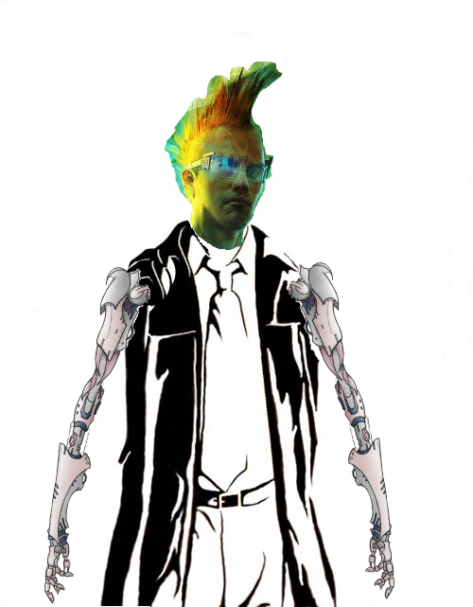
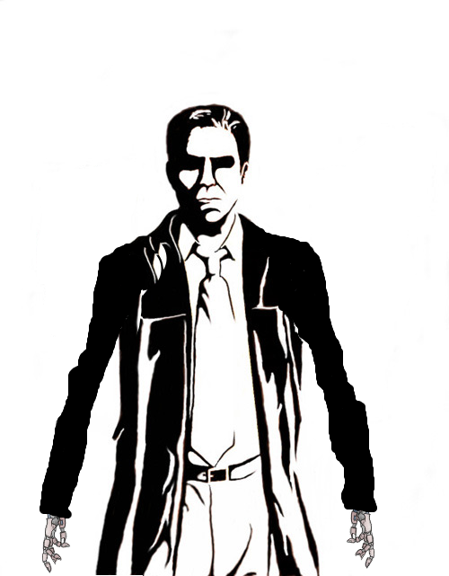

Everything will be a bit OTT but at it’s core it will still be a run of the mill scifi/cyberpunk story/plot.

Game starts. Player is taken through a quick *this is how you play* bit.

-A bunch of shit

-City that escaped the clutches of the big bad guys where the player learns of such things called “freedom”.(skycity ancient)

-Some more shit

-Somewhere along the way the player might decided to not be an ass hole

-Range of endings based on number of enemies killed/civilians killed

-Leaderboard

Areas:

Pride - NaziSpaceForce
Greed - SpacePirates/Cowboys
Lust – NeonPoor(Basicaly opening chapters of nuromancer)
Envy – cleanRichDarkSide(Apple but bad)
Gluttony – cleanRichLightSide(Apple)
Wrath - madMaxWastes
Sloth – GrimyPoor(zion?)

Non of the above- skyCityAncient

