1. Sensehat 坐标说明

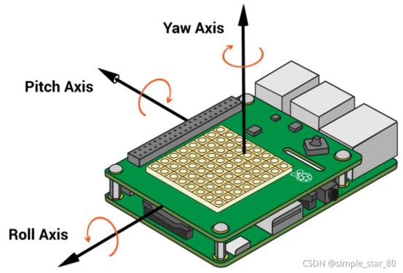

1. 前后跌倒

正常站立roll：270 pitch：360/0

def fall_forward_or_backward():

orientation = sense.get_orientation_degrees()

if 230 < orientation['roll'] < 300: #变化范围前不超过40°后不超过30°

return False

else:

return True

1. 左右跌倒：

#变化范围 向左倾0~90 向右倾 270~360

def fall_left_or_right():

orientation = sense.get_orientation_degrees()

if 30 > orientation['pitch'] > 0: #变化范围 左不超过30°

return False

elif 330 < orientation['pitch'] < 360:#变化范围 右不超过30°

return False

else:

print("P:{pitch}, R:{roll}, Y:{yaw}".format(**orientation))

return True