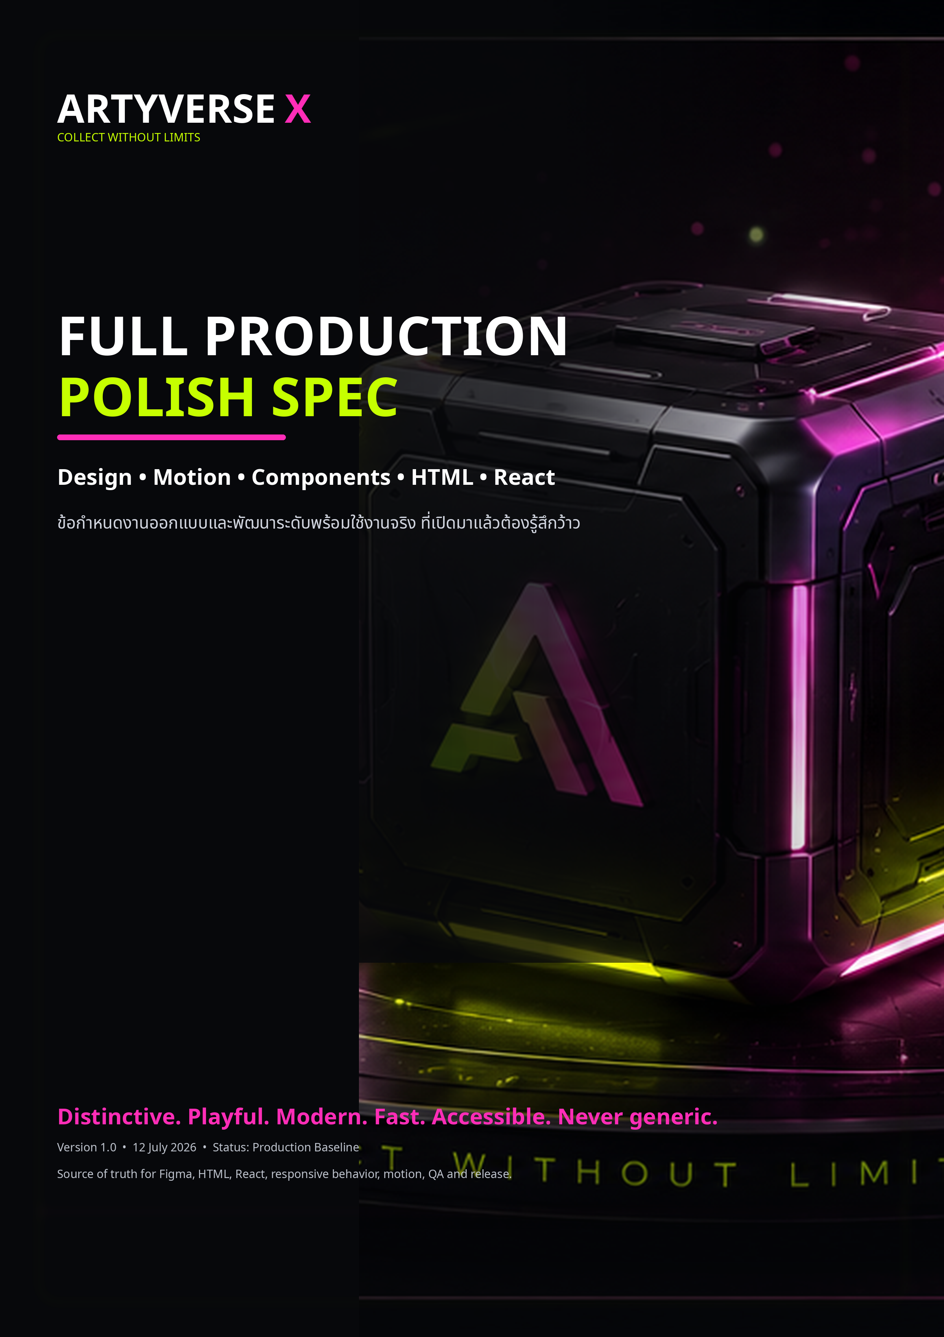

DOCUMENT CONTROL

Production baseline and source of truth
เอกสารนี้เป็นข้อกำหนดกลางสำหรับ Figma, semantic HTML, React + TypeScript, responsive layout, motion, accessibility, performance, QA และ release ของ ARTYVERSE X
QUALITY COMMITMENT
งานต้องมี Brand Memory, Product Clarity, Motion Purpose, Responsive Integrity และ Implementation Fidelity จนผู้ใช้เปิดมาแล้วรู้สึกว้าว แต่ยังเร็ว อ่านง่าย และซื้อของได้จริง

Field | Value
Primary brand | ARTYVERSE
Campaign lockup | ARTYVERSE X / artyverse x
Product | Multi-vendor e-marketplace + e-commerce
Targets | Desktop, tablet, mobile
Implementation | HTML/CSS/JavaScript + React/TypeScript
Motion | CSS/WAAPI, Motion for React; optional GSAP, Rive, dotLottie
Current React baseline | Vite production build passes; 107.38 kB gzip JS
Accessibility | WCAG 2.2 AA target
Version | 1.0 — 12 July 2026

Status language
Label | Meaning
LOCKED | ห้ามเปลี่ยนโดยไม่ผ่าน design review
REQUIRED | ต้องมีใน production
RECOMMENDED | ค่าเริ่มต้น เปลี่ยนได้เมื่อมีเหตุผลและหลักฐาน
EXPERIMENTAL | ใช้ภายใต้ campaign / feature flag
BLOCKER | ห้าม release จนแก้ไข

NAVIGATION

Contents
Section | Title
01 | Product Vision and Experience Promise
02 | Non-Negotiable Quality Bar
03 | Brand Architecture and Personality
04 | Audience and Emotional Outcomes
05 | Experience Narrative — Five Acts
06 | Information Architecture and Screen Inventory
07 | Responsive Layout System
08 | Visual Foundations
09 | Image, 3D and Placeholder Direction
10 | Motion Operating System
11 | Story Motion Specifications
12 | Custom Node Component System
13 | Core Component State Contract
14 | Page and Journey Requirements
15 | Desktop Interaction Patterns
16 | Mobile Interaction Patterns
17 | Semantic HTML Implementation Contract
18 | React + TypeScript Implementation Contract
19 | Package Governance
20 | Accessibility and Inclusive Motion
21 | Performance Budgets
22 | SEO, Metadata and Social Sharing
23 | Data, Security and Transaction Integrity
24 | Analytics and Experimentation
25 | Figma Production Structure and Handoff
26 | QA Matrix
27 | Definition of Done
A–C | Appendices and Release Blockers

VISUAL SOURCE OF TRUTH

ARTYVERSE X Brand System
Brand board ด้านล่างกำหนด logo family, Orbit mascot, palette, typography, product placeholder และ light/dark direction ส่วน visual legacy ที่ยังเขียน ARTVERSE ใน hero asset ถือเป็น release blocker และต้องเปลี่ยนเป็น ARTYVERSE X
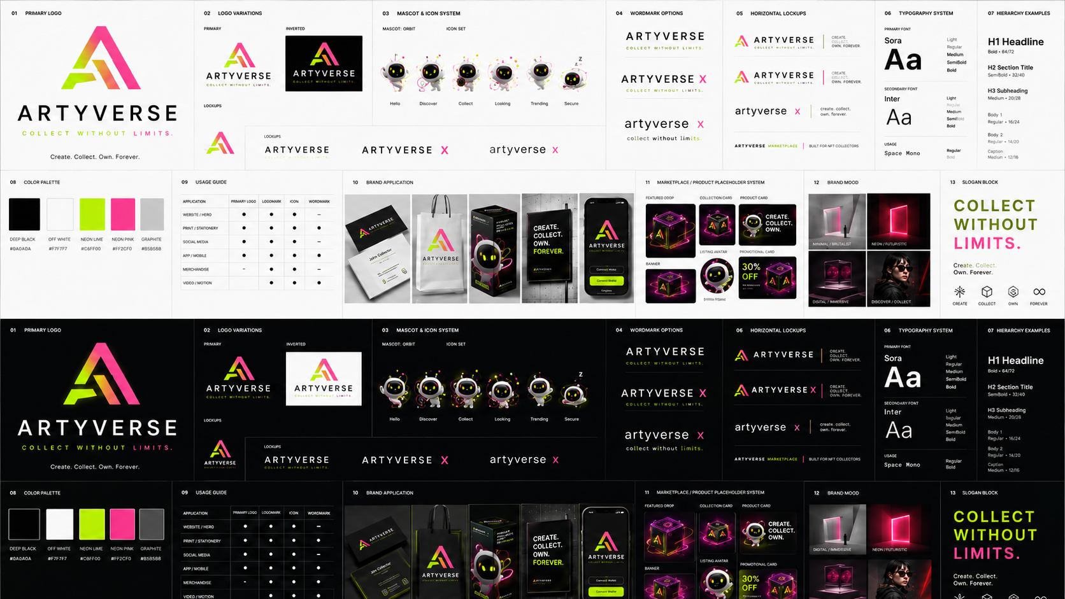
VISUAL RULE
Neon ไม่ใช่คำตอบของทุก section — ใช้ calm structure เป็นฐาน แล้วเลือก expressive moment เฉพาะจุดที่ช่วยสินค้า เรื่องราว หรือ feedback

1. Product Vision and Experience Promise
ARTYVERSE X คือ marketplace สำหรับ digital products, collectibles, creator drops และ limited editions ที่รวมความรู้สึก “ค้นพบของแปลกที่ใช่” เข้ากับความชัดเจนของ e-commerce ที่เชื่อถือได้ ผู้ใช้ต้องรู้สึกว่าสนุกตั้งแต่วินาทีแรก แต่ไม่หลงทาง ไม่สงสัยราคา ไม่กังวลเรื่องของแท้ และไม่ติด checkout ที่ยืดเยื้อ

Experience promise
- Open with wonder — First viewport มีเอกลักษณ์ภายใน 3 วินาทีโดยไม่รบกวนการอ่าน
- Make products the hero — Effect ทุกอย่างส่งสินค้า ไม่แย่งสินค้า
- Playful, not childish — Orbit และ microcopy มีอารมณ์ขันแต่ไม่ลดความน่าเชื่อถือ
- Fast enough to trust — Motion ลื่นและ loading สื่อสถานะจริง
- Clear enough to buy — ราคา สต็อก ตัวเลือก ค่าจัดส่ง คืนเงิน COA และ seller ชัดเจน
- Built as a system — Figma, HTML และ React ใช้ token, state และ anatomy เดียวกัน

Non-goals
- ไม่ทำเป็น neon cyberpunk template ที่มีแต่ glow และ glass card
- ไม่ใช้ animation ทุก element เพียงเพราะทำได้
- ไม่ซ่อน action สำคัญไว้หลัง hover
- ไม่ทำ desktop แล้วค่อยย่อเป็น mobile
- ไม่ใช้ placeholder สีเทาไร้บุคลิกใน final production
- ไม่ใช้ copy ทั่วไปเมื่อสามารถพูดแบบ ARTYVERSE ได้

2. Non-Negotiable Quality Bar

Anti-generic rules
- ทุกหน้ามีหนึ่ง memorable moment และหนึ่ง conversion anchor
- Section ต่อเนื่องไม่ใช้ layout/reveal pattern เหมือนกันเกินสอง section
- Critical product data มาก่อน decoration
- Glassmorphism จำกัดที่ navigation, overlay และ contextual surface
- Gradient สื่อ energy/state/brand transition ไม่ใช่ทาทุกพื้นผิว
- Mascot ทำหน้าที่ guide, feedback, trust หรือ reward
- Loop หยุดเมื่อออกนอก viewport และมี reduced-motion branch
- Hero มี static first frame ที่ดีแม้ JavaScript ยังไม่ทำงาน
Category | Weight | Release gate
Brand distinctiveness | 15 | ไม่มี legacy naming หรือ generic template
Visual craft | 15 | Hierarchy, spacing, alignment, asset quality
Product clarity | 10 | ราคา ตัวเลือก สต็อก seller CTA ชัดเจน
Motion & interaction | 15 | Purposeful, smooth, reduced motion complete
Responsive | 10 | 320px–wide desktop ไม่มี overflow
Accessibility | 10 | Keyboard, focus, semantics, contrast
Performance | 10 | Budgets and no interaction jank
Engineering | 10 | Typed, semantic, reusable state
QA | 5 | Test matrix and DoD complete

RELEASE THRESHOLD
อย่างน้อย 90/100 และไม่มี BLOCKER แม้คะแนนรวมผ่าน

3. Brand Architecture and Personality
Name | Usage
ARTYVERSE | ผลิตภัณฑ์หลัก, navigation, SEO, legal, account, transaction
ARTYVERSE X | Campaign, experimental drop, creator collaboration, immersive experience
artyverse x | Editorial lowercase lockup สำหรับ campaign เท่านั้น
Orbit | Mascot and experience guide

RELEASE BLOCKER
ข้อความหรือ asset ใดที่ยังใช้ “ARTVERSE” ถือเป็น legacy และต้องเปลี่ยนก่อน release

Personality sliders
Dimension | Target
Premium ↔ Mass | 70/30 premium-accessible
Serious ↔ Playful | 45/55
Minimal ↔ Expressive | 45/55; calm structure + expressive moments
Technical ↔ Human | 40/60
Cute ↔ Childish | Cute 35; Childish 0
Trendy ↔ Timeless | 45/55

Voice rules
- ประโยคสั้น อ่านได้ในหนึ่ง glance
- มุกอยู่ใน supporting copy ไม่อยู่ใน payment/legal decision
- Error บอกว่าเกิดอะไร ทำอะไรต่อ และข้อมูลสูญหายหรือไม่
- Scarcity ต้องอิงสต็อก/เวลา ไม่สร้าง fake scarcity
State | ARTYVERSE copy
Cart empty | ตะกร้าว่างขนาดนี้ Orbit เริ่มเป็นห่วงแล้วนะ
Stock low | เหลือน้อยแล้วนะ ไม่ได้กดดัน แค่กระซิบดัง ๆ
Payment loading | กำลังคุยกับธนาคารด้วยภาษาต่างดาว…
Success | ได้ของแล้ว ทีนี้ทำเป็นใจเย็นได้
Sold out | ช้าไปหนึ่งวงโคจร เจอกัน Drop หน้า

4. Audience and Emotional Outcomes
Audience | Primary need | Desired feeling | UX emphasis
New collector | เข้าใจสินค้าและความน่าเชื่อถือ | ตื่นเต้นแต่ปลอดภัย | Guided discovery, trust signals
Experienced collector | Serial, provenance, limited info | ควบคุมและทันเวลา | Fast filters, drop reactor, COA
Creator / seller | จัดการสินค้าและรายได้ | มีพลัง ไม่วุ่นวาย | Batch tools, operational signals
Marketplace admin | คุมคุณภาพและความเสี่ยง | เห็นภาพรวม ตัดสินใจเร็ว | Moderation, audit, severity
Mobile-first shopper | ซื้อระหว่างเดินทาง | เร็ว ใช้นิ้วเดียวได้ | Thumb-zone CTA, sheets

5. Experience Narrative — Five Acts
Stage | Title | Experience rule
Act 01 | Enter the Verse | Cinematic first frame แล้วค่อยเปิดข้อมูล ห้าม splash ที่บังคับรอ
Act 02 | Discover Something Weird | Product variety พร้อม search/filter/price ที่เข้าถึงทันที
Act 03 | Catch the Drop | เวลา สต็อก limit และเงื่อนไขตรวจสอบได้ ไม่มี fake urgency
Act 04 | Verify the Real One | COA/serial/seller verification ใช้ Lock motion และ static fallback
Act 05 | Reward the Collector | เชื่อม purchase เข้าสู่ collection progress โดยไม่บังคับ upsell

6. Information Architecture and Screen Inventory
TARGET INVENTORY
107 screens: 95 desktop role screens + 12 mobile key flows

6.1 Storefront & Buyer — 24
No. | Screen
01 | Home / Landing
02 | Category Landing
03 | Search Results
04 | Search Empty
05 | Product Detail
06 | Product Gallery Zoom
07 | Shop / Artist Profile
08 | Collection / Series
09 | Limited Drop
10 | Pre-order
11 | Wishlist
12 | Recently Viewed
13 | Shopping Cart
14 | Checkout — Address
15 | Checkout — Delivery
16 | Checkout — Payment
17 | Checkout — Review
18 | Payment Success
19 | Payment Failed
20 | Guest Order Tracking
21 | Authenticity / COA Verify
22 | Community Feed
23 | Community Post Detail
24 | Help Center

6.2 Account & Orders — 20
No. | Screen
01 | Login
02 | Register
03 | OTP Verification
04 | Forgot Password
05 | Reset Password
06 | Account Overview
07 | Profile
08 | Address Book
09 | Payment Methods
10 | My Orders
11 | Order Detail
12 | Shipment Tracking
13 | Return / Refund Request
14 | Return Status
15 | Reviews
16 | Messages / Chat
17 | Vouchers & Credits
18 | Following / Saved Shops
19 | Notifications & Preferences
20 | Security & Sessions

6.3 Seller Center — 26
No. | Screen
01 | Seller Onboarding
02 | KYC / Business Verification
03 | Shop Profile Setup
04 | Seller Dashboard
05 | Product List
06 | Product Basics
07 | Media Gallery
08 | Variants & Options
09 | Inventory
10 | Pricing & Discount
11 | Shipping Profile
12 | Product Preview / Publish
13 | Bulk Import
14 | Order List
15 | Order Detail
16 | Fulfillment
17 | Shipping Labels
18 | Return Requests
19 | Dispute Detail
20 | Promotions
21 | Coupon Builder
22 | Drop / Pre-order Manager
23 | Analytics
24 | Finance / Payout
25 | COA / Serial Management
26 | Staff / Roles / Settings

6.4 Admin & Operations — 25
No. | Screen
01 | Admin Dashboard
02 | User Management
03 | User Detail
04 | Seller Applications
05 | Seller Detail
06 | Product Moderation Queue
07 | Product Moderation Detail
08 | Categories
09 | Brands / Collections
10 | Orders
11 | Order Detail
12 | Payments
13 | Refunds
14 | Disputes
15 | Commission / Fees
16 | Campaign / Banners
17 | CMS / Pages
18 | Community Moderation
19 | Shipping Rules
20 | Tax / Invoice
21 | Reports
22 | Audit Logs
23 | Integrations / Webhooks
24 | Roles / Permissions
25 | System Settings / Health

6.5 Mobile Key Flows — 12
No. | Screen
01 | Mobile Home
02 | Search / Filter Sheet
03 | Product Detail
04 | Limited Drop
05 | Cart
06 | Checkout
07 | Payment / QR
08 | Order Tracking
09 | Account
10 | Messages
11 | Seller Quick Dashboard
12 | Notifications / Orbit Center

7. Responsive Layout System
Name | Range | Intent
Compact | 320–479 | One-thumb mobile, single column
Mobile | 480–767 | Larger mobile, sheets and micro grids
Tablet | 768–1023 | 2-column products, compact navigation
Desktop | 1024–1279 | Full navigation, 3-column where appropriate
Wide | 1280–1599 | 4-column products
Cinema | 1600+ | Content capped, atmosphere extends

Container and grid
- Max content 1440px; inset clamp(20px,5vw,72px)
- Desktop 12 columns / 24px gutter; tablet 8 / 20px; mobile 4 / 16px
- Body line length 45–75 characters
- Section rhythm 84–150px desktop; 64–96px mobile
- Fixed header uses scroll-margin-top for anchor destinations

Responsive behavior
- Mobile is recomposed, not scaled desktop
- Primary action stays in thumb zone
- Product media uses explicit aspect ratio
- Dense tables convert to cards or controlled horizontal scroll
- Hover content has tap/focus equivalent
- No horizontal overflow at 320px

8. Visual Foundations

Semantic color system
Token | Dark | Light | Usage
canvas | #07080B | #F7F7F7 | Page background
surface-1 | #0E1015 | #FFFFFF | Cards / panels
surface-2 | #151820 | #F0F1F4 | Nested surfaces
text-primary | #F7F7F7 | #0A0A0A | Headings and body
text-muted | #999EAA | #626874 | Secondary copy
accent-lime | #C6FF00 | #76A800 text | Primary energy / CTA
accent-pink | #FF2DB7 | #C31183 text | Campaign / limited
cyan | #30EBDA | #087F78 | Information / tracking
violet | #8C5CFF | #6140C8 | Mystery / community
danger | #FF3D5A | #C6233F | Destructive / failed

Typography
Role | Font | Weight | Usage
Display | Sora | 700–800 | Hero, drop, campaign
Body/UI | Inter | 400–600 | Copy, controls, tables
Code/Data | Space Mono | 400–700 | Serial, countdown, logs
Thai fallback | Noto Sans Thai | 400–700 | Thai copy and exports

Token | CSS | Line height | Use
display-xl | clamp(3.75rem,8vw,7.5rem) | .88–.96 | Hero only
display-lg | clamp(2.75rem,6vw,5.75rem) | .92 | Campaign / drop
heading-1 | clamp(2.25rem,4vw,4rem) | 1.0 | Page titles
heading-2 | clamp(1.75rem,3vw,3rem) | 1.08 | Section titles
body-lg | 18px | 1.6 | Intro copy
body | 16px | 1.55 | Normal content
label | 12px | 1.2 | Controls / chips
micro | 10px | 1.2 | Non-critical metadata

Spacing, radius and elevation
- 4px primitive; main sequence 4–150px
- Control radius 10–16px; card 20–24px; feature 28–36px; pill 999px
- One elevation per hierarchy; avoid shadow stacking
- Blur is atmospheric and never reduces text sharpness
Layer | Range
Base content | 0–9
Sticky content | 10–19
Header / dock | 40–59
Drawer / modal | 60–79
Toast / cursor / debug | 90–109

9. Image, 3D and Placeholder Direction
Asset | Ratio / format | Production rule
Product Hero | 16:9 / 3:2 | Responsive AVIF/WebP
Square Product | 1:1 | Consistent visual safe area
Product Portrait | 4:5 | Marketplace listing/detail
Wide Campaign | 3:1 | No essential copy baked into art
Gallery | 1:1 / 4:3 | Zoom-ready source
Packaging | Transparent PNG/WebP | Stage shadow separate
Creator Avatar | 1:1 | Face/mark within 70% safe area
Mobile Mockup | 9:19.5 | Use only when it adds context
COA Card | 3:4 | Serial remains real text

- Controlled studio light and one dominant color story
- Abstract object must resemble a sellable product
- Dark/light surface compatibility
- No essential text inside product art
- Hero preload; below-fold lazy; dimensions required
- No legacy ARTVERSE naming

10. Motion Operating System
Family | Character | Use
Orbit | Curved, gravitational | Mascot, product path, background energy
Snap | Fast, precise | Button, tabs, filter, quantity
Squish | Tactile compression | Tap, add, save, mobile
Float | Slow, weighted | Hero product and ambient objects
Warp | Continuous spatial change | Route, modal, shared element
Mischief | Tiny playful offset | Mascot, empty/error
Reward | Energy to destination | Purchase, coupon, achievement
Lock | Rotate and settle | COA, payment, security

Token | Duration | Use
instant | 120ms | Visual confirmation
quick | 180ms | Hover / tap / toggle
responsive | 280ms | Card / drawer / tabs
expressive | 480ms | Overlay / shared transition
story | 800ms | Section sequence
cinematic | 1200ms | Hero / campaign

--ease-snap: cubic-bezier(.2,.9,.25,1);
--ease-orbit: cubic-bezier(.16,1,.3,1);
--ease-exit: cubic-bezier(.7,0,.84,0);

Constraints
- Transform and opacity first
- Stable start/end dimensions for layout motion
- Max 3 ambient loops desktop; 1 mobile
- No blur animation on mobile interaction path
- Scroll transforms clamp and never block scroll
- All expressive branches implement reduced motion
- Price, stock and legal text never delayed

11. Story Motion Specifications
Moment | Sequence / constraints
Hero | Atmosphere immediate → lockup 0–200ms → headline 120–600ms → product 180–900ms → CTA 450–760ms
Product grid | 40–70ms stagger only when multiple cards visible; removed cards leave focus order
Add to cart | Immediate state update, compress → cart highlight → count → toast; under 650ms
COA lock | Finite search; success settles lime; failure stops and explains retry
Purchase reward | Confirmation first, reward after; max 1.2s, no autoplay audio

FALLBACK RULE
Page remains actionable if animation is interrupted or disabled

12. Custom Node Component System
Node | Purpose | Variants / states | HTML contract
OrbitPortal | Mascot/context surface | idle, tracking, opening, loading, success, error, sleep | section/aside + optional live status
ProductCapsule | Sellable product card | standard, featured, limited, preorder, sold-out, owned, mystery | article with real controls
MagneticCTA | High-emphasis action | primary, secondary, ghost, danger + interaction states | button/link semantics
DropReactor | Countdown + stock + CTA | scheduled, live, low-stock, ended, waitlist | server-derived time
OrbitRail | Responsive carousel | default, loading, empty | DOM reading order + controls
WarpTabs | Tabs with shared indicator | default, selected, disabled | ARIA tabs pattern
LootReveal | Hold/charge/open/result | idle, charging, result, error | alternate simple action
CollectorPulse | Level/progress/rewards | default, achieved, locked | numeric text + visual
SellerSignal | Operational alert | info, attention, warning, critical | finite pulse, not color-only

Supporting production components
SmartHeader, SearchCommand, FilterDock, CheckoutStepper, COALock, QuantityControl, PriceBlock, SellerTrustCard, ShippingTimeline, ReturnStatus, ToastStack, BottomOrbNav, EmptyState และ ErrorBoundarySurface

13. Core Component State Contract
Component | Required states | Accessibility
Button | default, hover, focus, pressed, loading, success, disabled | Button semantics, focus, disabled
Input | empty, filled, focus, valid, invalid, disabled, read-only | Label, help, error association
Product card | default, focus, saved, adding, added, unavailable | Article, logical heading, controls
Modal / sheet | opening, open, closing | Focus trap, return focus, escape
Toast | info, success, warning, error | Live region by severity
Skeleton | loading, timeout | Hidden from AT; real status outside
Tabs | default, selected, focus | ARIA tabs keyboard pattern
Menu | closed, open | Keyboard navigation and dismissal

14. Page and Journey Requirements

Product detail
Above the fold ต้องมีชื่อ ราคา seller availability primary media selected variant quantity และ CTA ส่วน shipping/return/COA summary ต้องมาก่อน long description

Cart and checkout
- Group by seller where marketplace rules differ
- Total breakdown before payment
- Address → Delivery → Payment → Review
- Preserve data after recoverable errors
- Double-submit protection
- Success shows order reference and tracking next action

Seller center
Operational clarity สำคัญกว่า decoration ใช้ SellerSignal, batch progress, downloadable error report และ confirmation สำหรับ high-impact action

Admin
High-density screens ใช้ calm surfaces, sticky filters และ audit context; ห้าม ambient mascot motion ใน moderation/risk workflows ยกเว้น static helper

15. Desktop Interaction Patterns
- Pointer attraction only for large CTA
- Product depth under 4° and resets on leave/blur
- Hover reveals secondary actions while critical data stays visible
- Header compresses after scroll but target remains ≥44px
- Command search shortcut cannot conflict with browser/AT
- Shared product transition has normal-route fallback

16. Mobile Interaction Patterns
- BottomOrbNav for persistent application destinations
- Swipe rail with snap and visible progress
- Filter bottom sheet with pinned Apply/Clear
- Hold-to-confirm only for high-risk or loot interaction
- Haptics are progressive enhancement
- Touch target minimum 44×44px; 48px preferred

17. Semantic HTML Implementation Contract

Structure and state
- Use header/nav/main/section/article/aside/footer and real button/link
- Visual state via data-state, data-variant, data-size
- Selection via aria-current/aria-selected/native checked state
- Disclosure via aria-expanded and aria-controls
- Feedback via aria-live / status / alert by severity

Motion and progressive enhancement
- CSS transitions for local states
- WAAPI for finite orchestrated sequences
- IntersectionObserver for reveal and lazy activation
- Observers/listeners cleaned on removal
- Browse, product detail, cart and content remain usable without expressive JS

18. React + TypeScript Implementation Contract
Area | Requirement
Stack | React 19 + TypeScript + Vite
Motion | motion/react; centralized config and useReducedMotion
Code split | Route-level and optional media engines
State | Business state separate from animation state
Types | No any in public component APIs
Keys | Stable domain identifiers
Errors | Route and async error boundaries
Semantics | Motion wrappers preserve correct DOM

export type ProductCapsuleVariant =
| 'standard' | 'featured' | 'limited'
| 'preorder' | 'sold-out' | 'owned' | 'mystery';
export interface ProductCapsuleProps {
id: string;
title: string;
price: Money;
image: ProductImage;
seller: SellerSummary;
availability: Availability;
variant?: ProductCapsuleVariant;
saved?: boolean;
onAdd?: (id: string) => Promise<void>;
}

VERIFIED BUILD
Current Vite build passes. Output: 107.38 kB gzip JavaScript and 4.22 kB gzip CSS. New modules must be route-split to protect initial load.

19. Package Governance
Need | Preferred | Rule
React component/state motion | Motion for React | Default React motion layer
HTML local motion | CSS + WAAPI | No framework dependency
Complex scroll story | GSAP + ScrollTrigger | Isolated story modules only
Interactive mascot | Rive | State machine, load on demand
Decorative loops | dotLottie | Pause offscreen; no critical info

- No duplicate animation libraries for the same problem
- Optional engines use dynamic import
- Upgrade requires visual regression and reduced-motion test
- Third-party kit may provide primitive, ARTYVERSE anatomy remains custom

20. Accessibility and Inclusive Motion
- WCAG 2.2 AA target
- One H1 per page and logical headings
- Visible focus for every action
- Keyboard can reach actions and escape overlays
- Names include product/action context
- Color is never the only signal
- Error summary links to invalid fields
- Reduced motion disables orbit/parallax/continuous rotation
- No rapid flashing or autoplay audio
- Thai/English font fallback and line-height verified

21. Performance Budgets
Metric / asset | Target
LCP | ≤2.5s p75 representative mobile
INP | ≤200ms p75
CLS | ≤0.10
Initial JavaScript | ≤170 kB gzip excluding optional media engines
Route chunk | ≤70 kB gzip preferred
Hero visual | ≤350 kB mobile; ≤650 kB desktop preferred
Initial font subset | ≤100 kB
Interaction long task | Avoid >50ms
Ambient loops | 3 desktop; 1 mobile

PERFORMANCE EVIDENCE
Lighthouse score อย่างเดียวไม่พอ ต้องดู waterfall, CPU, interaction และ representative mobile profile

22. SEO, Metadata and Social Sharing
- Unique title/description per indexable route
- Canonical URL and Open Graph/social image
- Organization, Product, Offer and BreadcrumbList structured data
- Price/availability reflect server state
- Crawl strategy for search/filter URLs
- Semantic pagination/load-more fallback
- Descriptive alt text; decorative art uses empty alt

23. Data, Security and Transaction Integrity
- Server source of truth for price, stock, discount, countdown and order
- Never trust client total or quantity
- Idempotency key for payment/order
- Appropriate CSRF protection
- Sanitize creator content and encode output
- CSP with nonce strategy; no uncontrolled unsafe inline scripts
- No payment secrets in localStorage
- Designed session expiry and retry behavior
- Audit logs for seller/admin high-impact actions

24. Analytics and Experimentation
Family | Events
Discovery | view_item_list, select_item, search, filter_apply
Product | view_item, save_item, view_seller, verify_coa
Commerce | add_to_cart, remove_from_cart, begin_checkout, add_shipping_info, add_payment_info, purchase
Campaign | view_promotion, select_promotion, drop_waitlist
Account/Seller | return_request, message_send, product_publish, payout_view

Events ใช้ stable IDs และ context; ห้ามส่ง private free-text หรือ payment secrets ส่วน animation impression ไม่ใช่ event เว้นแต่ตอบ business question ที่ชัดเจน

25. Figma Production Structure and Handoff
Page | Content
01 Foundations | Brand, variables, typography, effects, motion language, custom nodes
02 Desktop System | Storefront, Account, Seller, Admin sections
03 Mobile & Flow | Mobile screens, responsive rules, prototype flows

- Auto Layout for structural relationships
- Variables for colors, spacing, radius and supported type/effects
- Code-aligned component and variant names
- Meaningful layer names; no Frame 123
- Descriptions include HTML tag and React mapping
- Default and reduced-motion prototype examples
- Screenshot QA for key sections
- Code Connect after APIs stabilize

26. QA Matrix

Automated
- TypeScript strict build and lint/format
- Unit tests for state/formatters
- Component interaction tests
- axe accessibility checks
- Playwright E2E browse → checkout → success/error
- Visual regression at 390, 768, 1280 and 1440
- Bundle/performance budget in CI

Manual
- Keyboard-only journey
- Screen reader smoke test
- 200% zoom and text spacing
- Reduced motion
- Slow 4G/offline/timeout
- Touch without hover
- Long Thai/English data
- Empty/one/many/sold-out data
- Payment retry and double-click prevention

Browser support
Current stable and previous major versions of Chrome, Edge, Firefox and Safari plus representative iOS Safari and Android Chrome. Unsupported visual APIs must fail gracefully.

27. Definition of Done
- Design, responsive and all required states exist
- Copy is production-shaped, not lorem ipsum
- Asset has final ratio, alt and loading behavior
- Keyboard/focus/semantics verified
- Reduced motion verified
- Loading, empty, error, success and offline defined
- HTML and React mapping documented
- Analytics and data requirements documented
- Visual regression approved
- Performance budget has no regression
- No legacy ARTVERSE naming
- Product, design and engineering acceptance complete

A. Token Starter
:root {
--color-canvas: #07080b;
--color-surface-1: #0e1015;
--color-surface-2: #151820;
--color-text: #f7f7f7;
--color-muted: #999eaa;
--color-lime: #c6ff00;
--color-pink: #ff2db7;
--color-cyan: #30ebda;
--color-violet: #8c5cff;
--radius-control: 14px;
--radius-card: 22px;
--radius-feature: 32px;
--duration-quick: 180ms;
--duration-responsive: 280ms;
--duration-expressive: 480ms;
--ease-snap: cubic-bezier(.2,.9,.25,1);
--ease-orbit: cubic-bezier(.16,1,.3,1);
}

B. Release Blockers
- Legacy ARTVERSE text in visuals, source, metadata or Figma
- Checkout without double-submit protection
- Motion without reduced-motion branch
- Critical action available only on hover
- Missing focus or keyboard escape from overlay
- Product image without dimensions/aspect ratio
- Price/stock/countdown sourced only from client
- Horizontal overflow at 320px
- Visual asset or copy that looks like a generic template

C. Final Experience Review Prompt
- เปิดมาแล้วจำได้ไหมว่าเป็น ARTYVERSE X โดยไม่เห็นชื่อ?
- สิ่งที่ว้าวช่วยสินค้าและเรื่องราว หรือแค่โชว์ effect?
- ผู้ใช้ซื้อของได้เร็วพอเมื่อไม่สนใจ animation หรือไม่?
- Mobile ออกแบบเฉพาะ ไม่ใช่ desktop ที่ถูกบีบหรือไม่?
- ทุก state ดูตั้งใจเท่ากับ happy path หรือไม่?
- HTML, React และ Figma ใช้ภาษา component/state เดียวกันหรือไม่?
- ถ้าปิด motion งานยังดู premium และใช้งานครบหรือไม่?
FINAL LOCK
งานที่ “สวยแต่ใช้ไม่ได้”, “ใช้ได้แต่จำไม่ได้” หรือ “ว้าวแต่ช้า” ยังไม่ถือว่าเสร็จ

D. Implementation Baseline Files
File | Role
README.md | Kit overview and run instructions
PRODUCTION_LOCK.md | Condensed current lock
FULL_PRODUCTION_POLISH_SPEC.md | Editable technical source
ARTYVERSE_X_FULL_PRODUCTION_POLISH_SPEC.docx | Polished review document
html/index.html + styles.css + app.js | Framework-free implementation
react/src/App.tsx + styles.css | React + Motion implementation
assets/brand-board.png | Brand source of truth
assets/hero-dark.png / hero-light.png | Current visual assets; legacy wording must be replaced

E. Production Sign-off
Release approval ต้องมีหลักฐานจากแต่ละ discipline ไม่ใช่การกดผ่านด้วยความรู้สึกเพียงอย่างเดียว
Owner | Required evidence | Approval gate
Product | Journey acceptance, scope and business rules | All P0 journeys accepted
Design | Responsive, states, motion, visual regression | 90/100 quality score; no blocker
Frontend | Build, semantics, component API, bundle report | CI green and budgets pass
Backend / Commerce | Price, stock, order, payment integrity | Server source of truth verified
QA | E2E, browser, data edge cases | No P0/P1 defect
Accessibility | Keyboard, screen reader, reduced motion | WCAG 2.2 AA target evidence
Performance | CWV lab + representative profile | Budgets pass or approved exception
Security | CSP, session, sanitization, audit | No open critical/high issue
Content | Thai/English copy, legal, metadata | Production copy signed off

Approval record
Discipline | Approver | Date | Status / notes
Product
Design
Frontend
Backend
QA
Accessibility
Performance
Security
Content

