Computer Networks (112039)
Assignment 1#

Student ID: 201711123028 Student Name:赵婧宇
2019-3-21
School of Computing, CUC

I declare that the assignment here submitted is original except for source material explicitly acknowledged. I also acknowledge that I am aware of University policy and regulations on honesty in academic work, and of the disciplinary guidelines and procedures applicable to breaches of such policy and regulations.

Name: 赵婧宇
Student ID: 201711123028
Notes:

Please answer the following problems for the chapter 1 of the textbook:
- Explain Client-Server model for distributed computing by example.
Answer: Such as Web application. The server generates Web pages based on its database in response to client requests that may update the database. When a person at home accesses a page on the World Wide Web, the same model is employed, with the remote Web server being the server and the user’s personal computer being the client
1. 举例说明分布式计算的客户机-服务器模型。
答:如Web应用程序。服务器根据其数据库生成Web页面，以响应可能更新数据库的客户机请求。当一个人在家里访问万维网上的一个页面时，使用相同的模型，远程Web服务器是服务器，用户的个人计算机是客户机
- Explain Peer-to-Peer model for distributed computing by example
Answer: In this form, individuals who from a loose group can communicate with others in the group. In principle everybody can communicate with one or more other people; There is no fixed division into clients and serves. One of the most popular Internet applications of all, email, is inherently peer-to-peer, and Twitter service that lets people send short text message to their circle of friends or other willing audience.
2. 举例说明分布式计算的对等模型

回答:在这种形式中，来自松散群体的个体可以与群体中的其他人进行交流。原则上每个人都可以和一个或多个其他人交流;没有固定的客户和服务划分。最流行的互联网应用之一，电子邮件，本质上是点对点的，和Twitter服务，让人们发送短消息给他们的朋友圈或其他愿意的观众。
- Compare concepts of Broadcasting, Multicasting, and Unicasting.
Answer: Broadcast systems usually allow the possibility of addressing a packet to all destinations by using a special code in the address field. When a packet with this code is transmitted, it is received and processed by every machine on the network. This model of operation is called broadcasting.
Some broadcast systems also support transmission to a subset of the machines, which known as multicasting.
Unicasting only has one sender and one receiver. To go from the source to the destination on a network made up of point-to-point links, short messages have to first visit one or more intermediate machines. It sometimes called Point-to-Point transmission.
3.比较广播、多播和单播的概念。

答:广播系统通常允许使用地址字段中的特殊代码将数据包寻址到所有目的地。当带有此代码的包被传输时，网络上的每台机器都会接收并处理它。这种运作模式称为广播。
一些广播系统还支持向机器的一个子集传输，即多播。
单播只有一个发送方和一个接收方。要在由点对点链接组成的网络上从源到目标，短消息必须首先访问一台或多台中间机器。它有时被称为点对点传输。

- What are the two generally accepted angles by which computer networks can be classified?
Answer: Transmission technology and scale
4. 计算机网络分类的两种普遍接受的角度是什么?

答:传输技术和规模
- Describe some characteristics of the Ethernet.
Answer: Ethernet is the most common type of wired LAN by far. It can use a variety of connection media, including coaxial cable, optical fiber and so on. And Ethernet adopted a shared access scheme called CSMA/CD. That is the broadcast all the packets over a single linear cable. At most one machine could successfully transmit at a time. If two or more packets collided, each computer just waited a random time and tried later.
5. 描述以太网的一些特性。

答:以太网是目前最常见的有线局域网。它可以使用多种连接介质，包括同轴电缆、光纤等。以太网采用了一种名为CSMA/CD的共享访问方案。那就是在一条线性电缆上广播所有的包。一次最多只能有一台机器成功传输。如果两个或多个数据包发生冲突，每台计算机只是随机等待一段时间，然后再尝试。
- How is a WAN organized? Explain packet-switched principle.
Answer: A WAN spans a large geographical area, often a country or continent. Usually in a WAN, the hosts and subnet are owned and operated by different people. Before the massage be sent, it would be cut into packets, every packet’s header be inserted some message about the target address, and then post them, be received at each intermediate router.
6. 广域网是如何组织的?解释分封交换的原则。

答:广域网跨越很大的地理区域，通常是一个国家或大陆。通常在广域网中，主机和子网由不同的人拥有和操作。在发送消息之前，它会被切成数据包，每个数据包的头都插入一些关于目标地址的消息，然后发送出去，在每个中间路由器上接收。
- What are two reasons for using layered protocols?
Answer: To reduce the design complexity and when the protocols changes, the other layers ’protocol don’t need to change.
7. 使用分层协议的两个原因是什么?
答:为了降低设计复杂度，当协议发生变化时，其他层的协议不需要变化。
- What is the principal difference between connectionless communication and connection-oriented communication?
Answer: connectionless communication is modeled after the postal system. It transmits data directly but does not guarantee that the order in which data is received is the same as the order in which it is sent.
connection-oriented communication is modeled after the telephone system. Connection orientation is divided into three stages. The first stage is to establish a connection. In this stage, a request to establish a connection is made. The data transfer can begin only after the connection is successfully established, which is the second stage. Then, when the data transfer is complete, the connection must be released. In most cases the order is preserved so that the data arrive in the order they were sent
8. 无连接通信和面向连接通信的主要区别是什么?

答:无连接通信是模仿邮政系统的。它直接传输数据，但不保证接收数据的顺序与发送数据的顺序相同。

面向连接的通信是以电话系统为模型的。连接定向分为三个阶段。第一步是建立联系。在此阶段，将发出建立连接的请求。数据传输只有在连接成功建立之后才能开始，这是第二阶段。然后，当数据传输完成时，必须释放连接。在大多数情况下，保留了顺序，以便数据按照发送的顺序到达
- Explain the relationship between services and protocols.
Answer: Services and Protocols are distinct concepts. They are completely decoupled.
A service is a set of primitives(operation) that a layer provides to the layer above it. The service defines what operations the layer is prepared to perform on behalf of its users, but it says nothing at all about how these operations are implemented. A service relates to an interface between two layers, with the lower layer being the service provider and the upper layer being the service user.
A protocol is a set of rules governing the format and meaning of the packets, or messages that are exchanged by the peer entities within a layer. Entities use protocols to implemented their service definitions. They are free to change their protocols at will, provided they do not change the service visible to their users.
9. 解释服务和协议之间的关系。

答:服务和协议是不同的概念。它们完全解耦了。

服务是一组基元(操作)，由一个层提供给它上面的层。服务定义了层准备代表其用户执行哪些操作，但是它完全没有说明这些操作是如何实现的。服务与两层之间的接口有关，下层是服务提供者，上层是服务用户。

协议是一组规则，控制数据包的格式和含义，或层内对等实体交换的消息。实体使用协议来实现它们的服务定义。它们可以随意更改协议，前提是不更改用户可见的服务。
- Which of the OSI layers handles each of the following:
  - Dividing the transmitted bit stream into frames.
Data link layer
  - Determining which route through the subnet to use.
Network layer
10. OSI的哪一层分别处理以下各层:

(a)将传输的比特流划分为帧。

数据链路层

(b)决定通过子网使用哪条路线。

网络层
- If the unit exchanged at the data link level is called a frame and the unit exchanged at the network level is called a packet, do frames encapsulate packets or do packets encapsulate frames? Explain your answer.
Answer: Do frames encapsulate packets. The data link layer is lower than network layer. When a packet reaches the data link layer, the entire packet, including the header, data, and all of its contents, is used as the data area for the frame.
11. 如果在数据链路层交换的单元称为帧，而在网络层交换的单元称为包，那么是帧封装包还是包封装帧?解释你的答案。

答:帧封装包吗?数据链路层低于网络层。当数据包到达数据链路层时，整个数据包，包括报头、数据及其所有内容，都被用作帧的数据区域。
- A system has an n-layer protocol hierarchy. Applications generate messages of length M bytes. At each of the layers, an h-byte header is added. What fraction of the network bandwidth is filled with headers?
Answer: h*n/(h*n+M)*100%
- Suppose the algorithm used to implement the operations at layer k is changed, how does this impact operations at layers k-1 and k+1?
Answer: It has no influence.
- Suppose there is a change in the service (set of operations) provided by layer k, how does this impact services at layers k-1 and k+1?
Answer: It has no influence.
- List two ways in which the OSI reference model and the TCP/IP reference model are the same. Now list two ways in which they differ.
Answer: The same: they are based on the concept of a stack of independent protocols. Also, the functionality of the layers is rough similar.
Differences: OSI reference model makes the distinction among Services, Interfaces and Protocols. TCP/IP reference model did not originally clearly distinguish among services, interface and protocols. And OSI reference model was devised before the corresponding protocols were invented. But with TCP/IP the reverse was true; the protocols came first, and the model was really just a description of the existing protocols.
15. 列出OSI参考模型和TCP/IP参考模型相同的两种方式。现在列出两种不同之处。

答:相同:它们基于独立协议栈的概念。此外，这些层的功能大致相似。

区别:OSI参考模型区分服务、接口和协议。TCP/IP参考模型最初并没有明确区分服务、接口和协议。OSI参考模型是在相应的协议发明之前设计的。但是对于TCP/IP，情况正好相反;首先是协议，模型实际上只是对现有协议的描述。
- Please draw a diagram showing the OSI reference model.
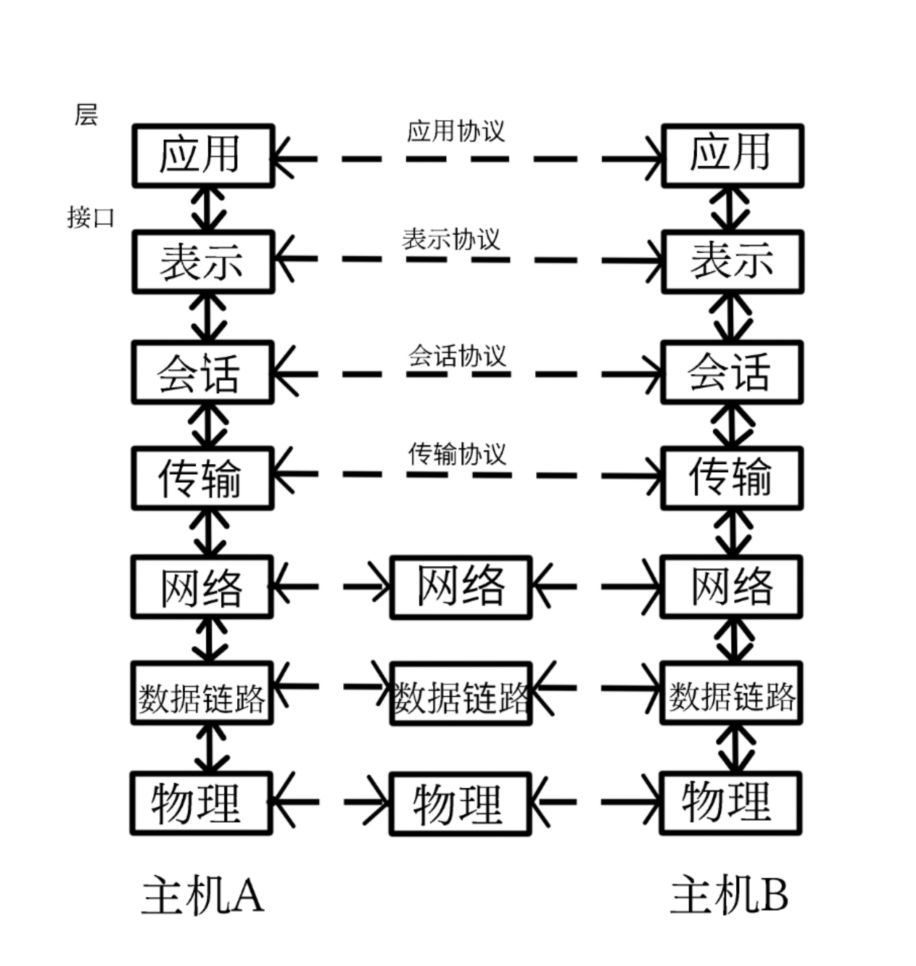
- What is the main difference between TCP and UDP?
Answer; TCP is connection-based and connection-oriented transport layer protocol. For example, before making a phone call, it is necessary to set up a connection, while UDP is connectionless, that is, it is not necessary to set up a connection before sending data
- When a file is transferred between two computers, two acknowledgement strategies are possible. In the first one, the file is chopped up into packets, which are individually acknowledged by the receiver, but the file transfer as a whole is not acknowledged. In the second one, the packets are not acknowledged individually, but the entire file is acknowledged when it arrives. Discuss these two approaches.
Answer: If the package has error, it does not need to send all files again, but the size of the first approach is bigger than the second. But the second approach needs to send again if the package has error.
1. 当文件在两台计算机之间传输时，可以采用两种确认策略。在第一种方法中，文件被分割成多个包，每个包由接收方单独确认，但是文件传输作为一个整体不被确认。在第二种方法中，数据包不是单独被确认的，而是在整个文件到达时被确认的。讨论这两种方法。

答:如果包有错误，它不需要重新发送所有文件，但是第一种方法的大小比第二种方法大。但如果包有错误，则需要再次发送第二种方法。
- Assume you post a regular letter to a friend; do you think the postal service is a reliable service? If you want to make sure that the letter will arrive at your friend's mailbox, think of a protocol based on the regular letter postal service.
Answer: I don’t think so, I would send two letters, one is the massage which is encrypted, the other is a key and each ones’ header has the message that tell friend if he only got one letter, then replied me, I would send it again. If he got two letters, replied OK to me.
19. 假设你给朋友寄了一封普通的信;你认为邮政服务可靠吗?如果您想确保信件能到达您朋友的邮箱，请考虑基于普通信件邮政服务的协议。

答:我不这么认为，我会寄两封信，一封是加密的按摩，另一封是钥匙，每个人的头都有信息，告诉朋友如果他只收到一封信，然后回复我，我会再寄一次。如果他收到两封信，回复OK给我。
- The Internet is made up of a large number of networks. Their arrangement determines the topology of the Internet. A considerable amount of information about the Internet topology is available online. Use a search engine to find out more about the Internet topology and summarize your finding.
Answer: Internet topology is the network topology of the Internet. The most widely used network (Internet) topology is the star structure, in addition to the bus and ring network (Internet) structure.
20.因特网是由许多网络组成的。它们的排列决定了Internet的拓扑结构。关于Internet拓扑结构的大量信息可以在网上获得。使用搜索引擎查找更多关于Internet拓扑的信息，并总结您的发现。

答:互联网拓扑就是互联网的网络拓扑。目前应用最广泛的网络(Internet)拓扑结构是星形结构，另外还有总线和环形网络(Internet)结构。

- Please visit IEEE 802, make a brief introduction to IEEE 802 LAN/MAN Standards Committee.
Answer: It is dedicated to the study of services and protocols defined in the physical layer and MAC layer of local and metropolitan area networks, corresponding to the lowest two layers of the OSI network reference model (that is, the physical layer and the data link layer). IEEE 802 also refers to a set of IEEE standards for local and metropolitan area networks. Rather, the IEEE 802 standard is limited to networks that transmit variable-sized packets.
请访问IEEE 802，简要介绍IEEE 802局域网/MAN标准委员会。

答:专门研究局域网和城域网物理层和MAC层中定义的服务和协议，对应OSI网络参考模型的最低两层(物理层和数据链路层)。IEEE 802还涉及一套用于局域网和城域网的IEEE标准。相反，IEEE 802标准仅限于传输可变大小数据包的网络。
- Notes for Submission
1. Accepted submission file type: Microsoft Word or Acrobat PDF.
2. The file name of your submission must be a combination of your Student ID, hw# ( where # is the assignment number ) ,your name and submission date. e.g, your name is ZhangSan, student ID is 201616013092, you are submitting your 1st homework on date 2016/03/07, the file name must be: 201616013092-hw1-ZhangSan-20190307.doc

