Computer Networks (112039)
Assignment 4#

Student ID: 201711123028 Student Name:赵婧宇
2019-4-16
School of Computing, CUC

I declare that the assignment here submitted is original except for source material explicitly acknowledged. I also acknowledge that I am aware of University policy and regulations on honesty in academic work, and of the disciplinary guidelines and procedures applicable to breaches of such policy and regulations.

Name: 赵婧宇 Student ID: 201711123028
Notes:

Please answer the following problems for the chapter 4 of the textbook:
- Draw a protocol stack to show what place of MAC sublayer is.
Answer: 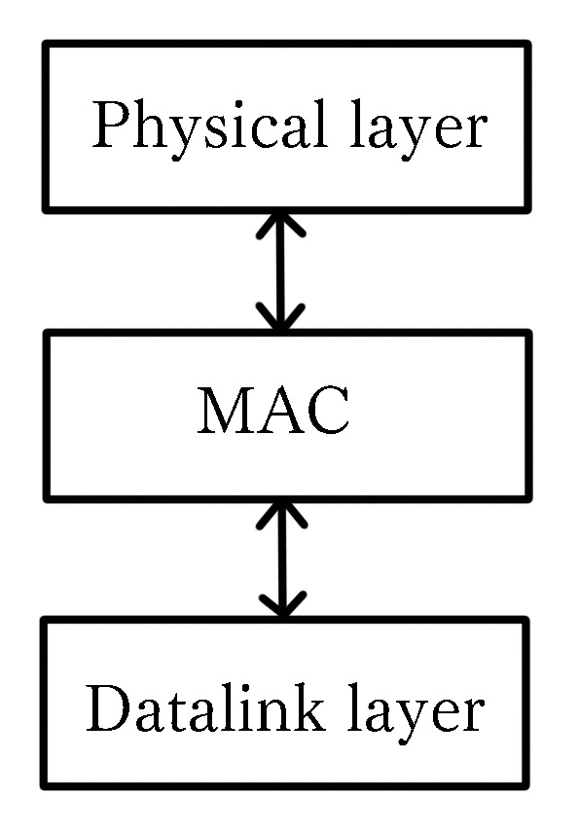
- For this problem, use a formula from Chapter 4, but first state the formula; Frames arrive randomly at a 100-Mbps channel for transmission. If the channel is busy when a frame arrives, it waits its turn in a queue. Frame length is exponentially distributed with a mean of 10,000 bits/frame. For each of the following frame arrival rates, give the delay experienced by the average frame, including both queueing time and transmission time.
  - 90 frames/sec
  - 900 frames/sec
  - 9000 frames/sec
Answer: The formula is T=1/（μC-λ）
T | Mean time delay
C | A channel of capacity C bps
μ | The average length of frame is 1/μ bits
λ | An average arrival rateλ frames /s
From the problem we can get:
C=100M 1/μ=10000->μ=10^(-4)
- T=1/（μC-λ）=1/(10^(-4)x100x10^6-90)= 0.1ms
- T=1/（μC-λ）=1/(10^(-4)x100x10^6-900)= 0.11ms
- T=1/（μC-λ）=1/(10^(-4)x100x10^6-9000)= 1ms
2. 对于这个问题，使用第4章中的公式，但首先声明公式;帧随机到达100 mbps的信道进行传输。如果一个帧到达时通道正忙，它将在队列中等待轮到它。帧长呈指数分布，平均为10,000位/帧。对于以下每个帧到达率，给出平均帧所经历的延迟，包括排队时间和传输时间。

(一)90帧/秒

(b) 900帧/秒

(c) 9000帧/秒

答:这个公式是T = 1 /(μC-λ)
- Compare and contrast Static Channel Allocation and Dynamic Channel Allocation
Answer: Static spectrum allocation channel utilization is low, The basic problem is that when some users are quiescent, their bandwidth is simply lost. They are not using it, and no one else is allowed to use it either. A static allocation is a poor fit to most computer systems, in which data traffic is extremely bursty, often with peak traffic to mean traffic ratios of 1000:1. Consequently, most of the channels will be idle most of the time.
The channel utilization of DCA is high. And DCA is more complex than SCA.
- Explain terms: Carrier Sense, Collision Detection, 1-persistent CSMA
Answer: Carrier Sense: Before sending data, Ethernet "listens" on the cable to see if there is another data transfer.
Collision Detection: When sending data, the sending site should listen to the channel at the same time. If there is interference signal in the channel, it means that there is a conflict, so the sending frame must be stopped.
1-persistent CSMA: When a station has data to send, it first listens to the channel to see if anyone else is transmitting at that moment. If the channel is idle, the station sends its data. Otherwise, if the channel is busy , the station just waits until it becomes idle. Then the station transmits a frame. If a collision occurs, the station waits a random amount of time and starts all over again.
- In CSMA/CD algorithm, how to determine the worst time for a station to detect collision?
Answer: 2τ time after sending the data frame
- Consider building a CSMA/CD network running at 1 Gbps over a 1-km cable with no repeaters. The signal speed in the cable is 2000,000 km/sec. What is the minimum frame size?
Answer: The length of a contention slot t=2T=2 x s/v= 2x 1/2000,000=0.001 ms
Minimum frame size=10000bit
- Does MAC sublayer provide reliable service? Why?
Answer: No, Even in the absence of collisions, the receiver may not have copied the frame correctly for various reasons.
- Explain the differences between 10Base-T and 10Base2 cabling.
Answer: Only two pairs of UTP network cables are used in the 10Base-T and have a maximum length of 100m and a minimum length of 2.5m between nodes. 10Base2 uses coaxial cable which is usually black. The maximum length is 185 meters, and the minimum length between nodes is 0.5 meters.
- Ethernet supports a protocol known as Carrier Sense Multiple Access with Collision Detection (CSMA/CD). Explain how CSMA/CD works, giving an example of how it ensures a low probability of collision when two nodes attempt to transmit at the same time.
Answer: If a station detects a collision, it immediately terminates its transfer, waits for a random period of time, and then retries the transfer. Assume two stand at t time began to transmit data at the same time, the transmitted signal needed time for t, at time t, a standing start transmitting data, the moment before the signal to another station, the station began to transport, it almost immediately detected conflicts, and immediately stop the transfer, if not listening to the conflict in the 2 t time, to determine they ‘seize’ the cable.
3.对比静态信道分配和动态信道分配

答:静态频谱分配信道利用率低，基本问题是当一些用户处于静止状态时，他们的带宽就会简单地丢失。他们不使用它，其他人也不允许使用它。静态分配不适用于大多数计算机系统，因为在这些系统中，数据流量非常频繁，通常峰值流量与平均流量之比为1000:1。因此，大多数通道大部分时间都是空闲的。

DCA信道利用率高。DCA比SCA更复杂。

4. 解释术语:载波感知，碰撞检测，1-持久性CSMA

答:载波感知:在发送数据之前，以太网“监听”电缆，看看是否有其他数据传输。

冲突检测:发送数据时，发送站点应同时监听信道。如果信道中有干扰信号，说明存在冲突，必须停止发送帧。

1-persistent CSMA:当一个站点有数据要发送时，它首先监听信道，看看此时是否有其他人在传输。如果信道空闲，则站发送它的数据。否则，如果信道繁忙，则站将等待空闲。然后电台传送一个帧。如果发生碰撞，空间站会随机等待一段时间，然后重新开始。

5. 在CSMA/CD算法中，如何确定一个站点检测碰撞的最坏时间?

答:2τ时间后发送数据帧

6. 考虑建立一个CSMA/CD网络，在没有中继器的1公里电缆上以每秒1 Gbps的速度运行。电缆中的信号速度为每秒20万公里。最小帧大小是多少?

答:争用槽的长度t=2T=2 x s/v= 2x /2000,000=0.001 ms

最小帧大小= 10000

7. MAC子层是否提供可靠的服务?为什么?

答:没有，即使在没有碰撞的情况下，接收机也可能由于各种原因没有正确复制帧。

8. 解释10Base-T和10Base2布线的区别。

答:10Base-T仅使用两对UTP网络电缆，节点间最大长度为100m，最小长度为2.5m。10Base2采用同轴电缆，通常是黑色的。节点之间的最大长度为185米，最小长度为0.5米。

9. 以太网支持一种称为冲突检测载波感知多址(CSMA/CD)的协议。解释CSMA/CD的工作原理，给出一个例子，说明当两个节点试图同时传输时，CSMA/CD如何确保低冲突概率。

答:如果一个站点检测到碰撞，它会立即终止传输，等待一段随机时间，然后重试传输。假设两个站在t时间同时开始传送数据,传输信号所需的时间t,在时间t,站开始传输数据,信号前的时刻到另一个车站,车站开始运输,它几乎立即检测到冲突,并立即停止传输,如果不是听2 t的冲突时间,来确定他们抓住的电缆。
- Please read RFC 894, explain how to encapsulate an IP packet into an Ethernet II frame, draw necessary diagrams to show the frame format.
Answer: 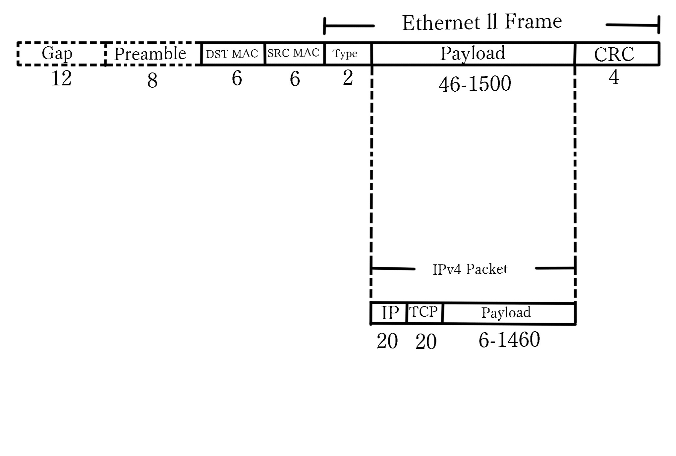

- Consider the extended LAN connected using bridges B1 and B2 in the figure.
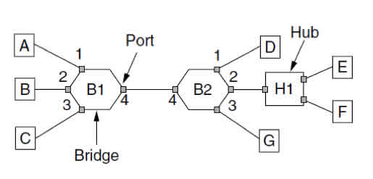
Suppose the hash tables in the two bridges are empty. List all ports on which a packet will be forwarded for the following sequence of data transmissions:
  - A sends a packet to C.
  - E sends a packet to F.
  - F sends a packet to E.
  - G sends a packet to E.
  - D sends a packet to A.
  - B sends a packet to F.
Answer: Bridges use backward learning algorithm to maintain the table
- A->C
B1’table
Receive frame from Port1 and flooding frame to Port 2,3,4.
A | 1
B2’table
Receive frame from Port4 and flooding frame to Port 1,2,3.
A | 4

- E->F
B2 receive frame from Port2 and flooding it to Port 1,2,4.
A | 4
E | 2
B1 receive flooding frame from Port4 and flooding it to Port 1,2,3.
A | 1
E | 4
- F->E
B2 receive frame from Port2 and discard it and B2’table is:
A | 4
E | 2
F | 2
B1 can not receive the frame, and it’s table
A | 1
E | 4
- G->E
B2 Receive frame from Port3 and forward it to Port2 and B2’s table is :
A | 4
E | 2
F | 2
G | 3
B1 receive no frame this time
A | 1
E | 4

- D->A
B2 Receive frame and forward it to Port4 according to its table
A | 4
E | 2
F | 2
G | 3
D | 1
B1 Receive the frame from Port4 and forward to port1.
A | 1
E | 4
D | 4
- B->F
B1 Receive frame and flooding it to Port1,3,4.
A | 1
E | 4
D | 4
B | 2
B2 Receive frame Port4 and forward it to port2 according to its table.
A | 4
E | 2
F | 2
G | 3
D | 1
B | 4

- Store-and-forward switches have an advantage over cut-through switches with respect to damaged frames. Explain what it is.
Answer: The store-and-forward switches will check the frame that has arrived, and if it is found damaged, it will be discarded. The pass-through switches begins forwarding when the target header field of a frame comes in. When an error is found in the transmission frame, the frame has already been transmitted and the wrong frame will not be discarded.
- Provide a description of the key differences between a 10Base-T hub, an Ethernet Bridge, and an IP Router. Your answer should include appropriate diagrams and may include a table comparing the features provided by each equipment.
Answer:
 | 10Base-T hub | Ethernet Bridge | IP Router
layer | Physical layer | Data link layer | Network layer
aim | include a group of modem cards for dial-in users, a gateway card | copying a data frame from one network to the next network along the communications path. | share a broadband internet connection
definition | the central part of a wheel where the spokes come together. | connects a local area network (LAN) to another local area network | like a switch forwards packets based on address.

12. 对于损坏的框架，存储转发开关比直通开关具有优势。解释它是什么。

答:存储转发开关将检查已到达的帧，如果发现已损坏，将丢弃。当帧的目标头字段进入时，直通开关开始转发。当在传输帧中发现错误时，该帧已经被传输，错误的帧不会被丢弃。

13. 提供对10Base-T集线器、以太网桥和IP路由器之间的关键区别的描述。您的答案应该包括适当的图表，并可能包括一个表，比较每个设备提供的功能。
- Ethernet supports Broadcast, Unicast and Multicast transmission modes, explain in detail what is meant by each term.
Answer: Broadcast transmission: One host sends a packet to all hosts.
Unicast transmission: A unicast MAC address is the unique address from the source to the destination.
Multicast transmission: When a frame is sent to a group address, all stations in that group receive it. The act of sending to a set of addresses is called multicast.
- Explain the term of collision domain. How many collision domains are created when you segment a network with a 12-port switch?
Answer: In Ethernet, if two computers on a CSMA/CD network collide while communicating, the CSMA/CD network is a collision domain. There are 12 collision domains would be created.
- What is the purpose of Spanning Tree Protocol in a switched LAN?
Answer: In a fault-tolerant network with redundant path to calculate a loop free path, and put forward on part of the port, the other part in the blocking state (backup), resulting in a stable, no loop of the spanning tree network topology, and the fault, once found that the current path spanning tree protocol can activate the corresponding port, immediately open the backup link, to regenerate the STP network topology, to maintain the normal work of the network.
- What is the purpose of VLAN technology? Explain frame tagging of 802.1q.
Answer: In many companies, the organizational structure is constantly changing, which means that system administrators spend a lot of time unplugging connectors and plugging them into other switches. In response to users' demands for flexibility, network providers are starting to consider rewiring buildings in software. Frame tagging of 802.1q specifies which VLAN the frame belongs to.
14. 以太网支持广播、单播和组播传输模式，详细解释每个术语的含义。

答:广播传输:一个主机向所有主机发送一个数据包。

单播传输:单播MAC地址是从源到目标的唯一地址。

组播传输:当一个帧被发送到一个组地址时，该组中的所有站都接收它。发送到一组地址的行为称为多播。

15. 解释碰撞域的术语。当您使用12端口交换机分割网络时，会创建多少冲突域?

答:在以太网中，如果CSMA/CD网络上的两台计算机在通信时发生冲突，则CSMA/CD网络是一个冲突域。将创建12个冲突域。

16. 在交换局域网中生成树协议的目的是什么?

答:在容错网络冗余路径计算循环自由程,并提出在港口的一部分,另一部分处于阻塞状态(备份),导致一个稳定的,不循环的生成树网络拓扑,和故障,一旦发现当前路径生成树协议可以激活相应的端口,立即打开备份链接,重新生成STP网络拓扑结构,维护网络的正常工作。

17. VLAN技术的目的是什么?解释802.1q的帧标记。

答:在许多公司，组织结构在不断变化，这意味着系统管理员要花费大量时间拔掉连接器，并将它们插入其他开关。为了满足用户对灵活性的需求，网络供应商开始考虑在软件中重新布线。帧标签802.1q指定了帧属于哪个VLAN。
- Notes for Submission
- Accepted submission file type: Microsoft Word or Acrobat PDF.
- The file name of your submission must be a combination of your Student ID, hw# (where # is the assignment number), your name and submission date. e.g., your name is ZhangSan, student ID is 201616013092, you are submitting your 1st homework on date 2016/03/07, the file name must be: 201616013092-hw1-ZhangSan-20160307.doc

