Computer Networks (112039)
Assignment 5#

Student ID: 201711123028 Student Name:赵婧宇
2017-5-19
School of Computer Science & Cybersecurity, CUC

I declare that the assignment here submitted is original except for source material explicitly acknowledged. I also acknowledge that I am aware of University policy and regulations on honesty in academic work, and of the disciplinary guidelines and procedures applicable to breaches of such policy and regulations.

Name: 赵婧宇 Student ID: 201711123028
Notes:

Please answer the following problems for the chapter 5 of the textbook:
- What is a router ?
Answer: A router is a typical network-layer device, it will automatically select and set the route according to the situation of the channel, to the best path, in order to send data packets.
- Routing tables, routing algorithm and packet forwarding are parts of routing, what are they and how are they connected to each other?
Answer: ①Routing tables is a spreadsheet stored in a router. It Stores a path to a specific network address and Topology information around the network. The main goal of routing table is to realize routing protocol and static routing.② Routing algorithms are part of network-layer software that determines which output line an inbound packet should be sent to.③ Packet forwarding is what you do when a packet arrives.④ Think of a router as having two processes inside. One process processes each packet as it arrives, and it looks for the outgoing route for that packet in the routing table. The other process is responsible for generating and updating the routing table, which is where routing algorithms come into play
- What is the difference between connecting networks by switch and by router?
Answer: Use a network cable to connect the two switches The switch is mainly used for everyone to connect to the Internet through one network line, but everyone USES their own broadband, and everyone has no influence on the Internet, even if others are downloading, it has no influence on their own Internet access, and all computers using the same switch are in the same LAN. The router has a virtual dial-up function more than the switch. The computers surfing the Internet through the same router share a broadband account, and the Internet access is interactive. For example, if one computer is downloading, the other computers on the same router will obviously feel the slow Internet speed. The computer on the same router is also on a LAN.
- Explain the count to infinity problem in Distance Vector algorithm, describe the problem by an example
A----B----C----D----E
Answer: Assuming that A is initially down, which all other routers know, when A starts up,B immediately knows that A is up, and the other routers still think that A is down and need to go through vector switching to know that A is up.
All of A sudden, A stops, and B doesn't hear anything from A, but C tells B that it can go to A, and B doesn't suspect that the path from C to A has to go through itself, so after the first exchange, D and E don't update their A table entries. No router has a value greater than the minimum of all its neighbors, and gradually, all routers go to infinity
- Answer to the following questions concerning the network given in next figure. An distance vector based routing algorithm is used in the network.
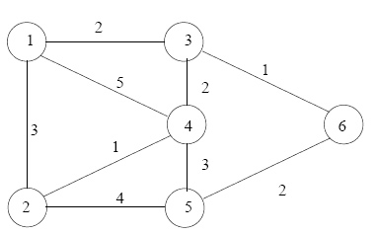

Draw a table according to the example below. write the routing information of nodes 1 to 5 as (nextnode, distance) pairs when the destination is node 6.

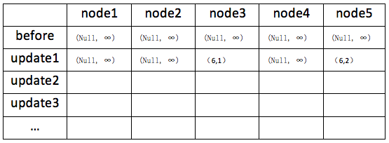

- Let's assume that the nodes of the network update their routing tables in parallel simultaneously "step by step" by using distance vector routing algorithm. Fill your table step by step and explain how the information about break between node 3 and 6 propagates in the network, i.e (next node, distance) pairs after each update.

 | Node 1 | Node 2 | Node 3 | Node 4 | Node 5
before | (null,∞) | (null,∞) | (null,∞) | (null,∞) | (null,∞)
Update1 | (null,∞) | (null,∞) | (6,1) | (null,∞) | (6,2)
Update 2 | (3,3) | (5,6) | (6,1) | (3,3) | (6,2)
Update 3 | (3,3) | (4,4) | (6,1) | (3,3) | (6,2)
Node 3 and node 6 will exchange their routing table,break:count-to-infinity
 | Node 1 | Node 2 | Node 3 | Node 4 | Node 5
before | (3,3) | (4,4) | (6,1) | (3,3) | (6,2)
Update1 | (3,7) | (4,6) | (4,5) | (3,7) | (6,2)
Update 2 | (3,11) | (4,12) | (4,9) | (3,11) | (6,2)
Update 3 | ... | ... | ... | ... | ...

- How does using a link state based routing algorithm differ from the situation presented in question b where a distance vector routing algorithm is used?
Answer: Link state routing: Each router maintains a database describing the topology and link delays between each router. That is, each router keeps track of the full graph of links and nodes.
Distance vector routing :Each router maintains a table (vector) giving the best known distance to a destination and the line to use for sending there. Tables are updated by exchanging information with neighbors. Each router knows the distance (cost) of reaching its neighbors. Routers periodically exchange routing tables with each of their neighbors.
- Consider the subnet of the figure below, Distance Vector Routing is used, and the following vectors have just come in to router C:From B:（5，0，8，12，6，2），From D：（16，12，6，0，9，10），From E：（7，6，3，9，0，4）. The measured delays to B, D, and E, are 6, 3, and 5, respectively. What is C’s new routing table? Give both the outgoing line to use and the expected delay.
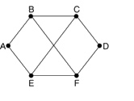

Answer: By B:(11,6,14,18,12,8)
By D:(19,15,9,3,12,13)
By E:(12,11,8,14,5,9)
The minimum value to reach each destination(but C):(11,6,0,3,5,8)
Output line:(B,B,-,D,E,B)
- Explain Shortest Path Algorithm.
Answer: The path from one vertex to another along the edge of the graph is called the shortest path. Mark a node in the figure as permanent, represented by a solid circle in the figure, then we check each node adjacent to the node at a time, and mark them again with the distance between them and the original node. In order to reconstruct the final path, every time a node is re-marked, the starting node (that is, the previous node) of this probe action is also marked. After checking every node adjacent to the first node, we will check all nodes in the whole graph that have temporary marks, and make the one with the smallest mark permanent. This node will become the new work node. After all the nodes in the whole graph and make the one with the smallest value. This node is made permanent and becomes the working node for the next round.
- Compare the differences between Distance Vector Routing and Link State Routing.
Answer: A router that uses distance vector routing does not know the entire path to the destination network; it knows only the distance between itself and the destination network and the interface to which it should forward packets. Routers using link-state routing can create their own network topology to determine the shortest path.
Routing | Convergence time | The router determines the shortest path to each network | resource utilization | Implementation and maintenance
Distance Vector Routing | slow | No | low | simple
Link State Routing | quick | Yes | high | complex

- What is Maximum Transmission Unit (MTU)? explain the reason and strategy of fragmentation in a connectionless network like IP?
Answer: MTU refers to the maximum datagram size that can pass above a certain layer of a communication protocol.
- Draw a figure to show the IPV4 header. (you are required to draw it yourself, don't copy from the Internet or course powerpoint slides).
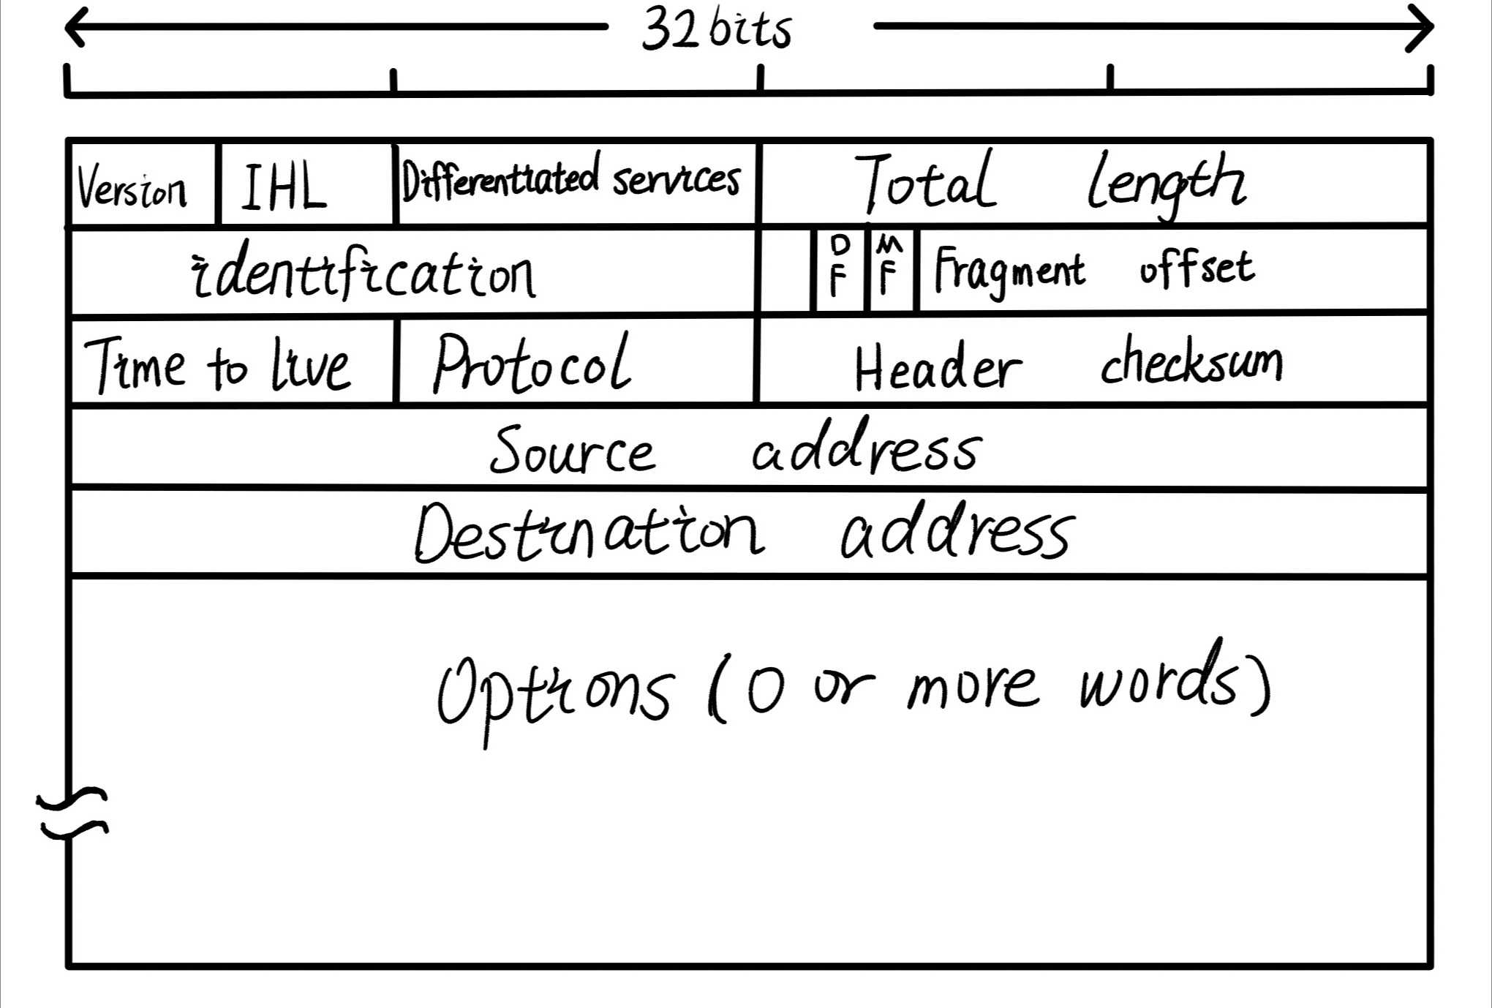
- What is Subnet What is Subnet MASK? Tell me the IP Address, Subnetmask, Default Gateway of the computer you are using currently.
Answer: ①A subnet mask is a 32-bit address used to mask part of an IP address to distinguish the network identity from the host identity and to indicate whether the IP address is on a local area network or a remote network ② IP Address: 192.168.1.8 Subnetmask: 255.255.255.0 Default Gateway: 192.168.1.1
- What is CIDR? Fill blanks in following table with subnet masks corresponding to the CIDR Value.
==========================
Subnet Mask CIDR Value
==========================
[255.255.255.0 ] [ /24 ]
[255,255,255,128] [ /25 ]
[255,255,255,192] [ /26 ]
[255,255,255,224] [ /27 ]
[255,255,255,240] [ /28 ]
[255,255,255,248] [ /29 ]
[255,255,255,252] [ /30 ]
[255,255,255,254] [ /31 ]
[255,255,255,255] [ /32 ]
Answer: CIDR combines several standard networks into one large network. It eliminates the traditional class A and class B and class C address the concept of subnet, thus it can be more effectively assign IPv4 address space it can combine several IP network together, using an unclassified domain international routing algorithms, and make them merge into A less routing and routing entry in the routing table to reduce the burden of the Internet router
- We are going to subnet the Class C network address 192.168.10.0 by using a subnet mask of 255.255.255.128. Answer the following subquestions.
- How many subnets?
Answer: 2
- How many hosts per subnet?
Answer:126
- What are the valid subnets (the start address of each subnet)?
Answer:192.168.10.0
192.168.10.128
- What's the broadcast address for each subnet?
Answer:192.168.10.255
- What are the valid hosts range for each subnet (the first and the last host)?
Answer:192.168.10.0 -- 192.168.10.127
- You have a Class B network and need 29 subnets. What is your mask?
Answer: 255.255.248.0
- What is the broadcast address of 192.168.192.10/29?
Answer: 192.168.192.255
- How many hosts are available with a Class C /29 mask?
Answer:6
- What is the subnet for host ID 10.16.3.65/23?
Answer: 10.16.2.0
- A large number of consecutive IP address are available starting at 192.16.0.0. Suppose that four organizations, A,B,C, and D, request 4000,2000,4000, and 8000 addresses, respectively, and in that order. For each of these, give the first IP Address assigned, the last IP address assigned, and the mask in the w.x.y.z/s notation.
Answer: 192.16.0.0 192.16.15.255 192.16.0.0/20
192.16.16.0 192.16.23.255 192.16.16.0/21
192.16.32.0 192.16.47.255 192.16.32.0/20
192.16.64.0 192.16.95.255 192.16.64.0/19
- A router has the following (CIDR) entries in its routing table:

Subnet Next hop
------------------------------------
135.46.56.0/22 Interface 0
135.46.60.0/22 Interface 1
192.53.40.0/23 Router 1
default Router 2

For each of the following IP addresses, what does the router do if a packet with that address arrives?

(a)135.46.63.10
(b)135.46.57.14
(c)135.46.52.2
(d)192.53.40.7
(e)192.53.56.7
Answer: The packets are routed as follows:
(a)interface 1
(b)interface 0
(c)Router 2
(d)Router 1
(e)Router 2

- The functions of ARP and how does it work?
Answer: When sent via Ethernet IP packets, need to encapsulate the third layer (32-bit IP address) of the second layer (48 MAC address) header, but because of send only know target IP address, do not know its MAC address, can't cross the second of three layers, so you need to use the address resolution protocol using the address resolution protocol, according to the network layer IP address information in IP packet header parsing out the target hardware address (MAC address) information, to ensure the smooth progress of communication.
First of all, set in its own ARP buffer every host an ARP list, to show the corresponding relationship between the IP and MAC address when the source host to send data, first check the ARP list for corresponding to the IP address of the destination MAC address, if you have, send data directly, if not, just send this period of all the hosts ARP packets, the packets include are: the content of the source host IP address, the source host MAC address, the IP address of the destination host When all the host of this network received the ARP packets, first check whether the IP address on the packet is its own IP address, if not, then ignore this packet, if it is, the first from the packet source host IP and MAC address written to the ARP list, if it already exists, cover, and then to write their own MAC address into the ARP reply packet, tell the source host is that it is a MAC address which source host wants. The source host after receiving the ARP reply packet to its destination IP and MAC address in the ARP list, and use this information to send data If the source host has not received the ARP response packet, the ARP query has failed.
- Give a instruction of OSPF routing Algorithm in detail.
Answer: The OSPF routing algorithm considers having the entire network topology in each router's database.
Here are a Network topology:
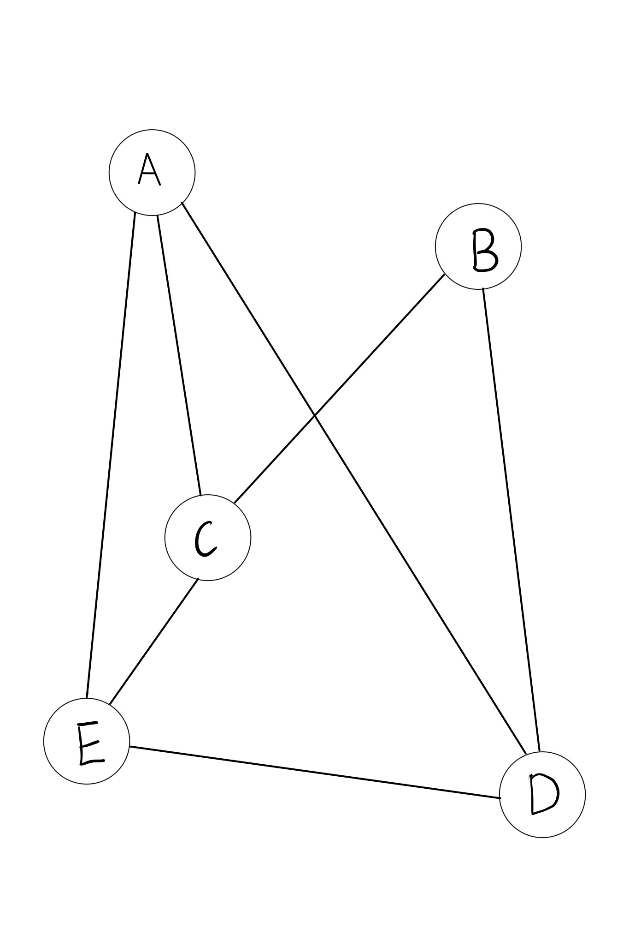
A and E communicate, A and E send messages to each other, and receive A response message. Each party will periodically send its own routing data summary to the other party. Usually, The two sides just corresponded until the other side did not drop the line. A periodically sends its route summary to all of its neighbors. For example, for router E, router A will send a packet called a DD packet that says it knows E,C,D, and E from its database
They only know A,C,D, so they send A request message asking them to tell them what they don't know Routing details. This request message is called the LSR(link status request message) message.After A receives it, he knows that E does not know his other friends, so he sends an LSU message (link status update) to inform E of the details. After E receives it, give A confirmation -LSAck message. Two people now know as many routers as they do.
- Make a research on the Internet; write an essay about ARP virus (explain how it works and how to prevent it).
When the machine A to host B sends A message, will check out the local ARP cache table, find the IP address of the corresponding MAC address B, for data transmission, if not found, then A broadcast an ARP request message, request the host B answer the physical address, all hosts will receive ARP request online, after identification of host B to A reply to an APR response message, including MAC address, B received B reply, update the local ARP cache, and then use the MAC address to send data.
ARP protocol does not receive ARP response only after ARP request is sent. When the computer receives ARP response packet, it updates the local ARP cache and stores the IP and MAC addresses in the ARP cache. Therefore, when some computer B in the LAN sends A forged ARP response to A, if the response is forged by B posing as C, that is, IP address of C is IP, while the MAC address is forged, when A receives A forged ARP response from B, it updates the local ARP cache. So from A's point of view, C's IP address doesn't change, but its mac address is no longer the same. Since the LAN's network is based on the MAC address rather than the IP address, the bogus MAC address is changed to A nonexistent MAC address on A, which can cause the network to fail.
How to prevent:
Set up the ARP table on the switching device, Static binding of IP address and MAC address, although the initial workload is relatively large, but the specific implementation can greatly reduce the workload of daily maintenance and ARP virus on the exchange equipment fraud.

Notes for Submission
- Accepted submission file type: Microsoft Word or Acrobat PDF.
- The file name of your submission must be a combination of your Student ID, hw# (where # is the assignment number), your name and submission date. e.g., your name is ZhangSan, student ID is 201616013092, you are submitting your 1st homework on date 2016/03/07, the file name must be: 201616013092-hw1-ZhangSan-20160307.doc

1. 什么是路由器?

答:路由器是典型的网络层设备，它会根据信道的情况自动选择和设置路由，到最佳路径，以便发送数据包。

2. 路由表、路由算法和包转发是路由的组成部分，它们是什么以及如何相互连接的?

答:①路由表是一个电子表格存储在一个路由器。它存储到特定网络地址的路径和网络周围的拓扑信息。路由表的主要目标是实现路由协议和静态路由。②路由算法的网络层软件的一部分,决定哪些应该发送到输出线入站信息包。③数据包转发数据包到达时你做什么。④认为路由器有两个流程里面。一个进程在每个包到达时对其进行处理，并在路由表中查找该包的出站路由。另一个进程负责生成和更新路由表，这就是路由算法发挥作用的地方

3.用交换机连接网络和用路由器连接网络有什么不同?

答:使用一个网络电缆来连接两个开关开关主要用于每个人通过一个网络连接到互联网,但每个人都用自己的宽带,在互联网上,每个人都没有影响,即使别人下载,它没有影响自己的互联网接入,和所有电脑使用相同的开关在同一个局域网。路由器比交换机有更多的虚拟拨号功能。通过同一路由器上网的计算机共享一个宽带帐户，并且Internet访问是交互式的。例如，如果一台计算机正在下载，同一路由器上的其他计算机显然会感觉到互联网速度变慢。同一路由器上的计算机也在LAN上。

4. 解释距离向量算法中的计数到无穷大问题，并举例说明

D C B - - - - - - - - - - - - - - - - - - - - E

答:假设一开始A是向下的，其他路由器都知道，当A启动时，B立刻知道A是向上的，而其他路由器仍然认为A是向下的，需要通过向量交换才能知道A是向上的。

突然,停止,和B没有听到任何东西,从一个,但C告诉B,它可以去,从C和B不怀疑路径要经历本身,所以第一次交换后,D和E不更新一个表条目。没有路由器的值大于它所有邻居的最小值，渐渐地，所有路由器都趋于无穷大

5. 回答下图中关于网络的以下问题。该网络采用了一种基于距离向量的路由算法。

8. 比较距离向量路由和链路状态路由的区别。

答:使用距离向量路由的路由器不知道到目标网络的整个路径;它只知道自己与目标网络之间的距离，以及它应该转发数据包的接口。路由器使用链路状态路由可以创建自己的网络拓扑来确定最短路径。
9. 什么是最大传输单元(MTU)?解释在无连接网络(如IP)中出现碎片的原因和策略?

答:MTU是指在通信协议的某一层之上可以传递的最大数据报大小。
11. 什么是子网掩码?告诉我您当前使用的计算机的IP地址、子网掩码、默认网关。

答:①子网掩码是一个32位地址用来掩盖一个IP地址来区分网络身份的一部分从主机身份和显示IP地址是否在局域网或远程网络②IP地址:192.168.1.8 Subnetmask: 255.255.255.0默认网关:192.168.1.1
20.ARP的功能及其工作原理?

答:当通过以太网发送IP数据包,需要封装第三层(32位IP地址)的第二层(48 MAC地址)头,但由于发送只知道目标IP地址,不知道它的MAC地址,不能穿过第二个三层,所以你需要使用地址解析协议使用地址解析协议,根据网络层IP地址信息在IP数据包报头分析目标硬件地址(MAC地址)信息,确保沟通的顺利进行。

首先,设置每台主机的ARP缓冲区ARP列表,显示相应的IP和MAC地址之间的关系源主机发送数据时,首先检查的ARP表对应的IP地址目的MAC地址,如果你有,直接发送数据,如果没有,就把这段时间的所有主机的ARP包,包包括:源主机IP地址的内容,源主机的MAC地址,目的地主机的IP地址在这个网络的所有主机收到了ARP数据包,首先检查数据包的IP地址是否是自己的IP地址,如果没有,那么忽略这个包,如果是,第一个数据包源主机的IP和MAC地址写入ARP列表,如果它已经存在,盖,然后将自己的MAC地址写入ARP应答包,告诉源主机它是源主机想要的MAC地址。源主机收到ARP应答包后，将其发送到ARP列表中的目标IP和MAC地址，并使用此信息发送数据，如果源主机没有收到ARP响应包，则ARP查询已经失败。

21. 详细介绍了OSPF路由算法。

答:OSPF路由算法考虑在每个路由器的数据库中拥有整个网络拓扑。

以下是网络拓扑结构:
A和E通信，A和E互相发送消息，并接收响应消息。每一方都将定期向另一方发送自己的路由数据摘要。通常，双方只是通信，直到对方没有掉线。A定期将它的路由摘要发送给它的所有邻居。例如，对于路由器E，路由器A将发送一个称为DD包的包，该包说它从它的数据库中知道E、C、D和E

他们只知道A、C、D，所以他们发送一条请求消息，要求他们告诉他们不知道路由细节的内容。此请求消息称为LSR(链接状态请求消息)消息。A收到后，他知道E不认识他的其他朋友，所以他发了一条LSU消息(link status update)通知E详情。E收到后，给出一个确认-LSAck消息。现在两个人知道的路由器和他们知道的一样多。
22. 在互联网上做一个研究;写一篇关于ARP病毒的文章(解释它是如何工作的以及如何预防它)。

当机主机B发送一条消息,查看本地ARP缓存表,找到相应的MAC地址的IP地址,数据传输,如果没有找到,然后广播ARP请求消息,请求主机B答案物理地址,将收到的所有主机在线ARP请求,在识别主机B回复4月响应消息,包括MAC地址,收到B回答,更新本地ARP缓存,然后使用MAC地址发送数据。

ARP协议仅在ARP请求发送后才接收ARP响应。当计算机接收到ARP响应包时，它更新本地ARP缓存并将IP和MAC地址存储在ARP缓存中。因此,当B在局域网一些计算机发送伪造的ARP响应,如果响应由B冒充C伪造的,也就是说,IP地址的IP, MAC地址是伪造的,当收到一个伪造的ARP响应从B,它更新本地ARP缓存。所以从A的角度来看，C的IP地址没有改变，但是它的mac地址已经不一样了。由于局域网的网络是基于MAC地址而不是IP地址，所以虚假的MAC地址被更改为A上不存在的MAC地址，这可能导致网络失败。

如何预防:

在交换机上设置ARP表，静态绑定IP地址和MAC地址，虽然初始工作量比较大，但是具体的实现可以大大减少日常维护的工作量和ARP病毒对交换机设备的欺诈。

