Computer Networks (112039)
Assignment 6#

Student ID: 201711123028 Student Name:赵婧宇
2019-5-27
School of Computer Science & CyberSecurity, CUC

I declare that the assignment here submitted is original except for source material explicitly acknowledged. I also acknowledge that I am aware of University policy and regulations on honesty in academic work, and of the disciplinary guidelines and procedures applicable to breaches of such policy and regulations.

Name: 赵婧宇 Student ID: 201711123028
Notes:

Please answer the following problems for the chapter 6 of the textbook:
- What is the function of the Transport Layer in the OSI Reference Model?
Answer: The basic function of the transport layer is to receive data from the previous layer, divide the data into smaller units where necessary, and then pass the data units to the network layer, ensuring that the data units reach the other end correctly. Moreover, all this work must be done efficiently and in an up-down manner, transparent to the upper layers as the underlying hardware technology inevitably changes over time.
The transport layer is also the true end-to-end layer, carrying data all the way from the source to the receiver. In other words, a program on the source machine USES header and control information to talk to a similar program on the target machine. In each layer below it, each protocol involves a machine and its immediate neighbors, not the ultimate source and target machines.

- Some protocols are said to provide a "reliable" service. What guarantees must a reliable protocol offer?
Answer: Ensure that the error rate is as low as possible, confirm that the packet can be received and answered by the other side, and re-transmit if problems such as packet loss or data transmission error occur. There are flow control and congestion control mechanisms to prevent packet loss due to congestion and other problems.。
- To a certain extent, the transport service is similar to the network service, why are there two distinct layers? Why is one layer not adequate? What are the important differences between them?
Answer: The network layer does not necessarily guarantee the reliability of the service, and the user cannot directly control the communication subnet. Therefore, a transport layer is added on top of the network layer to improve the quality of transmission.
- In some ways, transport protocols resemble the data link protocols we studied in detail in Chap. 3. Both have to deal with error control, sequencing, and flow control, among other issues. However, significant differences between the two also exist. Please explain these differences between the environments in which the two protocols operate.
Send serial number: HDLC can only be sent one by one in order; TCP is also sent sequentially, but it can send packets with large serial Numbers without prior packet confirmation.
send window size: HDLC can only be 1; TCP can be dynamically tuned.
connection establishment: HDLC only back and forth confirmation can be, TCP is 3 handshake.
- Explain what is meant by the term Service Access Point
Answer: Service access point is a logical interface between the adjacent layer entity. Starting from the physical layer, each layer to the upper provide service access point. In the ordinary microcomputer connection to the Internet, the data link layer service access point TYPE of TYPE specification, (0800 represents the upper IP for example), the network layer service access point is protocol field in the IP header (17 said the upper is UDP, 6 is TCP, 89 is OSPF, 88 is the EIGRP, 1 is the ICMP, etc.), the transport layer service access point is the port number.
- Using suitable diagrams, explain the purpose of the Ethernet Frame Type Field. Provide two examples of protocols whose operation relies on the presence of the Ethernet Frame Type Field.
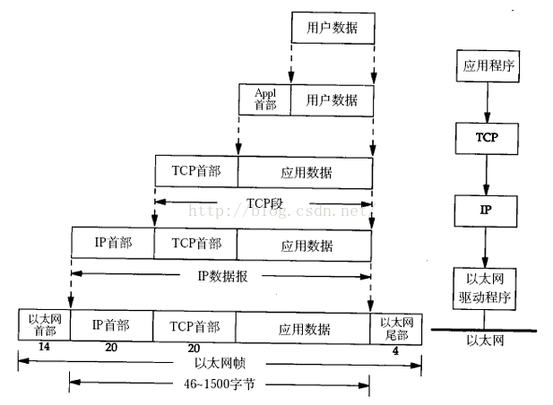

- Draw diagrams to show UDP header format and TCP header format. You are supposed to draw them by yourself (don't copy from the Internet or the PowerPoint slides).
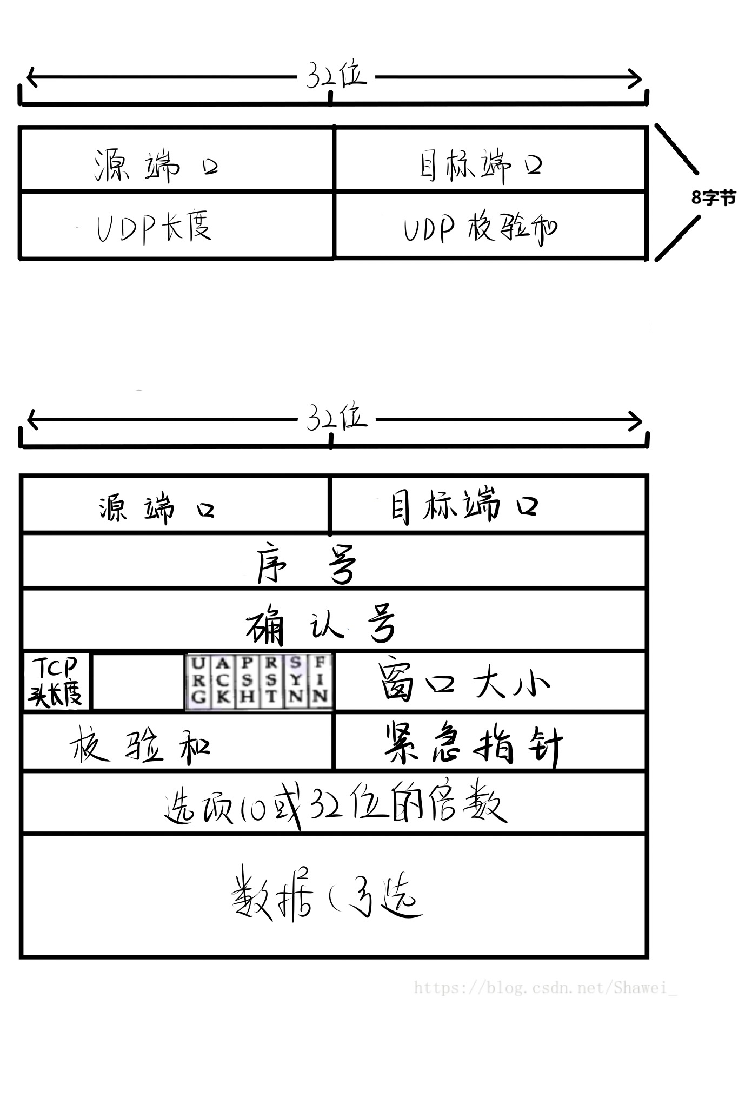
- Why does UDP exist? Would it not have been enough to just let user processes send raw IP packets?
Answer: It's not enough to just use IP groups. IP groups contain IP addresses that specify a destination machine. Once such a group reaches the destination machine, how does the network control program know which process to hand it over to? UDP packets contain a destination port. This information is required so that the packets can be delivered to the correct process.
- A session uses the User Datagram Protocol (UDP). It sends a series of packets over an Ethernet LAN. The payload of each UDP packet has a size of 690 bytes. Determine the total size of each Ethernet frame.
Answer: UDP packet head takes 8 bytes, IP head takes 20 bytes, Ethernet head takes 14 bytes, Ethernet tail takes 4 bytes, the total size is 690+8+21+14+4=737 bytes.
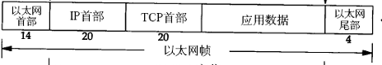

- Describe the operation of the "traceroute" program.
Answer: In Windows, the source sends a series of ICMP packets to the target destination. For both operating systems, the program sends the first packet with TTL=1, the second packet with TTL=2, and so on. Recall that a router will decrement a packet’s TTL value as the packet passes through the router. When a packet arrives at a router with TTL=1, the router sends an ICMP error packet back to the source. Traceroute program can let us see how many routers when we visit the target destination.
- A process on host 1 has been assigned port p, and a process on host 2 has been assigned port q. Is it possible for there to be two or more TCP connections between those two ports at the same time?
Answer: NO, A connection is only identified by its socket, so (1, p) - (2, q) is the only possible connection between the two ports.
- What is the total size of the minimum TCP/IP MTU, including TCP and IP overhead but not including dad link layer overhead.
Answer: The default is 536bytes, and TCP adds 20bytes, so the minimum TCP/IP MTU total length is 576bytes.
- In the TCP header (Fig.6-36 in the text), we saw that in addition to the 32-bit acknowledgement field, there is an ACK bit in the fourth word. Does this really add anything? Why or why not.
Answer: The ACK bit is used to tell whether the 32-bit field is used. But if it were not there, the 32-bit field would always have to be used, if necessary acknowledging a byte that had already acknowledged. In short, it is not absolutely essential for normal data traffic. However, it plays a crucial role during connection establishment, where it is used in the second and third messages of the threeway handshake.
- Can both UDP and TCP deal with data on same port simultaneously?
Answer: Can.
- The maximum payload of a TCP segment is 65,495 bytes. Why was such a strange number chosen?
Answer: The entire TCP segment must be adapted to the load segment of IP packet 65515 bytes, because TCP header is at least 20 bytes,
Therefore, the maximum payload is 65535-20-20 =65495 bytes
- Explain the TCP congestion Control mechanism in detail.
Answer: Congestion control of TCP consists of four core algorithms: Slow Start, Congestion voidance, Fast Retransmit, and Fast Recovery.
Slow Start: TCP applications developed in the early stage send a large number of packets to the network when starting a connection, which can easily lead to the router cache space running out and network congestion, resulting in a sharp decline in the throughput of TCP connections. Since the TCP source side has no way of knowing the current utilization of network resources, a newly established TCP connection cannot send large amounts of data at the beginning, but can only gradually increase the amount of data sent each time to avoid this phenomenon. Specifically, congestion window (CWND) initializes as one packet size when a new TCP connection is established. The source sends data at the size of CWND. For each ACK acknowledgement received, the CWND increases the number of packets sent, so that the CWND will grow exponentially with the Round Trip Time (RTT) of the loop, and the amount of data sent to the network by the source will increase sharply. In fact, slow start is not slow at all. It grows exponentially
Congestion voidance: If the TCP source finds a timeout or receives three copies of the same ACK, the network is considered congested (mainly because the probability of packet corruption and loss caused by transmission is small (<<1%)). This is when congestion avoidance begins. The slow start threshold (ssthresh) is set to half the current congestion window size; If timeout, the congestion window is set to 1. If CWND >ssthresh, TCP performs congestion avoidance algorithm. At this time, CWND only adds 1/ CWND packet each time it receives an ACK. In this way, CWND will increase by 1 in an RTT. So in the congestion avoidance phase, CWND does not grow exponentially, but linearly.
Fast Retransmit: When the TCP source receives three identical copies of the ACK, the packet is considered missing, and the source retransmits the missing packet without waiting for the RTO timeout. At the same time, ssthresh is set to half the current CWND value and CWND is reduced to half the original value.
Fast Recovery: The number of packets transmitted in the network is constant at the same time. Only when the "old" packet leaves the network can the "new" packet be sent into the network. If the sender receives a duplicate ACK, it assumes that a packet has left the network and adds 1 to the congestion window. If the "packet conservation" principle can be strictly observed, then the network will rarely occur congestion; In essence, the purpose of congestion control is to find violations and fix them.
- Consider the effect of using slow start on a line with a 10 ms round-trip time and no congestion. The receive window is 24KB and the maximum segment size is 2 KB How long does it take before the first full window can be sent?
考虑在往返时间为10毫秒且没有阻塞的线路上使用慢启动的效果。接收窗口为24KB，最大段大小为2kb第一个完整窗口发送需要多长时间?
T=0,第一次发送，发送窗口=拥塞窗口=2KB
T=10MS，得到确认，所以拥塞窗口变为4KB（2个TCP报文）
T=10ms,第二次发送，发送窗口=4KB
T=20MS，得到确认，所以拥塞窗口变为16KB（8个TCP报文）
T=20ms,第三次发送，发送窗口=8KB
T=30ms,得到确认，拥塞窗口变为32KB（16个TCP报文）
T=30ms,第四次发送，发送窗口=16KB
T=40ms,第五次发送，发送窗口=MIN(拥塞窗口，接收窗口)=24KB，
因此，需要40ms才能发送第一个完全窗口。
- Suppose that the TCP congestion window is set to 18KB and timeout occurs. How big will the window be if the next four transmission bursts are all successful? Assume that the maximum segment size is 1KB
假设TCP拥塞窗口被设置为18KB并发生超时。如果接下来的四次传输都成功了，窗口会有多大?假设最大段大小为1KB
发生超时，则阈值=发生超时时拥塞窗口/2=18kb/2=9kb,
拥塞窗口=1个TCP报文=1KB，
重新发送：
第一次，发送窗口=1KB,得到确认后拥塞窗口等于2KB
第二次，发送窗口=2KB, 得到确认后拥塞窗口等于4KB
的三次，发送窗口=3KB, 得到确认后拥塞窗口等于8KB
第四次，发送窗口=4KB, 得到确认后拥塞窗口等于9KB
- Notes for Submission
- Accepted submission file type: Microsoft Word or Acrobat PDF.
- The file name of your submission must be a combination of your Student ID, hw# (where # is the assignment number), your name and submission date. e.g., your name is ZhangSan, student ID is 201616013092, you are submitting your 1st homework on date 2016/03/07, the file name must be: 201616013092-hw1-ZhangSan-20160307.doc

请回答课本第六章的问题:

1. OSI参考模型中的传输层的功能是什么?

答:传输层的基本功能是从上一层接收数据，根据需要将数据划分为较小的单元，然后将数据单元传递给网络层，确保数据单元正确到达网络的另一端。此外，所有这些工作都必须以一种上下颠倒的方式高效地完成，对上层透明，因为底层硬件技术不可避免地会随着时间发生变化。

传输层也是真正的端到端层，将数据从源一直传输到接收端。换句话说，源计算机上的程序使用头信息和控制信息与目标计算机上的类似程序进行通信。在它下面的每一层中，每个协议都涉及一台机器及其近邻，而不是最终的源和目标机器。

2. 有些协议据说提供“可靠”的服务。一个可靠的协议必须提供什么保证?

答:确保错误率尽可能低，确认数据包可以由对方接收和应答，如果出现丢包或数据传输错误等问题，则重新发送。有流量控制和拥塞控制机制来防止由于拥塞等问题而导致的数据包丢失。

3.在一定程度上，传输服务类似于网络服务，为什么会有两个不同的层呢?为什么一层不够?它们之间的重要区别是什么?

答:网络层并不一定保证服务的可靠性，用户也不能直接控制通信子网。因此，为了提高传输质量，在网络层之上增加了传输层。

4. 在某些方面，传输协议类似于我们在第3章中详细研究的数据链路协议。两者都必须处理错误控制、顺序和流控制等问题。然而，两者之间也存在着显著的差异。请解释这两种协议操作的环境之间的这些差异。

发送序列号:HDLC只能按顺序一个一个发送;TCP也是按顺序发送的，但是它可以发送序列号很大的数据包，而不需要事先确认数据包。

发送窗口大小:HDLC只能为1;TCP可以动态调优。

连接建立:HDLC只能来回确认，TCP是3握手。

5. 解释术语服务访问点的含义

答:服务接入点是相邻层实体之间的逻辑接口。从物理层开始，每一层到上层都提供服务访问点。在普通微机连接互联网,数据链路层服务访问点类型类型的规范,例如(0800代表上层IP),网络层服务访问点是IP报头中的协议字段(17说上面是UDP, 6是TCP、89是OSPF, 88是EIGRP, 1是ICMP,等等),传输层服务访问点的端口号。
8. 为什么存在UDP ?仅仅让用户进程发送原始IP包还不够吗?

答:仅仅使用IP组是不够的。IP组包含指定目标计算机的IP地址。一旦这样一个组到达目标计算机，网络控制程序如何知道要将其交给哪个进程?UDP数据包包含一个目标端口。此信息是必需的，以便数据包可以交付到正确的进程。

9. 会话使用用户数据报协议(UDP)。它通过以太局域网发送一系列数据包。每个UDP数据包的有效负载大小为690字节。确定每个以太网帧的总大小。

答:UDP数据包头8字节，IP头20字节，以太网头14字节，以太网尾4字节，总大小为690+8+21+14+4=737字节。
10. 描述“traceroute”程序的操作。

答:在Windows中，源程序向目标目的地发送一系列ICMP包。对于这两个操作系统，程序发送第一个TTL=1的包，第二个TTL=2的包，以此类推。回想一下，当包通过路由器时，路由器将减少包的TTL值。当一个包到达一个TTL=1的路由器时，路由器将一个ICMP错误包发送回源。Traceroute程序可以让我们看到有多少路由器当我们访问目标目的地。

11. 主机1上的进程被分配了p端口，主机2上的进程被分配了q端口。这两个端口之间是否可能同时有两个或多个TCP连接?

答:不，连接只由它的套接字标识，因此(1,p) - (2, q)是两个端口之间唯一可能的连接。

12. 最小TCP/IP MTU的总大小是多少，包括TCP和IP开销，但不包括dad链路层开销。

答:默认值为536字节，TCP添加20字节，因此TCP/IP MTU的最小总长度为576字节。

13. 在TCP报头中(图6-36)，我们看到除了32位的确认字段外，第四个单词中还有一个ACK位。这真的增加了什么吗?为什么或为什么不。

答:ACK位用于判断是否使用32位字段。但是，如果它不存在，则始终必须使用32位字段，如果需要的话，必须确认已经确认的字节。简而言之，它对于正常的数据流量不是绝对必要的。然而，它在连接建立过程中起着至关重要的作用，在three eway握手的第二和第三条消息中使用它。

14. UDP和TCP可以同时处理同一端口上的数据吗?

回答:可以。

15. TCP段的最大有效负载为65,495字节。为什么选择这么奇怪的数字?

答:整个TCP段必须适应IP包65515字节的加载段，因为TCP头至少是20字节，

因此，最大有效负载是65535-20-20 =65495字节

16. 详细说明TCP拥塞控制机制。

答:TCP的拥塞控制由四种核心算法组成:慢启动、拥塞无效、快速重传和快速恢复。

启动慢:早期开发的TCP应用程序在启动连接时向网络发送大量数据包，容易导致路由器缓存空间耗尽和网络拥塞，导致TCP连接吞吐量急剧下降。由于TCP源端无法知道当前网络资源的使用情况，新建的TCP连接在开始时不能发送大量的数据，只能逐步增加每次发送的数据量来避免这种现象。具体来说，当建立新的TCP连接时，拥塞窗口(CWND)初始化为一个数据包大小。源以CWND的大小发送数据。对于每个收到的ACK确认，CWND都会增加发送的包的数量，这样CWND就会随着循环的往返时间(RTT)呈指数增长，源发送到网络的数据量也会急剧增加。事实上，慢启动一点也不慢。以指数级增长

拥塞无效:如果TCP源发现超时或接收到相同ACK的三个副本，则认为网络是拥塞的(主要是因为传输导致数据包损坏和丢失的概率很小(<<1%))。这时就开始避免拥塞了。慢启动阈值(ssthresh)设置为当前拥塞窗口大小的一半;如果超时，则拥塞窗口被设置为1。如果CWND >ssthresh, TCP执行拥塞避免算法。此时，CWND每次接收ACK时只添加1/ CWND包。这样，CWND将在RTT中增加1。因此在拥塞避免阶段，CWND不是指数增长，而是线性增长。

快速重传:当TCP源接收到三个相同的ACK副本时，认为包丢失了，源重新传输丢失的包而不需要等待RTO超时。同时，将ssthresh设置为当前CWND值的一半，并将CWND减少到原始值的一半。

快速恢复:网络中同时传输的数据包数量是恒定的。只有当“旧”包离开网络时，“新”包才能被发送到网络中。如果发送方收到一个重复的ACK，它假定一个数据包已经离开网络，并向拥塞窗口添加1。如果能严格遵守“包守恒”原则，那么网络就很少发生拥塞;从本质上讲，拥塞控制的目的是发现违规并修复它们。

