Computer Networks (112039)
Assignment 7#

Student ID: 201711123028 Student Name:赵婧宇
2019-6-10
School of Computing, CUC

I declare that the assignment here submitted is original except for source material explicitly acknowledged. I also acknowledge that I am aware of University policy and regulations on honesty in academic work, and of the disciplinary guidelines and procedures applicable to breaches of such policy and regulations.

Name: 赵婧宇 Student ID: 201711123028
Notes:

Please answer the following problems for the chapter 7 of the textbook:
- DNS uses UDP instead of TCP. If a DNS packet is lost, there is no automatic recovery. Does this cause a problem, and if so, how is it solved?
Answer: When the process makes a DNS request, it starts a timer. If the timer expires, it will only make another request.
- Can a machine with a single DNS Name have multiple IP Address? How could this occur?
Answer: You can. If a machine has two Ethernet CARDS, it can be located on two separate networks, with two IP addresses.
- Please draw a diagram to show the basic model of the browser/WebServer architecture, and explain how it works.
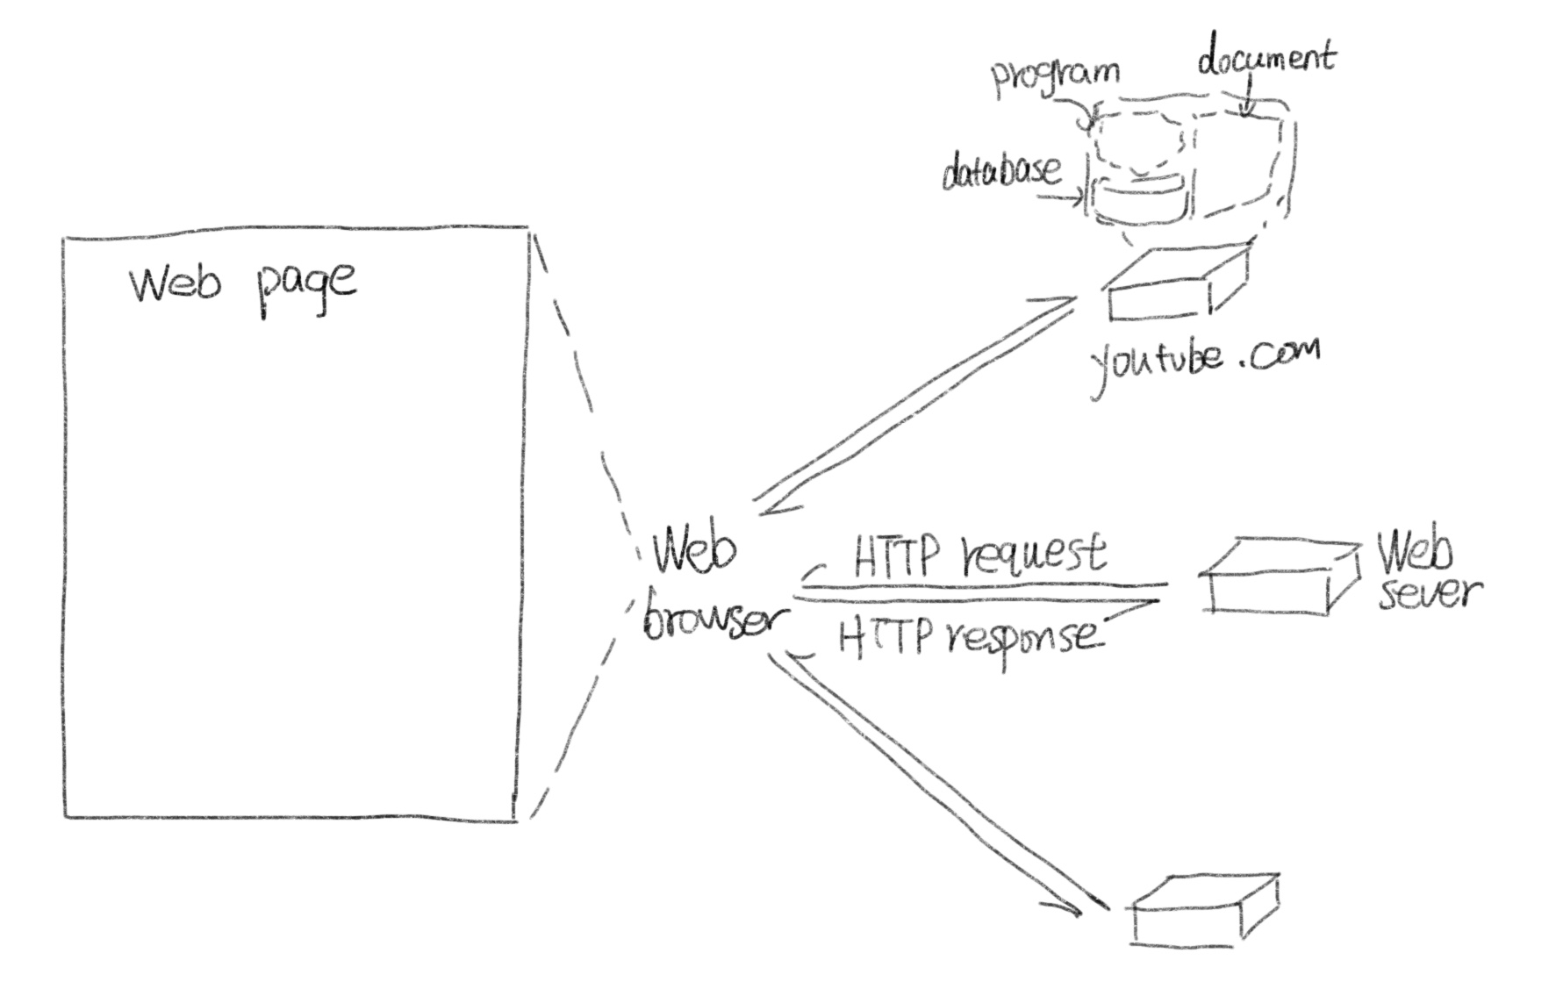
- The standard http URL assumes that the Web server is listening on port 80. However it is possible for a Web server to listen to some other ports. Devise a reasonable syntax for a URL accessing a file on a nonstandard port.
- Suppose you are using a computer in the CUC's campus network and want to visit a host machine which has a domain name of www.lenovo.com, please describe the possible DNS query process.
Answer: When client requests the query, the first on the local computer's cache lookup if unable to get the query information locally, it will query requests sent to the DNS server .
First of all, the client will request sent to the local DNS server domain name query, when the local DNS server received after the search, the first in the server management is recorded in the area of the search, if found the record, the use of the record for parsing; If there is no area information can satisfy the query request, the server in the local cache lookup
If the local server cannot find the client queries on the local information, the client request is sent to the DNS server 4 root root domain name server is responsible for parsing the client requests to the root of the domain, it will contain the next level domain DNS server information
- When a user clicks on a hyperlink of a Web page, the browser carries out a series steps in order to fetch the page pointed to. Suppose that a user is browsing the Web and finds a link which is http://www.eecs.mit.edu/. Please give a brief introduction of the steps that occur when this link is selected.
Answer: The browser determines the URL(by seeing what was selected).
The browser asks the DNS for the IP address of the server www.eecs.mit.edu.
DNS replies with IP address
The browser makes a TCP connection to IP address on port 80, the well-known port for the HTTP protocol.
It sends over an HTTP request asking for the page.
The www.eecs.mit.edu sever sends the page as an HTTP response.
If the page includes URLs that are needed for display, the browser fetches the other URLs using the same process.
The browser displays the page.
The TCP connections are released if there are no other requests to the same servers for a short period.

- What is Cookie? How does it work? Can you find cookies that are stored on your computer?
Answer: Cookie, a mechanism invented by Netscape to track users. When a client requests a WEB page, the server provides additional information in addition to the requested page, such as a cookie (a small file or string). If the user does not disable the cookie, the browser stores the cookie received in the cookie directory on the client's hard disk. Before the browser sends a page request to a Web site, check its cookie directory to determine if the target domain of the request has placed a cookie on the client, and if so, all of the domain's cookies are included in the request message, and the server gets them and can interpret them in the way it expects.
- Suppose a bank wants to make on-line banking easy for its lazy customers, so after a customer signs up and is authenticated by a password, the bank returns a cookie containing a customer ID number. In this way, the customer does not have to identify himself or type a password on future visits to the online bank. What do you think of this idea? Will it work? Is it a good idea?
Answer: Technically, it works, but it's a bad idea. All a customer has to do is modify the cookie to access someone else's bank account. It is safe for cookies to provide a customer's id number, but the customer must enter a password to prove his or her identity.
- HTTP 1.1 supports persistent connections, explain how it works compared with that is in HTTP 1.0.
Answer: HTTP1.0 early in the Web, the connection is established after the browser sends a request, only after a response message is sent back, and then a TCP connection is released the HTTP to establish a TCP connection, on the first line on it sends a request and receive a response, and then send the additional requests and get extra response through the establishment of a TCP connection to start and released to the multiple requests, relative to each request TCP cost is greatly reduced
- What is the major difference between HTTP methods of GET and POST?
Answer: Data uploaded by GET is added to the URL, so the uploaded data is completely exposed and has security risks, especially some sensitive information. But what the POST method submits to the server doesn't show up in clear text in the URL and isn't visible to the user, so it's more secure. Due to the limitation on the length of URL, the amount of data that can be uploaded is very small, generally around 1024Byte. However, POST transfers data through HTTP requests, and the amount of data transmitted is larger, which is not restricted by default.
- Notes for Submission
- Accepted submission file type: Microsoft Word or Acrobat PDF.
- The file name of your submission must be a combination of your Student ID, hw# (where # is the assignment number), your name and submission date. e.g., your name is ZhangSan, student ID is 201616013092, you are submitting your 1st homework on date 2016/03/07, the file name must be: 201616013092-hw1-ZhangSan-20160307.doc

