**实验四 宏指令及子程序设计实验**

**1. 实验目的**

1.熟悉宏指令、宏定义、宏调用以及宏展开的概念;掌握宏指令的定义与调用的方法。

2.掌握子程序的定义、调用以及调用程序与子程序之间参数的传递方法。

3.了解宏指令与子程序的异同以及各自的适用场合。

**2.实验内容**

**2.1题目一**

**1.实验内容**

从键盘输入10个无符号十进制数(小于256)，将其转换为二进制数并存放在NUM字节型变量中，找出其中的最大数，并在屏幕上显示出来。

1. **流程图**

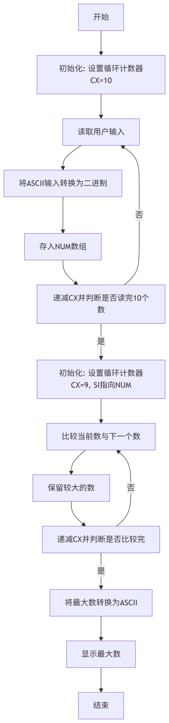

**3.程序代码**

|  |
| --- |
| XML  COUNT EQU 10 DATA SEGMENT  NUM DB 10 DUP(?)  IBUF DB 7,0,6 DUP(?)  OBUF DB 6 DUP(?)  INFOR1 DB "Please input 10 numbers:",0AH,0DH,'$'  INFOR2 DB "The max found in the 10 numbers is $"  INFOR3 DB 0AH,0DH,'$' DATA ENDS  STACK SEGMENT stack  DATA2 DW 40 DUP(?)  TOP EQU LENGTH DATA2 STACK ENDS  CODE SEGMENT  ASSUME CS:CODE, DS:DATA, SS:STACK  START:  MOV AX, DATA  MOV DS, AX  MOV AX, STACK  MOV SS, AX  MOV AX, TOP  MOV SP, AX  DSTRING MACRO STRING  PUSH DX  PUSH AX  MOV DX, OFFSET STRING  MOV AH, 09H  INT 21H  POP AX  POP DX ENDM   DSTRING INFOR1  MOV BX, OFFSET NUM  MOV CX, COUNT  LOOP1: CALL DTOB  DSTRING INFOR3  MOV [BX], AL  INC BX  LOOP LOOP1   MOV AX, OFFSET NUM  PUSH AX  MOV CX, COUNT  PUSH CX  CALL FMAX   DSTRING INFOR2  CALL BTOAD  MOV AH, 4CH  INT 21H  DTOB PROC  PUSH CX  PUSH DX  PUSH SI   MOV DX, OFFSET IBUF  MOV AH, 0AH  INT 21H   MOV CL, IBUF+1  MOV CH, 0  MOV SI, OFFSET IBUF+2  MOV AX, 0  AGAIN:  MOV DX, 10  MUL DX  AND BYTE PTR [SI], 0FH  ADD AL, [SI]  ADC AH, 0  INC SI  LOOP AGAIN   POP SI  POP DX  POP CX  RET DTOB ENDP  FMAX PROC  PUSH CX  PUSH SI   MOV AL, NUM  MOV SI, OFFSET NUM  MOV CX, 9  LOOP2:  INC SI  CMP AL, [SI]  JAE LOOP3  XCHG AL, [SI]  LOOP3:  DEC CX  JNZ LOOP2   MOV AH, 0  POP SI  POP CX  RET FMAX ENDP  BTOAD PROC  PUSH BX  PUSH CX  PUSH DX   MOV BX, OFFSET OBUF+5  MOV BYTE PTR [BX], '$'  MOV CX, 10  LOOP4:  MOV DX, 0  DIV CX  ADD DL, 30H  DEC BX  MOV [BX], DL  XOR AX, 0  JNZ LOOP4   MOV DX, BX  MOV AH, 09H  INT 21H   POP BX  POP CX  POP DX  RET BTOAD ENDP  CODE ENDS END START |

**2.2题目二**

**1.实验内容**

计算1+2+3+…+N。要求N由键盘输入;给出必要的提示信息(由宏调用实现);累加功能由子程序调用实现;二进制数(累加和)转换为十进制数并显示由子程序调用实现。

**2.流程图**

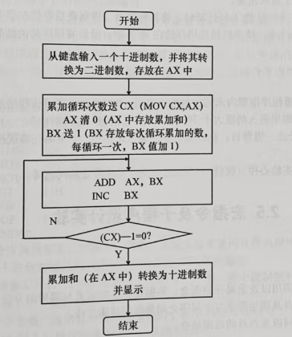

**3.程序代码**

|  |
| --- |
| XML  STACK SEGMENT STACK  DB 100 DUP(?) STACK ENDS  DATA SEGMENT  INF1 DB "Please input a number N(1-361): $"  IBUF DB 7,0,6 DUP(?)  OBUF DB 6 DUP(?)  INF2 DB 0AH,0DH,"$" DATA ENDS  CODE SEGMENT  ASSUME CS:CODE,DS:DATA  START:  MOV AX,DATA  MOV DS,AX  DSTRING MACRO STRING  PUSH DX  PUSH AX  MOV DX,OFFSET STRING  MOV AH,09H  INT 21H  POP AX  POP DX ENDM   DSTRING INF1  CALL DTOB  CALL ADDN  CALL BTOAD  MOV AH,4CH  INT 21H  DTOB PROC NEAR  PUSH CX  MOV DX,OFFSET IBUF  MOV AH,0AH  INT 21H  MOV CL,IBUF+1  MOV CH,0  MOV SI,OFFSET IBUF+2  MOV AX,0  AGAIN:  MOV DX,10  MUL DX  AND BYTE PTR [SI],0FH  ADD AL,[SI]  ADC AH,0  INC SI  LOOP AGAIN   POP CX  RET DTOB ENDP  ADDN PROC NEAR  MOV CX,AX  XOR AX,AX  MOV BX,01H  LOOP5:  ADD AX,BX  INC BX  LOOP LOOP5  RET ADDN ENDP  BTOAD PROC NEAR  MOV BX,OFFSET OBUF+5  MOV BYTE PTR [BX],'$'  MOV CX,10  LOOP4:  MOV DX,0  DIV CX  ADD DL,30H  DEC BX  MOV [BX],DL  XOR AX,0  JNZ LOOP4   MOV DX,OFFSET INF2  MOV AH,09H  INT 21H   MOV DX,BX  MOV AH,09H  INT 21H  RET BTOAD ENDP  CODE ENDS END START |

**3.实验结果**

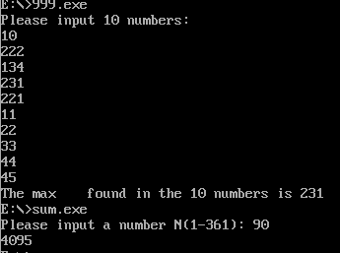

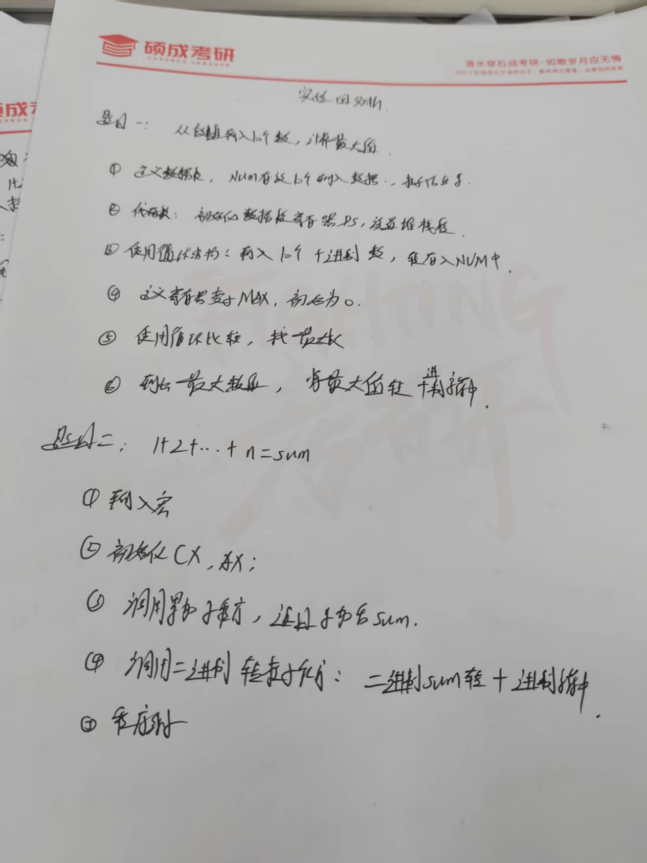

**4.实验总结**

