Instructions:

1). View Demo and instructions (Follow instructions in video)

2) Download submissionforGITZip.zip
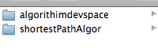
- Unzip the file. There will be 2 folders

shortestPathAlgor -> This contains the Xamarin project.
-> Open it in Visual Studio 2017 Build and Run the Android project.

algorithimdevspace -> This contains the shortest path algorithm and also the NUnit tests.
-> Open in Visual Studio 2017.
-> If NUNIT tests don’t run, install nuget package for NUNIT and NUNIT3.Adapter

