Homework 2

Qinghua He

qh2297

Q1.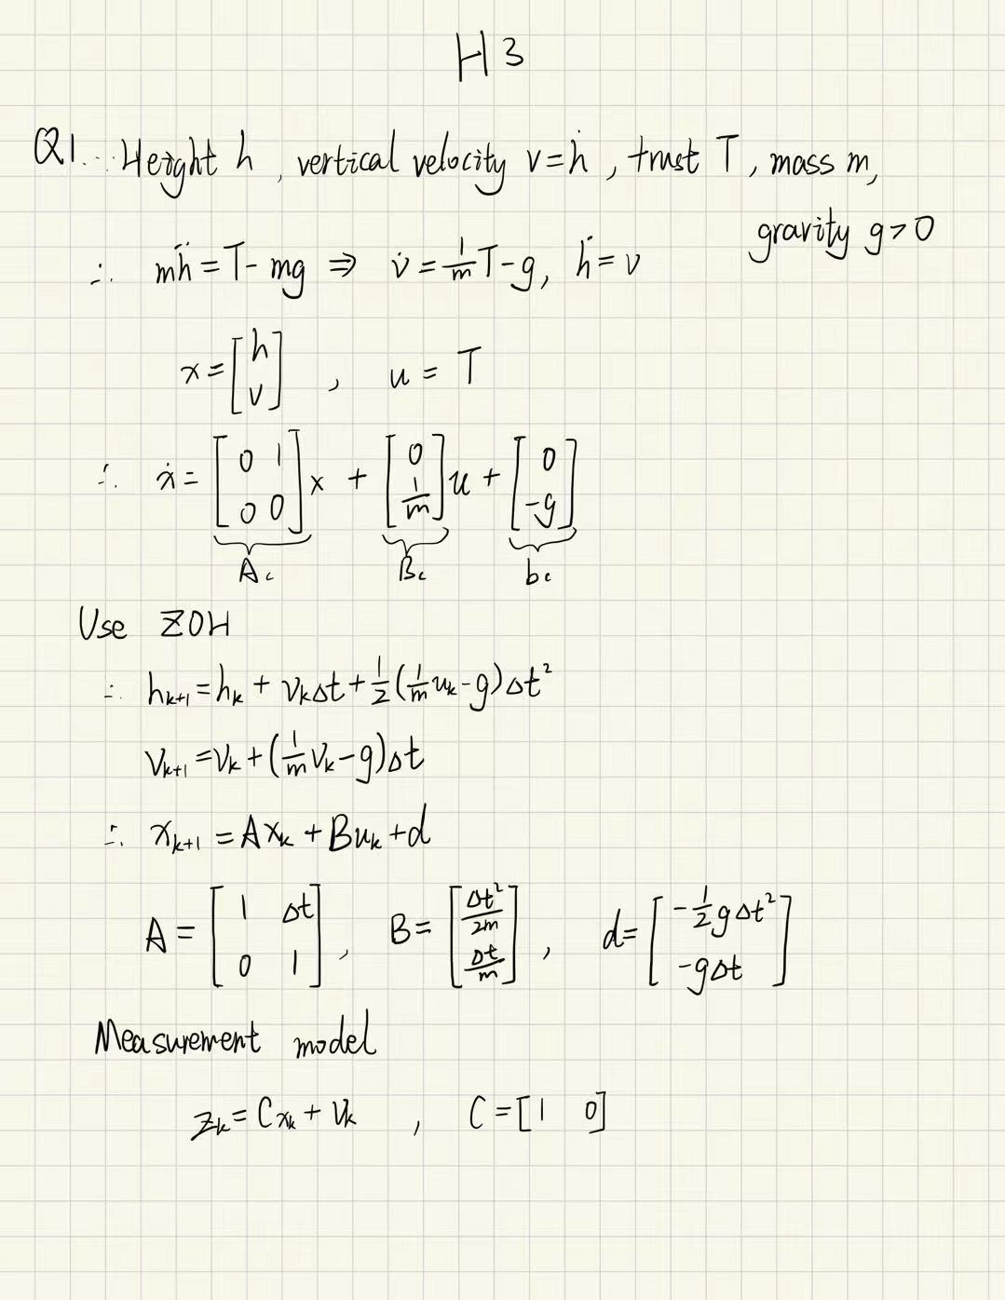

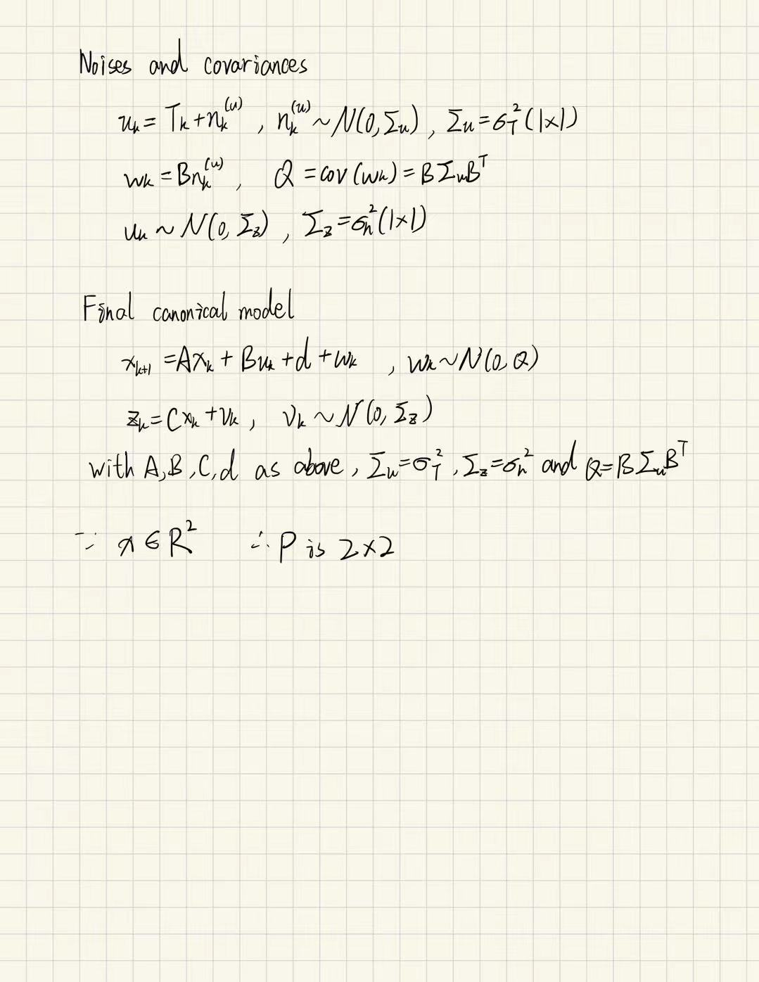

Q2.

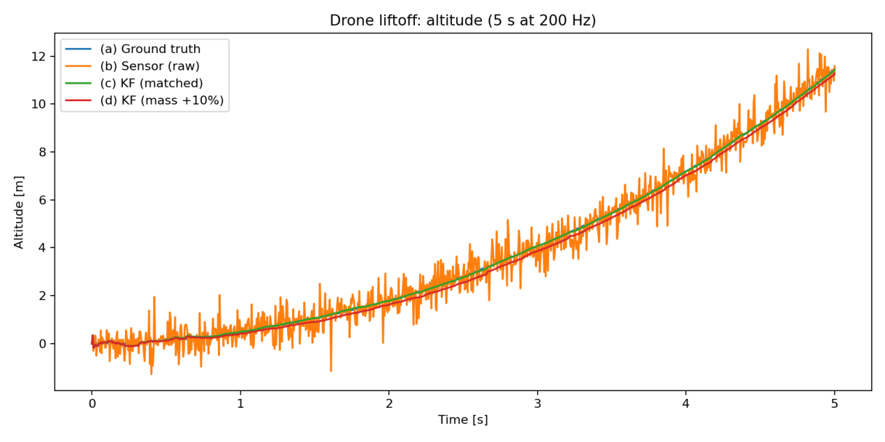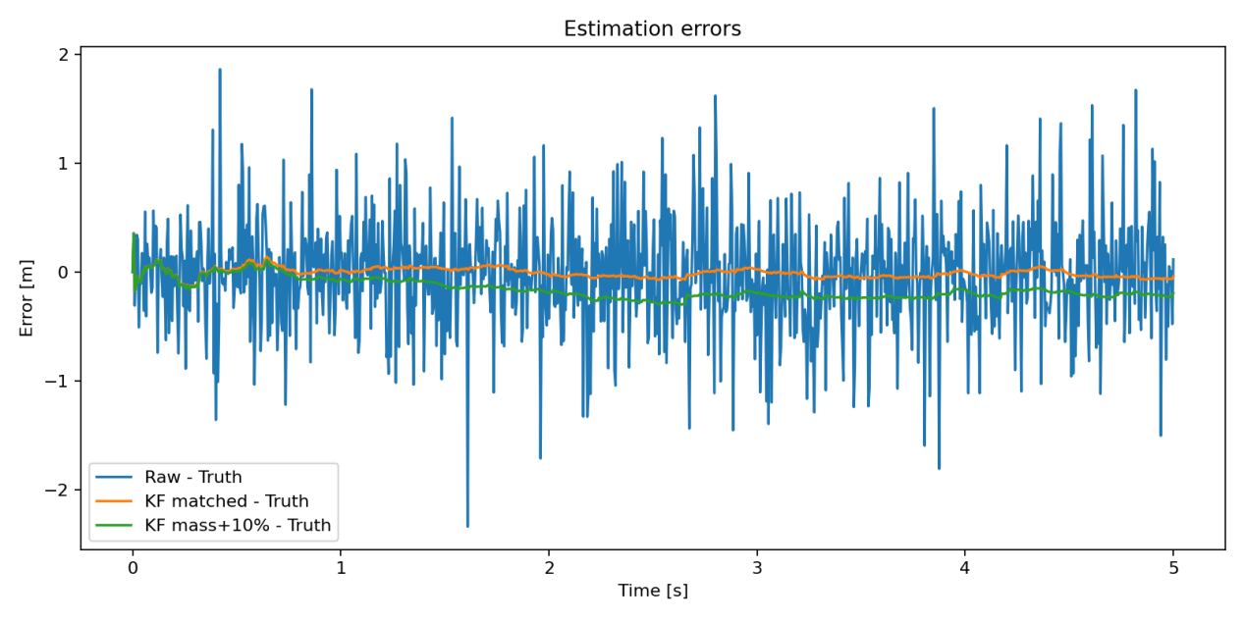

If the filter assumes the drone is heavier than it really is (mass +10%), it will think the thrust causes less acceleration. This makes the predicted altitude lower than the real one, so the filter output stays a bit below the true altitude. The sensor updates help reduce the error, but cannot fully remove it, especially when the sensor noise is large.

**Answer:** A wrong mass value causes the Kalman filter to underestimate altitude and produce a small bias, but the result is still smoother and more accurate than using the raw sensor data.