HANOI UNIVERSITY OF SCIENCE AND TECHNOLOGY

School of Information and Communications Technology

Software Requirement Specification

Version 1.1

An Internet Media Store

Capstone Project

Subject: Software Design and Construction

Function : Manage Media

Group 21

Hoang Duc Thanh 20204689

# **.Data Modeling**

## ***Er Diagram***

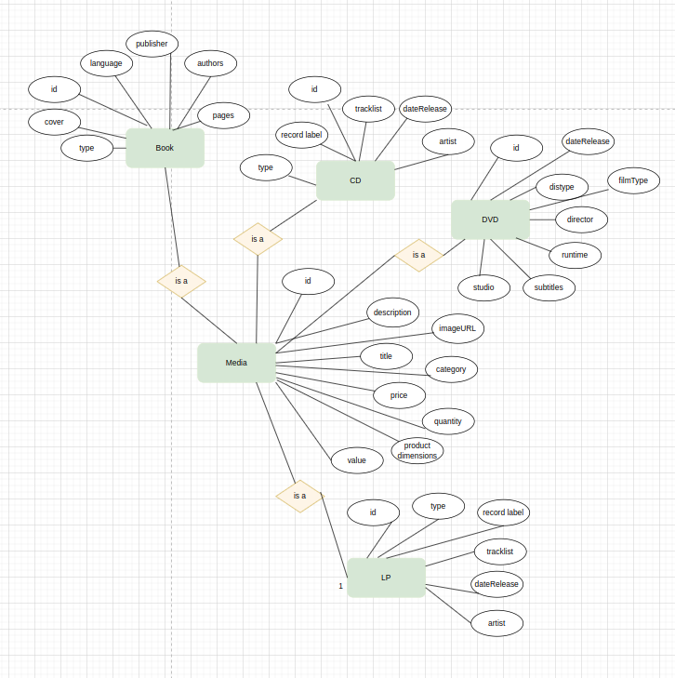

## ***Database Design***

### Logical Data Model

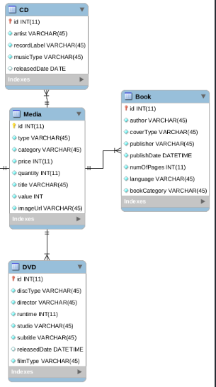

### Physical Data Model

#### **Media**

| **#** | **PK** | **FK** | **Column Name** | **Data type** | **Mandatory** | **Description** |
| --- | --- | --- | --- | --- | --- | --- |
|  | x |  | id | int | yes | ID, auto increment |
|  |  |  | title | Varchar(45) | yes | Product's name |
|  |  |  | category | Varchar(45) | yes | Media type, eg., cd, DVD |
|  |  |  | value | int | yes | Value of the product |
|  |  |  | price | int | yes | Current price |
|  |  |  | quantity | int | yes | Number of products |
|  |  |  | productDimensions | Varchar(45) | yes | horizontal, length, width dimensions |
|  |  |  | description | Varchar(45) | yes | Product description |
|  |  |  | imageURL | Varchar(45) | yes | Product image path |
|  |  |  | createAt | timestamp | yes | The time the product is added to the system |
|  |  |  | updateAt | timestamp | no | The time the product is updated to the system |

#### **CD**

| **#** | **PK** | **FK** | **Column Name** | **Data type** | **Mandatory** | **Description** |
| --- | --- | --- | --- | --- | --- | --- |
|  |  | x | id | int | yes | ID, same as ID of Media of which type is CD |
|  |  |  | type | Varchar(45) | yes | Music genres |
|  |  |  | artist | Varchar(45) | yes | Artist's name |
|  |  |  | dateRelease | datetime | No | Release date |
|  |  |  | recordLabel | Varchar(45) | yes | Record label |

#### **Book**

| **#** | **PK** | **FK** | **Column Name** | **Data type** | **Mandatory** | **Description** |
| --- | --- | --- | --- | --- | --- | --- |
|  |  | x | id | int | yes | ID, same as ID of Media of which type is Book |
|  |  |  | authors | Varchar(45) | yes | Authors of the book |
|  |  |  | publisher | Varchar(45) | yes | Publishing house |
|  |  |  | language | Varchar(45) | yes | Language |
|  |  |  | type | Varchar(45) | yes | Cover type |
|  |  |  | cover | Varchar(45) | yes | Book cover |
|  |  |  | page | int | yes | Page number |
|  |  |  | publishDate | datetime | yes | Date of publishing |

#### **dvd**

| **#** | **PK** | **FK** | **Column Name** | **Data type** | **Mandatory** | **Description** |
| --- | --- | --- | --- | --- | --- | --- |
|  |  | x | id | int | yes | ID, same as ID of Media of which type is DVD |
|  |  |  | discType | VARCHAR(45) | yes | Disc type |
|  |  |  | director | VARCHAR(45) | Yes | Director |
|  |  |  | runtime | int | Yes | Duration |
|  |  |  | subtitles | VARCHAR(45) | Yes | Subtitles |
|  |  |  | studio | VARCHAR(45) | yes | Manufacturer |
|  |  |  | releaseDate | Datetime | Yes | Release date |
|  |  |  | filmType | VARCHAR(45) | yes | Genres |

### SQL

| BEGIN TRANSACTION; |  |  |
| --- | --- | --- |
|  |  | CREATE TABLE IF NOT EXISTS "Book" ( |
|  |  | "id" INTEGER NOT NULL, |
|  |  | "author" VARCHAR(45) NOT NULL, |
|  |  | "coverType" VARCHAR(45) NOT NULL, |
|  |  | "publisher" VARCHAR(45) NOT NULL, |
|  |  | "publishDate" DATETIME NOT NULL, |
|  |  | "numOfPages" INTEGER NOT NULL, |
|  |  | "language" VARCHAR(45) NOT NULL, |
|  |  | "bookCategory" VARCHAR(45) NOT NULL, |
|  |  | PRIMARY KEY("id" AUTOINCREMENT), |
|  |  | CONSTRAINT "fk_book_media" FOREIGN KEY("id") REFERENCES "Media"("id") |
|  |  | ); |
|  |  | CREATE TABLE IF NOT EXISTS "CD" ( |
|  |  | "id" INTEGER NOT NULL, |
|  |  | "artist" VARCHAR(45) NOT NULL, |
|  |  | "recordLabel" VARCHAR(45) NOT NULL, |
|  |  | "musicType" VARCHAR(45) NOT NULL, |
|  |  | "releasedDate" DATE, |
|  |  | PRIMARY KEY("id"), |
|  |  | CONSTRAINT "fk_cd_media" FOREIGN KEY("id") REFERENCES "Media"("id") |
|  |  | ); |
|  |  | CREATE TABLE IF NOT EXISTS "Card" ( |
|  |  | "id" INTEGER NOT NULL, |
|  |  | "cardNumber" VARCHAR(45) NOT NULL, |
|  |  | "holderName" VARCHAR(45) NOT NULL, |
|  |  | "expirationDate" DATE NOT NULL, |
|  |  | "securityCode" VARCHAR(45) NOT NULL, |
|  |  | "userID" INTEGER NOT NULL, |
|  |  | PRIMARY KEY("id"), |
|  |  | CONSTRAINT "fk_card_user" FOREIGN KEY("userID") REFERENCES "User"("id") |
|  |  | ); |
|  |  | CREATE TABLE IF NOT EXISTS "DVD" ( |
|  |  | "id" INTEGER NOT NULL, |
|  |  | "discType" VARCHAR(45) NOT NULL, |
|  |  | "director" VARCHAR(45) NOT NULL, |
|  |  | "runtime" INTEGER NOT NULL, |
|  |  | "studio" VARCHAR(45) NOT NULL, |
|  |  | "subtitle" VARCHAR(45) NOT NULL, |
|  |  | "releasedDate" DATETIME, |
|  |  | "filmType" VARCHAR(45) NOT NULL, |
|  |  | PRIMARY KEY("id"), |
|  |  | CONSTRAINT "fk_dvd_media" FOREIGN KEY("id") REFERENCES "Media"("id") |
|  |  | ); |
|  |  | CREATE TABLE IF NOT EXISTS "Media" ( |
|  |  | "id" INTEGER NOT NULL, |
|  |  | "type" VARCHAR(45) NOT NULL, |
|  |  | "category" VARCHAR(45) NOT NULL, |
|  |  | "price" INTEGER NOT NULL, |
|  |  | "quantity" INTEGER NOT NULL, |
|  |  | "title" VARCHAR(45) NOT NULL, |
|  |  | "value" INTEGER NOT NULL, |
|  |  | "imageUrl" VARCHAR(45) NOT NULL, |
|  |  | PRIMARY KEY("id" AUTOINCREMENT) |
|  |  | ); |
|  |  | CREATE TABLE IF NOT EXISTS "Order" ( |
|  |  | "id" INTEGER NOT NULL, |
|  |  | "email" VARCHAR(45) NOT NULL, |
|  |  | "address" VARCHAR(45) NOT NULL, |
|  |  | "phone" VARCHAR(45) NOT NULL, |
|  |  | "userID" INTEGER NOT NULL, |
|  |  | "shipping_fee" INTEGER NOT NULL, |
|  |  | PRIMARY KEY("id" AUTOINCREMENT), |
|  |  | CONSTRAINT "fk_order_user" FOREIGN KEY("userID") REFERENCES "User"("id") |
|  |  | ); |
|  |  | CREATE TABLE IF NOT EXISTS "OrderMedia" ( |
|  |  | "mediaID" INTEGER NOT NULL, |
|  |  | "orderID" INTEGER NOT NULL, |
|  |  | "price" INTEGER NOT NULL, |
|  |  | "quantity" INTEGER NOT NULL, |
|  |  | PRIMARY KEY("mediaID","orderID"), |
|  |  | CONSTRAINT "fk_ordermedia_media" FOREIGN KEY("mediaID") REFERENCES "Media"("id"), |
|  |  | CONSTRAINT "fk_ordermedia_order" FOREIGN KEY("orderID") REFERENCES "Order"("id") |
|  |  | ); |
|  |  | CREATE TABLE IF NOT EXISTS "Transaction" ( |
|  |  | "id" INTEGER NOT NULL, |
|  |  | "orderID" INTEGER NOT NULL, |
|  |  | "createAt" DATETIME NOT NULL, |
|  |  | "content" VARCHAR(45) NOT NULL, |
|  |  | PRIMARY KEY("id" AUTOINCREMENT), |
|  |  | CONSTRAINT "fk_transaction_order" FOREIGN KEY("orderID") REFERENCES "Order"("id") |
|  |  | ); |
|  |  | CREATE TABLE IF NOT EXISTS "User" ( |
|  |  | "id" INTEGER NOT NULL, |
|  |  | "name" VARCHAR(45) NOT NULL, |
|  |  | "email" VARCHAR(45) NOT NULL, |
|  |  | "address" VARCHAR(45) NOT NULL, |
|  |  | "phone" VARCHAR(45) NOT NULL, |
|  |  | PRIMARY KEY("id" AUTOINCREMENT) |
|  |  | ); |
|  |  | CREATE INDEX IF NOT EXISTS "Card.fk_card_user_idx" ON "Card" ( |
|  |  | "userID" |
|  |  | ); |
|  |  | CREATE INDEX IF NOT EXISTS "Order.fk_order_user_idx" ON "Order" ( |
|  |  | "userID" |
|  |  | ); |
|  |  | CREATE INDEX IF NOT EXISTS "OrderMedia.fk_ordermedia_order_idx" ON "OrderMedia" ( |
|  |  | "orderID" |
|  |  | ); |
|  |  | CREATE INDEX IF NOT EXISTS "Transaction.fk_transaction_order_idx" ON "Transaction" ( |
|  |  | "orderID" |
|  |  | ); |
|  |  | COMMIT; |