HANOI UNIVERSITY OF SCIENCE AND TECHNOLOGY

School of Information and Communications Technology

Software Requirement Specification

Version 1.1

An Internet Media Store

Capstone Project

Subject: Software Design and Construction

Function : Manage Media

Group 21

Hoang Duc Thanh 20204689

*Hanoi, <month, year>*

**Table of contents**

**1 Introduction 3**

1.1 Objective 3

1.2 Scope 3

1.3 Glossary 4

1.4 References 4

**2 Overall requirements 5**

2.1 Actors 5

2.2 General use case diagram 5

2.3 Business processes 6

2.4.1.Add Media Activity 6

2.4.2.View Media Activity 7

2.4.3.Update Media Activity 8

2.4.4.Delete Media Activity 9

**3 Detail requirements 10**

3.1 Specification of Use case UC001 - “View Media” 10

3.2 Specification of Use case UC002 - “Add Media” 11

3.3 Specification of Use case UC003 - “Update Media.” 13

3.4. Specification of Use case UC004 - “Delete Media” 15

**4 Sequence Diagram 17**

**5. Class Diagram 21**

1. General Class Diagram 21

2. Detail Class Diagram 22

1. Add Media 22

2. Delete Media 23

3. Update Media 24

4. View Media 25

3. Analysis Class Diagram 26

1. Add Media 26

2. Delete Media 27

3. Update Media 28

4. View Media 29

**6. .Data Modeling 30**

1. Er Diagram 30

2. Database Design 31

1. Logical Data Model 31

2. Physical Data Model 31

● Media 31

● CD 32

● Book 32

● dvd 33

**7. Interface 34**

1. GUI 34

● Screen View Media 34

● Screen Add Media 35

● Delete Media 36

● Update Media 37

**8. Good Design 39**

**9. Supplementary specification 40**

9.1. Functionality 40

9.2. Usability 40

9.3. Reliability 40

9.4. Performance 40

9.5. Maintainability 40

# Introduction

## Objective

Create an Internet Media Store (AIMS) that specializes in e-commerce for the buying and selling of media products. Specifically, the project focuses on the features related to ordering and payment of customer orders within the AIMS system

This document is for stakeholders and related software developers.

## Scope

The AIMS (An Internet Media Store) project is an e-commerce platform aimed at providing a convenient and flexible media shopping experience for users. This system is expected to operate continuously 24/7, with the capability to serve up to 1000 concurrent users without a significant loss in performance. The project's goal is to create an online shopping environment where users can browse and complete their orders easily.

In this project, administrators have the authority to manage products, including adding, updating, and deleting them. However, they can only add or update one product at a time and are restricted in the number of products they can delete to ensure security. For each product, administrators need to provide information such as title, product category (e.g., books, CDs, DVDs), value, and current price.

The AIMS project provides a website that allows users to browse and search for products based on criteria such as price, genre, and author. After selecting products, users can add them to their shopping cart and proceed to checkout. The system calculates shipping fees based on product weight and delivery address, and users can make payments using prepaid credit cards.

Once an order is created, administrators can review and approve or reject it. Users also have the option to cancel orders after payment, with refunds processed to their credit cards. The simulation of this system does not require user account registration and provides virtual credit cards for transactions.

In summary, the AIMS project aims to deliver a user-friendly e-commerce platform for media products, allowing users to browse, shop, and complete orders efficiently, while administrators can manage products and orders effectively

## Glossary

## References

# Overall requirements

## Actors

The function has actor admin

## General use case diagram

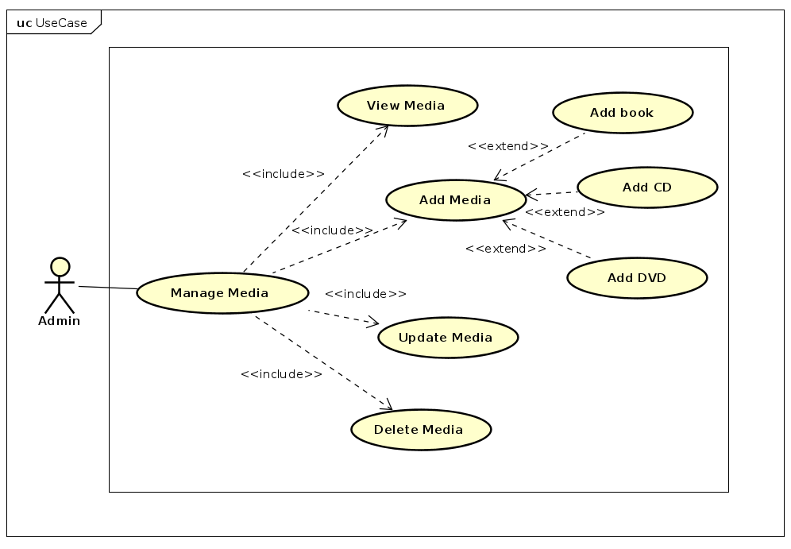

The administrator can manage media The use cases of the administrator in this overall use case diagram are complex use cases that consist of a group of sub-use cases. Details about these composite use cases are provided in the subsequent decomposition diagrams."

## Business processes

### 2.4.1.Add Media Activity

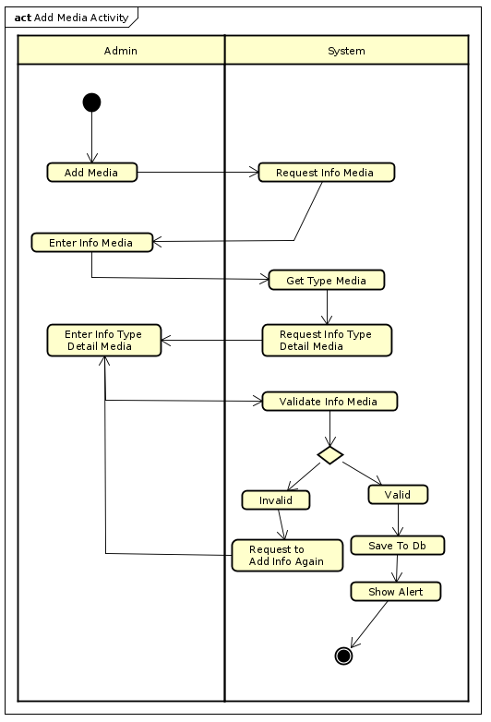

### 2.4.2.View Media Activity

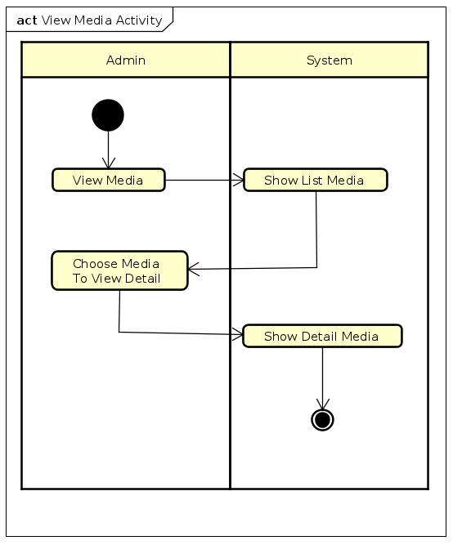

### 2.4.3.Update Media Activity

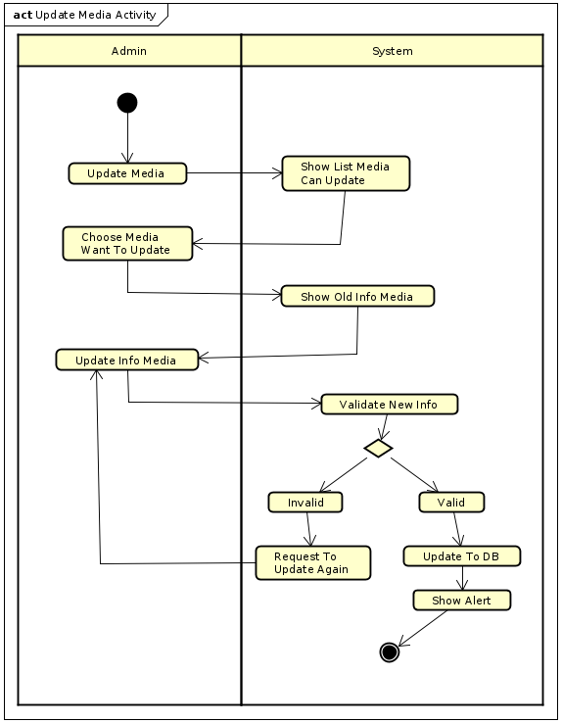

### 2.4.4.Delete Media Activity

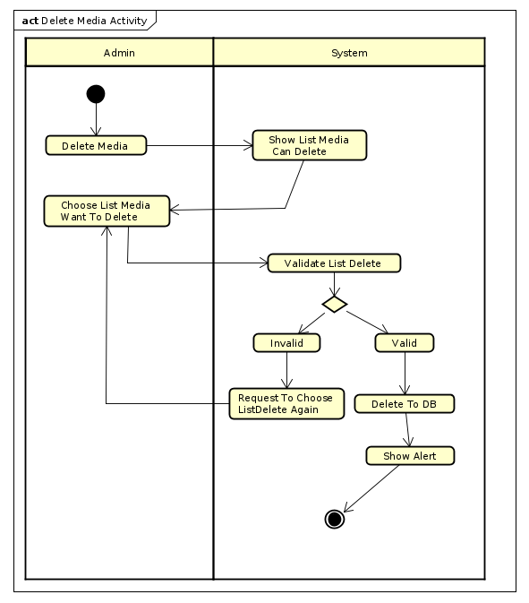

# Detail requirements

Details of the use cases given in the following sections are specified below.

## Specification of Use case UC001 - “View Media”

1. **Use case code**

UC001

1. **Brief Description**

This use case describes the interaction between admin and system when the admin wishes to View Media

1. **Actor**

Administrators

1. **Preconditions**
2. **Basic Flow of Events**
3. The actor select view Media

2. The software displays list of Media

3. The actor select to view detail Media

4. The software displays detail of Media

1. **Alternative flows**
2. **Input data**

**No**

1. **Output data**

**Table 1 output of Info Media**

| **No** | **Data fields** | **Description** | **Display format** | **Example** |
| --- | --- | --- | --- | --- |
|  | title | Name of Media | String | Book3 |
| 2. | category |  | String | Story |
| 3. | value | market value of the product | Int with currency unit 1000 VND | 32 |
| 4. | price | tax not included | Int with currency unit 1000 VND | 150.000VND |
| 5. | quantity | quantity of Media | Int | 13 |
| 6. | type | Type Of Media | String | Book |
| 7. | image | Image Of Media | jpg,png,.. |  |

1. **Postconditions**

## Specification of Use case UC002 - “Add Media”

1. **Use case code**

UC002

1. **Brief Description**

This use case describes the interaction between admin and system when the admin wishes to Add New Media

1. **Actors**

Admin

1. **Preconditions**
2. **Basic Flow of Events**

1.Admin select Add Media function

2.System display form to input Info Media

3.Admin Input Info Media

4.System get type and show type detail form

5.Admin Input type detail Info Media

6.System save Info Media to Db

1. **Alternative flows**

**Table 2 flows of events for UC Add Media**

| **No** | **Location** | **Condition** | **Action** | **Resume location** |
| --- | --- | --- | --- | --- |
| 1. | After step 3 | If Admin input invalid info | System Notify warning | Use case ends |
| 2. | Before step 6 | If Admin want cancel process | Revert data maybe save to database | Use case ends |

1. **Input data**

**Table 3 Input of Media**

| **No** | **Data fields** | **Description** | **Mandatory** | **Valid condition** | **Example** |
| --- | --- | --- | --- | --- | --- |
|  | Info Media | Info of Media | Yes | -Have all require Info  -price isn’t over 150% or less than 30% of value | -type:Book  -category:story  -price:32  -quantity:12  -title:Harry Potter  value:30  -image:Image |
| 2. | Info Book | Info of Book Media |  | -cover type is hardcover or paperback | -author:CircleRow  cover type:Hard Cover  -publisher:Kim Dong  -publish Date:14/11/2010  -nums of Page:130  -language:English -book category:comic |
| 3 | Info CD | Info of CD Media |  |  | -Artist:CircleRow  -Record Label:kingtop  -Music Type:Pop  -Released Date: 14/11/2020 |
| 4 | Info DVD | Info Of DVD Media |  |  | -Disc Type:Blu-ray  -Director:CircleRow -Runtime:2h -Studio:Subpile  -Subtitle:English  -Released Date:14/11/2002  -Film Type:Single Film |

1. **Output data**

**Table 4 Output of Add Media**

| **No** | **Data fields** | **Description** | **Display format** | **Example** |
| --- | --- | --- | --- | --- |
| 1. | Status | Status of result add Media | String | SUCCESS |

1. **Postconditions**

No

## 3.3 Specification of Use case UC003 - “Update Media.”

1. **Use case code.**

UC003

1. **Brief Description**

This use case describes the interaction between admin and system when the admin wishes to Add New Media

1. **Actors**

Admin

1. **Preconditions**
2. **Basic Flow of Events**

1. Admin request to update media product

2. The system displays list media product

3. The customer chooses media want to update

4. The system display old media info and access to update media

5. The customer add new info to update

6. The system validate and notify

1. **Alternative flows**

**Table 5 flows of events for UC Update Media**

| **No** | **Location** | **Condition** | **Action** | **Resume location** |
| --- | --- | --- | --- | --- |
| 1. | At Step 3 | If admin reach to limit media in day | System denied request | Use case ends |
| 2. | At Step 5 | New Info is Invalid | System notify to admin | Continue step 5 |

1. **Input data**

**Table 6 Input data of “Update Media”**

| **No** | **Data fields** | **Description** | **Mandatory** | **Valid condition** | **Example** |
| --- | --- | --- | --- | --- | --- |
|  | Info Media | Info of Media | Yes | -Have all require Info  -price isn’t over 150% or less than 30% of value | -type:Book  -category:story  -price:32  -quantity:12  -title:Harry Potter  value:30  -image:Image |
| 2. | Info Book | Info of Book Media |  | -cover type is hardcover or paperback | -author:CircleRow  cover type:Hard Cover  -publisher:Kim Dong  -publish Date:14/11/2010  -nums of Page:130  -language:English -book category:comic |
| 3 | Info CD | Info of CD Media |  |  | -Artist:CircleRow  -Record Label:kingtop  -Music Type:Pop  -Released Date: 14/11/2020 |
| 4 | Info DVD | Info Of DVD Media |  |  | -Disc Type:Blu-ray  -Director:CircleRow -Runtime:2h -Studio:Subpile  -Subtitle:English  -Released Date:14/11/2002  -Film Type:Single Film |

1. **Output data**

| **No** | **Data fields** | **Description** | **Display format** | **Example** |
| --- | --- | --- | --- | --- |
| 1. | Status | Status of result update Media | String | SUCCESS |

1. **Postconditions**

## 3.4. Specification of Use case UC004 - “Delete Media”

1. **Use case code**

UC004

1. **Brief Description**

The admin choose list media to delete

1. **Actors**

Admin

1. **Preconditions**
2. **Basic Flow of Events**

1. Admin request to delete media

2. The system shows list media can be delete

3. Admin choose list media to delete

4. The system delete media

1. **Alternative flows**

**Table N-Alternative flows of events for UC Place order**

| **No** | **Location** | **Condition** | **Action** | **Resume location** |
| --- | --- | --- | --- | --- |
| 1 | After step 3 | If quality of list delete media over limit of session or day | Warning to admin adjust list delete media | Resumes at Step 3 |

1. **Input data**

**Table 7 Input data of “Delete Media"**

| **No** | **Data fields** | **Description** | **Mandatory** | **Valid condition** | **Example** |
| --- | --- | --- | --- | --- | --- |
| 1 | List Media | List Media Need To delete | Yes | list size <=10 | [Media1,Media2] |

1. **Output data**

**Table 8 Output data of “Delete Media"**

| **No** | **Data fields** | **Description** | **Display format** | **Example** |
| --- | --- | --- | --- | --- |
| 1. | Status | Status of result update Media | String | SUCCESS |

1. **Postconditions**

# Sequence Diagram

1. Add media Sequence Diagram

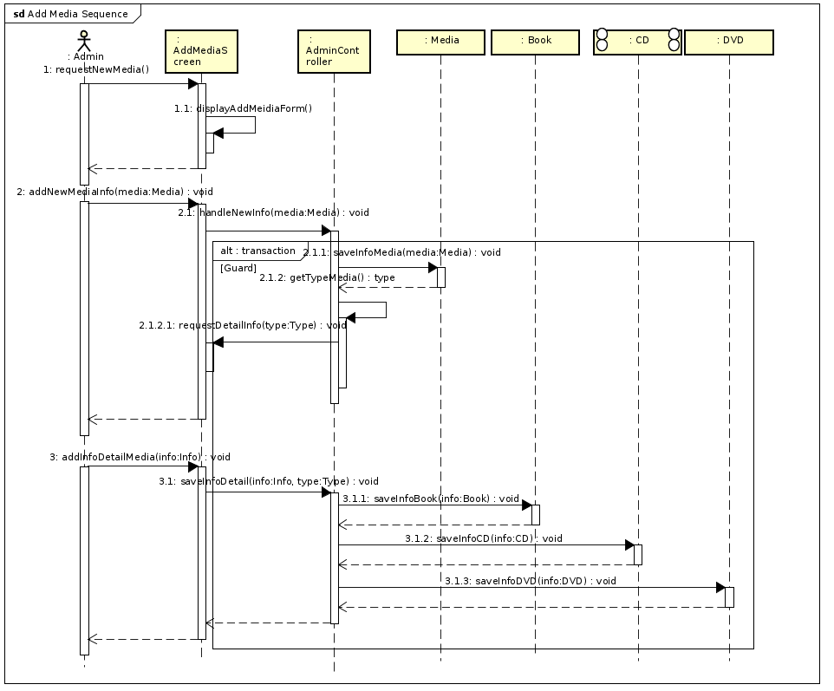

1. Delete Media Sequence Diagram

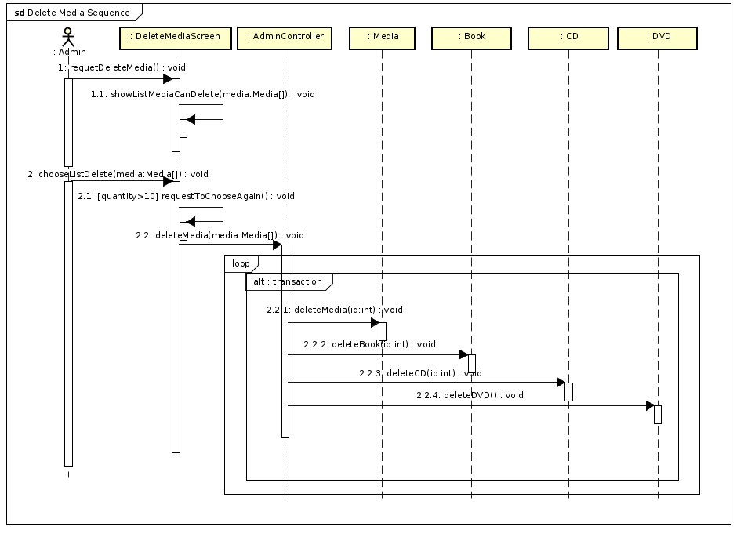

1. Update Media Sequence Diagram

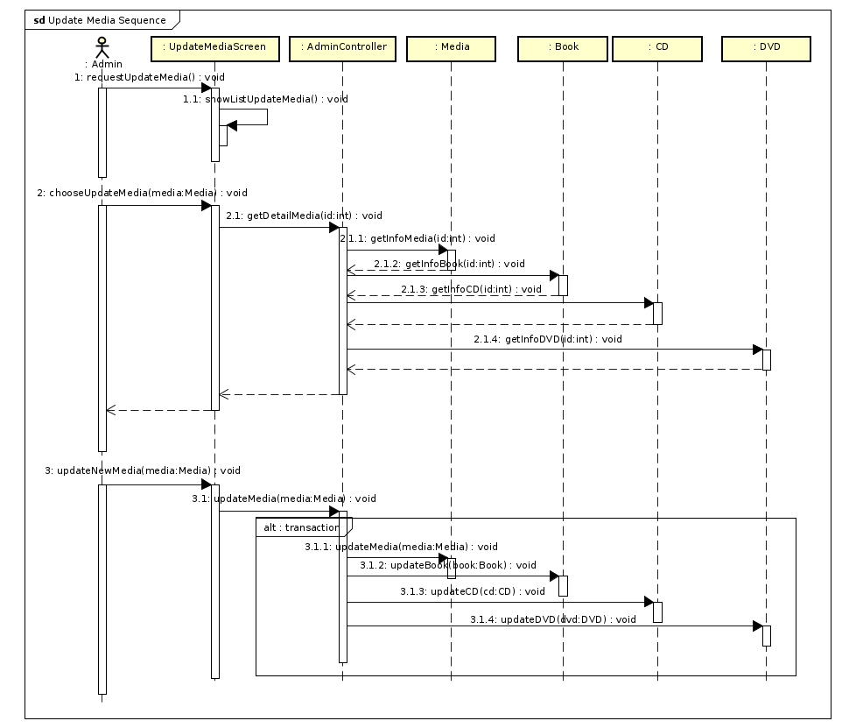

1. View Media Sequence Diagram

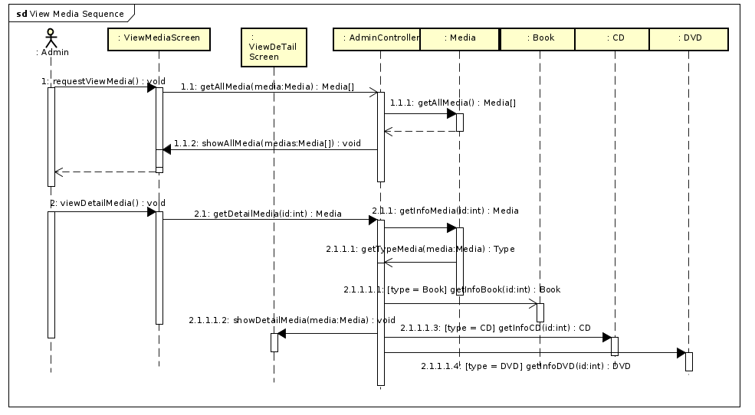

# Class Diagram

## General Class Diagram

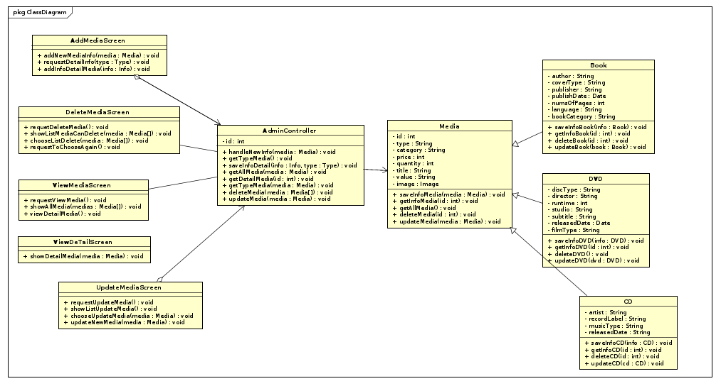

## Detail Class Diagram

### Add Media

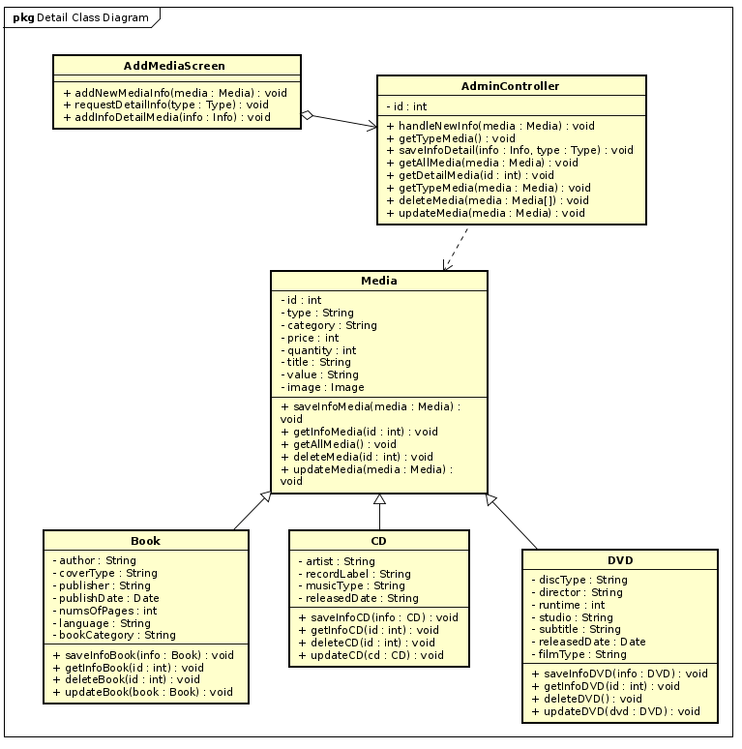

### Delete Media

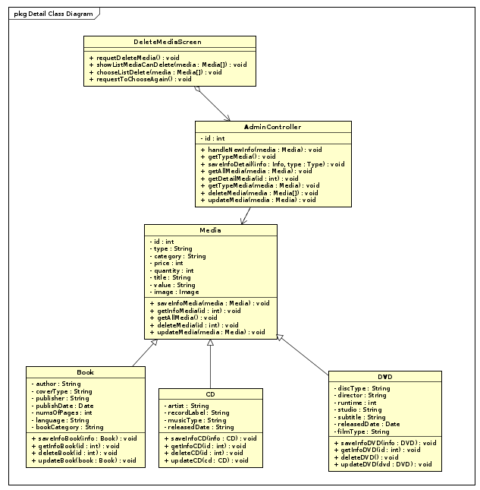

### Update Media

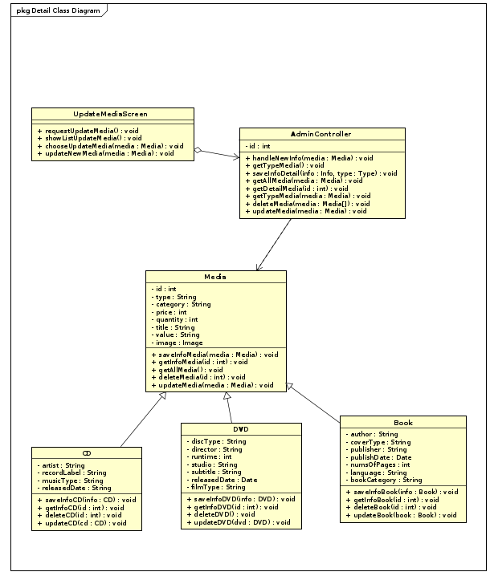

### View Media

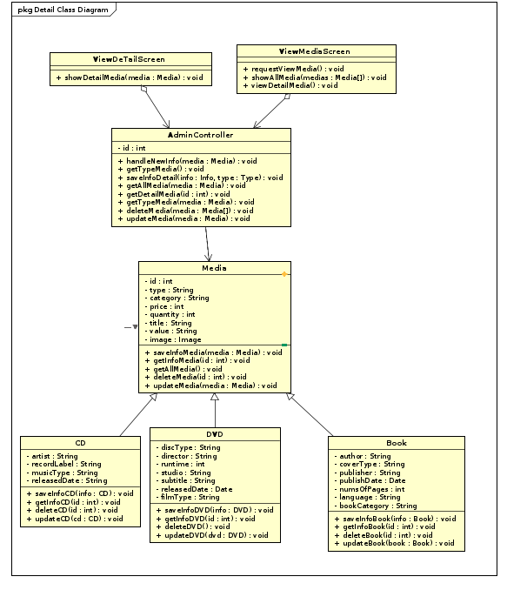

## Analysis Class Diagram

### Add Media

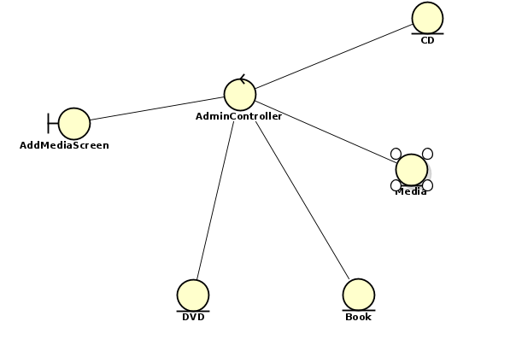

### Delete Media

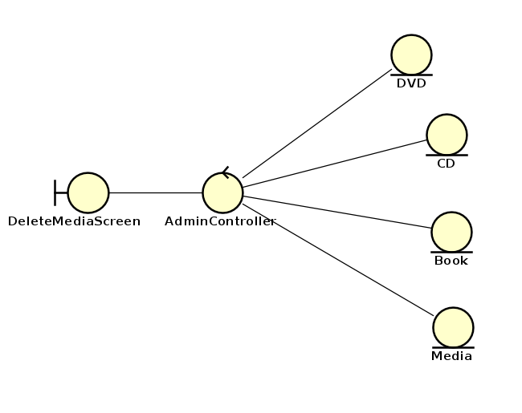

### Update Media

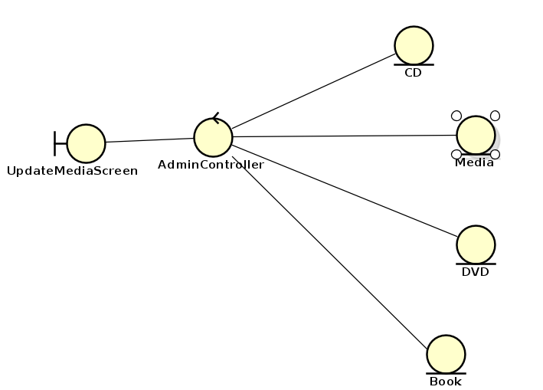

### View Media

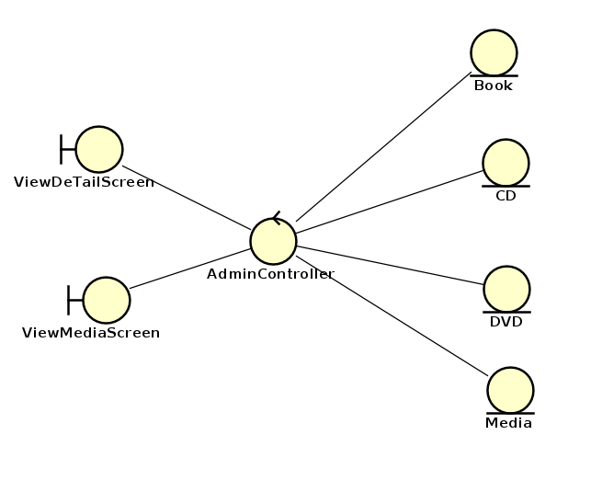

# .**Data Modeling**

## Er Diagram

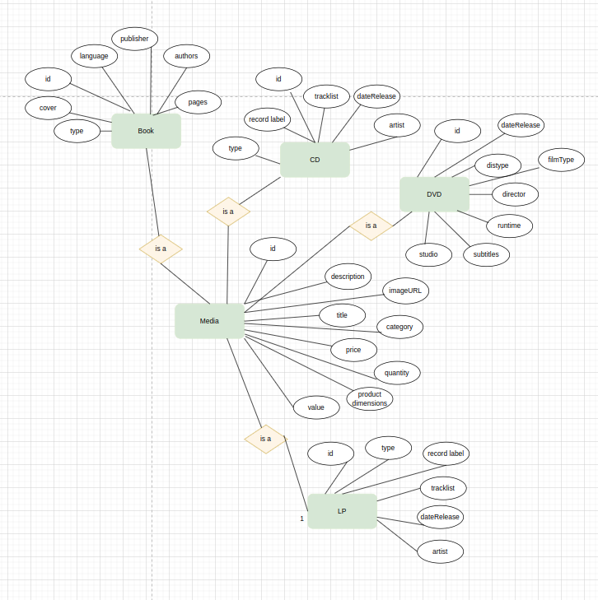

## Database Design

### Logical Data Model

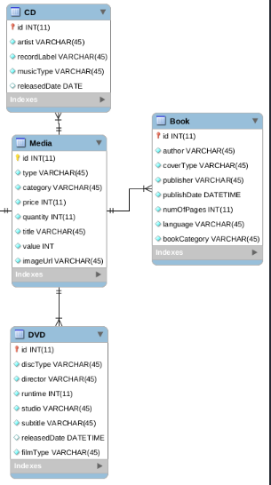

### Physical Data Model

#### Media

| **#** | **PK** | **FK** | **Column Name** | **Data type** | **Mandatory** | **Description** |
| --- | --- | --- | --- | --- | --- | --- |
|  | x |  | id | int | yes | ID, auto increment |
|  |  |  | title | Varchar(45) | yes | Product's name |
|  |  |  | category | Varchar(45) | yes | Media type, eg., cd, DVD |
|  |  |  | value | int | yes | Value of the product |
|  |  |  | price | int | yes | Current price |
|  |  |  | quantity | int | yes | Number of products |
|  |  |  | productDimensions | Varchar(45) | yes | horizontal, length, width dimensions |
|  |  |  | description | Varchar(45) | yes | Product description |
|  |  |  | imageURL | Varchar(45) | yes | Product image path |
|  |  |  | createAt | timestamp | yes | The time the product is added to the system |
|  |  |  | updateAt | timestamp | no | The time the product is updated to the system |

#### **CD**

| **#** | **PK** | **FK** | **Column Name** | **Data type** | **Mandatory** | **Description** |
| --- | --- | --- | --- | --- | --- | --- |
|  |  | x | id | int | yes | ID, same as ID of Media of which type is CD |
|  |  |  | type | Varchar(45) | yes | Music genres |
|  |  |  | artist | Varchar(45) | yes | Artist's name |
|  |  |  | dateRelease | datetime | No | Release date |
|  |  |  | recordLabel | Varchar(45) | yes | Record label |

#### **Book**

| **#** | **PK** | **FK** | **Column Name** | **Data type** | **Mandatory** | **Description** |
| --- | --- | --- | --- | --- | --- | --- |
|  |  | x | id | int | yes | ID, same as ID of Media of which type is Book |
|  |  |  | authors | Varchar(45) | yes | Authors of the book |
|  |  |  | publisher | Varchar(45) | yes | Publishing house |
|  |  |  | language | Varchar(45) | yes | Language |
|  |  |  | type | Varchar(45) | yes | Cover type |
|  |  |  | cover | Varchar(45) | yes | Book cover |
|  |  |  | page | int | yes | Page number |
|  |  |  | publishDate | datetime | yes | Date of publishing |

#### **dvd**

| **#** | **PK** | **FK** | **Column Name** | **Data type** | **Mandatory** | **Description** |
| --- | --- | --- | --- | --- | --- | --- |
|  |  | x | id | int | yes | ID, same as ID of Media of which type is DVD |
|  |  |  | discType | VARCHAR(45) | yes | Disc type |
|  |  |  | director | VARCHAR(45) | Yes | Director |
|  |  |  | runtime | int | Yes | Duration |
|  |  |  | subtitles | VARCHAR(45) | Yes | Subtitles |
|  |  |  | studio | VARCHAR(45) | yes | Manufacturer |
|  |  |  | releaseDate | Datetime | Yes | Release date |
|  |  |  | filmType | VARCHAR(45) | yes | Genres |

# Interface

## GUI

### Screen View Media

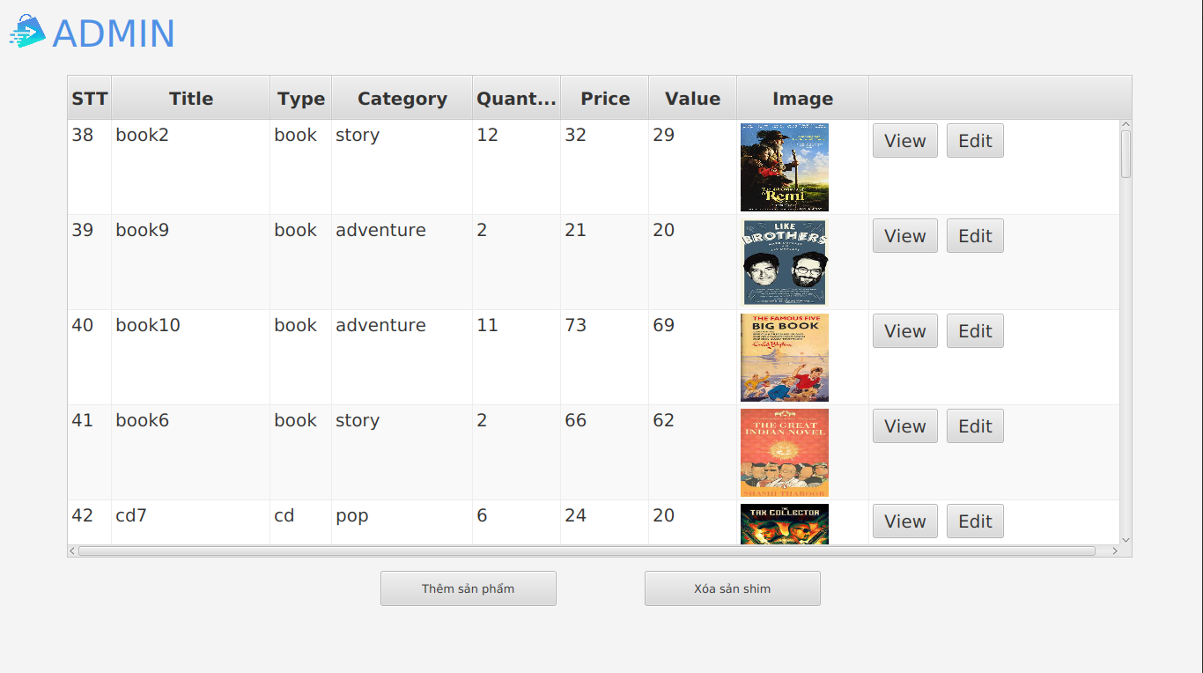

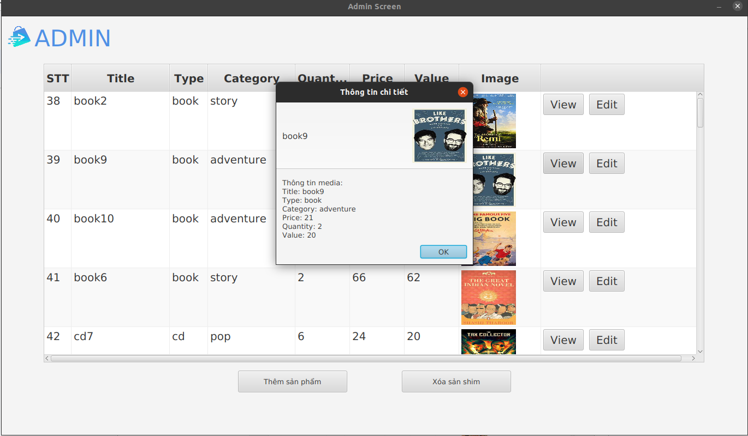

### Screen Add Media

### Delete Media

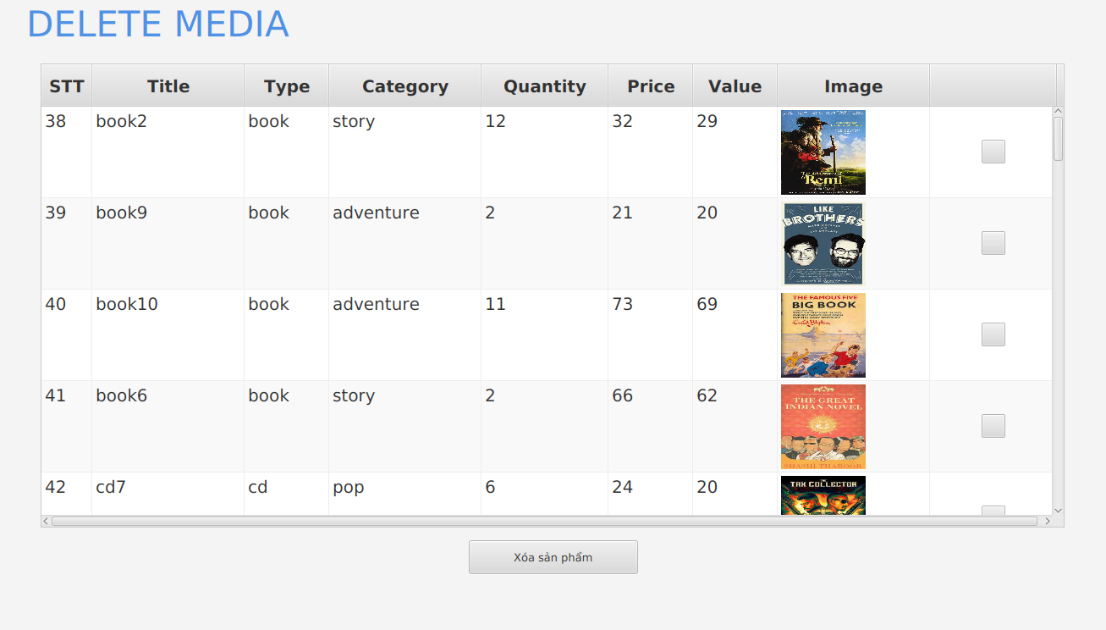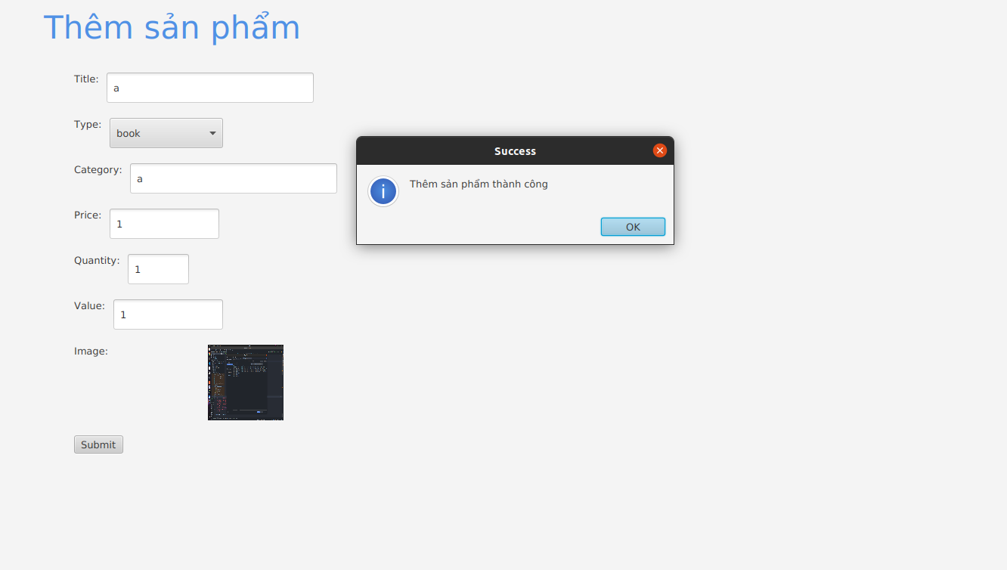

### Update Media

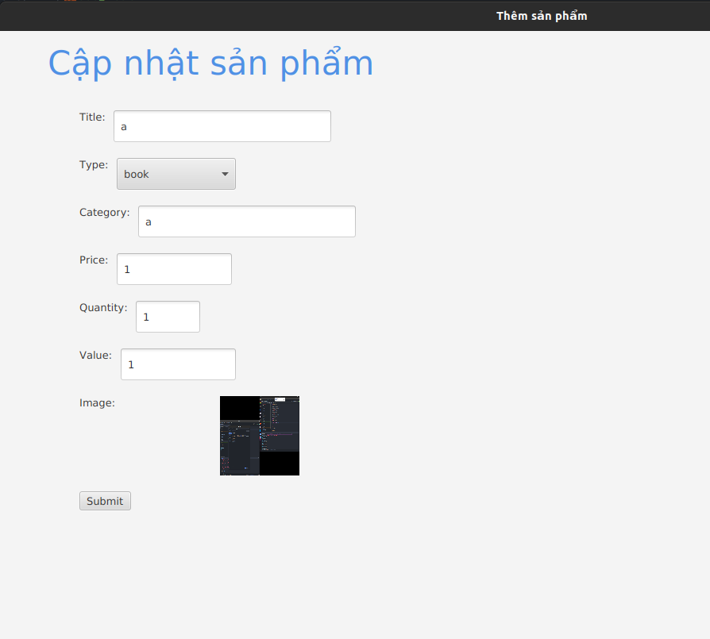

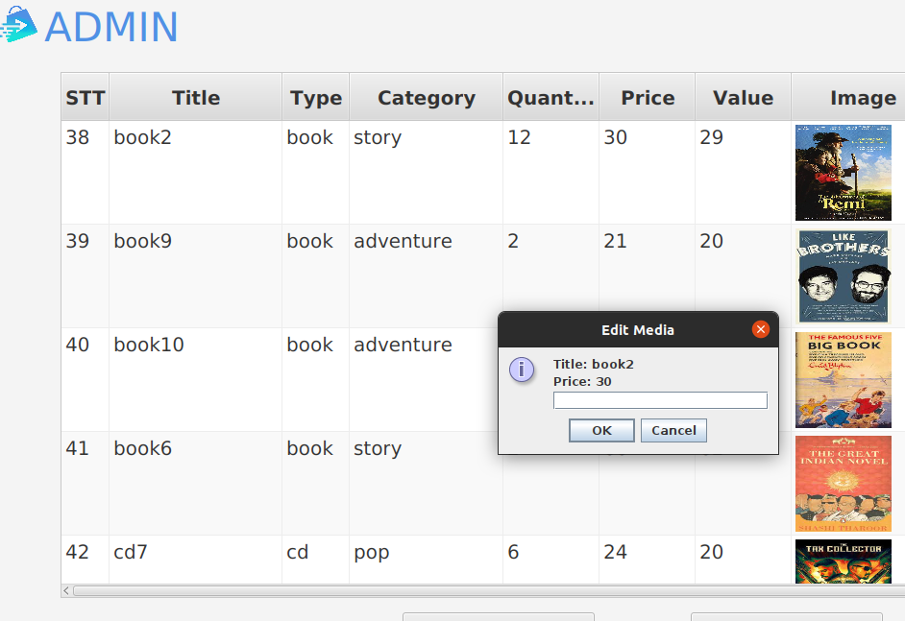

# Good Design

-Use singleton in checklimit delete and update in a day

# Supplementary specification

## Functionality

-In all event sequences of the use cases, if there are any errors during database connection or operations, there should be corresponding error notifications to inform the actors that the errors are related to the database, not user-related errors.

-Common display formatting is as follows:

+Right-aligned

+Left-justified text

+Font: Arial 14, black color

+White background

## Usability

The functions need to be designed for ease of use. There should be specific error instructions for users to identify errors, understand what the errors are, and know how to correct them.

## Reliability

This system should be able to serve 1000 customers simultaneously without a significant loss in performance and operate continuously for 300 hours without any failures. Additionally, the system should be able to recover to normal operation within 1 hour after encountering an error.

## Performance

The AIMS Project is a multi-platform system that operates 24/7.The maximum response time of the system is 2 seconds under normal conditions or 3 seconds during peak loads.

## Maintainability

Easily to update new function and product and user data