HANOI UNIVERSITY OF SCIENCE AND TECHNOLOGY

School of Information and Communications Technology

Software Requirement Specification

Version 1.1

An Internet Media Store

Capstone Project

Subject: Software Design and Construction

Function : Manage Media

Group 21

Hoang Duc Thanh 20204689

# **Sequence Diagram**

## Add media Sequence Diagram

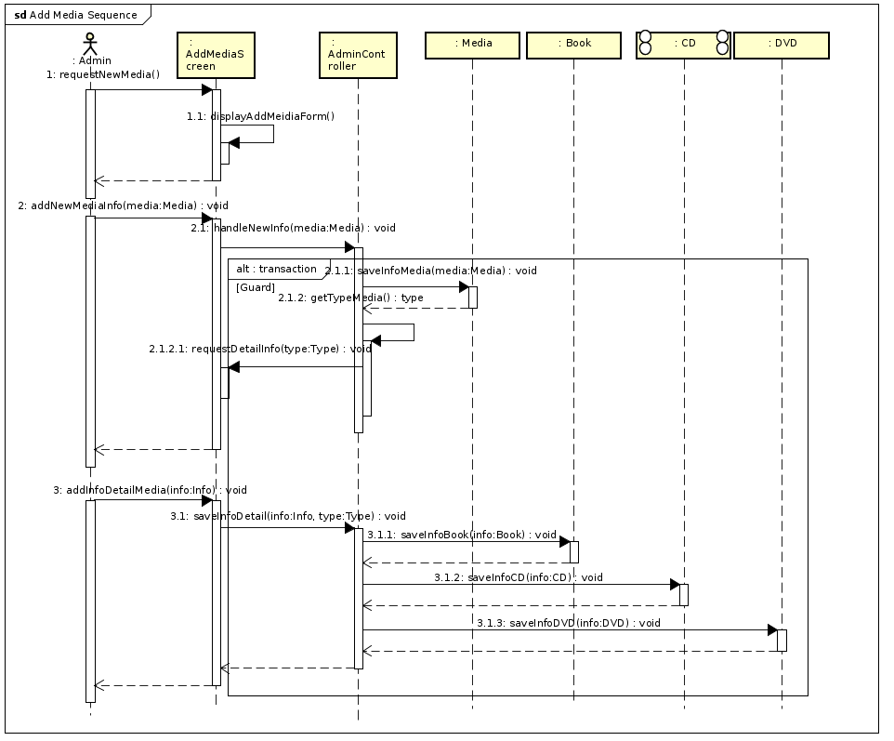

## Delete Media Sequence Diagram

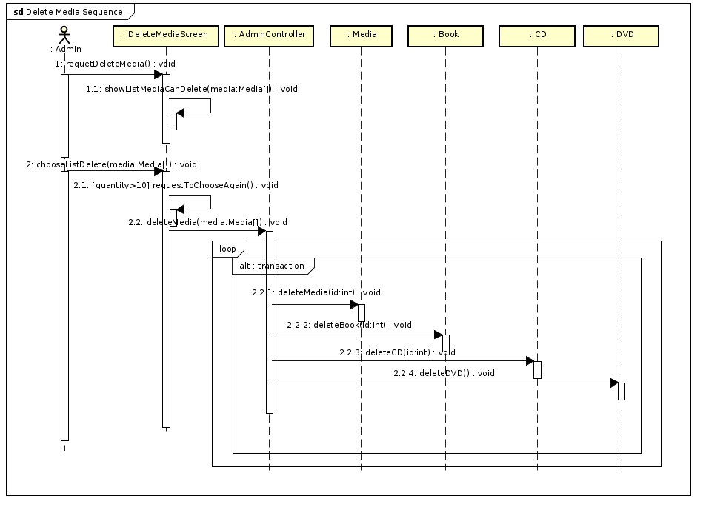

## Update Media Sequence Diagram

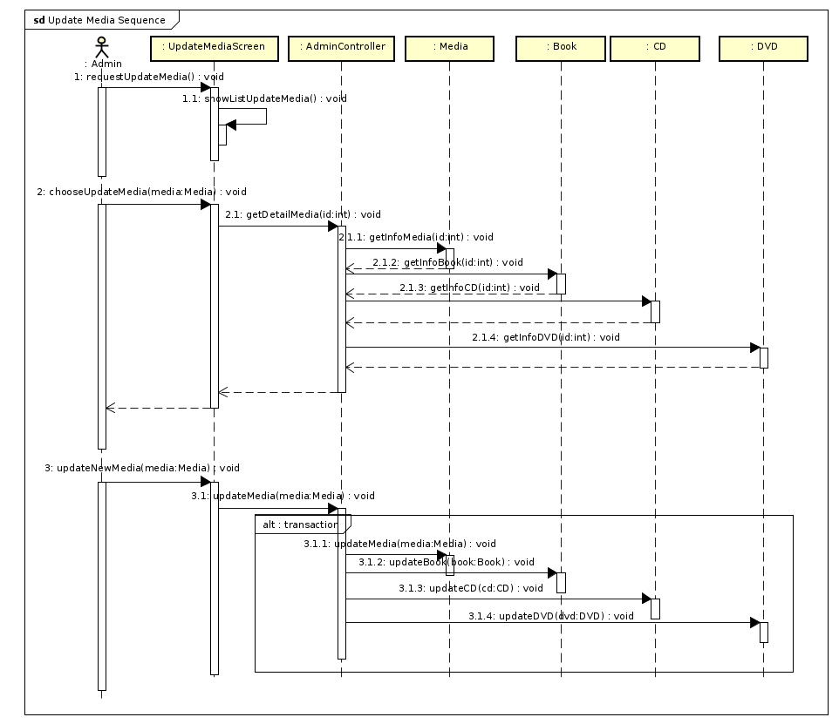

## View Media Sequence Diagram

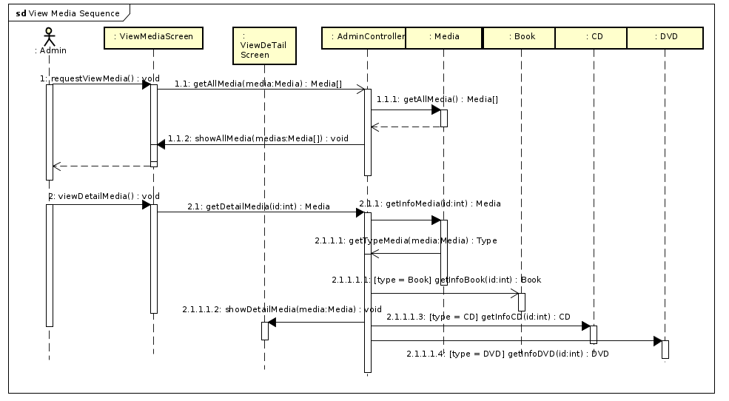

# Class Diagram

## ***General Class Diagram***

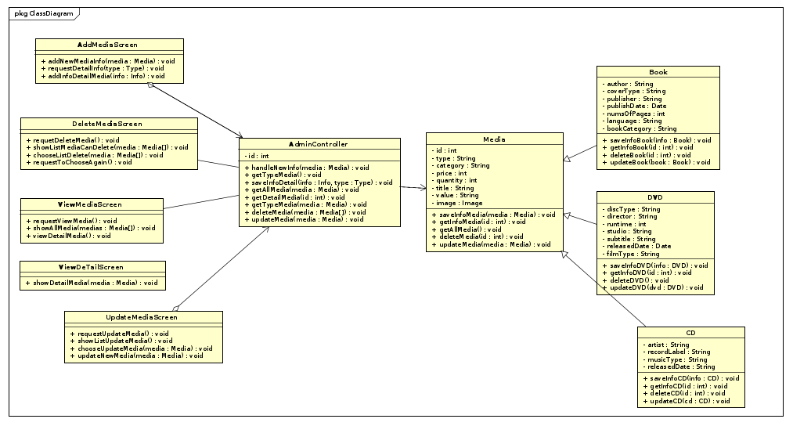

## ***Detail Class Diagram***

### Add Media

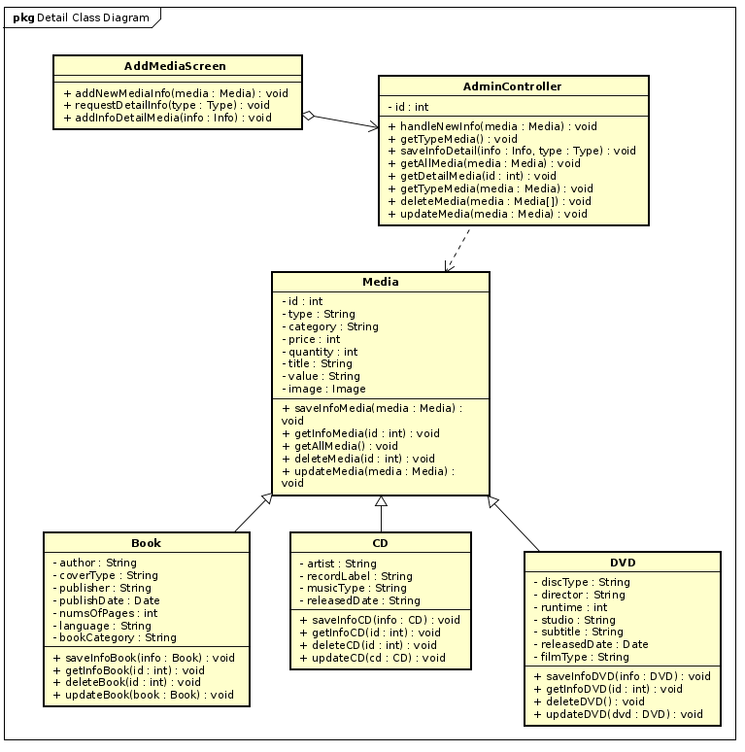

### Delete Media

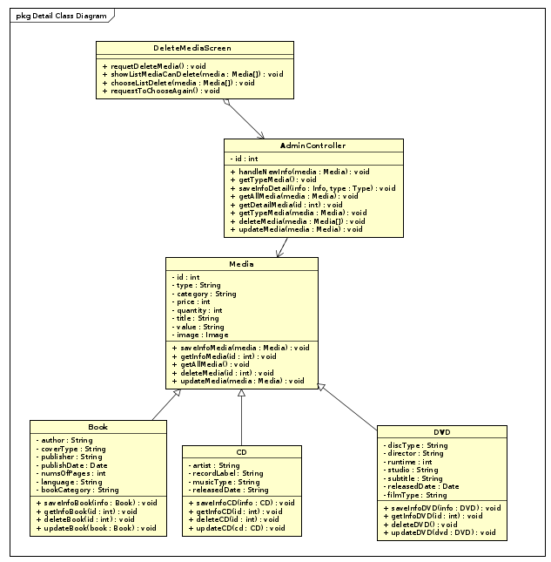

### Update Media

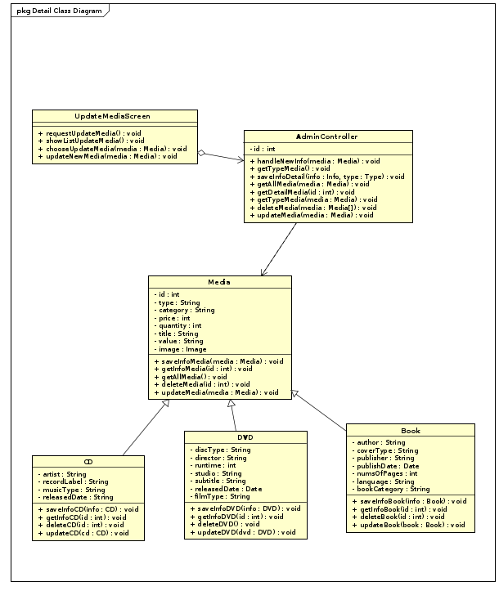

### View Media

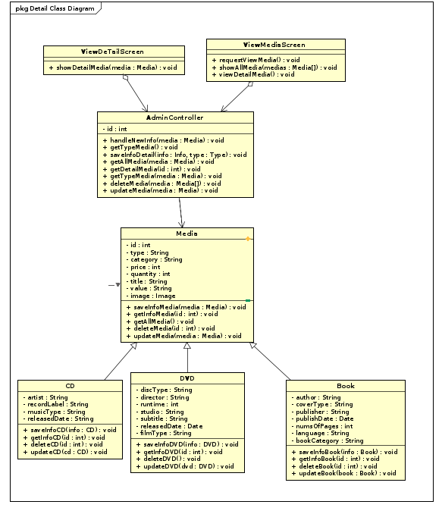

## ***Analysis Class Diagram***

### Add Media

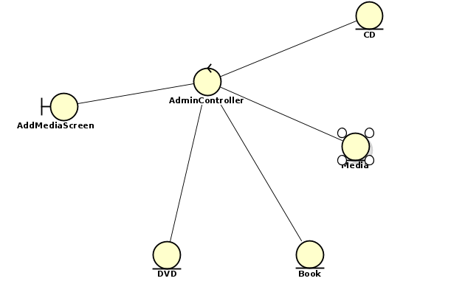

### Delete Media

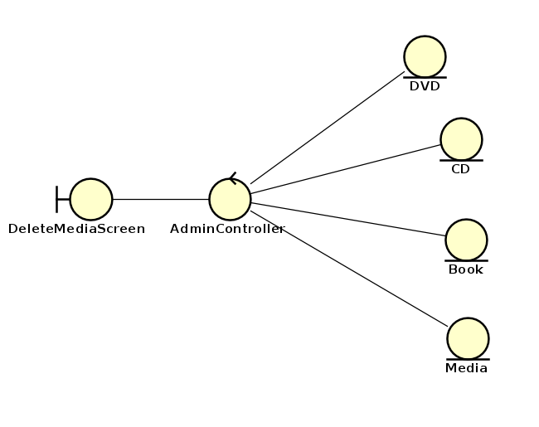

### Update Media

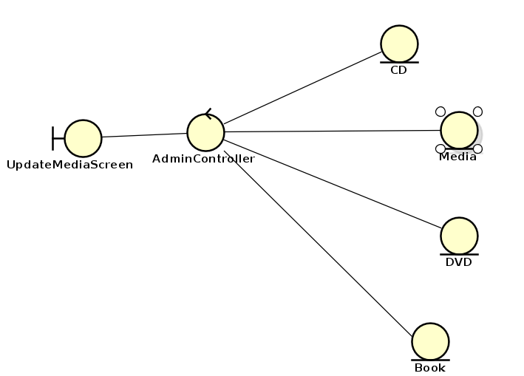

### View Media

