HANOI UNIVERSITY OF SCIENCE AND TECHNOLOGY

School of Information and Communications Technology

Software Design Document

Version 1.1

AIMS: An Internet Media Store

Software Design and Construction

Group 21

Mai Văn Tiến 20194183

*Hanoi,* *1/2024*

Table of contents

Table of contents 1

1. Use Case Analysis 2

1.1. Use Case “Refund” 2

***1.1.1.*** ***Sequence Diagram for UC “Refund”*** 2

***1.1.2.*** ***Analysis Class Diagram for UC “Refund”*** 2

1.2. Use Case “Search Products” 3

***1.2.1.*** ***Sequence Diagram for UC “Search Products”*** 3

***1.2.2.*** ***Analysis Class Diagram for UC "Search Products”*** 3

1.3. Use Case “Filter Products” 4

***1.3.1.*** ***Sequence Diagram for UC “Filter Products”*** 4

***1.3.2.*** ***Analysis Class Diagram for UC "Filter Products”*** 5

1.4. Use Case “Detail Products” 5

***1.4.1.*** ***Sequence Diagram for UC “Detail Products”*** 5

***1.4.2.*** ***Analysis Class Diagram for UC "Detail Products”*** 5

2. Class Design 8

2.1. General Class Diagram 8

2.2. Relationship Class Diagram 9

2.3. Class Design 9

2.3.1. HomeScreenHandler 9

# Use Case Analysis

## Use Case “Refund”

### ***Sequence Diagram for UC “Refund”***

### ***Analysis Class Diagram for UC “Refund”***

## Use Case “Search Products”

### ***Sequence Diagram for UC “Search Products”***

### ***Analysis Class Diagram for UC "Search Products”***

## Use Case “Detail Products”

### ***Sequence Diagram for UC “Detail Products”***

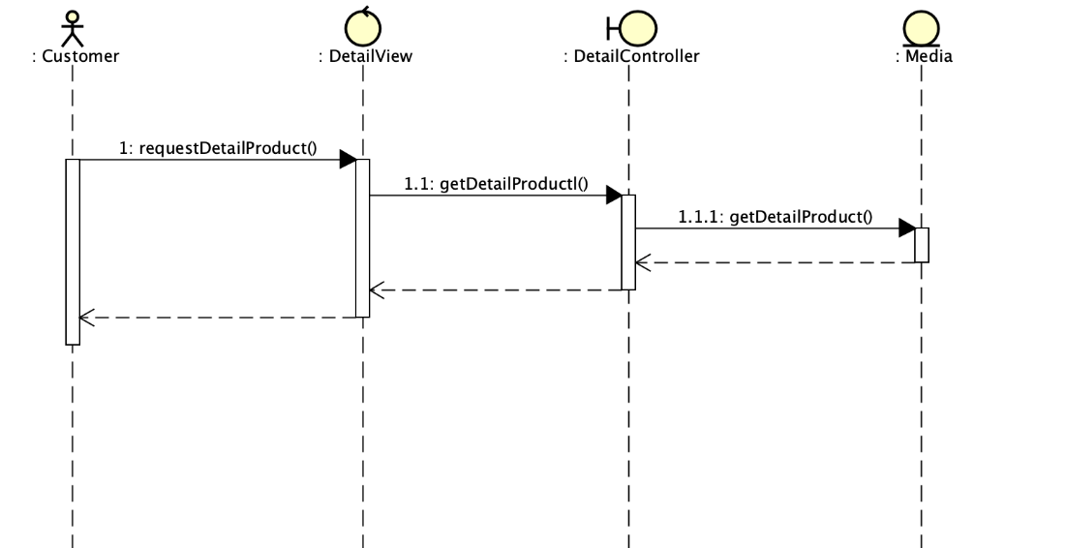

### ***Analysis Class Diagram for UC "Detail Products”***

